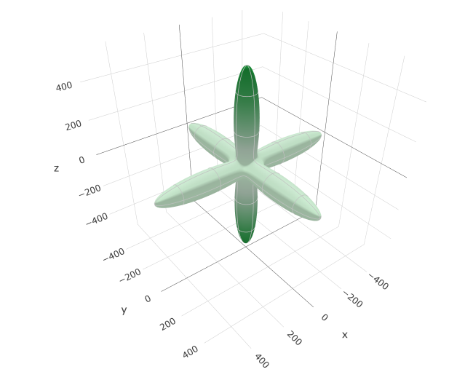
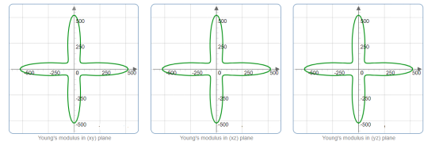

Figure S1. Directional dependence of Young’s modulus.

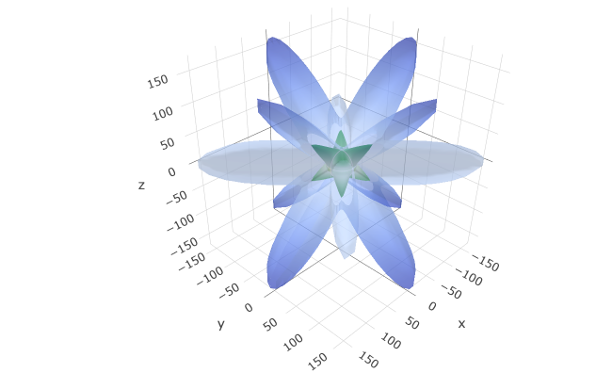
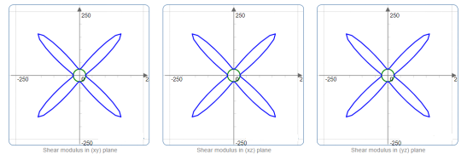

Figure S2. Directional dependence of the shear modulus: the blue and green shading show the maximum and minimum values, respectively.

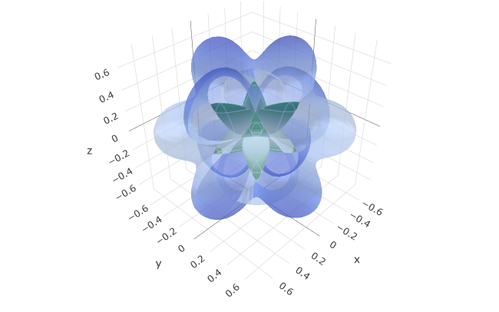
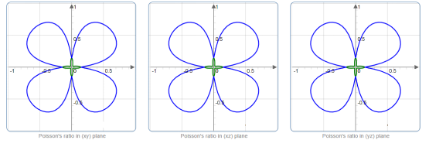

Figure S3. Directional dependence of Poisson’s ratio: the blue and green shading show the maximum and minimum values, respectively.

