Supplementary Material

Supplementary Figures
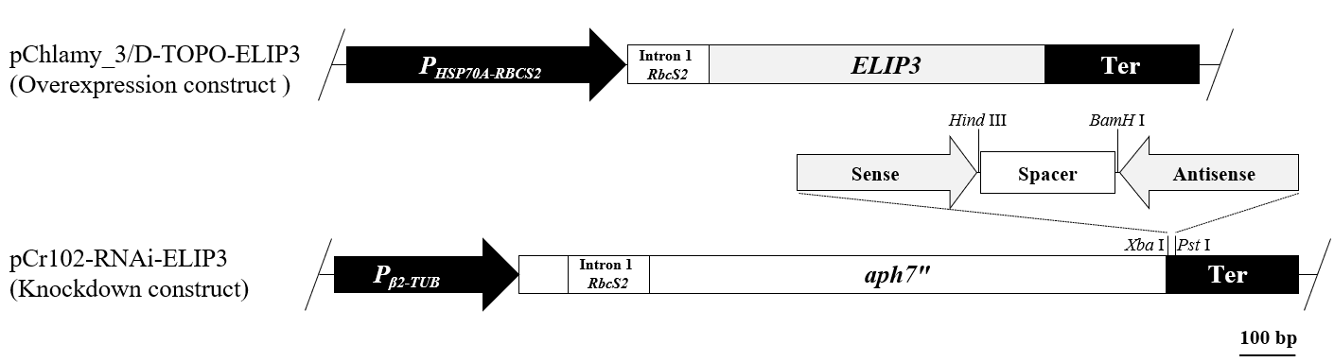
Supplementary Figure S1. Schematic diagram of the construct for overexpression and knockdown (RNAi) of ELIP3. Knockdown construct used to induce RNAi, which expresses hairpin ELIP3 dsRNA by cloning forward and reverse partial ELIP3 coding sequences (314 bp) on both sides of DNA spacer in the 3′ UTR of aph7″ marker gene (the hygromycin resistant gene).

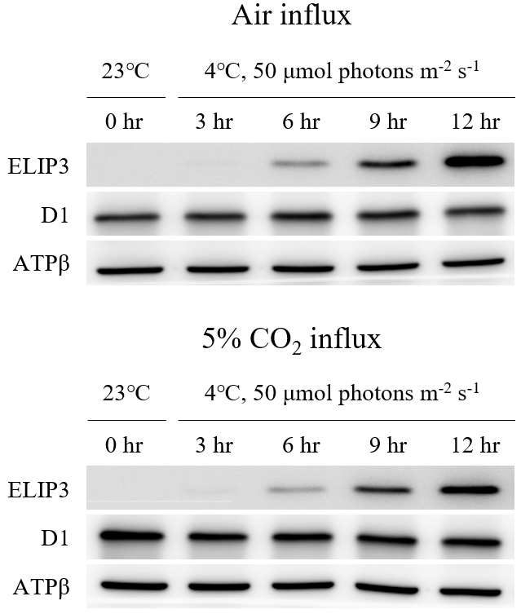
Supplementary Figure S2. Western blot analysis of ELIP3 and D1 in C. reinhardtii with or without supply of 5% CO₂ under 4℃ and nonstress light intensity (50 μmol photons m⁻² s⁻¹). ATPβ was detected as a loading control.

Supplementary Table
Supplementary Table S1. List of primers used in this study.
Name | Sense primer (forward) | Antisense primer (reverse)
ELIP3_RNAi | AACTGCAGATCTAGACGCCTGGCCATGCTGGGCTT | AACCTAGGAAAGCTTGCCGCAGCAGAATCGGCTGT
ELIP3_qPCR | GTGGCACCGTCGAG CCCAC | GCGGTGCCGCTGAAGGACAT
18s rRNA_qPCR | CCTGCGGCTTAATTTGACTC | ACCGGAATCAACCTGACAAG
ELIP3_Northern blot | GATGGCACCGTCGAGCCCAC | GCGGTGCCGCTGAAGGACAT

