Supplementary Material
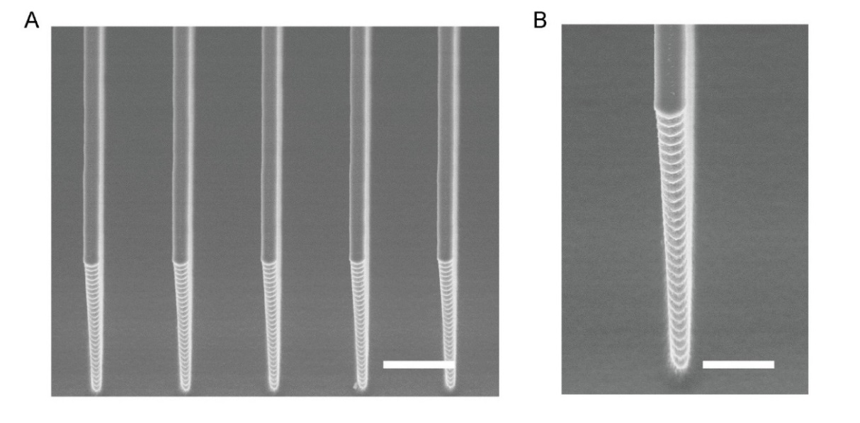
Supplementary Figure 1. Characterization of micropillar-structured template. (A) SEM image of the template. (B) Zoom in SEM image of the template. Scar bars: 5 μm.
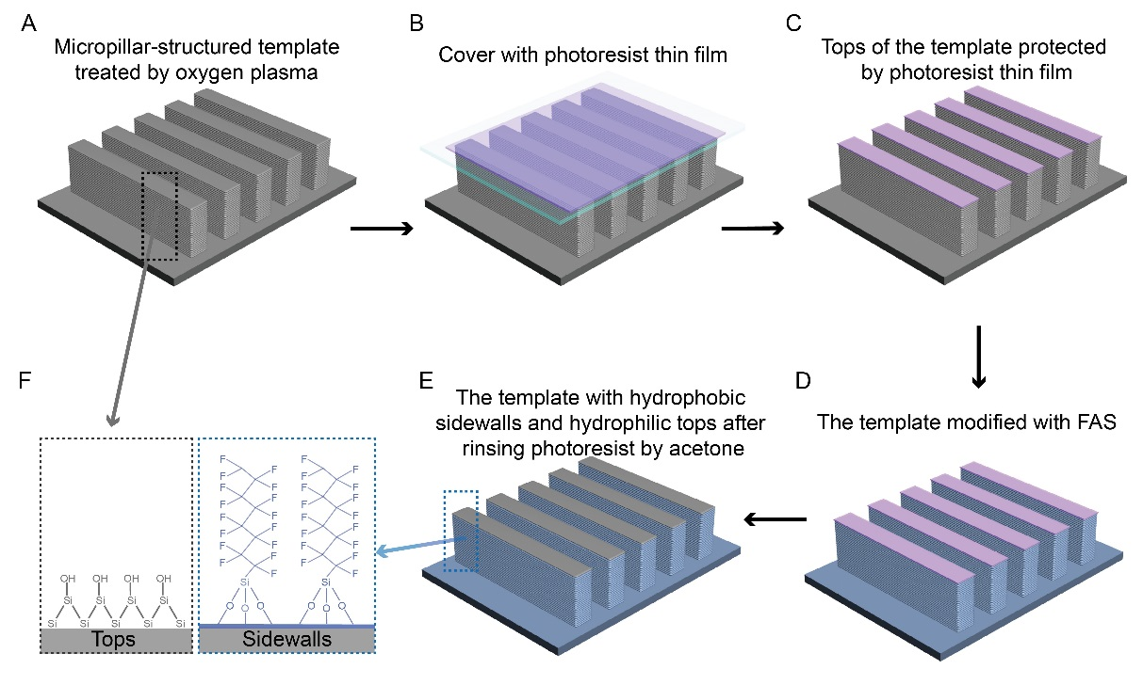
Supplementary Figure 2. Schematic illustration of FAS modification. (A) Micropillar-structured template after oxygen plasma treatment for 10 minutes. (B) Tops of template covered with a glass spin-coated with photoresist. (C) Tops of the template with a protect layer of photoresist thin film. (D) The template modified with FAS. (E) The template with hydrophobic sidewalls and superhydrophilic tops after immersing in acetone. (F) Schematic illustration of the superhydrophilic state in tops and hydrophobic state in sidewalls, respectively.

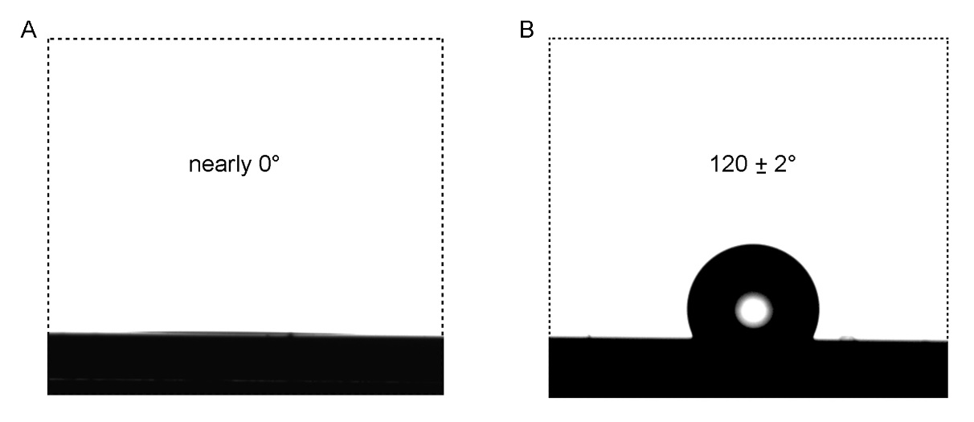
Supplementary Figure 3. CA characterization of the asymmetric wettability template. (A) The contact angle of water on the top, showing a superhydrophilic state with a contact angle of nearly 0°. (B) The contact angle of water on sidewalls modified with FAS, showing a contact angle of about 120 ± 2°, demonstrating a hydrophobic state.

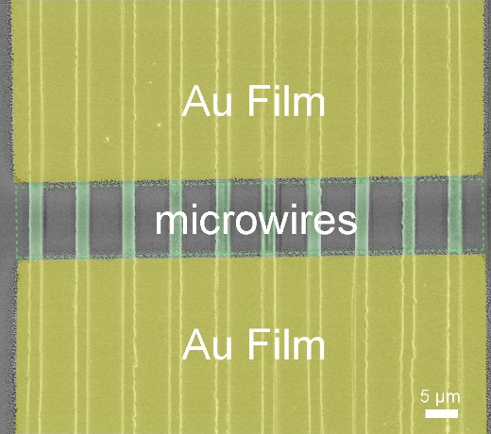
Supplementary Figure 4. Pseudocolor processed SEM image of the photodetector based on Cs₂AgBiBr₆ microwire arrays.

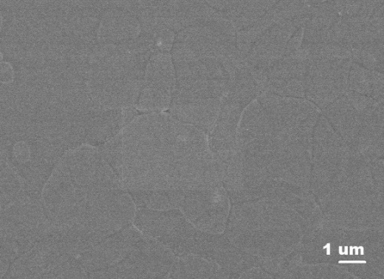
Supplementary Figure 5. SEM Characterization of Cs₂AgBiBr₆ film illustrating large grain size.

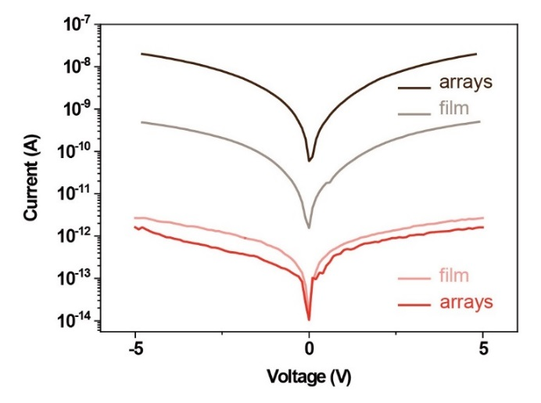
Supplementary Figure 6. Comparison of photodetector performance based on Cs₂AgBiBr₆ film and Cs₂AgBiBr₆ single crystal arrays. The photocurrent of the single crystal wire arrays is higher than thin film under the same irradiation intensity.

