Supplementary Material

CuInS₂/ZnS Core/Shell Quantum Dots Characterization. The crystal structure of the QDs was analyzed by X-ray powder diffraction (XRD) spectroscopy using D8-ADVANCE. The size and morphologies of the QDs were investigated by JEM-2100F transmission electron microscopy (TEM) operating at an acceleration voltage of 200 kV, the TEM samples were obtained by depositing a drop of QDs dispersion in chloroform onto carbon coated copper grid network. Fourier transformed infrared (FTIR) spectroscopy (Frontier IR/FIR STA 8000) were used to investigate the dried pure CuInS₂/ZnS QDs powder at different use of OA.

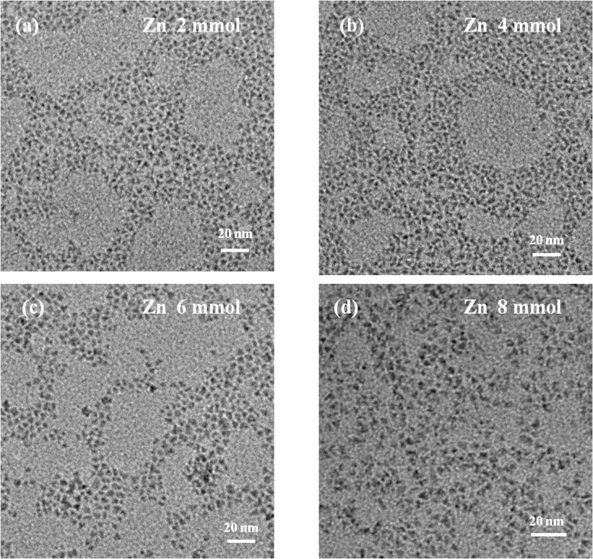

Figure S1. TEM image of CIS/ZnS QDs under the different use of zinc source. (a) 2 mmol; (b) 4 mmol; (c) 6 mmol; (d) 8 mmol.

Figure S2. XRD patterns of CIS/ZnS QDs at different use of zinc source of 2 mmol, 4 mmol, 6 mmol and 8 mmol.

Three main peaks of (111), (220) and (311) planes were positioned aside from the reflection peaks of CIS/ZnS phase and thus indicating that the ZnS overlayer was deposited appropriately on the surface of CIS core QDs (ZnS, JPDS 05-0566; CIS, JPDS 85-1575).

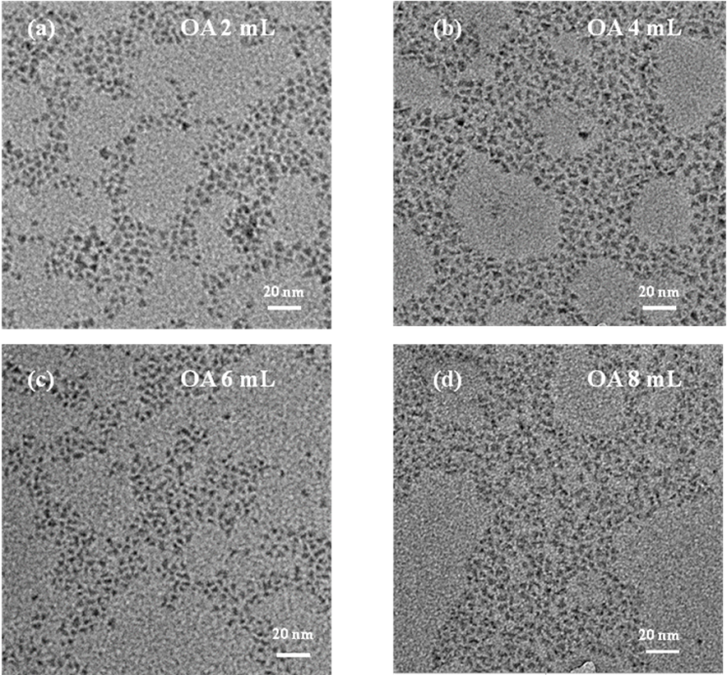

Figure S3. TEM image of CIS/ZnS QDs under different use of OA. (a) 2 mL; (b) 4 mL; (c) 6 mL; (d) 8 mL.
c

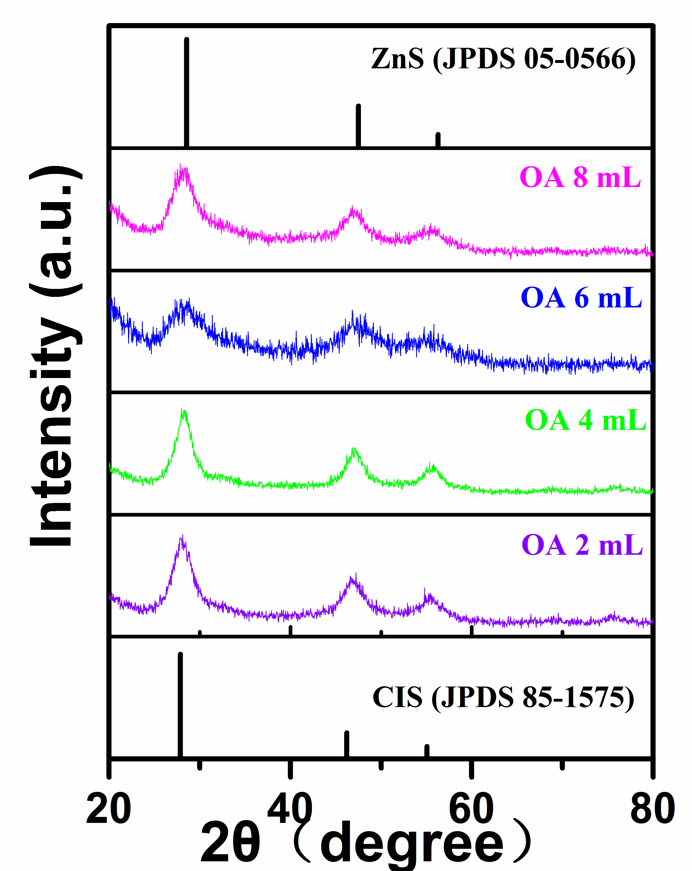

Figure S4. XRD patterns of CIS/ZnS QDs at different use of OA of 2 mL, 4 mL, 6mL and 8 mL.

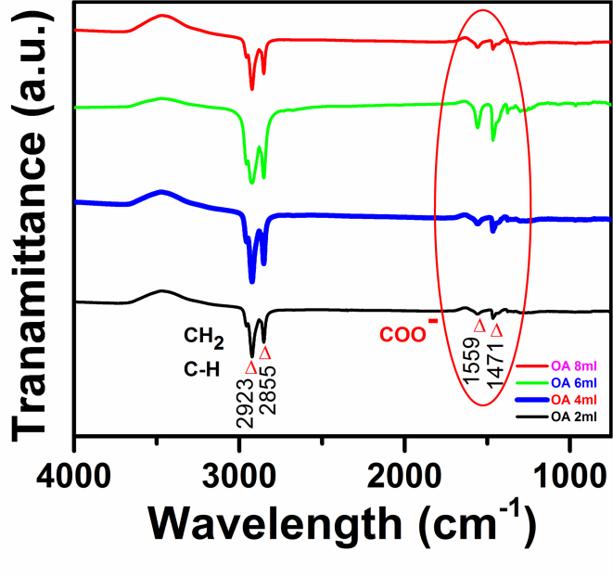
Figure S5. FTIR spectra of CuInS₂/ZnS QDs at different use of OA.

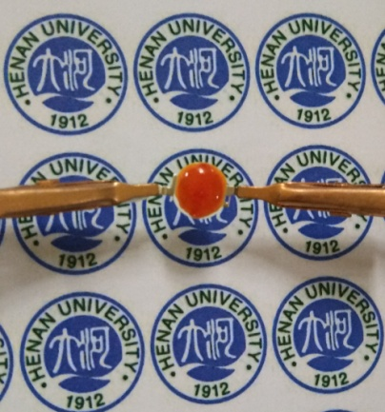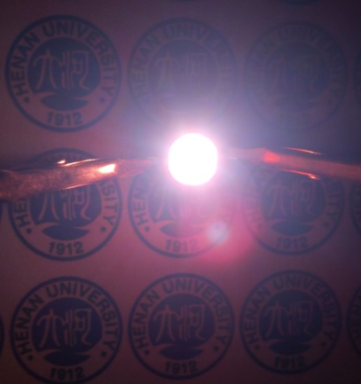
Figure S6. Digital camera images of fabricated device under zero bias (left) and forward bias 20 mA (right).

