Supplementary Material

Water temperature and depth measurements in front of Sobo-Sise Cliff
During the Lena 2019 summer campaign water temperature and depth (Supplementary Figure S1) of the Sardakhskaya channel were measured from boat in front of Sobo-Sise Cliff at five different locations (Supplementary Figure S2) with a handheld SontekTM CastAway CTD (conductivity, temperature, depth) device. There was no stratification in temperature with depth. On 8 August 2019, average temperature was 14.80 ± 0.06°C and average depth was 11.32 ± 0.37 m.

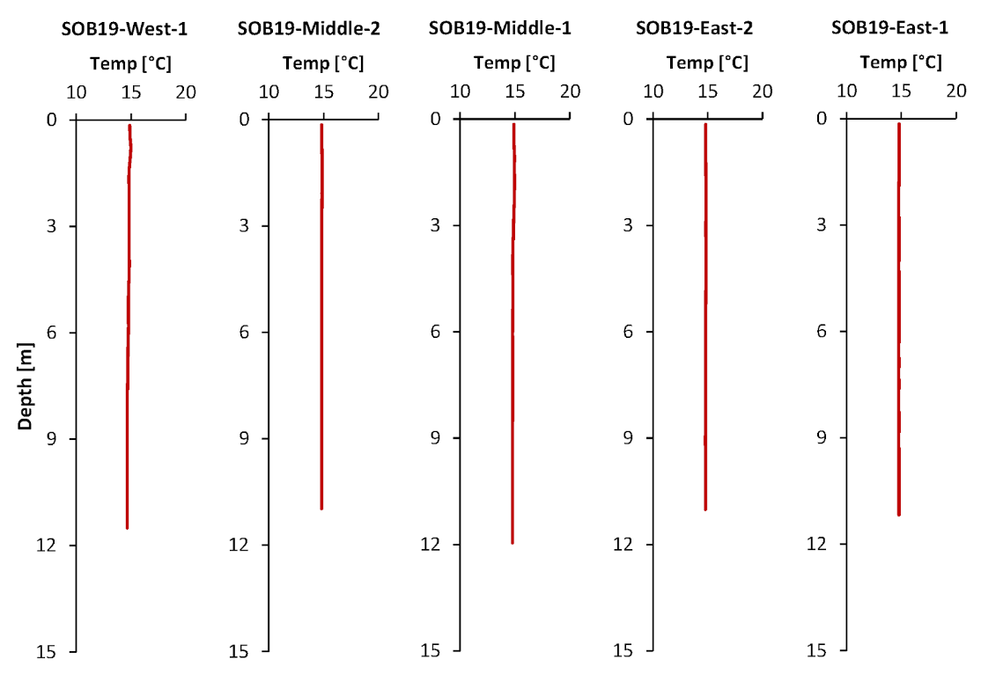
Supplementary Figure S1. Water temperature data from 8 August 2019 in front of Sobo-Sise Cliff. Water depth reached down to 11.95 m and water temperature was up to 14.97°C.
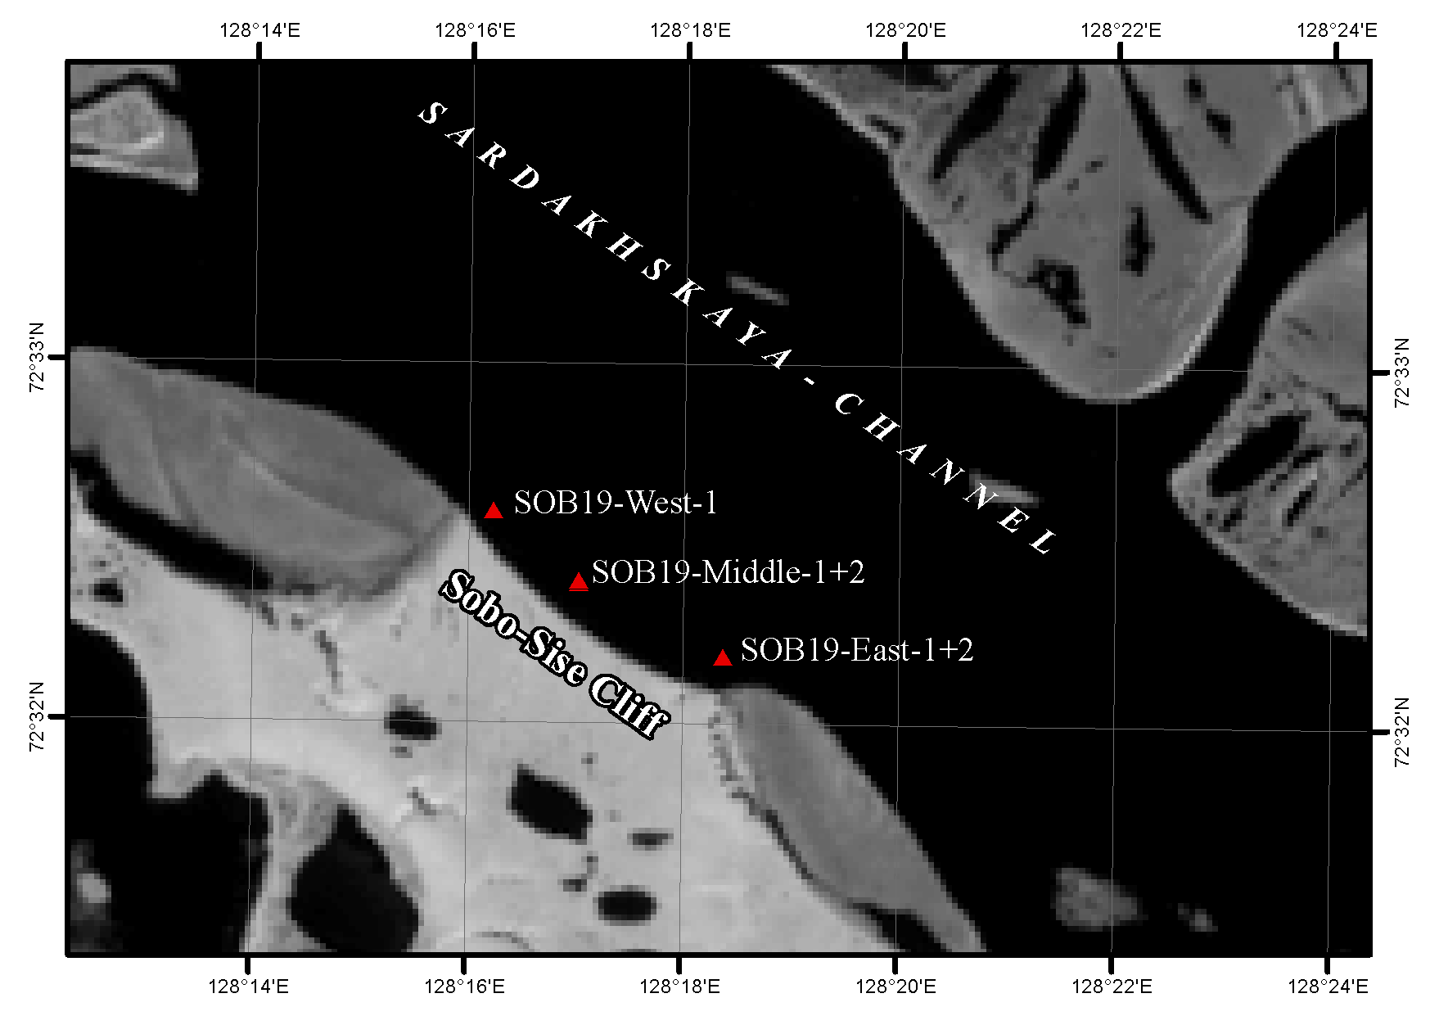
Supplementary Figure S2. CTD measurement locations (red triangles) in front of Sobo-Sise Cliff during the summer field campaign 2019.

Bulk density calculation
The bulk density (BD g cm⁻³) is a basic parameter for volumetric carbon quantification and was calculated following the approach by Strauss et al. (2012). For this, the density of the solid fraction (D_{s}, g cm⁻³) was assumed to 2.65 g cm⁻³ (Lide et al., 2008), which is the density of quartz. Afterwards, the volume of the solids (V_{s}, cm³) was derived following equation 1. Moreover, the mass of solid particles (m_{s}) is used.
$V_{s}=\frac{m_{s} }{D_{s}}$ [1]
After that, the porosity (P) was calculated using the volume of the pores (V_{p}, g cm⁻³, equation 2):
$P=\frac{V_{p}}{V_{p}+V_{s}}$ [2]
For solving this equation, we need the pore volume (V_{p}). This was done by to assuming that all pores are ice-saturated. We defined ice content >20 wt% as threshold for ice saturation. With this assumption, the absolute ice content gives the pore volume V_{p}. For the determination of ice volume (V_{ice} = m_{ice}/D_{ice}) an ice density (D_{ice}) of 0.917 10³kg/m³ (Lide et al., 2008) was assumed. Finally, determining the negative linear correlation (Horn, 2002) with the sediment porosity allows bulk density to be calculated (equation 3).
$BD=\left(P-1\right)×(-D_{s})$ [3]
For getting the segregated and pore ice volume in %, we assumed a 3-component model of the cliff consisting of ice, mineral fraction of the sediment and organic matter and assuming component densities of 2.65 (Lide et al., 2008) and 0.25 g cm⁻³ (Adams, 1973) for the latter two components, respectively. We used this for estimating the total volume of ice and organic matter at the Sobo-Sise Cliff.

Retrieving height information for the Sobo-Sise Cliff
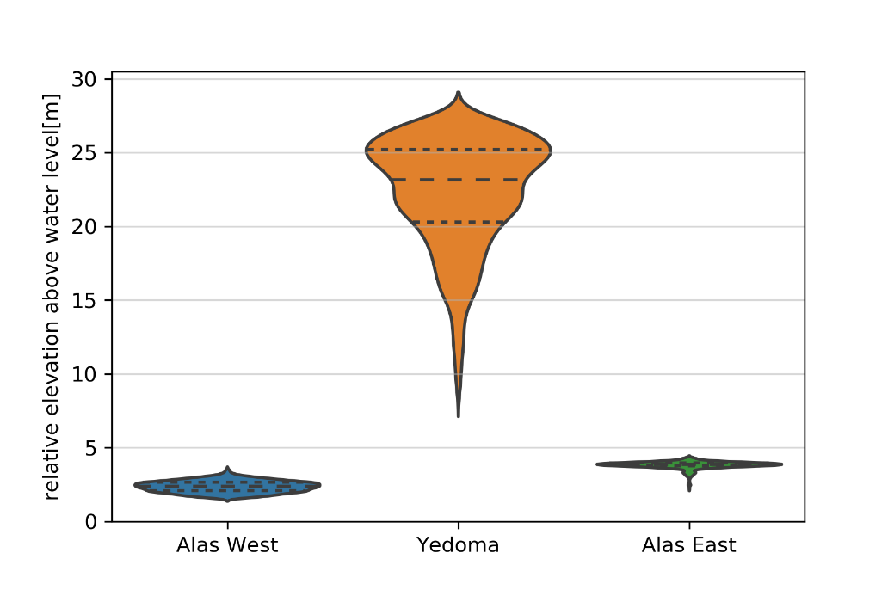
Supplementary Figure S3. Violin plot with quartiles of height distribution from yedoma, alas east, alas west above water level based on the Arctic DEM (10 m spatial resolution, Mosaic v3.0 10m: tile 59_43) (Porter et al., 2018). Data extracted based on representative sample areas of morphological units.

Ice wedge estimation

Segment photographs and equations
This section provides additional information on the ice wedge estimation for the Sobo-Sise Cliff. Supplementary Figure S4 shows the ten (a-j) different sections analyzed for the ice to sediment ratio (I:S_{width}) and Supplementary Table 1 gives metadata for the photographs as well as I:S_{width} and calculated ice wedge contents (IWC) for the ten sections. No absolute numbers were measured in the photographs. Only the relative size from the ice section width compared to the sediment section width was determined. The calculation of the inner and outer polygon area was based on the equation for regular hexagons. Ice wedge content was calculated according to equations 4 – 9 for each of the section and in a final step averaged to the resulting Sobo-Sise Cliff ice wedge content of 66 ± 13 vol%.
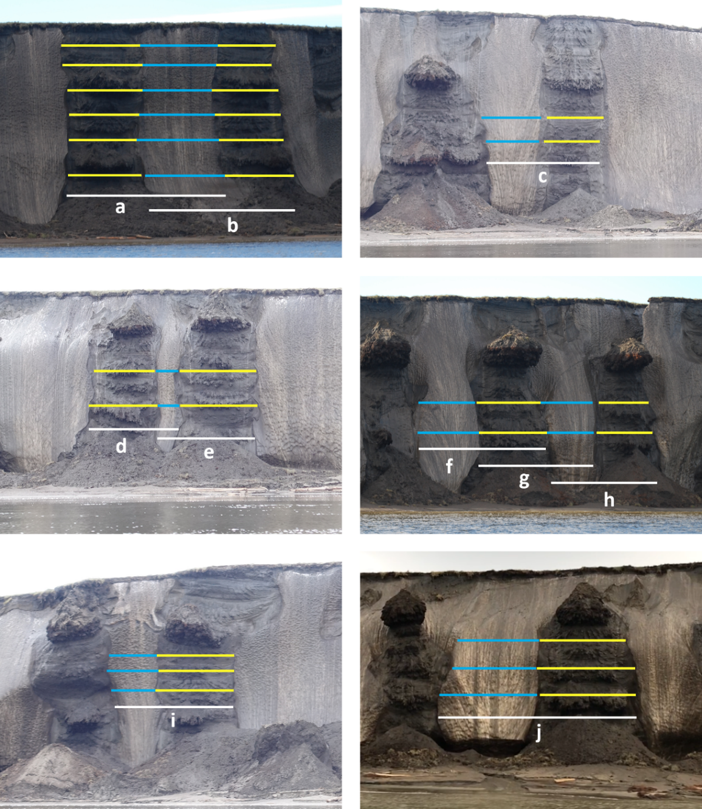
Supplementary Figure S4. I:S_{width} along the Sobo-Sise Cliff for different sections. The blue bars (width of ice wedge) and the red bars (width of sediment pocket) of each section were averaged for calculating the I:S_{width} and the ice wedge content. Resulting I:S_{width} and ice wedge content are presented in Supplementary Table 1.

${I:S}_{width}={Width}_{ICE}/{Width}_{SED}$ [4]
$diamter of inner (sediment) polygon=a$ [5]
$diamter of outer (ice) polygon=\frac{a}{{I:S}_{width}}$ [6]
${Volume of the inner \left(sediment\right) polygon: V}_{IP}= {(\frac{a}{2})}^{2}*2\sqrt{3}*h$ [7]
${Volume of the outer \left(ice\right)polygon: V}_{OP}=\left({\left(\frac{1}{2}*(\frac{a}{{I:S}_{width}}+a)\right)}^{2}*2\sqrt{3}*h\right)-V_{IP}$ [8]
$IWC [vol\%]=\left(\frac{V_{OP}}{V_{OP}+V_{IP}}\right)*100$ [9]

Supplementary Table S1. I:S_{width} and ice wedge content (IWC) for the sections in the photographs of Supplementary Figure S4
Section | I:S_{width} | IWC [vol%] | Date of the photograph | Photographer
a | 1.03 | 75.8 | 11.08.2014 | T. Opel
b | 1.22 | 79.6 | 11.08.2014 | T. Opel
c | 1.00 | 75.1 | 15.08.2015 | A. Fricke
d | 0.34 | 44.1 | 15.08.2015 | A. Fricke
e | 0.28 | 39.2 | 15.08.2015 | A. Fricke
f | 0.89 | 72.1 | 11.08.2014 | T. Opel
g | 0.75 | 67.2 | 11.08.2014 | T. Opel
h | 0.94 | 73.5 | 11.08.2014 | T. Opel
i | 0.62 | 61.9 | 15.08.2015 | A. Fricke
j | 0.93 | 73.3 | 07.08.2019 | M. Fuchs
Average |  | 66.2 ± 13.2

Comparison of ice wedge volumes in yedoma environments
Ice wedge volume is crucial for estimating sediment and C mass eroded from permafrost soils. An underestimation of the ice content leads to overestimations in eroded C. The challenge with ground ice is the sparse data availability on the size and extent of ice wedges. Often, ice wedge polygons or baydzherakhs are a surface indication on the distribution of ice within a landscape. This was used by the approaches of Strauss et al (2013), Ulrich et al. (2014) or Günther et al. (2015). However, both approaches were not feasible in our study area, since neither polygons nor baydzherakhs were detectable at the surface of Sobo-Sise Cliff. Therefore, we mapped ice wedges at the cliff front and put them into relation to sediment pockets. In particular, we calculated the ratio of ice wedges and sediment pockets dissecting the entire cliff height in order to assure that those former ice wedge polygons were eroded more or less through its center point, leaving behind representative portions of sediment and ice within an idealized ice wedge polygon landscape.
Our approach results in a similar ice wedge volume compared to previous studies. Ice wedge estimations by Ulrich et al. (2014) range from 17 to 63 vol% for yedoma deposits in Siberia and Alaska, Günther et al. (2015) calculated 44 vol% for Muostakh Island and Kanveskiy et al. (2016) had an average ice wedge volume of 61 vol% for the Itkillik yedoma exposure in Alaska. Limitations in our approach are, however, the sparse number of through-going sediment pockets restricting the number of ice to sediment ratio calculations (Supplementary Figure S4). Nevertheless, we assume that our ten measured ice and sediment sections are representative for the entire cliff in space and time. When comparing total ice content, our calculation of 88 vol% (wedge ice + segregated and pore ice) was almost identical to total ice content estimations like e.g. Itkillik exposure, Muostakh Island and yedoma at Camden Bay at the Alaskan Beaufort Sea Coast with 86, 87, and 89 vol%, respectively (Kanevskiy, et al., 2013, 2016, Günther et al., 2015).

DOC flux from yedoma ice wedges at Sobo-Sise Cliff
Since no own ice samples were collected from ice wedges at Sobo-Sise Cliff, the mean value for yedoma ice wedges by Fritz et al. (2015) of 11.1 mg L⁻¹ DOC were used to estimate the DOC contribution of ice wedges. The estimation was further based on a volumetric ice wedge volume of 66% (see Supplementary Chapter 4) and the eroded volume at Sobo-Sise Cliff (see Table 2 in the main text). Supplementary Table 2 presents the volume of eroded ice wedges and the ice wedge DOC flux at Sobo-Sise Cliff.
Supplementary Table S2. Ice wedge (IW) volume loss and ice wedge DOC flux estimations for Sobo-Sise Cliff
Period | Total eroded IW volume  [10⁶ m³] | Mean annual eroded IW volume  [10⁶ m³ yr⁻¹] | Total IW DOC_{flux}  [10³ kg] | Mean annual IW DOC_{flux}  [10³ kg yr⁻¹] | IW DOC contribution to total DOC flux  [%] | IW DOC contribution to total C flux  [%]
2000-2005 | 0.64 | 0.13 | 6.47 | 1.29 | 9.5 | 0.08
2005-2010 | 2.08 | 0.42 | 21.22 | 4.24 | 9.5 | 0.08
2010-2015 | 1.74 | 0.35 | 17.76 | 3.55 | 9.5 | 0.08
2015-2018 | 1.15 | 0.38 | 11.74 | 3.91 | 9.5 | 0.08
2000-2018 | 5.62 | 0.31 | 57.19 | 3.18 | 9.5 | 0.08

Weather data from Station Tiksi
We analyzed synoptic weather data from the nearest weather station in Tiksi provided by the National Oceanic and Atmospheric Administration (NOAA). We acquired the GHCN-Daily datasets (Menne et al., 2012) in CSV format through the web-search on the NOAA website (https://www.ncdc.noaa.gov/cdo-web/search). We calculated mean monthly temperatures and its anomaly from the climatological mean (Supplementary Figure S5).
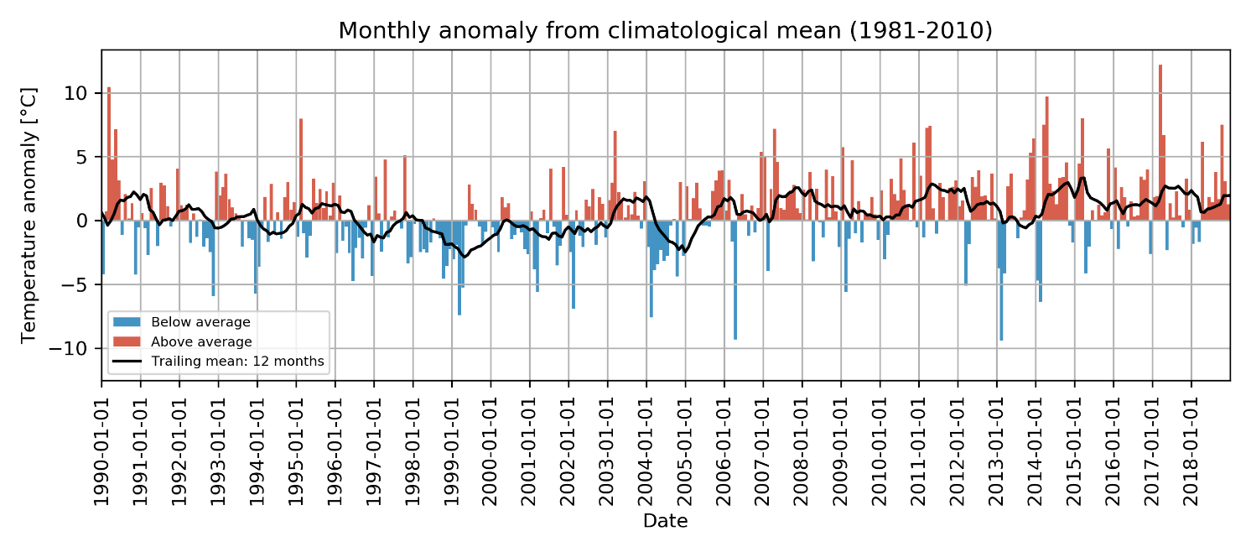
Supplementary Figure S5. Mean monthly temperature anomaly from climatological period (1981-2010) of weather station Tiksi. Positive anomaly in red, negative anomaly in blue. The black line indicates the mean temperature anomaly of the previous 12 months.

References
Adams, W.A. (1973). The effect of organic matter on the bulk and true densities of some uncultivated podzolic soils. Journal of Soil Science, 24(1), 10-17. doi:10.1111/j.1365-2389.1973.tb00737.x.
Fritz, M., Opel, T., Tanski, G., Herzschuh, U., Meyer, H., Eulenburg, A., and Lantuit, H. (2015). Dissolved organic carbon (DOC) in Arctic ground ice. The Cryosphere, 9, 737-752. doi:10.5194/tc-9-737-2015.
Günther, F., Overduin, P.P., Yakshina, I.A., Opel, T., Baranskaya, A.V., and Grigoriev, M.N. (2015). Observing Muostakh disappear: permafrost thaw subsidence and erosion of a ground-ice-rich island in response to arctic summer warming and sea ice reduction. The Cryosphere 9(1), 151-178. doi: 10.5194/tc-9-151-2015.
Horn, R. (2002), Bodenphysik, in Scheffer/Schachtschabel—Lehrbuch der Bodenkunde, edited by H.-P. Blume et al., pp. 155–271, Spektr. Akad., Heidelberg, Germany.
Kanevskiy, M., Shur, Y., Jorgenson, M.T., Ping, C.-L., Michaelson, G.J., Fortier, D., Stephani, E., Dillon, M., and Tumskoy V. (2013). Ground ice in the upper permafrost of the Beaufort Sea coast of Alaska. Cold Regions Science and Technology 85, 56-70. doi:10.1016/j.coldregions.2012.08.002
Kanevskiy, M., Shur, Y., Strauss, J., Jorgenson, T., Fortier, D., Stephani, E., et al. (2016). Patterns and rates of riverbank erosion involving ice-rich permafrost (yedoma) in northern Alaska. Geomorphology 253, 370-384.
Lide, D. R., G. Baysinger, H. V. Kehiaian, L. I. Berger, K. Kuchitsu, R. N. Goldberg, D. L. Roth, W. M. Haynes, and D. Zwillinger (2008). Properties of ice and supercooled water, in CRC Handbook of Chemistry and Physics, edited by D. R. Lide et al., p. 1101, CRC Press, Boca Raton, Florida.
Menne, M.J., I. Durre, B. Korzeniewski, S. McNeal, K. Thomas, X. Yin, S. Anthony, R. Ray, R.S. Vose, B.E.Gleason, and T.G. Houston, (2012). Global Historical Climatology Network - Daily (GHCN-Daily), Version 3. NOAA National Climatic Data Center. http://doi.org/10.7289/V5D21VHZ [2019-04-14]
Porter, C., Morin, P., Howat, I., Noh, M.-J., Bates, B., Peterman, K., Keesey, S., Schlenk, M. Gardiner, J., Tomko, K., Willis, M., Kelleher, C., Cloutier, M., Husby, E., Foga, S., Nakamura, H., Platson, M., Wethington, M.Jr., Williamson, C., Bauer, G., Enos, J., Arnold, G., Kramer, W., Becker, P., Doshi, A., D’Souza, C., Cummens, P., Laurier, F., Bojesen, M. (2018). “ArcticDEM”, https://doi.org/10.7910/DVN/OHHUKH, Harvard Dataverse, V1, [9th August 2019].
Strauss, J., Schirrmeister, L., Wetterich, S., Borchers, A., and Davydov, S.P. (2012). Grain-size properties and organic-carbon stock of Yedoma Ice Complex permafrost from the Kolyma lowland, northeastern Siberia. Global Biogeochemical Cycles, 26, GB3003, doi:10.1029/2011GB004104.
Strauss, J., Schirrmeister, L., Grosse, G., Wetterich, S., Ulrich, M., Herzschuh, U., et al. (2013). The deep permafrost carbon pool of the Yedoma region in Siberia and Alaska. Geophysical Research Letters 40(23), 6165-6170. doi: 10.1002/2013GL058088.
Ulrich, M., Grosse, G., Strauss, J., and Schirrmeister, L. (2014). Quantifying wedge-ice volumes in yedoma and thermokarst basin deposits. Permafrost and Periglacial Processes, 25(3), 151-161. doi:10.1002/ppp.1810.

