Supplementary Material

Supplementary Data

Supplementary Figures

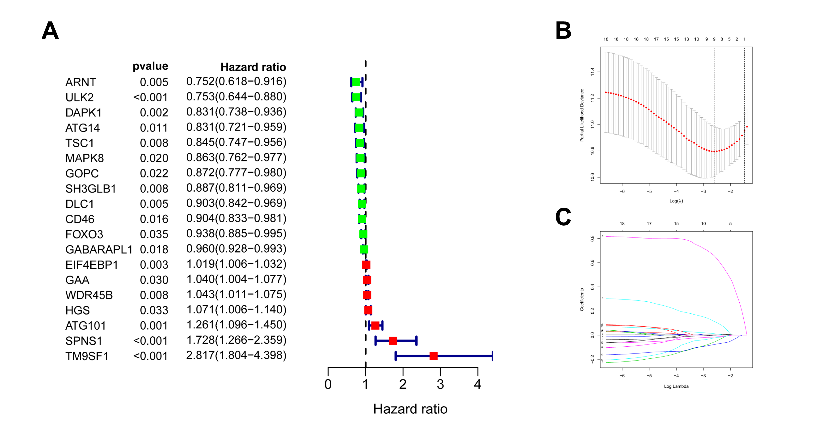
Supplementary Figure 1. Univariate Cox and LASSO Cox survival analyses for the ARGs in cohort 1. (A) Univariate Cox survival analyses for the differentially expressed and survival-related ARGs. (B,C) LASSO Cox analysis identified nine ARGs with the best prognostic value in cohort 1.

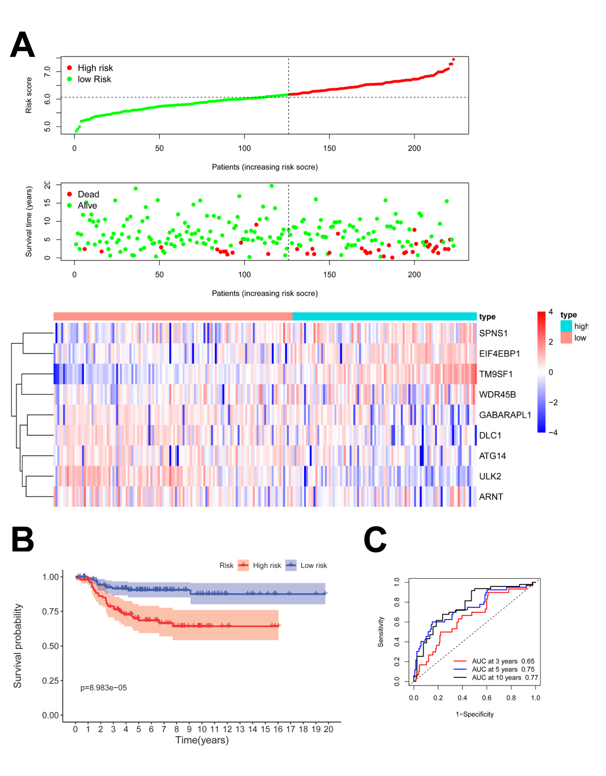
Supplementary Figure 2. The ARG signature risk score for neuroblastoma in cohort 3. (A) The distribution of risk scores, survival status of each patient, and heatmap of ARGs expression pattern in cohort 3. (B) Kalpan-Meier survival curve for OS of patients in the low risk group and high risk group for cohort 3. (C) Time-dependent ROC curves for the prognostic value of the ARG signature in cohort 3.

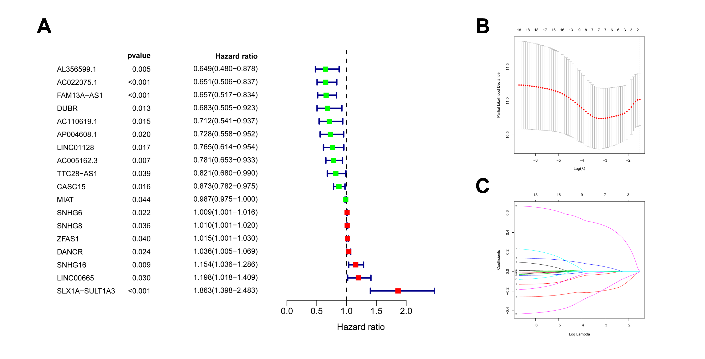
Supplementary Figure 3. Univariate Cox and LASSO Cox survival analyses for the autophagy-related lncRNAs in cohort 1. (A) Univariate Cox survival analyses for the survival-related lncRNAs. (B,C) LASSO Cox analysis identified seven lncRNAs with the best prognostic value in cohort 1.

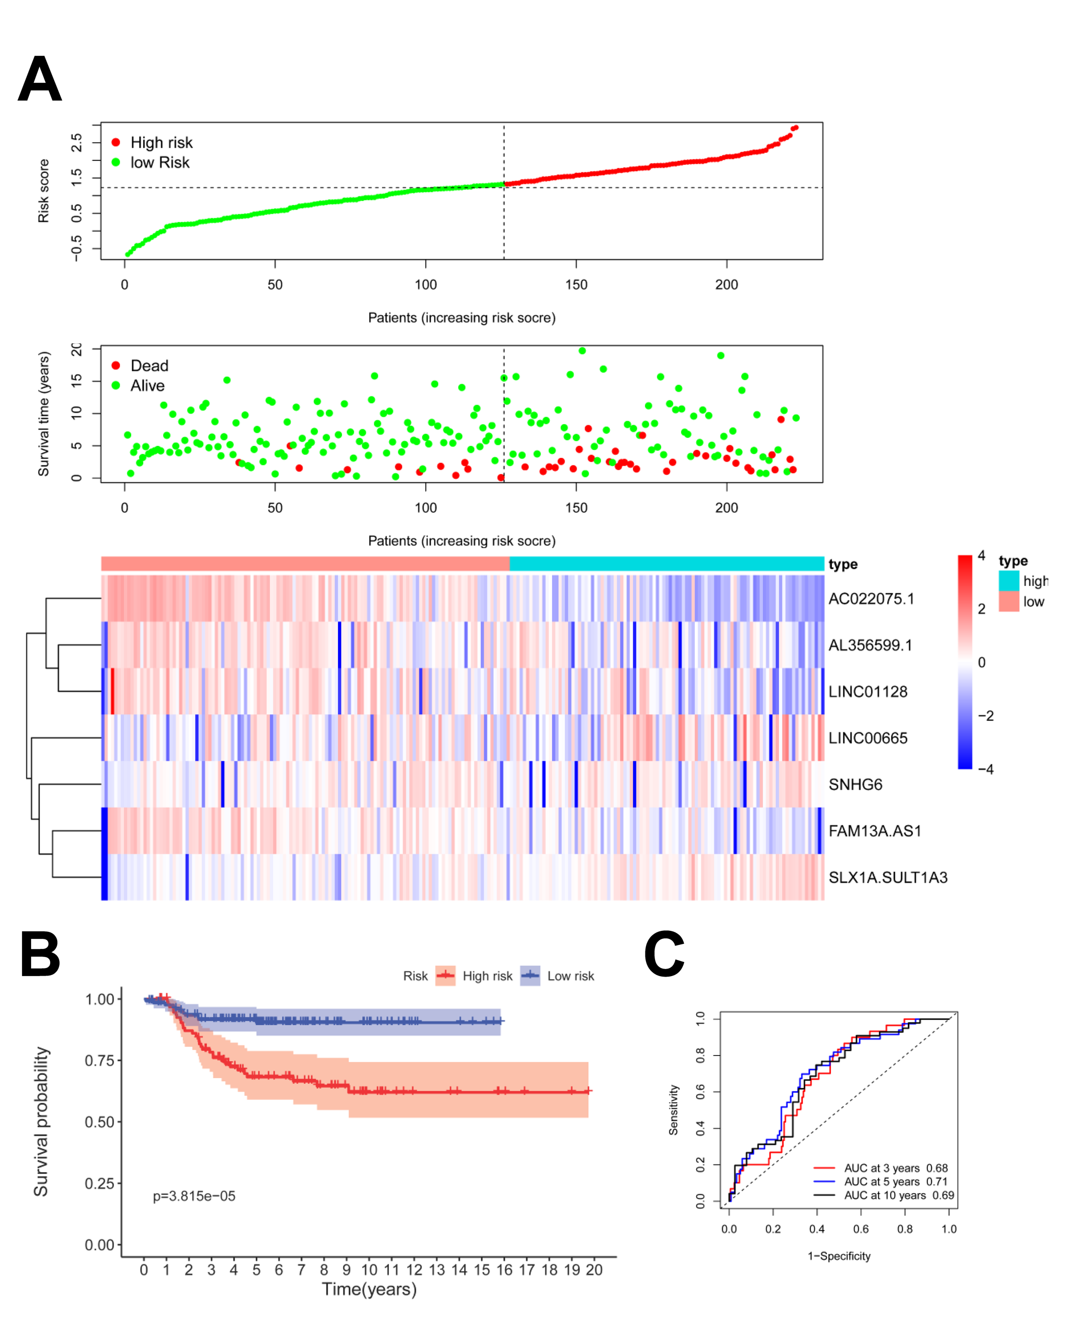
Supplementary Figure 4. The autophagy-related lncRNA signature risk score for neuroblastoma in cohort 3. (A) The distribution of risk scores, survival status of each patient, and heatmap of ARGs expression pattern in cohort 3. (B) Kaplan-Meier survival curve for OS of patients in the low risk group and high risk group for cohort 3. (C) Time-dependent ROC curves for the prognostic value of the lncRNA signature in cohort 3.

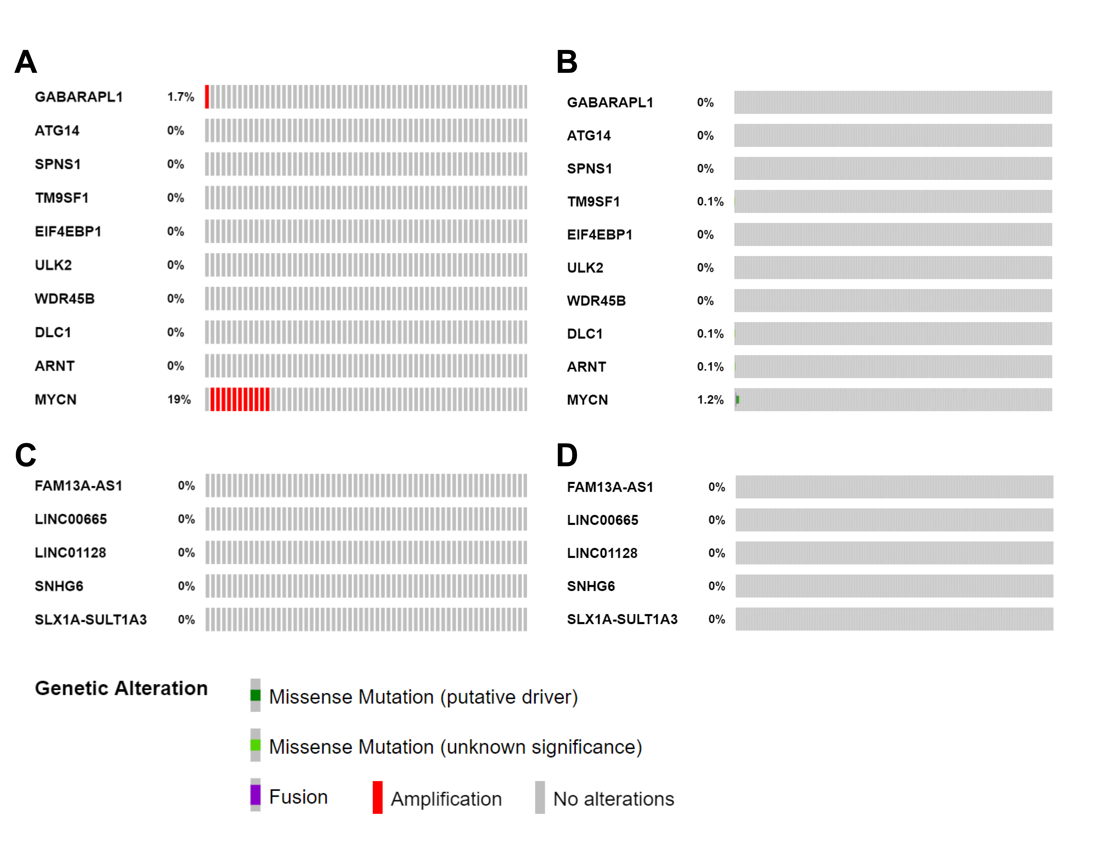
Supplementary Figure 5. Genetic alterations of the ARGs and lncRNAs in neuroblastoma. (A) Gene copy number alteration data of the ARGs in 59 NB cases. (B) Gene mutation data of the ARGs in 755 NB cases. (C) Gene copy number alteration data of the lncRNAs in 59 NB cases. (D) Gene mutation data of the lncRNAs in 755 NB cases.

Supplementary Table

Supplementary Table 1. The clinical characteristics of the three cohorts.
 | No. of cohort 1 (%) | No. of cohort 2 (%) | No. of cohort 3 (%)
Age
< 18 m | 29 (19.0%) | 300 (60.2%) | 103 (46.2%)
≥ 18 m | 124 (81.0%) | 198 (39.8%) | 120 (53.8%)
Gender
Male | 89 (58.2%) | 287 (57.6%) | -
Female | 64 (41.8%) | 211 (42.4%) | -
MYCN status
Non-amplified | 121 (79.1%) | 401 (80.5%) | 176 (78.9%)
Amplified | 31 (20.3%) | 92 (18.5%) | 46 (20.6%)
Risk
Low | 27 (17.6%) | 322 (64.7%) | -
High | 126 (82.4%) | 176 (35.3%) | -
INSS Stage
1 | 0 | 121 (24.3%) | 29 (13.0%)
2 | 1 (0.7%) | 78 (15.7%) | 39 (17.5%)
3 | 6 (3.9%) | 63 (12.7%) | 36 (16.1%)
4 | 125 (81.7%) | 183 (36.7%) | 89 (39.9%)
4S | 21 (13.7%) | 53 (10.6%) | 30 (13.5%)
Vital status
Dead | 77 (50.3%) | 105 (21.1%) | 42 (18.8%)
Alive | 76 (49.7%) | 393 (78.9%) | 181 (81.2%)

Supplementary Table 2. The ARGs in the prognostic signature.
Gene Symbol | Official Full Name | Ensemble ID | Location | Log2FC | FDR
ULK2 | unc-51 like autophagy activating kinase 2 | ENSG00000083290 | 17p11.2 | -1.02 | 1.16651E-06
DLC1 | DLC1 Rho GTPase activating protein | ENSG00000164741 | 8p22 | -0.95 | 1.75394E-06
GABARAPL1 | GABA type A receptor associated protein like 1 | ENSG00000139112 | 12p13.2 | -0.68 | 0.001463328
ATG14 | autophagy related 14 | ENSG00000126775 | 14q22.3 | -0.56 | 0.000565624
ARNT | aryl hydrocarbon receptor nuclear translocator | ENSG00000143437 | 1q21.3 | -0.52 | 2.03073E-05
SPNS1 | sphingolipid transporter 1 (putative) | ENSG00000169682 | 16p11.2 | 0.52 | 0.005034856
WDR45B | WD repeat domain 45B | ENSG00000141580 | 17q25.3 | 0.58 | 0.00016204
EIF4EBP1 | eukaryotic translation initiation factor 4E binding protein 1 | ENSG00000187840 | 8p11.23 | 0.61 | 0.026991444
TM9SF1 | transmembrane 9 superfamily member 1 | ENSG00000100926 | 14q12 | 0.81 | 1.09317E-06

Supplementary Table 3. The autophagy-related lncRNAs in the prognostic signature.
Gene Symbol | Official Full Name | Ensemble ID | Location
LINC01128 | long intergenic non-protein coding RNA 1128 | ENSG00000228794 | 1p36.33
AL356599.1 (FBXO30-DT) | FBXO30 divergent transcript | ENSG00000235652 | 6q24.3
FAM13A-AS1 | FAM13A antisense RNA 1 | ENSG00000248019 | 4q22.1
AC022075.1 (KLRK1-AS1) | KLRK1 antisense RNA 1 | ENSG00000245648 | 12p13.2
SLX1A-SULT1A3 | SLX1A-SULT1A3 readthrough | ENSG00000213599 | 16p11.2
LINC00665 | long intergenic non-protein coding RNA 665 | ENSG00000232677 | 19q13.12
SNHG6 | small nucleolar RNA host gene 6 | ENSG00000245910 | 8q13.1

