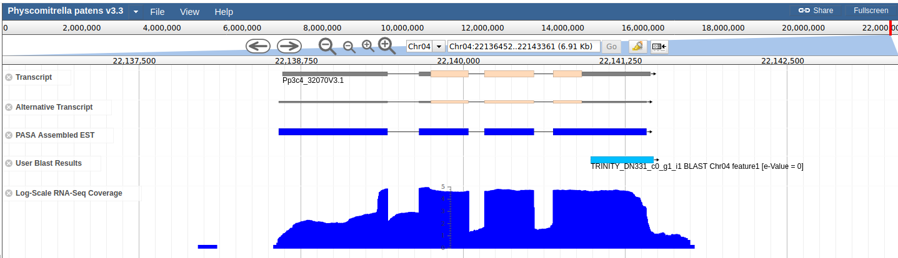

Supplementary Figure 1: Expression of a RLC5 solo-LTR as the result of a read-through transcription from the gene Pp3c4_32070. Screenshot of the Phytozome genome browser showing from top to bottom, the Pp3c4_32070 transcript, alternative transcripts, PASA Assembled EST, BLASTn best-hit of the TRINITY_DN331_c0_g1_i1, corresponding to a RLC5 solo-LTR, and the log-scale RNA-Seq coverage of the genome region.

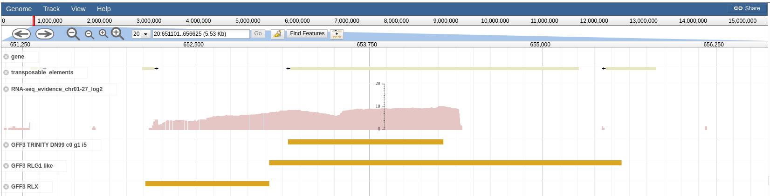
Supplementary Figure 2: Expression of a chimeric TE sequence. Screenshot of the COGE https://genomevolution.org/coge/) genome browser showing from top to bottom, the annotated genes in the genomic region, the TE annotation corresponding to a RLGU (unclassified Gypsy) element, the log-scale RNA-Seq coverage of the genome region, the best hit of the assembly TRINITY_DN99_c0_g1_i5, the manually curated truncated RLG1 element, and a manually curated repetitive sequence corresponding to a copy of an RLX (LTR-retrotransposon unclassified).

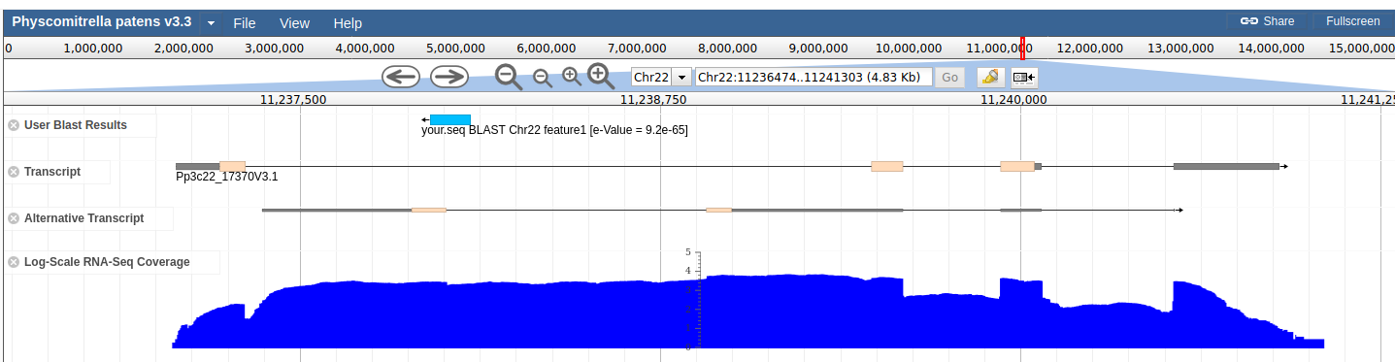
Supplementary Figure 3: Antisense expression of a LINE inserted within an intron as a result of gene expression. Screenshot of the Phytozome genome browser showing from top to bottom, the best hit of the assembly TRINITY_DN734_c0_g1_i1, the Pp3c22_17370 gene annotation, the alternative transcripts, and the log-scale RNA-Seq coverage of the genome region.

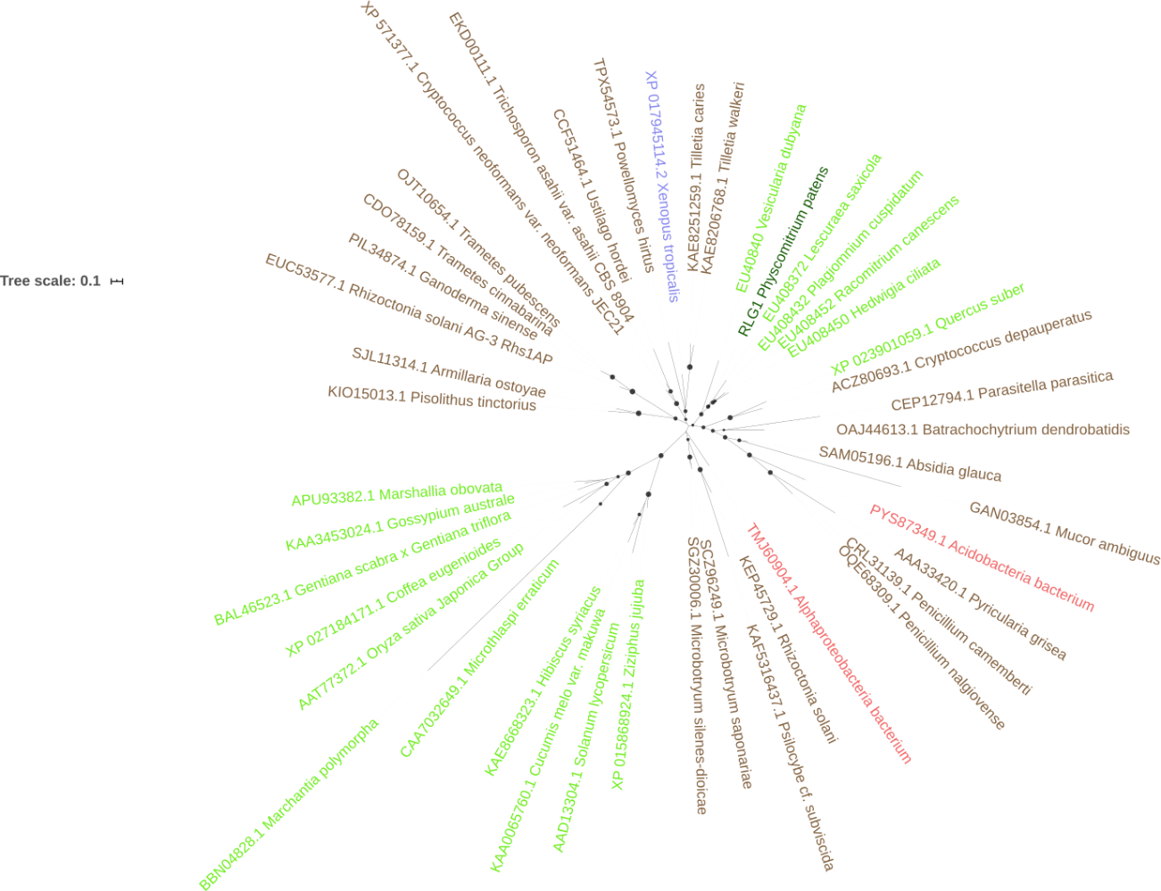

Supplementary Figure 4: Phylogenetic analysis of the Transposable elements RLG1 proteins with those potentially encoded by plant, fungal, animals and bacterial transposable elements elements. P. patens sequences are shown in dark green, plant sequences in light green, fungal sequences in brown, animal sequences in blue and bacterial sequences in red.

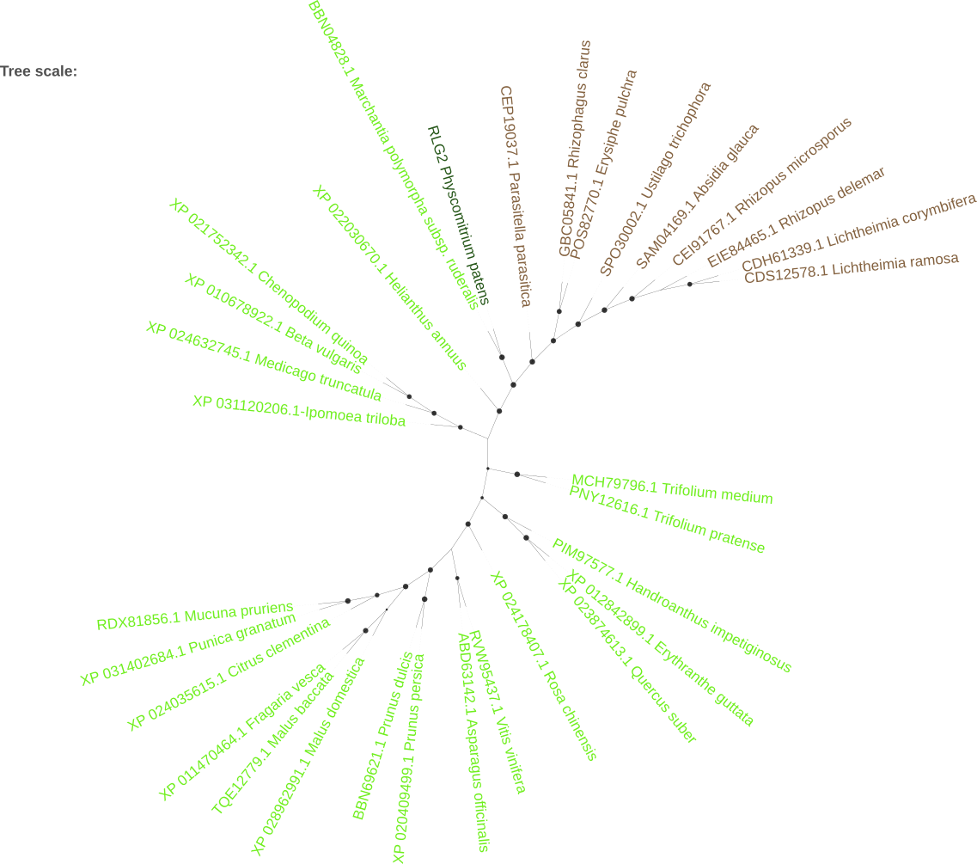

Supplementary Figure 5: Phylogenetic analysis of the Transposable elements RLG2 proteins with those potentially encoded by plant, fungal, animals and bacterial transposable elements elements. P. patens sequences are shown in dark green, plant sequences in light green, fungal sequences in brown

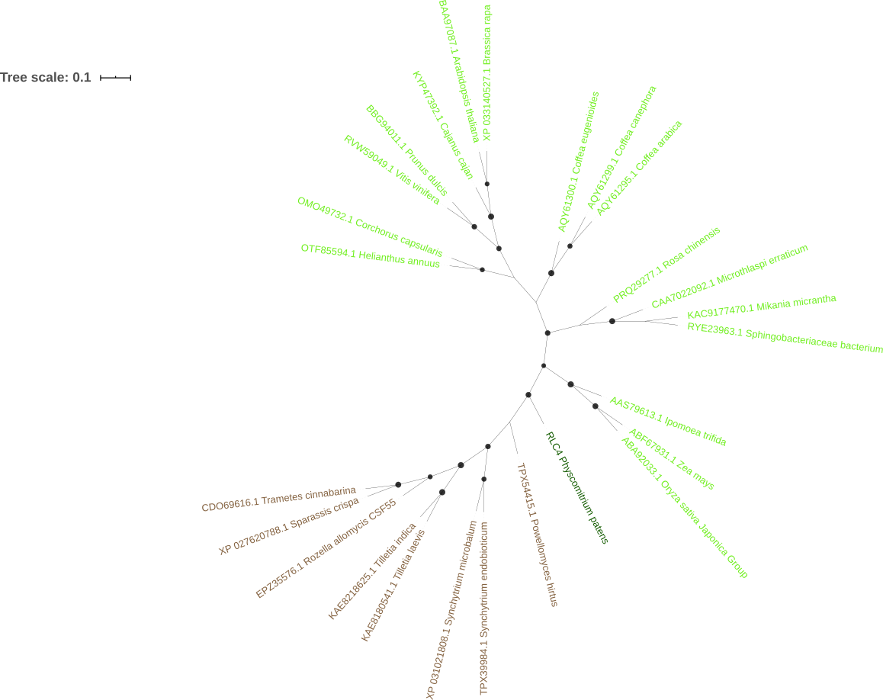

Supplementary Figure 6: Phylogenetic analysis of the Transposable elements RLC4 proteins with those potentially encoded by plant, fungal, animals and bacterial transposable elements elements. P. patens sequences are shown in dark green, plant sequences in light green, fungal sequences in brown

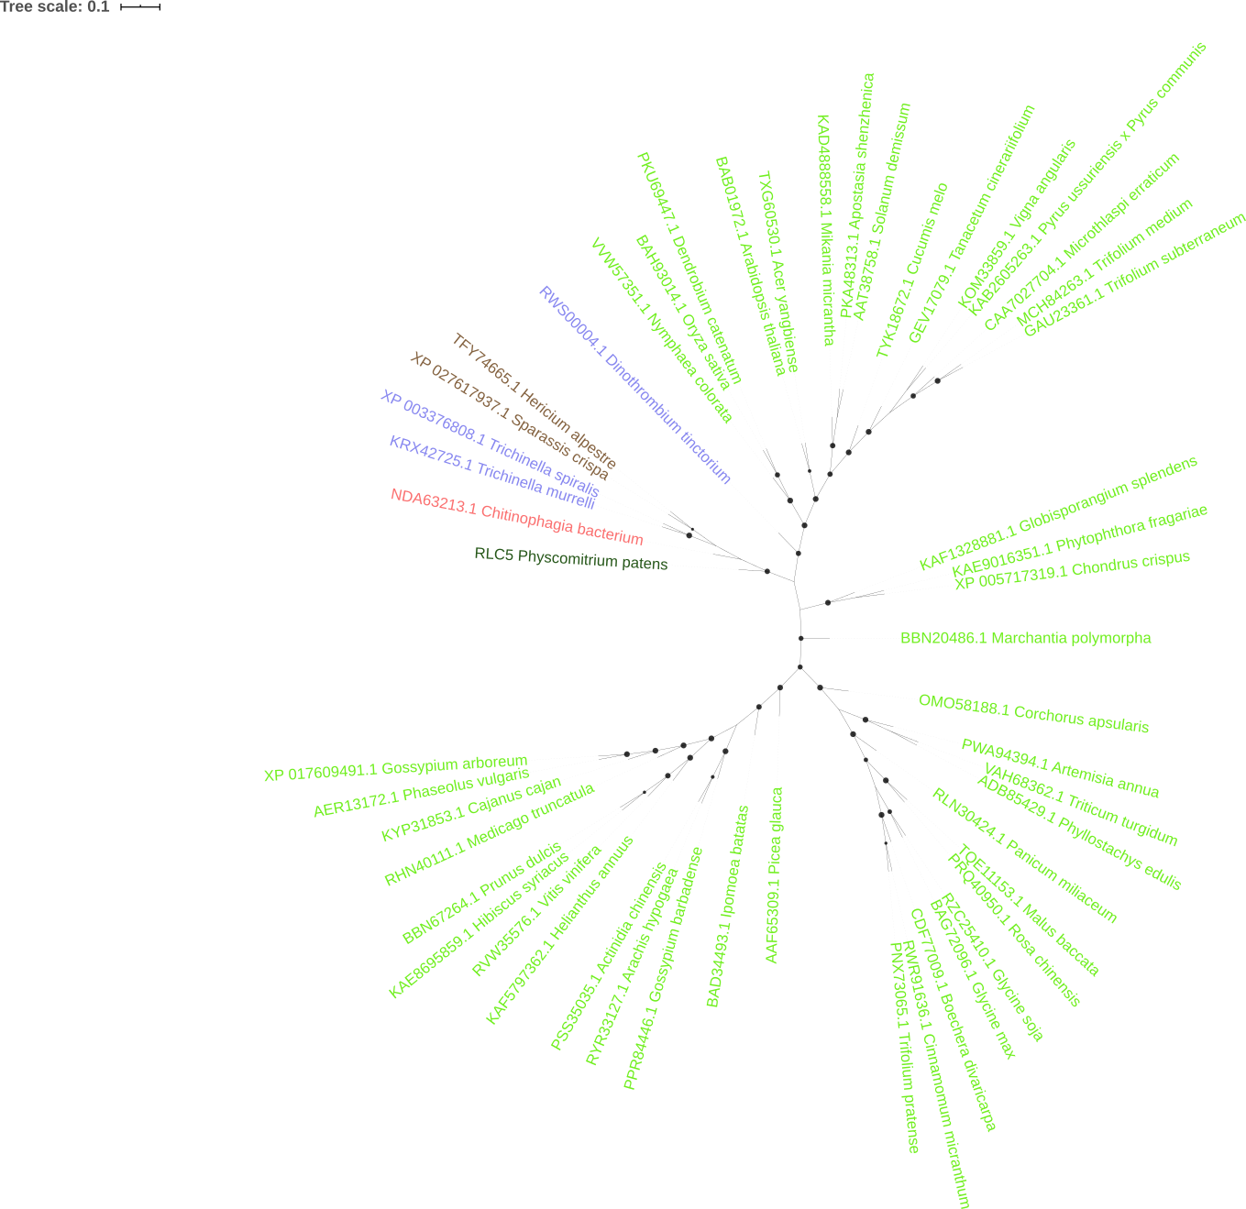

Supplementary Figure 7: Phylogenetic analysis of the Transposable elements RLC5 proteins with those potentially encoded by plant, fungal, animals and bacterial transposable elements elements. P. patens sequences are shown in dark green, plant sequences in light green, fungal sequences in brown, animal sequences in blue and bacterial sequences in red.

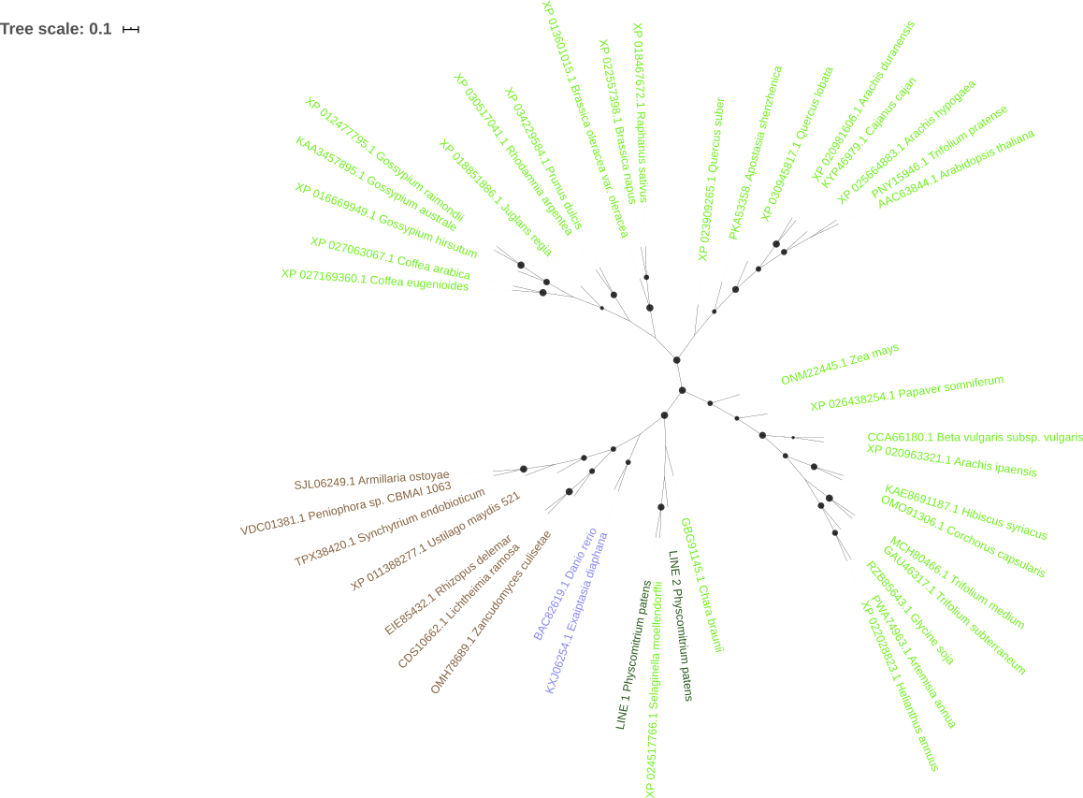

Supplementary Figure 8: Phylogenetic analysis of the Transposable elements LINE-1 and LINE-2 proteins with those potentially encoded by plant, fungal, animals and bacterial transposable elements elements. P. patens sequences are shown in dark green, plant sequences in light green, fungal sequences in brown and animal sequences in blue

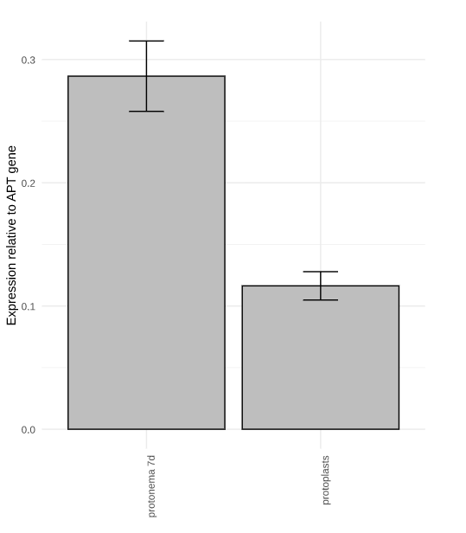

Supplementary Figure 9: qRT-PCR analysis of the expression of RLG1 in protonema grown for 7 days in BCDAT medium compared with the expression in protoplasts cells. The bars present the mean of three biological replicates. The standard deviation is shown.

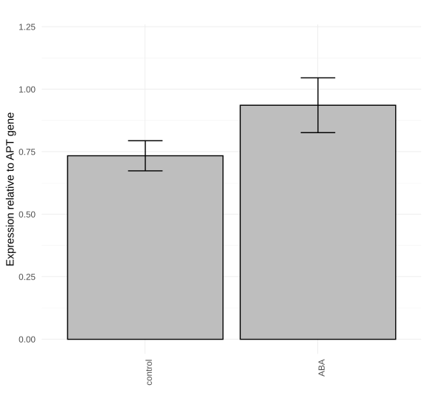

Supplementary Figure 10: Induction of RLG2 expression by ABA. qRT-PCR analysis of the RLG2 expression in protonema grown for 7 days in BCD medium (cotrol) and protonema grown for 6 days in BCD and one additional day in 50 µM ABA (ABA). The bars present the mean of three biological replicates. The standard deviation is shown.

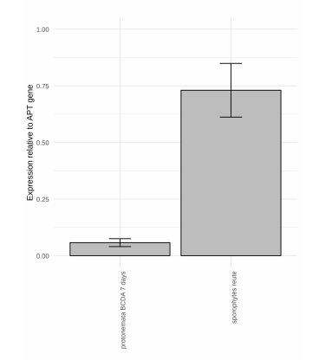
Supplementary Figure 11: Expression of tRLC5 elements in sporophytes. qRT-PCR analysis of the expression of tRLC5 elements in P. patens Reute sporophytes compared with its expression in protonema.

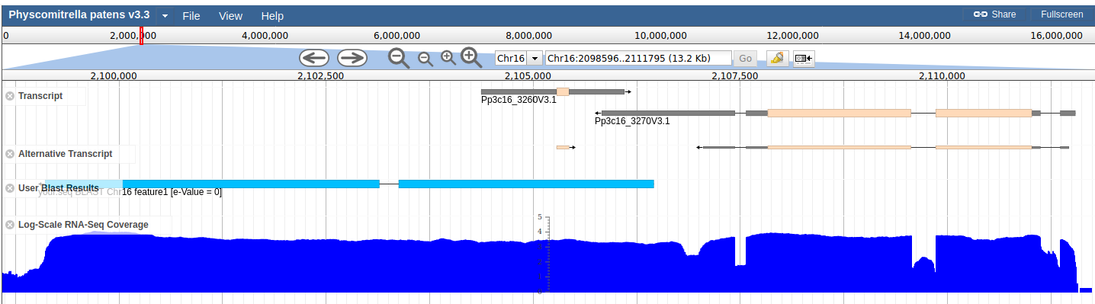
Supplementary Figure 12: Expression of the LINE-2 inserted at the 3' of a gene and potentially transcribed as the result of read-through transcription. Screenshot of the Phytozome genome browser showing from top to bottom, the Pp3c16_3270 predicted transcripts, the annotated alternative transcripts, the nBLAST best hit of the TRINITY_DN90_c0_g1_i9 assembly, and the log-scale RNA-Seq coverage of the genome region.

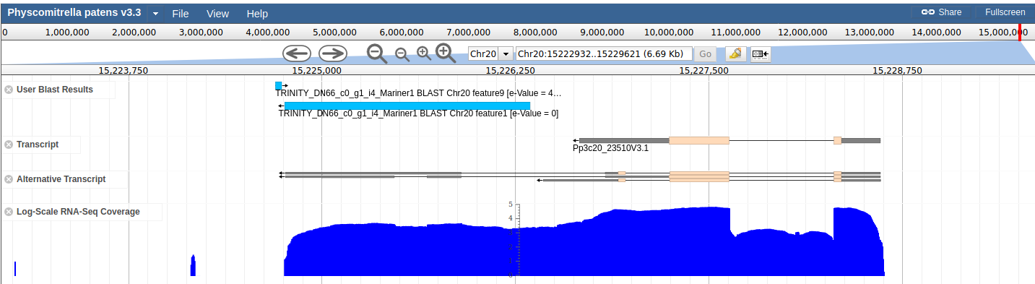
Supplementary Figure 13: Expression of PpTc1 as a result of read-through from the Pp3c20_23510 gene. Screenshot of the Phytozome genome browser showing from top to bottom, the best hit of the TRINITY_DN66_c0_g1_i4_Pp_Tc1 assembly, the Pp3c20_23510 gene transcript, the alternative transcript of the gene track, and the log-scale RNA-Seq coverage of the genome region.

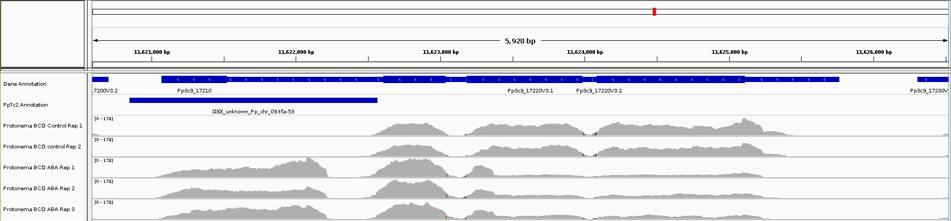

Supplementary Figure 14: Expression of PpTc2 and the Pp3c9_17210 gene located nearby. Screenshot of the IGV genome browser showing from top to bottom, the annotation the Pp3c9_17210 gene, PpTc2 annotation, RNA-Seq coverage of the genome region for two control protonema and 3 ABA-induced protonema samples.

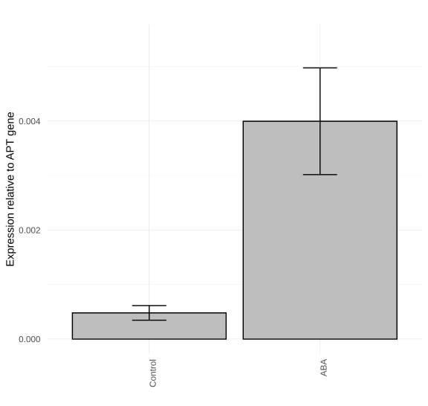

Supplementary Figure 15: Induction of PpTc2 expression by ABA. qRT-PCR analysis of the PpTc2 expression in protonema grown for 7 days in BCD medium (control) and protonema grown for 6 days in BCD and one additional day in 50 µM ABA (ABA).
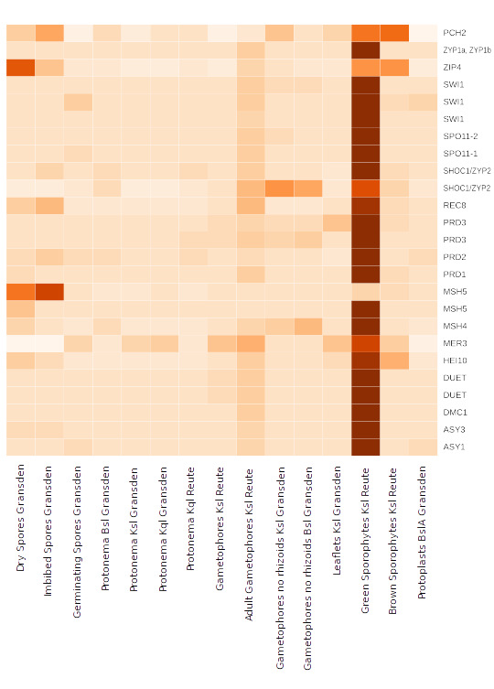

Supplementary Figure 16: Expression of meiosis-specific genes in young sporophites. Heat map of the expression of the meiosis-specific genes in different development conditions. The higher the expression, the darker the color.

