Alternative Splicing of BnaPAP2.A7 Isoforms Play Opposing Roles in Anthocyanin Biosynthesis of Brassica napus L.
Daozong Chen¹, Yi Liu¹, Qingdong Jin¹, Jie Qiu¹, Graham J King², Jing Wang¹, Xianhong Ge¹*, Zaiyun Li¹
¹National Key Laboratory of Crop Genetic Improvement, National Center of Oil Crop Improvement (Wuhan), College of Plant Science and Technology, Huazhong Agricultural University, Wuhan 430070, People’s Republic of China
²Southern Cross Plant Science, Southern Cross University, Lismore, NSW 2480, Australia.

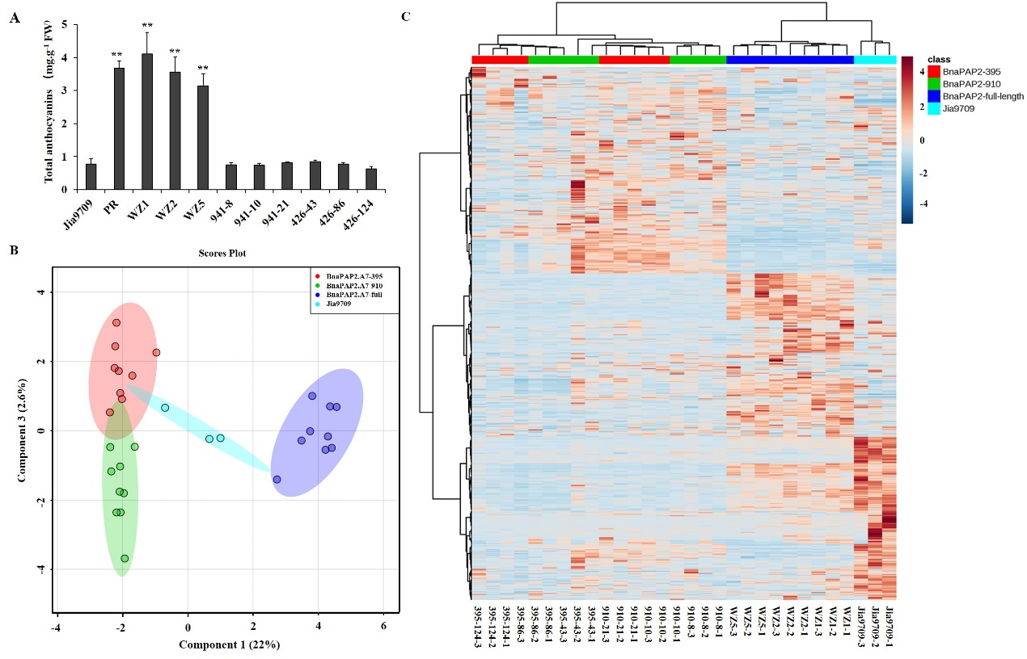

Figure S1. Analysis of anthocyanin content and related metabolites in transgenic lines (A) Analysis of anthocyanin content in leaves of transgenic lines containing full length PR BnaPAP2. A7, 395 and 910 isoform driven by the same 1.99kb promoter of BnaPAP2. A7. (B) Metabolites based principal component analysis (PCA) of controls, full-length BnaPAP2.A7, 395 and 910 transgenic lines.(C) Heat map of different plants based on the relative content of each metabolite.**, P < 0.01, one-way ANOVA test. Error bars represent the SD of three replicates.

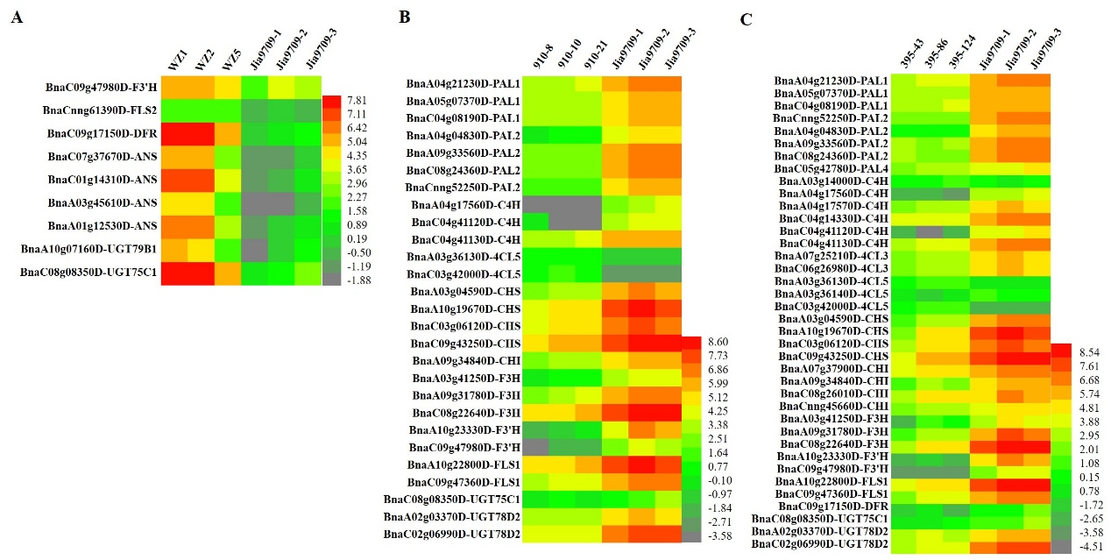

Figure S2. Heat map of DEGs involved in anthocyanin biosynthesis pathway
(A-C) DEGs involved in the anthocyanin metabolic pathway in full length BnaPAP2.A7 (A), 910 (B) and 395 (C) transgenic lines. Note: only structure genes in anthocyanin biosynthesis pathway were presented here.

Table S1. MBW components identified in Brassica rapa, B. oleracea and B. napus
No. | Gene name | Gene ID
 |  | Arabidopsis | B. rapa | B. oleracea | B. napus A subgenome | B. napus C subgenome
1 | PAP1(MYB75) | AT1G56650 | BraA02g017040 | Bo00835s060 | BnaA02g35530D | BnaCnng28030D
2 | MYB113 | AT1G66370 | BraA03g040840 | Bo3g081880 | BnaAnng41910D | BnaC03g74080D
3 | MYB114 | AT1G66380 | BraA07g032100 | Bo6g099880 | BnaA07g25800D | BnaCnng69610D
4 | PAP2(MYB90) | AT1G66390 |  | Bo6g100940 |  | BnaCnng17820D
5 |  |  |  |  |  | BnaCnng75540D
6 | EGL3 | AT1G63650 | BraA09g013280 | Bo9g029230 | BnaA09g11090D | BnaC09g11380D
7 |  |  | BraA09g015130 | Bo9g035460 | BnaA09g12420D | BnaC09g12820D
8 | TT8 | AT4G09820 | BraA09g028560 | Bo9g086910 | BnaA09g22810D | BnaC09g24870D
9 | GL3 | AT5G41315 | BraA04g013890 | Bo4g141990 | BnaA04g11060D | BnaCnng33960D
10 | TTG1 | AT5G24520 | BraA02g042110 | Bo7g096780 | BnaA02g32510D | BnaC02g41250D
11 |  |  | BraA06g031870 |  |  | BnaC07g29950D

Table S2. Statistics of transformation of BnaPAP2.A7-744under different conditions

Gene construct/Combinations | Infection time (min） | Infection concentration (OD) | Total explants | Effective callus | Positive transgenic plants containing 744 isoform
BnaPAP2.A7-744 | 15 | 0.8 | 195 | 0 | 0
BnaPAP2.A7-744 | 30 | 0.8 | 156 | 0 | 0
BnaPAP2.A7-744 | 60 | 0.8 | 29 | 0 | 0
BnaPAP2.A7-744 | 15 | 1.6 | 138 | 0 | 0
BnaPAP2.A7-744 | 15 | 2.4 | 343 | 0 | 0
BnaPAP2.A7-395 | 15 | 0.8 | 726 | 640 | 0
BnaPAP2.A7-744 | 15 | 0.8 | 472 | 0 | 0
BnaPAP2.A7-910 | 15 | 0.8 | 382 | 360 | 0
No Kana-BnaPAP2.A7-744 | 15 | 0.8 | 375 | 366 | 0
BnaPAP2.A7-395 & BnaPAP2.A7-744 | 15 | 0.8 | 519 | 432 | 0
BnaPAP2.A7-744 & BnaPAP2.A7-910 | 15 | 0.8 | 707 | 564 | 0
BnaPAP2.A7-395 & BnaPAP2.A7-744& BnaPAP2.A7-910 | 15 | 0.8 | 885 | 603 | 0

Table S3. Sequences of all primers used in this study
Name | Primer sequence (5’―3’)
Primers for plasmid construction
PAP2.A7-PF | TCATTTTACACATCATCTTCTACTACA
PAP2.A7-gR | ACTAATCAAGTTCCAGTTTCTCCA
PAP2.A7-CDS-PF | ATGGAGGGTTCGTCCCAAGGG
PAP2.A7-CDS-PR | ACTAATCAAGTTCCAGTTTCTCCA
PAP2.A7-KpnI-PF | TCGATCTGGTACCTCATTTTACACATCATCTTCTACTACA
PAP2.A7-BamHI-gR | AGTACAGGATCCACTAATCAAGTTCCAGTTTCTCCA
PAP2.A7-BamHI-PR | AGTACAGGATCC GGACCAGCTATAATTTTAGAAGTA
PAP2.A7-BamHI-PF | TAAATTGGTACCATGGAGGGTTCGTCCCAAGGG
PAP2.A7-BstEII-PR | CAGTCAGGTCACCACTAATCAAGTTCCAGTTTCTCCA
Primers for yeast two hybrid
AtPAP2-F | ATGGAGGGTTCGTCCAAAGGG
AtPAP2-R | CTAATCAAGTTCAACAGTCTCTC
AtPAP2-EcoRI-F | AGTGCAGAATTCATGGAGGGTTCGTCCAAAGGG
AtPAP2-BamHI-R | AGTACAGGATCCCTAATCAAGTTCAACAGTCTCTC
SG -EcoRI-F | AGTGCAGAATTCATGGAGGGTTCGTCCCAAGGG
SG-BamHI-R | AGTACAGGATCCTCAAGTTCCAGTTTCTCCATCCAA
At-TT8-F2 | GAGAGAGAGCTACCACGTTTT
At-TT8-R2 | TGGCATCAATAAAGTTAGGGT
AtTT8-EcoRI-F | AGTGCAGAATTCATGGATGAATCAAGTATTATT
AtTT8-BamHI-R | AGTACAGGATCCCTATAGATTAGTATCATGTAT
Primers for subcellular localization
A7-Eco105I-PF | TAAATTTACGTACCATGGAGGGTTCGTCCCAAG
A7-SmiI-PR | CGCCGGTAAATTTAACTAATCAAGTTCCAGTTTCTCCA
AT-BamHI-PF | AGTACAGGATCCCTTTTATATTAATTTTTCTTTGGTCC
AT-SmaI-PR | AGTACACCCGGGCTTAAACAAACGGTGAGAAAC
Primers for qRT-PCR
Bnaactin3-eF | TCCATCCATCGTCCACAG
Bnaactin3-eR | GCATCATCACAAGCATCCTT
RTPAP2A7-3-F | GCATTGATAAGTATGGAGAAGG
RTPAP2A7-426-R5 | CCTATTCTGTTTCCTAAAAGC
RTPAP2A7-775-R3 | GACCACCTGTTTCCTAAAAGC
RTPAP2A7-941-R | GGGATATATTTGACTTAGTAATGG
PAL-A04-RT1F | GTCTTCCTTCGAACCTAACC
PAL-A04-RT1R | TGAGTATGTCTACAGCTTCTGAT
C4H-C04-RT1F | CTATTGGTAGGTTGGTTCAAAACTTT
C4H-C04-RT1R | TGCAGAAATCATATTTTCTTGTCTATCTT
CHS-A10-RT1F | TCCTTGACGAGGTTGAGAAG
CHS-A10-RT1R | CAAGACCACTGTCTCTACG
F3'H-A10-RT1F | TGCACGGATTTGAATGGGAACT
F3'H-A10-RT1R | GCTTGTCATGCAAGCTAAGTTAG
DFR-C09-RT1F | TGTTCGCGATCCTGGAAATTTGA
DFR-C09-RT1R | CTTTGATTCAAAATCCATGGGAGTA
ANS-A01-RT1F | TGTTTTGTGAACCACCAAAGGAT
ANS-A01-RT1R | CTCAAACATAGAGTTTCAGACTCA
MYB4-C03-RT1F | ACAACACCATTAACATATCTTTCACTAA
MYB4-C03-RT1R | CTAAACTGCACTTGAAACAACGCT
MYBL2-A02-RT1F | AGTTTGTGGCCTTCAAGAATCTAA
MYBL2-A02-RT1R | TACAGATAAATACACCATTTTTCA

