Supplementary Materials

Supplemental Table 1. The Primers used for APAL-seq library construction and validations
Primers | Sequence (5' --- 3') | Purpose
1553 | ACACGACGCTCTTCCGATCT | PCR primers for 1st round of PacBio sequencing
1534 | CTGAACCGCTCTTCCGATCT
AT3G24780 | CGGATTACAAGGTGATTGTGAG | Variation of PAL
AT5G42300 | GAGCTTTACTACAACTAGGCC
AT5G65220 | GCAGAAGAAGCAGCTGAAGCTG C
Adapter 1 | ACACGACGCTCTTCCGATCTCCCCCCCCCCCCTT | For making cDNA Libraries
Adapter - 1 | ACACGACGCTCTTCCGATCT
Adapter 2 | AGATCGGAAGAGCGGTTCAGNNNNNNNNN

Supplemental Table 2. Primers and barcode sequences for library production
Libraries | Replicates | Sequence (5' --- 3')
Gradual | Replicate 1 | ACACGACGCTCTTCCGATCTNNACAGTGCCCCCCCCCCCCCTT
Control | Replicate 2 | ACACGACGCTCTTCCGATCTNNATCACGCCCCCCCCCCCCTT
Gradual |  | ACACGACGCTCTTCCGATCTNNCTAGCTCCCCCCCCCCCCTT
Abrupt |  | ACACGACGCTCTTCCGATCTNNCAGATCCCCCCCCCCCCCTT
Control | Replicate 3 | ACACGACGCTCTTCCGATCTNNTACAGCCCCCCCCCCCCCCTT
Gradual |  | ACACGACGCTCTTCCGATCTNNACTGATCCCCCCCCCCCCCTT
Abrupt |  | ACACGACGCTCTTCCGATCTNNCGATGTCCCCCCCCCCCCCCTT
Note: The nucleotides underlined are barcodes.

Supplemental Table 3. Target genes (14) with their gene specific primers
Target Gene IDs | Primer sequence (5' --- 3') | Purpose
AT1G54710 | ACTCACTGATGATCTTTAATACCCTG | For making libraries of the target genes for 2nd round of PacBio sequencing
AT4G12400 | ACAAGAGCATATGAAGAACCCA
AT2G18960 | AGGGAAGAGAACTCTTGTGTATT
AT1G59860 | CGGAGGCGCACGTGTTCAAG
AT3G09440 | GTCGACTAATAACTTTCTCTC
AT3G09350 | CGATGAGAA ACT GAGGCA GC
AT3G12580 | CTTGTTCTTAGTTTTATCTTTC
AT4G36040 | GGAACTAGTGTGCTAACATAC'
AT1G75280 | CACAAGTGTTGACGAGTATCT
AT3G48030 | ATCGTTGTATCTTGATCAATTG
AT3G62190 | GCCTAGAGTCTGGTGATG
AT1G74310 | GGTGAAGAAGATGAGGATCG
AT5G12020 | GGTTACTGTTCCGAAACTTCCTC
AT1G53540 | TGTGTGATGGTAGTGAAATAATTG

Supplemental Table 4. The average poly(A) tail length (nt) and copy number of 14 transcripts in treatments.
 | Treatments
Gene IDs | Control |  | Gradual heat shock |  | Abrupt heat shock
 | Ave. PAL. | Copy No. | Ave. PAL. | Copy No. | Ave. PAL. | Copy No.
AT1G59860 | 22 | 208 | 46 | 181 | 47 | 166
AT1G54710 | 16 | 128 | 90 | 179 | 98 | 210
AT3G12580 | 25 | 180 | 61 | 173 | 60 | 158
AT4G12400 | 16 | 129 | 47 | 126 | 46 | 158
AT3G09350 | 25 | 139 | 49 | 104 | 48 | 134
AT2G18960 | 15 | 97 | 75 | 161 | 69 | 153
AT3G09440 | 23 | 349 | 58 | 247 | 60 | 255
AT4G36040 | 15 | 125 | 42 | 122 | 77 | 124
AT3G62190 | 13 | 128 | 40 | 105 | 66 | 148
AT1G75280 | 15 | 173 | 60 | 201 | 94 | 197
AT1G74310 | 19 | 170 | 56 | 175 | 76 | 161
AT3G48030 | 19 | 160 | 56 | 146 | 93 | 166
AT5G12020 | 24 | 126 | 47 | 204 | 60 | 86
AT1G53540 | 21 | 150 | 65 | 172 | 96 | 169

Supplemental Table 5. The group threshold among treatments of the 14 target transcripts.
Threshold | Line | L1 | L2 | L3 = L2 / L1 | L4 | L5 = L4 / L1 | L6 = L5 / L3
 | Gene IDs | Control  Ave. PAL. | Gradual  Ave. PAL. | Ratio (Gradual / Control) | Abrupt  Ave. PAL. | Ratio (Abrupt / Control) | Threshold
Group 1: | AT1G59860 | 22 | 46 | 2.09 | 47 | 2.14 | 1.02
 | AT1G54710 | 16 | 90 | 5.63 | 98 | 6.13 | 1.09
 | AT3G12580 | 25 | 61 | 2.44 | 60 | 2.40 | 0.98
 | AT4G12400 | 16 | 47 | 2.94 | 46 | 2.88 | 0.98
 | AT3G09350 | 25 | 49 | 1.96 | 48 | 1.92 | 0.98
 | AT2G18960 | 15 | 75 | 5.00 | 69 | 4.60 | 0.92
 | AT3G09440 | 23 | 58 | 2.52 | 60 | 2.61 | 1.03
Group 2: | AT4G36040 | 15 | 42 | 2.8 | 77 | 5.13 | 1.83
 | AT3G62190 | 13 | 40 | 3.08 | 66 | 5.08 | 1.65
 | AT1G75280 | 15 | 60 | 4.00 | 94 | 6.27 | 1.57
 | AT1G74310 | 19 | 56 | 2.95 | 76 | 4.00 | 1.36
 | AT3G48030 | 19 | 56 | 2.95 | 93 | 4.89 | 1.66
 | AT5G12020 | 24 | 47 | 1.96 | 60 | 2.50 | 1.28
 | AT1G53540 | 21 | 65 | 3.10 | 96 | 4.57 | 1.48

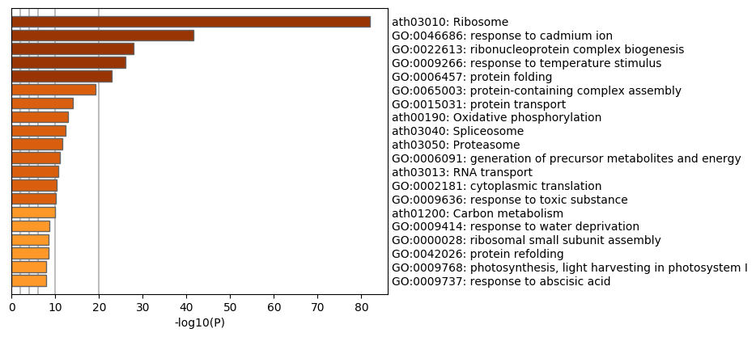
Supplemental Figure 1. Heatmap GO of 2477 transcripts whose PAL were changed
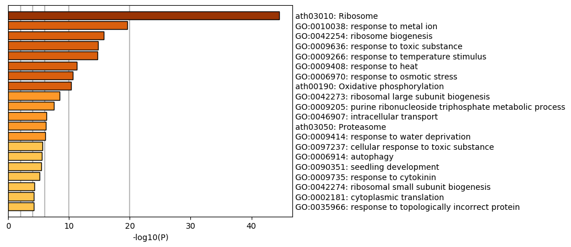
Supplemental Figure 2. Heatmap GO of 1160 transcripts whose PAL were longer in HSA
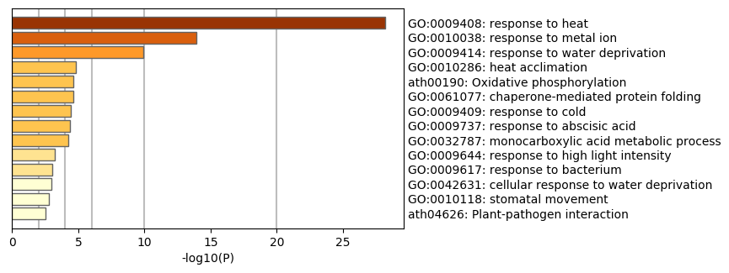
Supplemental Figure 3. Heatmap GO of 122 transcripts which are involved in thermotolerance or related pathways

