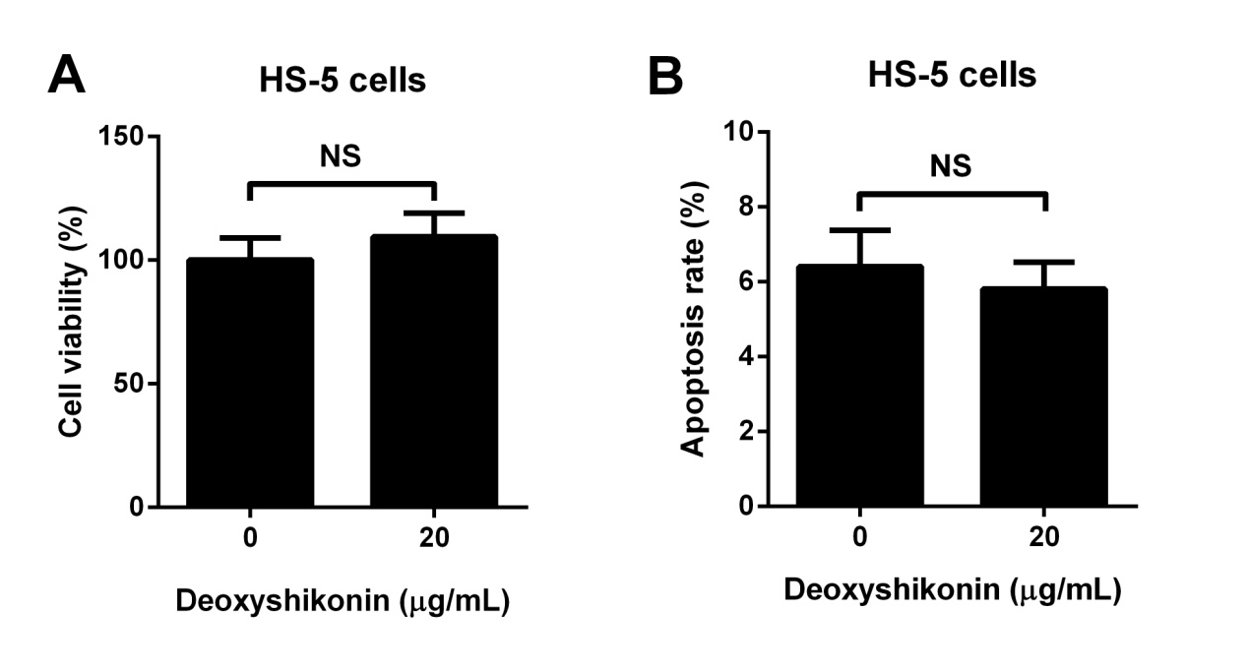
Supplementary Figure. Human bone marrow stromal HS-5 cells were treated with 0 or 20 μg/mL deoxyshikonin for 48 h. (A) Cell viability was assessed by CCK-8 assay. (B) The apoptotic rate was evaluated by Annexin V-FITC apoptosis assay. NS, not significant.

