Neurovascular uncoupling in schizophrenia: A bimodal meta-analysis of brain perfusion and glucose metabolism

SUPPLEMENTARY MATERIAL
Table S1. rCBF or rCMRglu abnormalities in schizophrenia: meta-regression analyses

 | MNI  Coordinates | SDM  z-value ^{(a)} | P Value ^{(b)} | No. of  voxels ^{(c)} | Breakdown  (No. of voxels) ^{(c)}
EFFECTS OF ILLNESS DURATION

Decreased rCBF or rCMRglu in patients with longer illness duration
(high < low duration)

Left inferior frontal gyrus (triangular) | -52,42,-2 | -2.118 | 0.00001 | 125 | Left BA45  Left BA46  Left BA47
EFFECTS OF ANTIPSYCHOTIC MEDICATION

Increased rCBF or rCMRglu in patients receiving higher doses of antipsychotics
(high > low doses)

Right middle occipital gyrus | 36, -92, 6 | 2.638 | <0.0001 | 47 | Right BA18
Left striatum | -22, 0, 2 | 1.912 | <0.0001 | 586 | Left BA48
EFFECTS OF NEGATIVE SYMPTOM SEVERITY

Decreased rCBF or rCMRglu in patients with higher PANSS negative scores
(high < low severity)

Right middle occipital gyrus | 38, -92, 2 | -3.839 | <0.0001 | 88 | Right BA18
Left superior occipital gyrus | -20, -90, 28 | -3.307 | <0.0001 | 86 | Left BA18

(a) Voxel probability threshold: p = 0.0005 (difference in slope)
(b) Peak height threshold: z = 1
(c) Cluster extent threshold: 10 voxels. Regions with less than 10 voxels are not reported in the cluster breakdown.
Table S2. Combined rCBF and rCMRglu abnormalities in schizophrenia: multimodal analyses

 | MNI  Coordinates | P Value ^{(b)} | No. of  voxels ^{(c)} | Breakdown  (No. of voxels) ^{(c)}
Increased rCBF with reduced rCMRglu  Reduced rCBF with increased rCMRglu  Increased rCBF with Increased rCMRglu  Left striatum  Right striatum  Right inferior temporal gyrus  Left temporal pole | none  none  -28,-2,-12  26,-4,-6  44,4,-40  -  38,-2,-44 | <0.001  <0.001  <0.001  <0.001 | 1146  1022  535  490 | Left BA34  Left BA48  Right BA34  Right BA48  Right BA20  Right BA36  Right BA20  Right BA36
Reduced rCBF with reduced rCMRglu

Right median cingulate | 6,22,34 | <0.001 | 2115 | Bilateral BA32  Bilateral BA24  Bilateral BA8  Left BA9
Left inferior frontal (triangular) | -44,22,0 | <0.001 | 606 | Left BA47  Left BA45  LeftBA48  Left BA38

(a) Voxel probability threshold: p = 0.0025 (tolerable pre-conjunction threshold p=0.05; error in p estimate assumed with desired threshold p<0.001)
(b) Peak height threshold: p=0.00025
(c) Cluster extent threshold: 10 voxels. Regions with less than 10 voxels are not reported in the cluster breakdown.

Figure S3. Correlation between patient antipsychotic dosage and negative symptom severity across studies included in the main analysis

Figure S4. Funnel plots for (a) Right putamen, and (b) Right median cingulate gyrus

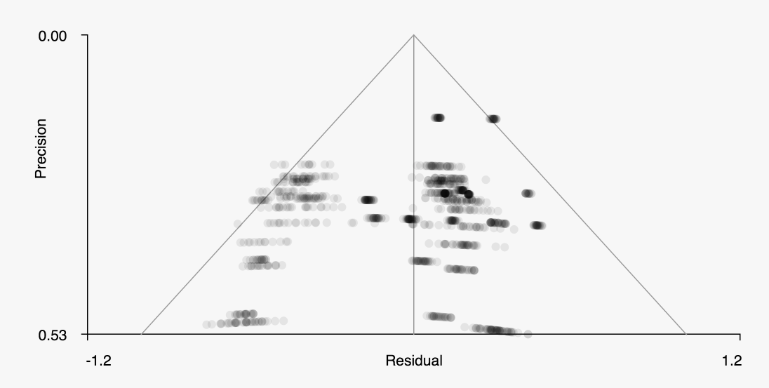
(a) Right Putamen (Bias test: z=-0.67, p=0.502; Excess significance test: p=0.86; I² statistic: I²=3.47)

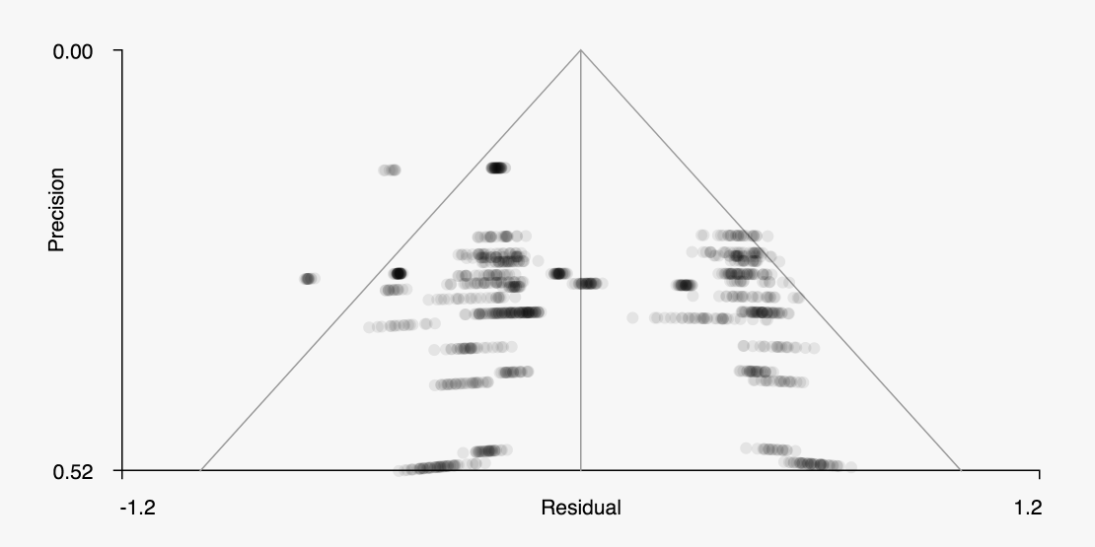
(b) Right Median Cingulate Gyrus (Bias test: z=0.62, p=0.538; Excess significance test: p=0.49; I² statistic: I²=30.1)

ASL studies | Reference Test | MRI Scanner | Field Strength | Label Type | Label Duration/TI1 (ms) | PLD/TI (ms) | Readout | Total Scan Time or # Control and Label pairs | T1 Blood (ms) | Label Efficiency | Motion Correction | CBF Quantification | Spatial Normalization Template | Intensity Scaling | Exclusion of non-GM Voxels | Accounted for Multiple Comparison Problem
Cui_2017 | DSM-IV, PANSS, Prodromal Questionnaire confirm absence of psychotic syndrome in HC | Siemens Trio | 3.0T | PASL-PICORE |  | 1800 |  | 4 min 20 s |  |  | Yes | Yes | PET Template | NO | No | AlphaSim (p<0.001, cluster extent >13 for cluster P<0.05)
Horn_2009 | DSM-IV based on Clinical interview, PANSS, Scale for the Assessment of Thought, Language and Communication | Siemens Vision | 1.5 T | PASL-QUIPPS II | 700 | 1400 |  | NS | 1200 | 0.9 | Yes | Yes |  | No | No | Cluster-size thresholding in BrainVoyager QX 1.7.6
Kindler 2015 | Clinical Intreview and ICD-10, psychiatry history, PANSS, PsyRats, AHRS | Siemens Trio | 3.0T | pCASL | 1600 | 1250 |  | 5 mins 44 s |  |  | Yes | Yes |  | No | No | familywise Error (FWE) correction
Kindler 2018 | ICD-10, PANSS, PsyRats | Siemens Trio | 3.0T | pCASL | 1600 | 1250 |  | NS |  |  | Yes | Yes | SPM MNI | Global Proportional | Yes | familywise Error (FWE) correction (small volume)
Liu2012 | DSM-IV | Siemens | 3.0T | PASL-QUIPSS II | 1400 | 1700 |  | NS |  |  | NS | Yes | MNI | No | No | Partial correction Cluster-size thresholding
Oliveria_2018 | DSM-V, PANSS | Philips Achieva | 3.0T | pCASL | 1620 | 1525 | 2D EPI | 6 min 48s | 1650 | 0.85 | Yes | Yes | MNI | Global GM mean | PVE-Asllani | FDR Correction
Ota_2014 | DSM-IV,PANSS | Philips | 3.0T | pCASL | 1650 | 1520 | 2D EPI | 4 min 24 s | 1664 | 0.85 | NS | Yes | MNI T1 | No | ANCOVA | No
Pinkham 2015 | DSM-IV with Structured Clinical Interview, PANSS | Philips Achieva | 3.0T | pCASL | 1650 | 1525 |  | 40 | 1279 | 0.86 | Yes | Yes | MNI | Global GM mean | No | AlphaSim p<0.05
Pinkham 2011 | Diagnostic Interview for Genetic studies, Best Estimate Final Diagnoses, SANS, SPAS | Siemens Trio | 3.0T | PASL-QUIPPS II | 700 | 1900 | 2D EPI | 40 | 1600 | 0.97 | Yes | Yes | MNI | No |  | AlphaSim p<0.05
Scheef 2010 | DSM-IV, PANSS | Philips Achieva | 3.0T | CASL | 2200 | 800 | 2D EPI | 40 | 1490 | 0.68 | Yes | Yes | PET Template | Global scaling | No | FDR p<0.05
Stegmayer 2017 | mini international neuropyschiatric interview, clinical interviews, PANSS | Siemens Trio | 3.0T | pCASL | 1600 | 1500 |  | 55 | 1650 | 0.95 | Yes | Yes | MNI T1 | Global GM mean ACOVA |  | TFCE (FWE) p<0.05
Walther 2011 | DSM-IV, PANSS | Siemens Trio | 3.0T | PASL-QUIPPS II | 700 | 1000 |  | 5 mins 9s | 1490 | 0.95 | Yes (3D PACE) | Yes | NS | No | No | FDR q<0.01
Walther 2017 | DSM-V, CASH, PANSS | Siemens Trio | 3.0T | pCASL | NS | NS |  | 55 |  |  | Ns | Yes | Ns | No | No | NO
Zhu 2015 | DSM-IV, PANSS | GE Discovery MR750 | 3.0T | pCASL | NS | 2025 | 3D FSE | 4min 44s |  |  | Ns | Yes | PET Template | Global mean | No | FWE p<0.05

Table S5. ASL acquisition parameter data
PET studies | Reference Test | PET Scanner | Dose (Mbq) | Uptake Period (min) | Scan Duration (min) | Fasting (minimum 4 hours) | Uptake Environment | Recon Method | Motion Compensation | PET Correction Mentioned |  |  |  |  | Intensity Scaling | Spatial Normalization Template | Exclusion of non-GM Voxels | Accounted for Multiple Comparison Problem
 |  |  |  |  |  |  |  |  |  | Attenuation | Scatter | Dead | Random | Decay
Ben_Shachar 2006 | DSM-IV, PANSS, Clinical Global Impression scale | Standalone PET; PET Positron Corp HZL/R | 370 | 30 | 15 |  | Yes | Filtered back projection |  | Yes | Yes | Yes | Yes |  | Global | SPM MNI | Yes | Unclear
Desco 2003 | DSM-IV, SANS, SPAS SCID confirmed interviews | Standalone PET; Positron Posicam EZL | 370 | 20 |  | 6 | Yes; eyes open ears unplugged |  |  |  |  |  |  |  | Global ANCOVA | Talairach | Yes | Peak-height corrected p<0.05, extent-corrected p<0.05, uncorrected p<0.001
Horga 2014 | DSM-IV Structred Clinical Interview, PANSS and CASH | Standalone PET; Advance Nxi, GE Healthcare | 4.7/Kg | 35 | 20 | 4 | dark room | Iterative | Head Immbolized | Yes |  |  |  |  | Global Proportional | SPM MNI |  | P<0.05 FWE or P<0.05 FDR
Kim 2017 | DSM-IV Structured Clinical Interview, PANSS | Standalone PET;Siemens HRRT | 172-255 | 40 | 30 |  | eyes closed; dark room | Iterative |  | Yes |  |  |  | Yes | Cerebellum | SPM MNI |  | P<0.05 FWE
Park 2009 | DSM-IV Structred Clinical Interview and PANSS | Standalne PET; GE Advance | 185 | 40 | 15 |  | Yes (eyes closed) | Filtered back projection |  | Yes |  |  |  |  | Global Proportional | PET Template |  | peak height threshold uncorrected p<0.0005 extent threshold corrected p<0.05

Table S6. PET acquisition parameter data

