Supplementary Information
Supplementary Table 1. Description of predictors.
Predictors | Description | Variable type
Age | Age in years | Integer (range: 8 - 17)
Gender | Participant gender | Binary (male/female)
Anxiety traits  (SCARED) | Anxiety disorder (total score) | Integer (range: 8-42; clinical cut-offs: 25 and 30)
 | Panic disorder (or significant somatic symptoms) | Integer (range: 0-8; clinical cut-off: 7)
 | Generalized anxiety disorder | Integer (range: 0-16; clinical cut-off: 9)
 | Separation anxiety disorder | Integer (range: 0-10; clinical cut-off: 5)
 | Social anxiety disorder | Integer (range: 0-14; clinical cut-off: 8)
 | School avoidance | Integer (range: 0-7; clinical cut-off: 3)
Attention (CBCL) | ADHD problems | Integer (range: 50-78; clinical cut-off: 65)
ASD Symptoms (SCQ) | Total score | Integer (range: 6-29; clinical cut-off: 15)
IQ (WASI) | Full-scale | Integer (range: 74-131)
 | Verbal | Integer (range: 74-127)
 | Non-verbal | Integer (range: 64-138)
Previous VR experience | Participant’s previous experience with VR | Binary (yes/no)

Supplementary Table 2. Classification results for preference question in different models using all/top features.
 | I preferred a VR bus to watching the video of a school bus
 | All features |  | Top features
 | Precision | Balanced Accuracy | Precision | Balanced Accuracy
Elastic net  (α=0) | 0.5 | 0.3 | - | -
Elastic net  (α=1, l₁=0) | 0.3 | 0.2 | - | -
Elastic net  (α=1, l₁=1) | 0.4 | 0.3 | - | -
Elastic net  (α=1, l₁=.5) | 0.3 | 0.3 | - | -
Neural network | 0.7 | 0.4 | 0.8 | 0.5
Random forest | 0.8 | 0.5 | 0.8 | 0.8
AdaBoost | 0.7 | 0.5 | 0.7 | 0.4

Supplementary Table 3. Results of linear and quadratic models for predicting spatial presence and engagement by full-scale IQ.
Target | Model | SCARED score <25  (N=16) |  |  | SCARED score ≥25  (N=15)
 |  | R² | RMSE | P-value | R² | RMSE | P-value
Spatial Presence | Linear | 0.56 | 0.55 | 0.008 | 0.015 | 0.94 | 0.6534
 | Quadratic | 0.57 | 0.57 | 0.0038 | 0.49 | 0.70 | 0.0170
Engagement | Linear | 0.50 | 0.75 | 0.0021 | 0.00 | 0.90 | 0.9579
 | Quadratic | 0.51 | 0.77 | 0.0096 | 0.55 | 0.62 | 0.0074

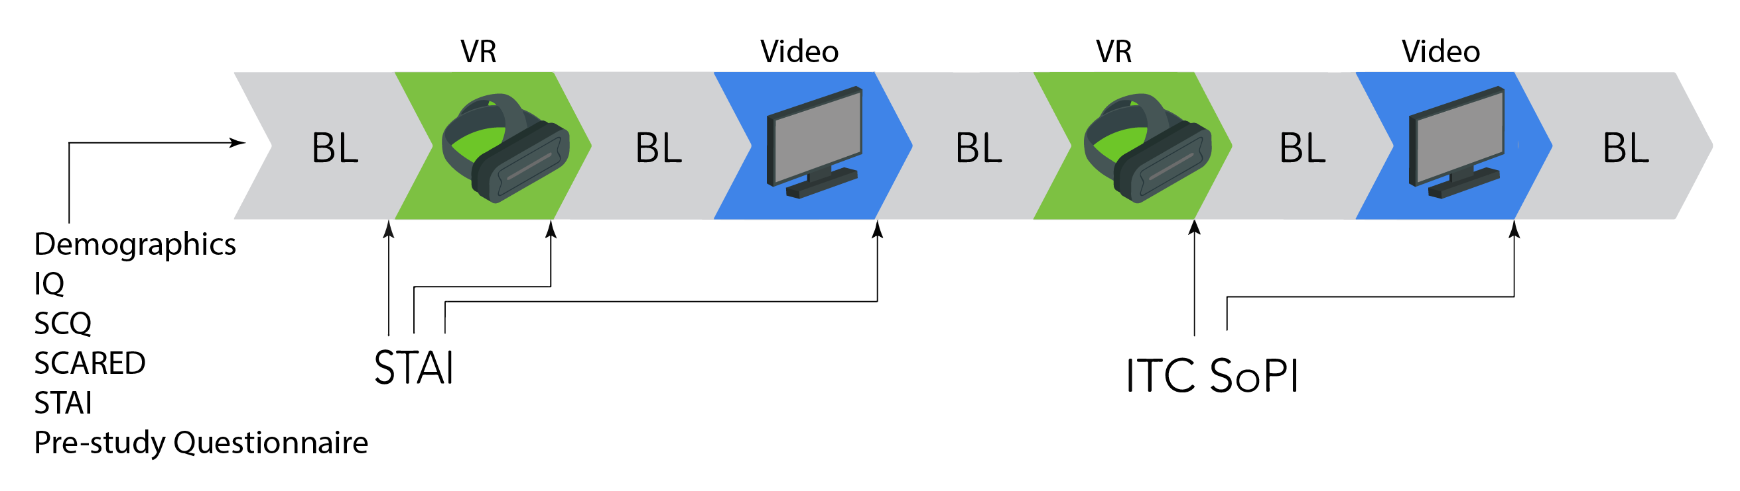
Figure 1. Timing and order of questionnaire administration (BL: baseline, VR: virtual reality, SCQ: Social Communication Questionnaire, SCARED: Screen for Anxiety Related Emotional Disorders; STAI: State-Trait Anxiety Inventory, ITC-SoPI: Independent Television Commission – Sense of Presence Inventory).

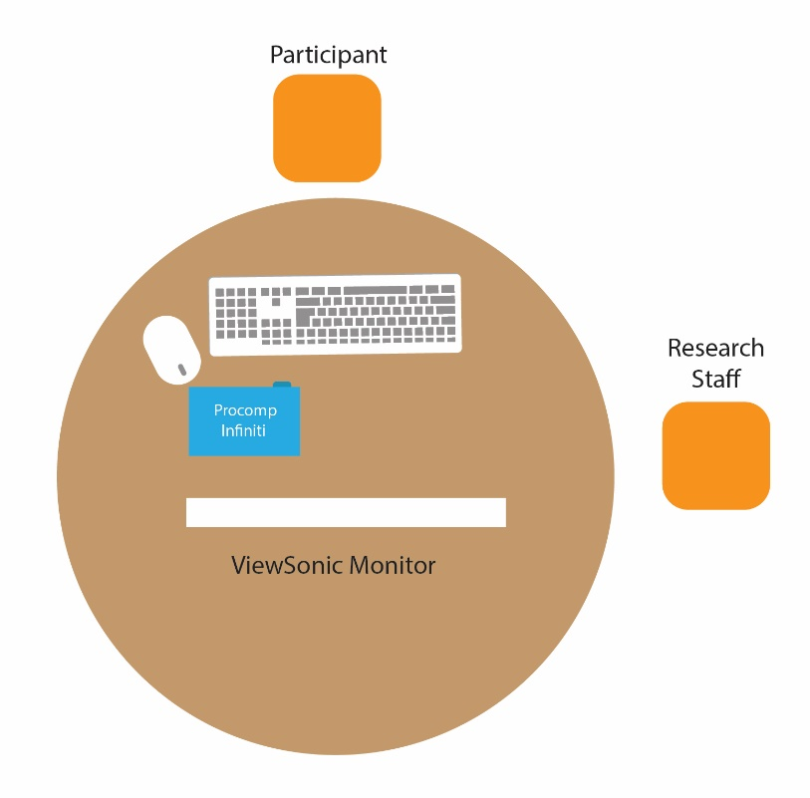
Figure 2. Schematic of the experiment room.

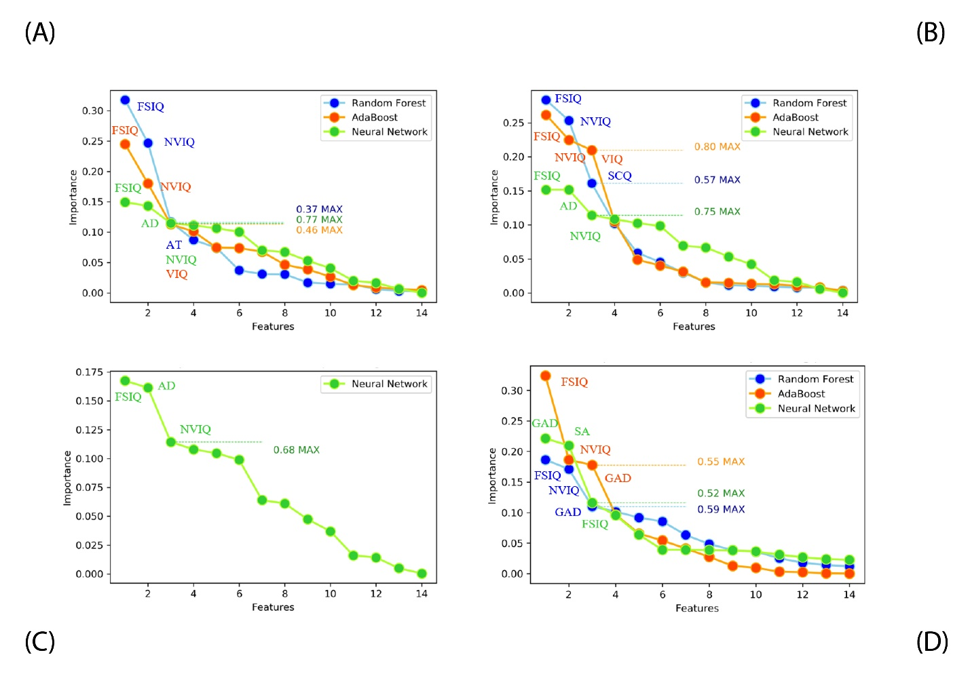
Figure 3. Ordered feature importance: (A) spatial presence, (B) engagement, (C) naturalness, (D) preference. MAX indicated the ratio between the importance scores for the 1st and 3rd features. FSIQ: Full-scale IQ, VIQ: Verbal IQ, NVIQ: Non-verbal IQ, AD: Anxiety Disorder, AT: Attention, GAD: Generalized Anxiety Disorder, SA: School Avoidance.

