Supplementary Material

Predicting Motor Imagery Performance From Resting-State EEG Using Dynamic Causal Modeling
Minji Lee^{1¶}, Jae-Geun Yoon^{1¶}, and Seong-Whan Lee^{2*}
¹Department of Brain and Cognitive Engineering, Korea University, Seoul, Republic of Korea
²Department of Artificial Intelligence, Korea University, Seoul, Republic of Korea
¶These authors contributed equally to this work.
* Correspondence:
Seong-Whan Lee
sw.lee@korea.ac.kr

Supplementary Figures and Tables

Supplementary Figures
Supplementary Figure S1. The channel information. We divided five brain regions into frontal, sensorimotor, temporal, parietal, and occipital regions.
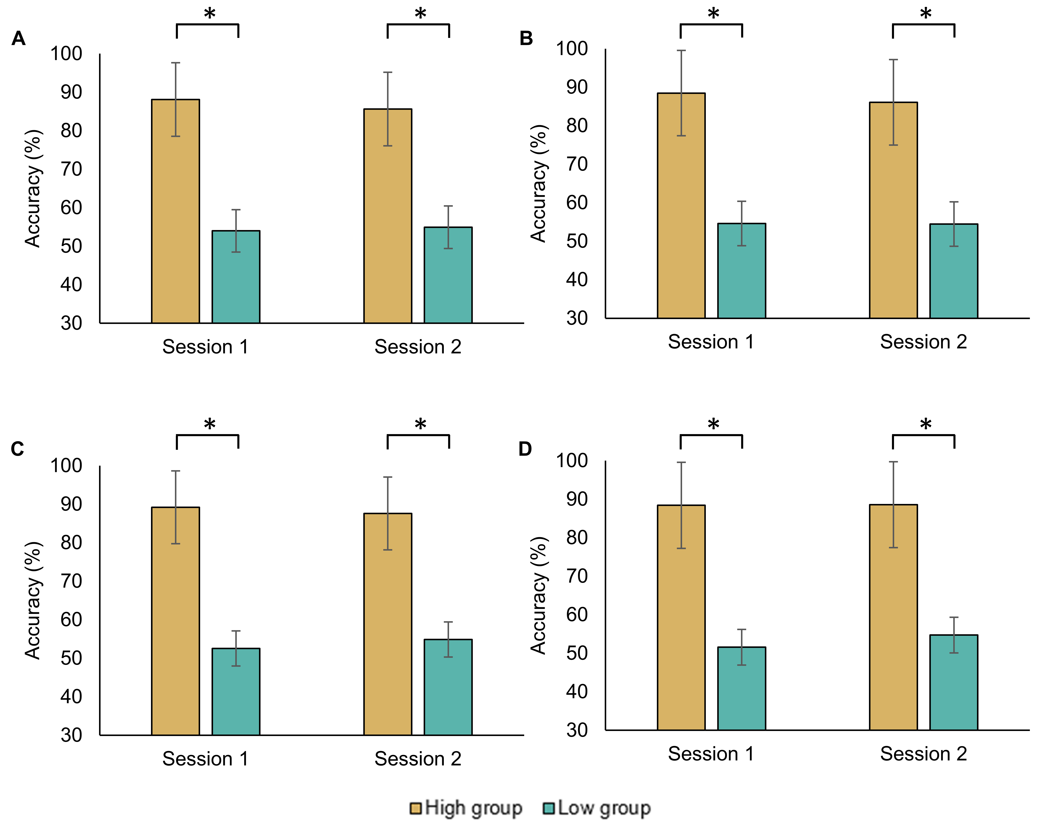
Supplementary Figure S2. Comparison of averaged MI classification accuracy between high- and low-MI performance groups based on (A) CSP, (B) CSSP, (C) FBCSP, and (D) BSSFO. The group was divided based on the median of MI classification accuracy across all subjects. The p-values below 0.05 are highlighted by an asterisk. CSP = common spatial pattern, CSSP = common spatio-spectral pattern, FBCSP = filter bank common spatial pattern, BSSFO = Bayesian spatio-spectral filter optimization.

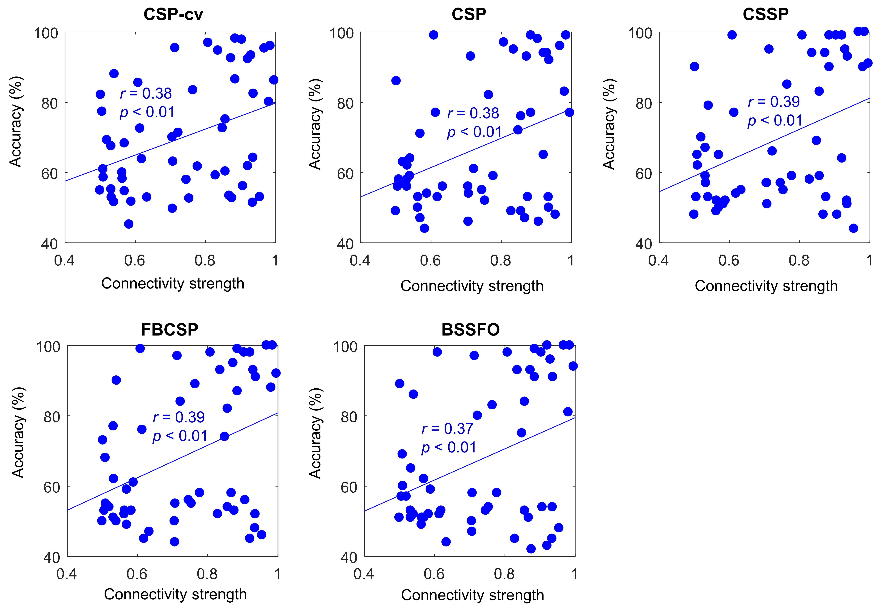
Supplementary Figure S3. Correlation between connectivity strength from the left DLPFC to SMA and MI-BCI performance. Each colored dot represents an individual connectivity strength from the left DLPFC to SMA and MI performance in Session 1. SMA = supplementary motor area, DLPFC = dorsolateral prefrontal cortex, CSP-cv = common spatial pattern with cross-validation, CSP = common spatial pattern, CSSP = common spatio-spectral pattern, FBCSP = filter bank common spatial pattern, BSSFO = Bayesian spatio-spectral filter optimization.

Supplementary Tables
Supplementary Table S1. The statistical differences in effective connectivity between high- and low-MI performance groups based on CSP. In Session 1, Model 4 is selected and there are 20 connections. In Session 2, Model 2 is selected and there are 16 connections. Therefore, four connections in Session 2 are excluded (‘NaN’). The session factor indicates Session 1 and Session 2, whereas the group factor indicates high-MI performance group and low-MI performance group. The session × group represents the interaction between session and group factors. The p-values below 0.05 are highlighted in bold. ROI = region of interest, dof = degree of freedom, l/rM1 = left/right primary motor cortex, l/rPMC = left/right pre-motor cortex, l/rDLPFC = left/right dorsolateral prefrontal cortex, SMA = supplementary motor area.
ROI |  | Session |  |  | Group |  |  | Session × Group
From | To | dof | F | p-value | dof | F | p-value | dof | F | p-value
lM1 | SMA | 1 | 1.28 | 0.260 | 1 | 0.39 | 0.535 | 1 | 0.41 | 0.521
rM1 | SMA | 1 | 0.57 | 0.453 | 1 | 0.10 | 0.751 | 1 | 0.49 | 0.484
lPMC | SMA | 1 | 1.80 | 0.182 | 1 | 1.74 | 0.189 | 1 | 0.08 | 0.779
rPMC | SMA | 1 | 1.37 | 0.244 | 1 | 0.16 | 0.692 | 1 | 0.60 | 0.440
lDLPFC | SMA | 0 | 0 | NaN | 1 | 11.58 | 0.001 | 0 | 0 | NaN
rDLPFC | SMA | 0 | 0 | NaN | 1 | 0.19 | 0.662 | 0 | 0 | NaN
SMA | lM1 | 0 | 0 | NaN | 1 | 2.75 | 0.103 | 0 | 0 | NaN
rM1 | lM1 | 1 | 3.27 | 0.073 | 1 | 1.84 | 0.177 | 1 | 0.72 | 0.398
lPMC | lM1 | 1 | 1.38 | 0.243 | 1 | 0.51 | 0.474 | 1 | 0.98 | 0.324
SMA | rM1 | 0 | 0 | NaN | 1 | 0.01 | 0.940 | 0 | 0 | NaN
lM1 | rM1 | 1 | 0.92 | 0.338 | 1 | 0.11 | 0.740 | 1 | 0.01 | 0.932
rPMC | rM1 | 1 | 0.88 | 0.350 | 1 | 0.86 | 0.355 | 1 | 0.04 | 0.847
rPMC | lPMC | 1 | 2.98 | 0.087 | 1 | 0.85 | 0.360 | 1 | 1.03 | 0.312
lPMC | rPMC | 1 | 0.39 | 0.531 | 1 | 0.48 | 0.490 | 1 | 0.31 | 0.576
SMA | lDLPFC | 1 | 0.42 | 0.517 | 1 | 0.13 | 0.719 | 1 | 0.40 | 0.527
lPMC | lDLPFC | 1 | 0.16 | 0.690 | 1 | 4.12 | 0.045 | 1 | 2.42 | 0.122
rDLPFC | lDLPFC | 1 | 0.33 | 0.567 | 1 | 0.87 | 0.353 | 1 | 0.42 | 0.517
SMA | rDLPFC | 1 | 0.45 | 0.502 | 1 | 18.71 | <0.001 | 1 | 0.01 | 0.928
rPMC | rDLPFC | 1 | 0.24 | 0.621 | 1 | 0.05 | 0.819 | 1 | 1.97 | 0.162
lDLPFC | rDLPFC | 1 | 1.42 | 0.236 | 1 | 0.10 | 0.7555 | 1 | 0.13 | 0.715

Supplementary Table S2. The statistical differences in effective connectivity between high- and low-MI performance groups based on CSSP. In Session 1, Model 4 is selected and there are 20 connections. In Session 2, Model 2 is selected and there are 16 connections. Therefore, four connections in Session 2 are excluded (‘NaN’). The session factor indicates Session 1 and Session 2, whereas the group factor indicates high-MI performance group and low-MI performance group. The session × group represents the interaction between session and group factors. The p-values below 0.05 are highlighted in bold. ROI = region of interest, dof = degree of freedom, l/rM1 = left/right primary motor cortex, l/rPMC = left/right pre-motor cortex, l/rDLPFC = left/right dorsolateral prefrontal cortex, SMA = supplementary motor area.
ROI |  | Session |  |  | Group |  |  | Session × Group
From | To | dof | F | p-value | dof | F | p-value | dof | F | p-value
lM1 | SMA | 1 | 2.00 | 0.160 | 1 | 0.65 | 0.423 | 1 | 0.63 | 0.428
rM1 | SMA | 1 | 0.42 | 0.520 | 1 | 0.02 | 0.892 | 1 | 0.78 | 0.378
lPMC | SMA | 1 | 2.04 | 0.156 | 1 | 1.37 | 0.243 | 1 | 0.10 | 0.750
rPMC | SMA | 1 | 1.14 | 0.287 | 1 | 0.32 | 0.573 | 1 | 0.09 | 0.762
lDLPFC | SMA | 0 | 0 | NaN | 1 | 7.00 | 0.010 | 0 | 0 | NaN
rDLPFC | SMA | 0 | 0 | NaN | 1 | 0.07 | 0.797 | 0 | 0 | NaN
SMA | lM1 | 0 | 0 | NaN | 1 | 0.20 | 0.652 | 0 | 0 | NaN
rM1 | lM1 | 1 | 3.01 | 0.085 | 1 | 2.58 | 0.111 | 1 | 0.41 | 0.521
lPMC | lM1 | 1 | 1.54 | 0.217 | 1 | 0.89 | 0.347 | 1 | 1.53 | 0.218
SMA | rM1 | 0 | 0 | NaN | 1 | 0.01 | 0.912 | 0 | 0 | NaN
lM1 | rM1 | 1 | 1.03 | 0.311 | 1 | 0.26 | 0.611 | 1 | 0.18 | 0.668
rPMC | rM1 | 1 | 0.78 | 0.379 | 1 | 1.59 | 0.209 | 1 | 0.40 | 0.529
rPMC | lPMC | 1 | 2.60 | 0.109 | 1 | 0.46 | 0.498 | 1 | 2.38 | 0.125
lPMC | rPMC | 1 | 0.47 | 0.495 | 1 | 0.46 | 0.500 | 1 | 0.26 | 0.609
SMA | lDLPFC | 1 | 0.43 | 0.511 | 1 | 0.35 | 0.555 | 1 | 0.33 | 0.565
lPMC | lDLPFC | 1 | 0.52 | 0.472 | 1 | 3.91 | 0.050 | 1 | 4.63 | 0.033
rDLPFC | lDLPFC | 1 | 0.06 | 0.807 | 1 | 0.11 | 0.744 | 1 | 3.17 | 0.077
SMA | rDLPFC | 1 | 0.73 | 0.395 | 1 | 22.65 | <0.001 | 1 | 0.05 | 0.816
rPMC | rDLPFC | 1 | 0.10 | 0.745 | 1 | 0.01 | 0.935 | 1 | 0.02 | 0.899
lDLPFC | rDLPFC | 1 | 1.40 | 0.239 | 1 | 0.01 | 0.979 | 1 | 0.02 | 0.895

Supplementary Table S3. The statistical differences in effective connectivity between high- and low-MI performance groups based on FBCSP. In Session 1, Model 4 is selected and there are 20 connections. In Session 2, Model 2 is selected and there are 16 connections. Therefore, four connections in Session 2 are excluded (‘NaN’). The session factor indicates Session 1 and Session 2, whereas the group factor indicates high-MI performance group and low-MI performance group. The session × group represents the interaction between session and group factors. The p-values below 0.05 are highlighted in bold. ROI = region of interest, dof = degree of freedom, l/rM1 = left/right primary motor cortex, l/rPMC = left/right pre-motor cortex, l/rDLPFC = left/right dorsolateral prefrontal cortex, SMA = supplementary motor area.
ROI |  | Session |  |  | Group |  |  | Session × Group
From | To | dof | F | p-value | dof | F | p-value | dof | F | p-value
lM1 | SMA | 1 | 1.49 | 0.225 | 1 | 0.01 | 0.931 | 1 | 0.13 | 0.721
rM1 | SMA | 1 | 0.75 | 0.388 | 1 | 0.01 | 0.998 | 1 | 0.05 | 0.823
lPMC | SMA | 1 | 1.71 | 0.193 | 1 | 0.65 | 0.420 | 1 | 0.35 | 0.554
rPMC | SMA | 1 | 1.09 | 0.298 | 1 | 0.24 | 0.623 | 1 | 0.01 | 0.904
lDLPFC | SMA | 0 | 0 | NaN | 1 | 7.97 | 0.006 | 0 | 0 | NaN
rDLPFC | SMA | 0 | 0 | NaN | 1 | 0.14 | 0.714 | 0 | 0 | NaN
SMA | lM1 | 0 | 0 | NaN | 1 | 0.46 | 0.498 | 0 | 0 | NaN
rM1 | lM1 | 1 | 2.70 | 0.103 | 1 | 6.05 | 0.015 | 1 | 0.05 | 0.828
lPMC | lM1 | 1 | 1.37 | 0.244 | 1 | 1.16 | 0.283 | 1 | 1.61 | 0.207
SMA | rM1 | 0 | 0 | NaN | 1 | 0.01 | 0.940 | 0 | 0 | NaN
lM1 | rM1 | 1 | 0.76 | 0.384 | 1 | 0.32 | 0.570 | 1 | 0.14 | 0.705
rPMC | rM1 | 1 | 0.87 | 0.352 | 1 | 0.89 | 0.348 | 1 | 0.52 | 0.470
rPMC | lPMC | 1 | 3.10 | 0.081 | 1 | 0.08 | 0.776 | 1 | 1.59 | 0.209
lPMC | rPMC | 1 | 0.41 | 0.522 | 1 | 0.03 | 0.854 | 1 | 0.09 | 0.758
SMA | lDLPFC | 1 | 0.44 | 0.510 | 1 | 0.01 | 0.966 | 1 | 0.58 | 0.446
lPMC | lDLPFC | 1 | 0.24 | 0.626 | 1 | 1.41 | 0.237 | 1 | 1.38 | 0.243
rDLPFC | lDLPFC | 1 | 0.22 | 0.641 | 1 | 0.81 | 0.371 | 1 | 0.84 | 0.361
SMA | rDLPFC | 1 | 1.10 | 0.296 | 1 | 18.33 | <0.001 | 1 | 0.21 | 0.646
rPMC | rDLPFC | 1 | 0.09 | 0.768 | 1 | 0.09 | 0.761 | 1 | 0.01 | 0.967
lDLPFC | rDLPFC | 1 | 1.50 | 0.223 | 1 | 0.18 | 0.674 | 1 | 0.01 | 0.991

Supplementary Table S4. The statistical differences in effective connectivity between high- and low-MI performance groups based on BSSFO. In Session 1, Model 4 is selected and there are 20 connections. In Session 2, Model 2 is selected and there are 16 connections. Therefore, four connections in Session 2 are excluded (‘NaN’). The session factor indicates Session 1 and Session 2, whereas the group factor indicates high-MI performance group and low-MI performance group. The session × group represents the interaction between session and group factors. The p-values below 0.05 are highlighted in bold. ROI = region of interest, dof = degree of freedom, l/rM1 = left/right primary motor cortex, l/rPMC = left/right pre-motor cortex, l/rDLPFC = left/right dorsolateral prefrontal cortex, SMA = supplementary motor area.
ROI |  | Session |  |  | Group |  |  | Session × Group
From | To | dof | F | p-value | dof | F | p-value | dof | F | p-value
lM1 | SMA | 1 | 2.01 | 0.159 | 1 | 1.68 | 0.198 | 1 | 0.91 | 0.343
rM1 | SMA | 1 | 1.06 | 0.306 | 1 | 0.05 | 0.817 | 1 | 1.39 | 0.241
lPMC | SMA | 1 | 1.55 | 0.216 | 1 | 0.54 | 0.466 | 1 | 0.65 | 0.420
rPMC | SMA | 1 | 1.10 | 0.297 | 1 | 0.10 | 0.752 | 1 | 0.01 | 0.912
lDLPFC | SMA | 0 | 0 | NaN | 1 | 4.77 | 0.033 | 0 | 0 | NaN
rDLPFC | SMA | 0 | 0 | NaN | 1 | 0.03 | 0.861 | 0 | 0 | NaN
SMA | lM1 | 0 | 0 | NaN | 1 | 0.56 | 0.456 | 0 | 0 | NaN
rM1 | lM1 | 1 | 2.96 | 0.088 | 1 | 3.32 | 0.071 | 1 | 0.03 | 0.560
lPMC | lM1 | 1 | 1.10 | 0.297 | 1 | 0.65 | 0.420 | 1 | 0.14 | 0.707
SMA | rM1 | 0 | 0 | NaN | 1 | 0.24 | 0.624 | 0 | 0 | NaN
lM1 | rM1 | 1 | 0.61 | 0.437 | 1 | 0.01 | 0.841 | 1 | 0.77 | 0.381
rPMC | rM1 | 1 | 0.96 | 0.328 | 1 | 2.45 | 0.120 | 1 | 0.04 | 0.842
rPMC | lPMC | 1 | 3.89 | 0.051 | 1 | 0.36 | 0.549 | 1 | 0.10 | 0.753
lPMC | rPMC | 1 | 0.39 | 0.534 | 1 | 0.05 | 0.822 | 1 | 0.04 | 0.845
SMA | lDLPFC | 1 | 0.33 | 0.564 | 1 | 0.22 | 0.639 | 1 | 1.26 | 0.264
lPMC | lDLPFC | 1 | 0.16 | 0.691 | 1 | 0.02 | 0.886 | 1 | 0.30 | 0.586
rDLPFC | lDLPFC | 1 | 0.21 | 0.651 | 1 | 0.01 | 0.997 | 1 | 0.76 | 0.385
SMA | rDLPFC | 1 | 1.02 | 0.315 | 1 | 15.47 | <0.001 | 1 | 0.46 | 0.499
rPMC | rDLPFC | 1 | 0.07 | 0.789 | 1 | 0.55 | 0.458 | 1 | 0.01 | 0.907
lDLPFC | rDLPFC | 1 | 1.08 | 0.300 | 1 | 0.010 | 0.755 | 1 | 1.18 | 0.279

Supplementary Table S5. Correlation between connectivity strength and MI classification accuracy. In Session 1, Model 4 is selected and there are 20 connections. In Session 2, Model 2 is selected and there are 16 connections. Therefore, four connections in Session 2 are excluded (‘NaN’). The p-values below 0.05 are highlighted in bold. ROI = region of interest, CSP = common spatial pattern, CSSP = common spatio-spectral pattern, FBCSP = filter bank common spatial pattern, BSSFO = Bayesian spatio-spectral filter optimization, l/rM1 = left/right primary motor cortex, l/rPMC = left/right pre-motor cortex, l/rDLPFC = left/right dorsolateral prefrontal cortex, SMA = supplementary motor area.
ROI |  | CSP |  |  |  | CSSP |  |  |  | FBCSP |  |  |  | BSSFO
 |  | Session 1 |  | Session 2 |  | Session1 |  | Session 2 |  | Session 1 |  | Session 2 |  | Session 1 |  | Session 2
From | To | r-value | p-value | r-value | p-value | r-value | p-value | r-value | p-value | r-value | p-value | r-value | p-value | r-value | p-value | r-value | p-value
lM1 | SMA | 0.096 | 0.488 | 0.066 | 0.638 | 0.045 | 0.749 | 0.090 | 0.519 | 0.105 | 0.449 | 0.002 | 0.990 | 0.093 | 0.505 | 0.151 | 0.277
rM1 | SMA | 0.031 | 0.826 | 0.018 | 0.898 | 0.002 | 0.986 | 0.0430 | 0.759 | -0.017 | 0.901 | 0.084 | 0.545 | -0.097 | 0.484 | 0.103 | 0.458
lPMC | SMA | -0.109 | 0.433 | -0.129 | 0.353 | -0.150 | 0.278 | -0.130 | 0.348 | -0.117 | 0.399 | -0.110 | 0.430 | -0.168 | 0.226 | -0.121 | 0.385
rPMC | SMA | -0.036 | 0.795 | -0.016 | 0.909 | -0.068 | 0.624 | -0.079 | 0.571 | -0.086 | 0.536 | -0.031 | 0.822 | -0.052 | 0.710 | -0.010 | 0.942
lDLPFC | SMA | 0.379 | 0.005 | NaN | NaN | 0.391 | 0.003 | NaN | NaN | 0.390 | 0.004 | NaN | NaN | 0.365 | 0.007 | NaN | NaN
rDLPFC | SMA | -0.105 | 0.450 | NaN | NaN | -0.054 | 0.700 | NaN | NaN | -0.021 | 0.880 | NaN | NaN | -0.047 | 0.734 | NaN | NaN
SMA | lM1 | -0.166 | 0.230 | NaN | NaN | -0.104 | 0.453 | NaN | NaN | -0.114 | 0.411 | NaN | NaN | -0.156 | 0.260 | NaN | NaN
rM1 | lM1 | -0.214 | 0.121 | -0.075 | 0.591 | -0.230 | 0.094 | -0.107 | 0.439 | -0.296 | 0.030 | -0.134 | 0.333 | -0.282 | 0.039 | -0.076 | 0.584
lPMC | lM1 | -0.131 | 0.344 | -0.029 | 0.834 | -0.155 | 0.263 | -0.046 | 0.742 | -0.148 | 0.286 | -0.057 | 0.683 | -0.141 | 0.309 | -0.079 | 0.572
SMA | rM1 | 0.061 | 0.659 | NaN | NaN | 0.026 | 0.854 | NaN | NaN | -0.035 | 0.801 | NaN | NaN | -0.002 | 0.988 | NaN | NaN
lM1 | rM1 | -0.057 | 0.680 | -0.043 | 0.760 | -0.048 | 0.733 | -0.090 | 0.517 | -0.015 | 0.913 | -0.040 | 0.774 | -0.024 | 0.864 | -0.038 | 0.783
rPMC | rM1 | 0.140 | 0.313 | 0.066 | 0.637 | 0.150 | 0.280 | -0.011 | 0.938 | 0.118 | 0.395 | 0.068 | 0.623 | 0.094 | 0.499 | 0.074 | 0.594
rPMC | lPMC | 0.213 | 0.122 | -0.023 | 0.867 | 0.202 | 0.142 | -0.098 | 0.482 | 0.137 | 0.322 | -0.061 | 0.660 | 0.171 | 0.215 | 0.078 | 0.577
lPMC | rPMC | 0.085 | 0.540 | 0.019 | 0.894 | 0.032 | 0.818 | -0.006 | 0.966 | -0.035 | 0.803 | 0.031 | 0.824 | 0.026 | 0.854 | 0.010 | 0.942
SMA | lDLPFC | 0.120 | 0.388 | -0.021 | 0.881 | 0.057 | 0.685 | -0.074 | 0.593 | 0.072 | 0.607 | -0.100 | 0.471 | 0.102 | 0.463 | -0.111 | 0.423
lPMC | lDLPFC | -0.079 | 0.569 | -0.320 | 0.018 | -0.082 | 0.556 | -0.306 | 0.024 | -0.019 | 0.894 | -0.287 | 0.035 | 0.024 | 0.864 | -0.212 | 0.124
rDLPFC | lDLPFC | 0.093 | 0.504 | -0.274 | 0.045 | 0.078 | 0.574 | -0.241 | 0.079 | 0.041 | 0.769 | -0.197 | 0.153 | 0.108 | 0.437 | -0.156 | 0.260
SMA | rDLPFC | 0.540 | <0.001 | 0.374 | 0.005 | 0.514 | <0.001 | 0.372 | 0.006 | 0.484 | <0.001 | 0.407 | 0.002 | 0.490 | <0.001 | 0.400 | 0.003
rPMC | rDLPFC | -0.053 | 0.702 | 0.137 | 0.324 | -0.040 | 0.776 | 0.090 | 0.518 | -0.001 | 0.992 | 0.143 | 0.302 | -0.032 | 0.820 | 0.144 | 0.297
lDLPFC | rDLPFC | 0.056 | 0.688 | -0.030 | 0.827 | 0.011 | 0.963 | -0.016 | 0.909 | 0.001 | 0.994 | -0.042 | 0.762 | 0.049 | 0.722 | -0.064 | 0.644

