Supplementary Material

Supplementary Figures

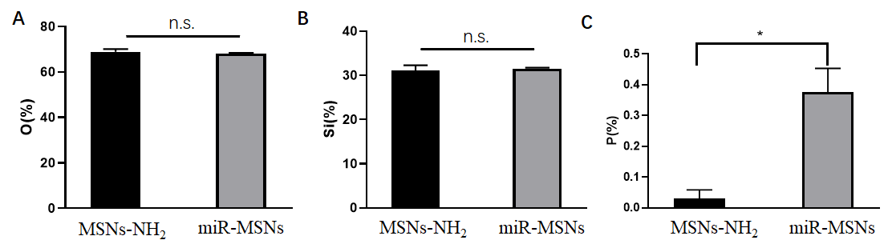 Supplementary Figure 1. X-ray energy dispersive spectrum (EDS) of MSNs-NH₂ and miR-MSNs. (A) The proportion of O element. (B) The proportion of Si element. (C) The proportion of P element.

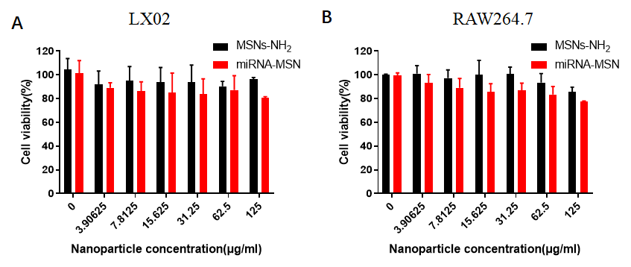
Supplementary Figure 2. Cytotoxicity of MSNs-NH₂ and miR-MSNs in LX02 (A) and RAW264.7 (B) cell lines.

