Supplementary Material

**Iron (III)-Mediated Rapid Radical-Type Three-Component Deuteration of Quinoxalinones with Olefins and NaBD4**

Wanmei Li,* Heng Cai, Lin Huang, Lei He, Yilan Zhang, Jun Xu, and Pengfei Zhang

College of Material Chemistry and Chemical Engineering, Hangzhou Normal University, Hangzhou 311121, China.

General Information 2

1. Experimental Section 2

2. Characterization of Products 4

3. X-ray Crystal Data for **4al** 19

4. Copies of 1H, 13C and 19F NMR Spectra 20

**General Information**

All reagents and deuterated solvents were commercially available and used without further purification. All products were separated by silica gel (200-300 mesh) column chromatography with petroleum ether (PE) (60-90°C) and ethyl acetate (EA). 1H, 13C and 19F NMR spectra were recorded on a Bruker Advance 500 spectrometer at ambient temperature with CDCl3 as solvent and tetramethylsilane (TMS) as the internal standard. Melting points were determined on an X-5 Data microscopic melting point apparatus. Analytical thin layer chromatography (TLC) was performed on Merk precoated TLC (silica gel 60 F254) plates. Compounds for HRMS were analyzed by positive mode electrospray ionization (ESI) using Agilent 6530 QTOF mass spectrometer.

1. **Experimental Section**

**1.1 General procedure for the synthesis of products 4**



A mixture of quinoxalinones (1) (0.2 mmol), olefins (2) (2.0 equiv), Fe(NO3)3•9H2O (4.0 equiv) and MeCN/EtOH (4.0 mL, v/v = 1:1) in a 15 mL tube was stirred at room temperature for 5 min to make all the components dissolved. Then, NaBD4 (2.0 equiv) was slowly added. The resulting mixture was stirred for another 5 min. After the completion (as indicated by TLC), the reaction mixture was quenched with aqueous NH3•H2O (2 mL), and extracted with EtOAc (5 mL x 3). The collected organic layer was washed with brine and dried with MgSO4. Finally, the organic solvent was removed under reduced pressure, and the obtained residue was purified by silica gel column chromatography (200-300 mesh silica gel, PE/EA = 3:1).

**1.2 General procedure for gram-scale synthesis of product 4a**



A mixture of quinoxalinones (**1a**) (6.0 mmol), olefins (**2a**) (2.0 equiv), Fe(NO3)3•9H2O (4.0 equiv) and MeCN/EtOH (100 mL, v/v = 1:1) in a 250 mL flask was stirred at room temperature for 5 min to make all the components dissolved. Then, NaBD4 (2.0 equiv) was slowly added. The resulting mixture was stirred for another 5 min. After the completion (as indicated by TLC), the reaction mixture was quenched with aqueous NH3•H2O (50 mL), and extracted with EtOAc (50 mL x 3). The collected organic layer was washed with brine and dried with MgSO4. Finally, the organic solvent was removed under reduced pressure, and the obtained residue was purified by silica gel column chromatography (200-300 mesh silica gel, PE/EA = 3:1) to provide product **4a** in 66% yield (1.05 g).

**1.3 A series of substrates besides quinoxalinones.**



1. **Characterization of Products**

**1-Methyl-3-(1-phenylethyl-2-d)quinoxalin-2(1H)-one (4a)**



Obtained as a white solid (39 mg, 73% yield); M.p. 173-174 oC. 1H NMR (500 MHz, CDCl3) *δ* 7.92 (dd, *J* = 8.0, 1.4 Hz, 1H), 7.50 (ddd, *J* = 8.5, 7.4, 1.5 Hz, 1H), 7.45 – 7.42 (m, 2H), 7.33 (t, *J* = 7.1 Hz, 1H), 7.26 (d, *J* = 9.9 Hz, 3H), 7.19 – 7.15 (m, 1H), 4.82 (t, *J* = 7.1 Hz, 1H), 3.61 (s, 3H), 1.67 (d, *J* = 7.1 Hz, 2H); 13C NMR (126 MHz, CDCl3) *δ* 161.89, 154.45, 143.13, 133.09, 132.72, 130.13, 129.73, 128.38, 128.15, 126.53, 123.46, 113.50, 41.81, 29.11, 19.40, (t, *J* = 20.1 Hz); HRMS (ESI+): Calculated for C17H15DN2O: [M+H]+ 266.1398, Found 266.1398.

**1-Ethyl-3-(1-phenylethyl-2-d)quinoxalin-2(1H)-one (4b)**



Obtained as a colourless liquid (43 mg, 77% yield); 1H NMR (500 MHz, CDCl3) *δ* 7.93 (d, *J* = 8.0 Hz, 1H), 7.50 (t, *J* = 7.8 Hz, 1H), 7.45 (d, *J* = 7.6 Hz, 2H), 7.32 (t, *J* = 7.6 Hz, 1H), 7.26 (dd, *J* = 11.9, 4.3 Hz, 3H), 7.17 (t, *J* = 7.3 Hz, 1H), 4.84 (t, *J* = 7.1 Hz, 1H), 4.24 (ddd, *J* = 63.1, 13.9, 7.0 Hz, 2H), 1.67 (d, *J* = 7.1 Hz, 2H), 1.31 (t, *J* = 7.2 Hz, 3H); 13C NMR (126 MHz, CDCl3) *δ* 161.95, 153.93, 143.21, 133.02, 132.00, 130.39, 129.70, 128.37, 128.14, 126.47, 123.25, 113.35, 41.60, 37.37, 19.47, (t, *J* = 20.1 Hz), 12.39; HRMS (ESI+): Calculated for C18H17DN2O: [M+H]+ 280.1555, Found 280.1559.

**1-Butyl-3-(1-phenylethyl-2-d)quinoxalin-2(1H)-one (4c)**



Obtained as a colourless liquid (46 mg, 75% yield); 1H NMR (500 MHz, CDCl3) *δ* 7.92 (dd, *J* = 8.0, 1.4 Hz, 1H), 7.49 (ddd, *J* = 8.6, 7.4, 1.5 Hz, 1H), 7.44 (dd, *J* = 8.1, 1.0 Hz, 2H), 7.33 – 7.29 (m, 1H), 7.28 – 7.24 (m, 3H), 7.17 (ddd, *J* = 8.5, 2.3, 1.2 Hz, 1H), 4.83 (t, *J* = 7.1 Hz, 1H), 4.28 – 4.02 (m, 2H), 1.67 (dd, *J* = 8.7, 4.7 Hz, 4H), 1.42 (dd, *J* = 15.1, 7.5 Hz, 2H), 0.95 (t, *J* = 7.4 Hz, 3H); 13C NMR (126 MHz, CDCl3) *δ* 161.91, 154.15, 143.24, 133.00, 132.27, 130.36, 129.64, 128.37, 128.12, 126.46, 123.23, 113.51, 42.23, 41.67, 29.26, 20.30, 19.47, (t, *J* = 20.1 Hz), 13.78; HRMS (ESI+): Calculated for C20H21DN2O: [M+H]+ 308.1868, Found 308.1874.

**1-(Cyclopropylmethyl)-3-(1-phenylethyl-2-d)quinoxalin-2(1H)-one (4d)**



Obtained as a colourless liquid (43 mg, 70% yield); 1H NMR (500 MHz, CDCl3) δ 7.93 (dd, J = 8.0, 1.1 Hz, 1H), 7.52 – 7.48 (m, 1H), 7.43 (d, J = 7.6 Hz, 2H), 7.38 (d, J = 8.3 Hz, 1H), 7.33 (t, J = 7.6 Hz, 1H), 7.29 – 7.25 (m, 2H), 7.17 (t, J = 7.3 Hz, 1H), 4.83 (t, J = 7.1 Hz, 1H), 4.12 (ddd, J = 20.5, 14.3, 7.0 Hz, 2H), 1.67 (d, J = 7.1 Hz, 2H), 1.25 – 1.19 (m, 1H), 0.57 – 0.41 (m, 4H); 13C NMR (126 MHz, CDCl3) δ 162.11, 154.44, 143.25, 132.93, 132.50, 130.34, 129.59, 128.35, 128.10, 126.45, 123.24, 113.79, 46.13, 41.72, 19.43 (t, *J* = 20.1 Hz), 9.61, 4.30, 3.91; HRMS (ESI+): Calculated for C20H19DN2O: [M+H]+ 306.1711, Found 306.1717.

**tert-Butyl 2-(2-oxo-3-(1-phenylethyl-2-d)quinoxalin-1(2H)-yl)acetate (4e)**



Obtained as a colourless liquid (45 mg, 71% yield); 1H NMR (500 MHz, CDCl3) *δ* 7.93 (dd, *J* = 8.0, 1.1 Hz, 1H), 7.50 – 7.46 (m, 1H), 7.41 (d, *J* = 7.3 Hz, 2H), 7.36 – 7.32 (m, 1H), 7.27 – 7.24 (m, 2H), 7.17 (t, *J* = 7.4 Hz, 1H), 7.02 (d, *J* = 8.3 Hz, 1H), 4.98 (d, *J* = 17.2 Hz, 1H), 4.81 (t, *J* = 7.1 Hz, 1H), 4.73 (d, *J* = 17.2 Hz, 1H), 1.67 (d, *J* = 7.1 Hz, 2H), 1.39 (s, 9H); 13C NMR (126 MHz, CDCl3) *δ* 166.17, 161.72, 153.98, 143.02, 132.73, 132.28, 130.41, 129.78, 128.37, 128.07, 126.49, 123.64, 112.97, 83.01, 44.27, 41.85, 27.90, 19.38 (t, *J* = 20.1 Hz); HRMS (ESI+): Calculated for C22H23DN2O3: [M+H]+ 366.1923, Found 366.1925.

**1-Benzyl-3-(1-phenylethyl-2-d)quinoxalin-2(1H)-one (4f)**



Obtained as a colourless liquid (42 mg, 61% yield); 1H NMR (500 MHz, CDCl3) *δ* 7.93 (dd, *J* = 7.9, 1.1 Hz, 1H), 7.46 (d, *J* = 7.3 Hz, 2H), 7.40 – 7.36 (m, 1H), 7.34 – 7.25 (m, 5H), 7.23 – 7.18 (m, 3H), 7.15 (d, *J* = 7.1 Hz, 2H), 5.42 (dd, *J* = 117.0, 15.7 Hz, 2H), 4.89 (t, *J* = 7.0 Hz, 1H), 1.70 (d, *J* = 7.1 Hz, 2H); 13C NMR (126 MHz, CDCl3) *δ* 162.05, 154.53, 143.16, 135.32, 132.98, 132.40, 130.24, 129.69, 128.86, 128.40, 128.11, 127.58, 126.82, 126.52, 123.50, 114.29, 45.93, 41.82, 19.46 (t, *J* = 20.1 Hz); HRMS (ESI+): Calculated for C23H19DN2O: [M+H]+ 342.1711, Found 342.1717.

**1-(4-Methylbenzyl)-3-(1-phenylethyl-2-d)quinoxalin-2(1H)-one (4g)**



Obtained as a colourless liquid (55 mg, 78% yield); 1H NMR (500 MHz, CDCl3) δ 7.91 (dd, *J* = 8.0, 1.4 Hz, 1H), 7.47 – 7.44 (m, 2H), 7.35 (dd, *J* = 8.3, 1.3 Hz, 1H), 7.30 – 7.25 (m, 3H), 7.22 – 7.17 (m, 2H), 7.05 (s, 4H), 5.36 (dd, *J* = 119.8, 16.3 Hz, 2H), 4.89 (t, *J* = 7.1 Hz, 1H), 2.26 (s, 3H), 1.69 (d, *J* = 7.1 Hz, 2H); 13C NMR (126 MHz, CDCl3) *δ* 162.08, 154.56, 143.22, 137.33, 132.98, 132.46, 132.35, 130.22, 129.70, 129.55, 128.43, 128.15, 126.90, 126.55, 123.47, 114.34, 45.72, 41.83, 21.09, 19.50 (t, *J* = 20.1 Hz); HRMS (ESI+): Calculated for C24H21DN2O: [M+H]+ 356.1868, Found 356.1868.

**1-(4-Fluorobenzyl)-3-(1-phenylethyl-2-d)quinoxalin-2(1H)-one (4h)**



Obtained as a colourless liquid (43 mg, 60% yield); 1H NMR (500 MHz, CDCl3) *δ* 7.93 (d, *J* = 7.8 Hz, 1H), 7.45 (d, *J* = 7.5 Hz, 2H), 7.40 (t, *J* = 7.5 Hz, 1H), 7.30 (dt, *J* = 11.8, 7.7 Hz, 3H), 7.19 (t, *J* = 8.4 Hz, 2H), 7.14 (dd, *J* = 8.3, 5.3 Hz, 2H), 6.95 (t, *J* = 8.5 Hz, 2H), 5.37 (dd, *J* = 104.5, 15.4 Hz, 2H), 4.87 (t, *J* = 7.0 Hz, 1H), 1.69 (d, *J* = 7.1 Hz, 2H); 13C NMR (126 MHz, CDCl3) *δ* 162.13 (t, *J* = 109.6 Hz), 154.47, 143.11, 133.01, 132.26, 131.09, (d, *J* = 2.5 Hz), 130.39, 129.76, 128.70, (d, *J* = 7.6 Hz) 128.44, 128.11, 126.58, 123.64, 115.92, 115.74, 114.06, 45.29, 41.86, 19.46, (t, *J* = 20.1 Hz); 19F NMR (471 MHz, CDCl3) δ -114.96; HRMS (ESI+): Calculated for C23H18DFN2O: [M+H]+ 360.1617, Found 360.1621.

**1-(4-Chlorobenzyl)-3-(1-phenylethyl-2-d)quinoxalin-2(1H)-one (4i)**



Obtained as a colourless liquid (45 mg, 61% yield); 1H NMR (500 MHz, CDCl3) *δ* 7.94 (dd, *J* = 8.0, 1.3 Hz, 1H), 7.44 (d, *J* = 7.3 Hz, 2H), 7.42 – 7.38 (m, 1H), 7.33 – 7.27 (m, 3H), 7.23 (d, *J* = 8.5 Hz, 2H), 7.19 (t, *J* = 7.4 Hz, 1H), 7.16 – 7.13 (m, 1H), 7.09 (d, *J* = 8.4 Hz, 2H), 5.37 (dd, *J* = 104.8, 15.7 Hz, 2H), 4.87 (t, *J* = 7.1 Hz, 1H), 1.70 (d, *J* = 7.1 Hz, 2H); 13C NMR (126 MHz, CDCl3) *δ* 162.01, 154.43, 143.06, 133.84, 133.49, 132.98, 132.18, 130.39, 129.77, 129.06, 128.42, 128.30, 128.09, 126.57, 123.67, 114.00, 45.30, 41.86, 19.43 (t, *J* = 20.1 Hz); HRMS (ESI+): Calculated for C23H18DClN2O: [M+H]+ 376.1322, Found 376.1329.

**1-(4-Bromobenzyl)-3-(1-phenylethyl-2-d)quinoxalin-2(1H)-one (4j)**



Obtained as a colourless liquid (59 mg, 70% yield); 1H NMR (500 MHz, CDCl3) *δ* 8.07 (dd, *J* = 8.1, 1.3 Hz, 1H), 7.77 (dd, *J* = 8.2, 1.2 Hz, 1H), 7.62 – 7.58 (m, 1H), 7.57 – 7.52 (m, 1H), 7.43 – 7.38 (m, 2H), 7.25 – 7.22 (m, 4H), 7.19 (dd, *J* = 8.0, 4.1 Hz, 1H), 7.02 (d, *J* = 8.4 Hz, 2H), 5.36 (dd, *J* = 61.4, 12.6 Hz, 2H), 4.64 (t, *J* = 7.1 Hz, 1H), 1.75 (d, *J* = 7.1 Hz, 2H); 13C NMR (126 MHz, CDCl3) *δ* 155.05, 152.19, 143.83, 139.58, 138.70, 135.58, 131.47, 129.68, 129.17, 128.82, 128.39, 128.05, 126.67, 126.51, 126.39, 121.82, 67.18, 42.13, 19.65 (t, *J* = 20.1 Hz); HRMS (ESI+): Calculated for C23H18DBrN2O: [M+H]+ 420.0817, Found 420.0811.

**1-(3-Methylbenzyl)-3-(1-phenylethyl-2-d)quinoxalin-2(1H)-one (4k)**



Obtained as a colourless liquid (52 mg, 73% yield); 1H NMR (500 MHz, CDCl3) *δ* 7.92 (d, *J* = 7.9 Hz, 1H), 7.45 (d, *J* = 7.8 Hz, 2H), 7.37 (dd, *J* = 8.2, 7.4 Hz, 1H), 7.28 (t, *J* = 7.6 Hz, 3H), 7.22 – 7.16 (m, 2H), 7.14 (t, *J* = 7.6 Hz, 1H), 7.02 (d, *J* = 7.5 Hz, 1H), 6.97 – 6.83 (m, 2H), 5.37 (dd, *J* = 108.0, 15.6 Hz, 2H), 4.90 (t, *J* = 7.1 Hz, 1H), 2.24 (s, 3H), 1.70 (d, *J* = 7.1 Hz, 2H); 13C NMR (126 MHz, CDCl3) *δ* 162.06, 154.57, 143.23, 138.66, 135.28, 132.99, 132.48, 130.22, 129.71, 128.73, 128.42, 128.40, 128.13, 127.43, 126.54, 123.90, 123.48, 114.36, 45.93, 41.86, 21.42, 19.44 (t, *J* = 20.1 Hz); HRMS (ESI+): Calculated for C24H21DN2O: [M+H]+ 356.1868, Found 356.1868.

**1-(3-Chlorobenzyl)-3-(1-phenylethyl-2-d)quinoxalin-2(1H)-one (4l)**



Obtained as a colourless liquid (52 mg, 70% yield); 1H NMR (500 MHz, CDCl3) *δ* 7.94 (dd, *J* = 8.0, 1.4 Hz, 1H), 7.50 – 7.43 (m, 2H), 7.42 – 7.38 (m, 1H), 7.34 – 7.27 (m, 3H), 7.19 (ddd, *J* = 12.0, 5.3, 2.6 Hz, 3H), 7.13 (d, *J* = 7.6 Hz, 2H), 7.01 (d, *J* = 6.5 Hz, 1H), 5.37 (dd, *J* = 125.5, 15.8 Hz, 2H), 4.87 (t, *J* = 7.1 Hz, 1H), 1.70 (d, *J* = 7.1 Hz, 2H); 13C NMR (126 MHz, CDCl3) *δ* 162.02, 154.43, 143.09, 137.41, 134.84, 132.99, 132.20, 130.42, 130.19, 129.85, 128.46, 128.08, 127.95, 126.96, 126.60, 125.00, 123.73, 114.01, 45.41, 41.91, 19.44 (t, *J* = 20.1 Hz); HRMS (ESI+): Calculated for C23H18DClN2O: [M+H]+ 376.1322, Found 376.1323.

**1-(3-Bromobenzyl)-3-(1-phenylethyl-2-d)quinoxalin-2(1H)-one (4m)**



Obtained as a colourless liquid (58 mg, 69% yield); 1H NMR (500 MHz, CDCl3) *δ* 8.02 – 7.89 (m, 1H), 7.44 (d, *J* = 7.4 Hz, 2H), 7.42 – 7.38 (m, 1H), 7.36 (d, *J* = 8.0 Hz, 1H), 7.34 – 7.26 (m, 4H), 7.19 (t, *J* = 7.4 Hz, 1H), 7.12 (t, *J* = 7.9 Hz, 2H), 7.05 (d, *J* = 7.7 Hz, 1H), 5.36 (dd, *J* = 125.1, 15.8 Hz, 2H), 4.87 (t, *J* = 7.1 Hz, 1H), 1.70 (d, *J* = 7.1 Hz, 2H); 13C NMR (126 MHz, CDCl3) *δ* 162.02, 154.43, 143.09, 137.67, 132.98, 132.19, 130.89, 130.46, 130.42, 129.86, 128.47, 128.08, 126.60, 125.46, 123.73, 123.01, 114.00, 45.35, 41.91, 19.44 (t, *J* = 20.1 Hz); HRMS (ESI+): Calculated for C23H18DBrN2O: [M+H]+ 420.0817, Found 420.0811.

**1-(2-Fluorobenzyl)-3-(1-phenylethyl-2-d)quinoxalin-2(1H)-one (4n)**



Obtained as a colourless liquid (44 mg, 61% yield); 1H NMR (500 MHz, CDCl3) δ 7.92 (dd, *J* = 7.9, 1.2 Hz, 1H), 7.45 (d, *J* = 7.3 Hz, 2H), 7.41 – 7.36 (m, 1H), 7.28 (td, *J* = 7.5, 4.0 Hz, 3H), 7.21 – 7.15 (m, 3H), 7.08 – 7.03 (m, 1H), 6.93 (t, *J* = 7.5 Hz, 1H), 6.86 (t, *J* = 7.2 Hz, 1H), 5.46 (dd, *J* = 85.1, 16.1 Hz, 2H), 4.88 (t, *J* = 7.0 Hz, 1H), 1.70 (d, *J* = 7.1 Hz, 2H); 13C NMR (126 MHz, CDCl3) *δ* 161.95, 161.25, 159.30, 154.66, 137.5 (d, *J* = 13.9 Hz), 132.11, 130.29, 129.89, 129.31 (d, *J* = 8.8 Hz), 128.41, 128.37, 128.09, 126.55, 124.63 (d, *J* = 3.8 Hz), 123.67, 122.37 (d, *J* = 13.9 Hz), 115.54, 115.37, 113.88 (d, *J* = 1.3 Hz), 41.86, 39.32 (d, *J* = 5.0 Hz), 19.42 (t, *J* = 20.1 Hz); 19F NMR (471 MHz, CDCl3) *δ* -118.48; HRMS (ESI+): Calculated for C23H18DFN2O: [M+H]+ 360.1617, Found 360.1620.

**1-(2-Bromobenzyl)-3-(1-phenylethyl-2-d)quinoxalin-2(1H)-one (4o)**



Obtained as a white solid (50 mg, 60% yield); M.p. 120-121 oC. 1H NMR (500 MHz, CDCl3) *δ* 8.08 (dd, *J* = 8.1, 1.2 Hz, 1H), 7.81 (dd, *J* = 8.2, 1.0 Hz, 1H), 7.63 – 7.59 (m, 1H), 7.59 – 7.54 (m, 2H), 7.28 (d, *J* = 7.2 Hz, 2H), 7.21 (t, *J* = 7.3 Hz, 2H), 7.19 – 7.11 (m, 3H), 7.07 (dd, *J* = 7.2, 1.9 Hz, 1H), 5.54 (dd, *J* = 45.5, 13.3 Hz, 2H), 4.72 (t, *J* = 7.1 Hz, 1H), 1.77 (d, *J* = 7.1 Hz, 2H); 13C NMR (126 MHz, CDCl3) *δ* 154.95, 152.20, 143.59, 139.61, 138.60, 135.95, 132.64, 129.66, 129.32, 129.17, 128.66, 128.35, 128.12, 127.34, 126.82, 126.53, 126.38, 123.19, 67.39, 41.95, 19.45 (t, *J* = 20.1 Hz); HRMS (ESI+): Calculated for C23H18DBrN2O: [M+H]+ 420.0817, Found 420.0810.

**1-(2,6-Difluorobenzyl)-3-(1-phenylethyl-2-d)quinoxalin-2(1H)-one (4p)**



Obtained as a white solid (45 mg, 60% yield); M.p. 122-123 oC. 1H NMR (500 MHz, CDCl3) δ 7.89 (dd, *J* = 7.9, 1.1 Hz, 1H), 7.44 (d, *J* = 7.3 Hz, 2H), 7.41 – 7.36 (m, 1H), 7.31 – 7.25 (m, 3H), 7.19 (dd, *J* = 15.4, 7.8 Hz, 3H), 6.81 (t, *J* = 8.2 Hz, 2H), 5.55 (dd, *J* = 92.9, 15.7 Hz, 2H), 4.87 (t, *J* = 7.1 Hz, 1H), 1.68 (d, *J* = 7.1 Hz, 2H); 13C NMR (126 MHz, CDCl3) *δ* 162.24 (d, *J* = 7.56 Hz), 161.83, 160.26 (d, *J* = 7.6 Hz), 154.35, 143.13, 133.06, 132.02, 130.35, 129.65, 128.35, 128.07, 126.47, 123.43, 113.43, 111.85 (d, *J* = 5.0 Hz), 111.66 (t, *J* = 6.3 Hz), 41.89, 34.90, 19.38 (t, *J* = 20.1 Hz); 19F NMR (471 MHz, CDCl3) *δ* -113.84; HRMS (ESI+): Calculated for C23H17DF2N2O: [M+H]+ 378.1523, Found 378.1523.

**1-(2,6-Dichlorobenzyl)-3-(1-phenylethyl-2-d)quinoxalin-2(1H)-one (4q)**



Obtained as a colourless liquid (48 mg, 59% yield); 1H NMR (500 MHz, CDCl3) δ 7.89 (dd, *J* = 7.9, 1.5 Hz, 1H), 7.42 (d, *J* = 7.2 Hz, 2H), 7.33 – 7.27 (m, 2H), 7.27 – 7.23 (m, 2H), 7.21 (dd, *J* = 7.4, 4.6 Hz, 2H), 7.18 (t, *J* = 7.4 Hz, 1H), 7.11 – 7.07 (m, 1H), 7.04 (dd, *J* = 8.3, 1.0 Hz, 1H), 5.74 (dd, *J* = 109.3, 16.0 Hz, 2H), 4.86 (t, *J* = 7.1 Hz, 1H), 1.69 (d, *J* = 7.1 Hz, 2H); 13C NMR (126 MHz, CDCl3) *δ* 161.42, 155.14, 142.70, 135.46, 133.21, 131.98, 130.98, 130.28, 129.39, 129.26, 128.30, 128.22, 126.49, 123.35, 114.22, 42.10, 41.73, 19.08 (t, *J* = 20.1 Hz); HRMS (ESI+): Calculated for C23H17DCl2N2O: [M+H]+ 410.0932, Found 410.0932.

**6-Methoxy-1-methyl-3-(1-phenylethyl-2-d)quinoxalin-2(1H)-one (4r)**



Obtained as a white solid (35 mg, 60% yield); M.p. 137-138 oC. 1H NMR (500 MHz, CDCl3) *δ* 7.83 (d, *J* = 8.8 Hz, 1H), 7.42 (d, *J* = 7.3 Hz, 2H), 7.29 – 7.26 (m, 2H), 7.17 (t, *J* = 7.3 Hz, 1H), 6.92 (dd, *J* = 8.7, 2.2 Hz, 1H), 6.67 (d, *J* = 2.4 Hz, 1H), 4.77 (t, *J* = 7.0 Hz, 1H), 3.91 (s, 3H), 3.59 (s, 3H), 1.65 (d, *J* = 7.1 Hz, 2H); 13C NMR (126 MHz, CDCl3) *δ* 160.82, 158.47, 154.73, 143.53, 134.52, 131.38, 128.33, 128.07, 127.67, 126.40, 110.37, 97.89, 55.79, 41.60, 29.14, 19.42 (t, *J* = 20.1 Hz); HRMS (ESI+): Calculated for C18H17DN2O2: [M+H]+ 296.1504, Found 296.1501.

**6-Chloro-1-methyl-3-(1-phenylethyl-2-d)quinoxalin-2(1H)-one (4s)**



Obtained as a white solid (36 mg, 61% yield); M.p. 156-157 oC. 1H NMR (500 MHz, CDCl3) *δ* 7.84 (d, *J* = 8.5 Hz, 1H), 7.41 (d, *J* = 7.6 Hz, 2H), 7.32 – 7.26 (m, 3H), 7.24 (d, *J* = 2.1 Hz, 1H), 7.18 (t, *J* = 7.3 Hz, 1H), 4.79 (t, *J* = 7.1 Hz, 1H), 3.58 (s, 3H), 1.65 (d, *J* = 7.2 Hz, 2H); 13C NMR (126 MHz, CDCl3) *δ* 162.03, 154.15, 142.81, 135.62, 133.97, 131.22, 131.18, 128.42, 128.12, 126.63, 123.82, 113.55, 41.82, 29.23, 19.30 (t, *J* = 20.1 Hz); HRMS (ESI+): Calculated for C17H14DClN2O: [M+H]+ 300.1009, Found 300.1004.

**6-Bromo-1-methyl-3-(1-phenylethyl-2-d)quinoxalin-2(1H)-one (4t)**



Obtained as a white solid (43 mg, 63% yield); M.p. 176-177 oC. 1H NMR (500 MHz, CDCl3) *δ* 7.76 (d, *J* = 8.5 Hz, 1H), 7.44 (dd, *J* = 8.5, 1.9 Hz, 1H), 7.41 (dd, *J* = 6.8, 1.5 Hz, 3H), 7.28 (dd, *J* = 10.3, 4.5 Hz, 2H), 7.18 (t, *J* = 7.3 Hz, 1H), 4.78 (t, *J* = 7.1 Hz, 1H), 3.58 (s, 3H), 1.64 (d, *J* = 7.1 Hz, 2H); 13C NMR (126 MHz, CDCl3) *δ* 162.28, 154.09, 142.76, 134.14, 131.56, 131.35, 128.43, 128.12, 126.70, 126.63, 123.70, 116.55, 77.28, 77.03, 76.78, 41.86, 29.22, 19.30 (t, *J* = 20.1 Hz); HRMS (ESI+): Calculated for C17H14DBrN2O: [M+H]+ 344.0504, Found 344.0504.

**1,6,7-Trimethyl-3-(1-phenylethyl-2-d)quinoxalin-2(1H)-one (4u)**



Obtained as a colourless liquid (41 mg, 70% yield); 1H NMR (500 MHz, CDCl3) δ 7.69 (s, 1H), 7.42 (d, *J* = 7.3 Hz, 2H), 7.25 (d, *J* = 6.7 Hz, 2H), 7.16 (t, *J* = 7.4 Hz, 1H), 7.02 (s, 1H), 4.80 (t, *J* = 7.1 Hz, 1H), 3.60 (s, 3H), 2.40 (s, 3H), 2.36 (s, 3H), 1.65 (d, *J* = 7.1 Hz, 2H); 13C NMR (126 MHz, CDCl3) *δ* 160.65, 154.53, 143.43, 139.42, 132.31, 131.11, 131.09, 130.22, 128.33, 128.11, 126.40, 114.09, 41.69, 29.01, 20.51, 19.60, 19.29 (t, *J* = 20.1 Hz); HRMS (ESI+): Calculated for C19H19DN2O: [M+H]+ 294.1711, Found 294.1713.

**3-(1-Phenylethyl-2-d)quinoxalin-2(1H)-one (4v)**



Obtained as a white solid (33 mg, 66% yield); M.p. 190-191 oC. 1H NMR (500 MHz, CDCl3) *δ* 12.03 (s, 1H), 7.89 (d, *J* = 8.1 Hz, 1H), 7.45 (t, *J* = 7.3 Hz, 3H), 7.32 (t, *J* = 7.6 Hz, 1H), 7.27 (d, *J* = 7.5 Hz, 2H), 7.16 (dd, *J* = 18.2, 7.8 Hz, 2H), 4.82 (t, *J* = 7.0 Hz, 1H), 1.69 (d, *J* = 7.1 Hz, 2H); 13C NMR (126 MHz, CDCl3) *δ* 162.38, 156.07, 143.01, 132.82, 130.85, 129.74, 129.15, 128.34, 128.17, 126.53, 123.98, 115.54, 41.30, 19.21 (t, *J* = 20.1 Hz); HRMS (ESI+): Calculated for C16H13DN2O: [M+H]+ 252.1242, Found 252.1250

**1-Methyl-3-(1-(p-tolyl)ethyl-2-d)quinoxalin-2(1H)-one (4aa)**



Obtained as a white solid (41 mg, 73% yield); M.p. 150-151 oC. 1H NMR (500 MHz, CDCl3) *δ* 7.92 (dd, *J* = 8.0, 1.3 Hz, 1H), 7.52 – 7.48 (m, 1H), 7.32 (d, *J* = 8.0 Hz, 3H), 7.23 (s, 1H), 7.08 (d, *J* = 7.9 Hz, 2H), 4.78 (t, *J* = 7.1 Hz, 1H), 3.61 (s, 3H), 2.28 (s, 3H), 1.65 (d, *J* = 7.1 Hz, 2H); 13C NMR (126 MHz, CDCl3) *δ* 162.03, 154.44, 140.11, 136.04, 133.09, 132.74, 130.11, 129.65, 129.11, 128.01, 123.42, 113.46, 41.46, 29.08, 21.06, 19.40 (t, *J* = 20.1 Hz); HRMS (ESI+): Calculated for C18H17DN2O: [M+H]+ 280.1555, Found 280.1560.

**3-(1-(4-Fluorophenyl)ethyl-2-d)-1-methylquinoxalin-2(1H)-one (4ab)**



Obtained as a colourless liquid (39 mg, 70% yield); 1H NMR (500 MHz, CDCl3) δ 7.90 (dd, *J* = 8.0, 1.4 Hz, 1H), 7.50 (ddd, *J* = 8.6, 7.4, 1.5 Hz, 1H), 7.42 – 7.37 (m, 2H), 7.35 – 7.31 (m, 1H), 7.24 (dd, *J* = 8.4, 0.8 Hz, 1H), 6.97 – 6.92 (m, 2H), 4.80 (t, *J* = 7.1 Hz, 1H), 3.62 (s, 3H), 1.64 (d, *J* = 7.2 Hz, 2H); 13C NMR (126 MHz, CDCl3) *δ* 161.65, 161.63 (d, *J* = 245.7 Hz), 154.40, 138.76 (d, *J* = 3.8 Hz), 133.07, 132.68, 130.13, 129.84, 129.59, (d, *J* = 7.6 Hz) 123.53, 115.13 (d, *J* = 21.4 Hz), 113.54, 41.06, 29.12, 19.44 (t, *J* = 20.1 Hz); 19F NMR (471 MHz, CDCl3) *δ* -116.76; HRMS (ESI+): Calculated for C17H14DFN2O: [M+H]+ 284.1304, Found 284.1311.

**3-(1-(4-Chlorophenyl)ethyl-2-d)-1-methylquinoxalin-2(1H)-one (4ac)**



Obtained as a white solid (46 mg, 78% yield); M.p. 157-158 oC. 1H NMR (500 MHz, CDCl3) *δ* 7.91 (dd, *J* = 8.0, 1.3 Hz, 1H), 7.54 – 7.50 (m, 1H), 7.36 (dd, *J* = 7.7, 5.8 Hz, 3H), 7.27 – 7.22 (m, 3H), 4.78 (t, *J* = 7.1 Hz, 1H), 3.63 (s, 3H), 1.64 (d, *J* = 7.2 Hz, 2H); 13C NMR (126 MHz, CDCl3) *δ* 161.38, 154.38, 141.62, 133.07, 132.67, 132.29, 130.16, 129.92, 129.51, 128.50, 123.56, 113.56, 41.27, 29.12, 19.27 (t, *J* = 20.1 Hz); HRMS (ESI+): Calculated for C17H14DClN2O: [M+H]+ 300.1009, Found 300.1022.

**3-(1-(4-Bromophenyl)ethyl-2-d)-1-methylquinoxalin-2(1H)-one (4ad)**



Obtained as a white solid (55 mg, 80% yield); M.p. 185-186 oC. 1H NMR (500 MHz, CDCl3) *δ* 7.91 (dd, *J* = 8.0, 1.1 Hz, 1H), 7.54 – 7.49 (m, 1H), 7.39 – 7.29 (m, 5H), 7.25 (d, *J* = 8.3 Hz, 1H), 4.76 (t, *J* = 7.1 Hz, 1H), 3.62 (s, 3H), 1.64 (d, *J* = 7.2 Hz, 2H); 13C NMR (126 MHz, CDCl3) *δ* 161.29, 154.37, 142.16, 133.07, 132.66, 131.45, 130.16, 129.94, 129.92, 123.58, 120.44, 113.57, 41.35, 29.13, 19.22 (t, *J* = 20.1 Hz); HRMS (ESI+): Calculated for C17H14DBrN2O: [M+H]+ 344.0504, Found 344.0501.

**1-Methyl-3-(1-(4-(trifluoromethyl)phenyl)ethyl-2-d)quinoxalin-2(1H)-one (4ae)**



Obtained as a white solid (47 mg, 70% yield); M.p. 115-116 oC. 1H NMR (500 MHz, CDCl3) *δ* 7.93 (dd, *J* = 8.0, 1.3 Hz, 1H), 7.56 – 7.51 (m, 5H), 7.37 (dd, *J* = 11.2, 4.0 Hz, 1H), 7.28 (d, *J* = 8.3 Hz, 1H), 4.87 (t, *J* = 7.1 Hz, 1H), 3.64 (s, 3H), 1.68 (d, *J* = 7.1 Hz, 2H); 13C NMR (126 MHz, CDCl3) *δ* 161.00, 154.39, 147.24, 133.08, 132.66, 130.22, 130.07, 128.45, 125.32, (q, *J* = 3.8 Hz), 123.64, 113.59, 41.76, 29.15, 19.20 (t, *J* = 20.1 Hz); 19F NMR (471 MHz, CDCl3) *δ* -62.38; HRMS (ESI+): Calculated for C18H14DF3N2O: [M+H]+ 334.1272, Found 334.1265.

**1-Methyl-3-(1-(m-tolyl)ethyl-2-d)quinoxalin-2(1H)-one (4af)**



Obtained as a colourless liquid (40 mg, 72% yield); 1H NMR (500 MHz, CDCl3) δ 7.93 (dd, *J* = 8.0, 1.4 Hz, 1H), 7.53 – 7.49 (m, 1H), 7.36 – 7.32 (m, 1H), 7.27 – 7.22 (m, 3H), 7.16 (t, *J* = 7.8 Hz, 1H), 6.99 (d, *J* = 7.4 Hz, 1H), 4.78 (t, *J* = 7.1 Hz, 1H), 3.62 (s, 3H), 2.30 (s, 3H), 1.65 (d, *J* = 7.1 Hz, 2H); 13C NMR (126 MHz, CDCl3) δ 161.95, 154.45, 143.09, 137.89, 133.10, 132.75, 130.14, 129.66, 128.81, 128.25, 127.32, 125.11, 123.40, 113.46, 41.75, 29.09, 21.48, 19.48 (t, *J* = 20.1 Hz); HRMS (ESI+): Calculated for C18H17DN2O: [M+H]+ 280.1555, Found 280.1557.

**3-(1-(3-Fluorophenyl)ethyl-2-d)-1-methylquinoxalin-2(1H)-one (4ag)**



Obtained as a colourless liquid (42 mg, 75% yield); 1H NMR (500 MHz, CDCl3) *δ* 7.91 (dd, *J* = 8.0, 1.4 Hz, 1H), 7.53 – 7.49 (m, 1H), 7.36 – 7.33 (m, 1H), 7.25 (d, *J* = 8.3 Hz, 1H), 7.22 (dd, *J* = 5.7, 4.7 Hz, 2H), 7.14 – 7.11 (m, 1H), 6.89 – 6.83 (m, 1H), 4.82 (t, *J* = 7.1 Hz, 1H), 3.63 (s, 3H), 1.65 (d, *J* = 7.1 Hz, 2H); 13C NMR (126 MHz, CDCl3) *δ* 163.86, 162.88 (d, *J* = 245.7 Hz), 154.40, 145.77 (d, *J* = 7.6 Hz), 133.09, 132.67, 130.20, 129.94, 129.71 (d, *J* = 8.8 Hz), 123.92 (d, *J* = 2.5 Hz), 123.55, 114.87 (d, *J* = 21.4 Hz), 113.54, 113.41 (d, *J* = 20.2 Hz), 41.51, 29.13, 19.31 (t, *J* = 20.1 Hz); 19F NMR (471 MHz, CDCl3) *δ* -113.36; HRMS (ESI+): Calculated for C17H14DFN2O: [M+H]+ 284.1304, Found 284.1302.

**1-Methyl-3-(1-(3-(trifluoromethyl)phenyl)ethyl-2-d)quinoxalin-2(1H)-one (4ah)**



Obtained as a colourless liquid (43 mg, 65% yield); 1H NMR (500 MHz, CDCl3) *δ* 7.93 (dd, *J* = 8.0, 1.4 Hz, 1H), 7.69 (s, 1H), 7.64 (d, *J* = 7.7 Hz, 1H), 7.56 – 7.52 (m, 1H), 7.44 (d, *J* = 7.8 Hz, 1H), 7.41 – 7.35 (m, 2H), 7.28 (d, *J* = 8.4 Hz, 1H), 4.88 (t, *J* = 7.1 Hz, 1H), 3.64 (s, 3H), 1.68 (d, *J* = 7.2 Hz, 2H); 13C NMR (126 MHz, CDCl3) *δ* 161.05, 154.39, 144.10, 133.09, 132.66, 131.73, 130.73, 130.48, 130.25, 130.04, 128.74, 124.79 (q, *J* = 3.8 Hz), 123.62, 123.44 (q, *J* = 3.8 Hz), 113.57, 41.61, 29.17, 19.38 (t, *J* = 20.1 Hz). 19F NMR (471 MHz, CDCl3) *δ* -62.39; HRMS (ESI+): Calculated for C18H14DF3N2O: [M+H]+ 334.1272, Found 334.1267.

**3-(1-(2-Chlorophenyl)ethyl-2-d)-1-methylquinoxalin-2(1H)-one (4ai)**



Obtained as a colourless liquid (38 mg, 63% yield); 1H NMR (500 MHz, CDCl3) *δ* 7.90 (dd, *J* = 8.0, 1.0 Hz, 1H), 7.57 – 7.52 (m, 1H), 7.39 (dd, *J* = 5.5, 3.8 Hz, 1H), 7.35 (t, *J* = 7.5 Hz, 1H), 7.29 (d, *J* = 8.3 Hz, 1H), 7.20 (dd, *J* = 6.1, 3.4 Hz, 1H), 7.13 (dd, *J* = 5.9, 3.5 Hz, 2H), 5.24 (t, *J* = 7.0 Hz, 1H), 3.65 (s, 3H), 1.61 (d, *J* = 7.1 Hz, 2H); 13C NMR (126 MHz, CDCl3) *δ* 161.67, 154.28, 141.17, 134.09, 133.21, 132.63, 130.20, 129.90, 129.72, 128.08, 127.63, 126.72, 123.49, 113.58, 38.78, 29.13, 18.32 (t, *J* = 20.1 Hz); HRMS (ESI+): Calculated for C17H14DClN2O: [M+H]+ 300.1009, Found 300.1007.

**1-Methyl-3-(pentan-2-yl-1-d)quinoxalin-2(1H)-one (4aj)**



Obtained as a colourless liquid (35 mg, 75% yield); 1H NMR (500 MHz, CDCl3) *δ* 7.85 (dd, *J* = 8.0, 1.2 Hz, 1H), 7.53 – 7.48 (m, 1H), 7.36 – 7.27 (m, 2H), 3.70 (s, 3H), 3.55 (p, *J* = 6.9 Hz, 1H), 1.91 – 1.84 (m, 1H), 1.58 – 1.51 (m, 1H), 1.46 – 1.38 (m, 1H), 1.35 (ddd, *J* = 8.4, 7.3, 4.8 Hz, 1H), 1.29 – 1.26 (m, 2H), 0.92 (t, *J* = 7.3 Hz, 3H); 13C NMR (126 MHz, CDCl3) *δ* 164.74, 154.68, 132.89, 132.75, 129.74, 129.43, 123.39, 113.46, 36.88, 35.87, 29.08, 20.73, 17.93 (t, *J* = 20.1 Hz), 14.23; HRMS (ESI+): Calculated for C14H17DN2O: [M+H]+ 232.1555, Found 232.1554.

**1-Methyl-3-(2-methylbutan-2-yl-3-d)quinoxalin-2(1H)-one (4ak)**



Obtained as a colourless liquid (28 mg, 60% yield); 1H NMR (500 MHz, CDCl3) *δ* 7.84 (dd, *J* = 8.0, 1.3 Hz, 1H), 7.53 – 7.48 (m, 1H), 7.31 (dd, *J* = 11.2, 4.0 Hz, 1H), 7.28 (s, 1H), 3.67 (s, 3H), 2.05 – 2.00 (m, 1H), 1.43 (s, 6H), 0.75 (d, *J* = 7.6 Hz, 3H); 13C NMR (126 MHz, CDCl3) *δ* 164.80, 153.79, 133.26, 132.25, 130.16, 129.48, 123.14, 113.26, 43.02, 32.33, 31.98 (t, *J* = 20.1 Hz), 28.77, 25.84, 25.81, 9.41; HRMS (ESI+): Calculated for C14H17DN2O: [M+H]+ 232.1555, Found 232.1550.

**3-Cyclohexyl-2-d)-1-methylquinoxalin-2(1H)-one (4al)**



**3-Cyclohexyl-2-d)-1-methylquinoxalin-2(1*H*)-one (4al):** Obtained as a white solid (37 mg, 76% yield); M.p. 108-109 oC. 1H NMR (500 MHz, CDCl3) *δ* 7.83 (d, *J* = 8.0 Hz, 1H), 7.51 – 7.46 (m, 1H), 7.31 (t, *J* = 7.6 Hz, 1H), 7.26 (d, *J* = 8.4 Hz, 1H), 3.68 (s, 3H), 3.33 (td, *J* = 11.4, 3.3 Hz, 1H), 2.05 – 1.88 (m, 2H), 1.86 (dd, *J* = 12.9, 2.8 Hz, 2H), 1.80 – 1.74 (m, 1H), 1.61 – 1.56 (m, 1H), 1.52 – 1.43 (m, 2H), 1.32 (tt, *J* = 12.7, 3.6 Hz, 1H); 13C NMR (126 MHz, CDCl3) *δ* 164.25, 154.52, 132.85, 129.72, 129.37, 123.36, 113.44, 40.71, 30.52, 30.47, 30.25, 30.16 (t, *J* = 20.1 Hz), 30.09, 29.94, 29.04, 26.32, 26.22, 26.14; HRMS (ESI+): Calculated for C15H17DN2O: [M+H]+ 244.1555, Found 244.1548.

**5-(4-Methyl-3-oxo-3,4-dihydroquinoxalin-2-yl)hexyl-6-d benzoate (4am)**



Obtained as a colourless liquid (57 mg, 78% yield); 1H NMR (500 MHz, CDCl3) *δ* 8.03 – 7.96 (m, 2H), 7.84 (dd, *J* = 8.0, 1.4 Hz, 1H), 7.54 – 7.49 (m, 2H), 7.39 (t, *J* = 7.8 Hz, 2H), 7.34 – 7.30 (m, 1H), 7.28 (d, *J* = 8.4 Hz, 1H), 4.31 (t, *J* = 6.6 Hz, 2H), 3.69 (s, 3H), 3.60 – 3.54 (m, 1H), 2.04 – 1.97 (m, 1H), 1.84 – 1.78 (m, 2H), 1.69 – 1.61 (m, 1H), 1.58 – 1.46 (m, 2H), 1.29 (d, *J* = 6.9 Hz, 2H); 13C NMR (126 MHz, CDCl3) *δ* 166.64, 164.24, 154.66, 132.88, 132.72, 130.48, 129.77, 129.55, 129.51, 128.26, 123.46, 113.50, 64.92, 35.98, 34.08, 29.10, 28.79, 23.98, 18.10 (t, *J* = 20.1 Hz); HRMS (ESI+): Calculated for C22H23DN2O3: [M+H]+ 366.1923, Found 366.1928.

**9-(4-Methyl-3-oxo-3,4-dihydroquinoxalin-2-yl)decyl-10-d benzoate (4an)**



Obtained as a yellow liquid (67 mg, 80% yield); 1H NMR (500 MHz, CDCl3) *δ* 8.03 (d, *J* = 7.7 Hz, 2H), 7.85 (d, *J* = 7.9 Hz, 1H), 7.55 – 7.47 (m, 2H), 7.42 (t, *J* = 7.7 Hz, 2H), 7.31 (t, *J* = 7.6 Hz, 1H), 7.28 – 7.25 (m, 1H), 4.29 (t, *J* = 6.7 Hz, 2H), 3.69 (s, 3H), 3.57 – 3.50 (m, 1H), 1.95 – 1.87 (m, 1H), 1.76 – 1.71 (m, 2H), 1.56 (dd, *J* = 13.4, 6.2 Hz, 1H), 1.45 – 1.38 (m, 3H), 1.32 (s, 9H); 13C NMR (126 MHz, CDCl3) *δ* 166.68, 164.68, 154.68, 132.87, 132.77, 130.52, 130.07, 129.73, 129.52, 129.46, 128.39, 128.30, 123.42, 113.50, 65.15, 36.13, 34.62, 29.67, 29.42, 29.25, 29.10, 28.71, 27.54, 26.04, 18.00 (t, *J* = 20.1 Hz); HRMS (ESI+): Calculated for C26H31DN2O3: [M+H]+ 422.2549, Found 422.2541.

**10-(4-Methyl-3-oxo-3,4-dihydroquinoxalin-2-yl)undecyl-11-d benzoate (4ao)**



Obtained as a colourless liquid (71 mg, 82% yield); 1H NMR (500 MHz, CDCl3) *δ* 8.04 (d, *J* = 7.3 Hz, 2H), 7.84 (dd, *J* = 7.9, 1.1 Hz, 1H), 7.53 (dd, *J* = 11.2, 3.8 Hz, 1H), 7.51 – 7.47 (m, 1H), 7.42 (t, *J* = 7.8 Hz, 2H), 7.31 (t, *J* = 7.6 Hz, 1H), 7.28 – 7.26 (m, 1H), 4.30 (t, *J* = 6.7 Hz, 2H), 3.69 (s, 3H), 3.56 – 3.49 (m, 1H), 1.93 – 1.85 (m, 1H), 1.77 – 1.71 (m, 2H), 1.58 – 1.53 (m, 1H), 1.44 – 1.28 (m, 14H); 13C NMR (126 MHz, CDCl3) *δ* 166.67, 164.73, 154.67, 132.90, 132.76, 130.54, 129.75, 129.53, 129.44, 128.31, 123.38, 113.48, 65.15, 36.12, 34.64, 29.72, 29.48, 29.46, 29.28, 29.08, 28.73, 27.56, 26.05, 18.00 (t, *J* = 20.1 Hz); HRMS (ESI+): Calculated for C27H33DN2O3: [M+H]+ 436.2705, Found 436.2691.

**5-(4-Methyl-3-oxo-3,4-dihydroquinoxalin-2-yl)hexyl-6-d cyclobutanecarboxylate (4ap)**



Obtained as a colourless liquid (47 mg, 69% yield); 1H NMR (500 MHz, CDCl3) *δ* 7.84 (dd, *J* = 8.0, 1.3 Hz, 1H), 7.54 – 7.50 (m, 1H), 7.35 – 7.31 (m, 1H), 7.30 (d, *J* = 8.3 Hz, 1H), 4.06 (t, *J* = 6.7 Hz, 2H), 3.71 (s, 3H), 3.56 – 3.49 (m, 1H), 3.13 – 3.05 (m, 1H), 2.27 – 2.20 (m, 2H), 2.18 – 2.12 (m, 2H), 1.96 – 1.90 (m, 2H), 1.89 – 1.84 (m, 1H), 1.66 (ddd, *J* = 8.4, 6.7, 1.8 Hz, 2H), 1.60 (ddd, *J* = 9.3, 6.5, 1.8 Hz, 1H), 1.45 – 1.37 (m, 2H), 1.27 (d, *J* = 6.9 Hz, 2H); 13C NMR (126 MHz, CDCl3) *δ* 175.58, 164.28, 154.66, 132.90, 132.79, 129.82, 129.53, 123.44, 113.49, 64.25, 38.16, 35.95, 34.11, 29.10, 28.76, 25.24, 23.86, 18.39, 18.03 (t, *J* = 20.1 Hz); HRMS (ESI+): Calculated for C20H25DN2O3: [M+H]+ 344.2079, Found 344.2076.

**5-(4-Methyl-3-oxo-3,4-dihydroquinoxalin-2-yl)hexyl-6-d-adamantane-1-carboxylate (4aq)**



Obtained as a colourless liquid (55 mg, 65% yield); 1H NMR (500 MHz, CDCl3) *δ* 7.85 (d, *J* = 7.9 Hz, 1H), 7.52 (dd, *J* = 11.8, 4.4 Hz, 1H), 7.33 (t, *J* = 7.6 Hz, 1H), 7.30 (d, *J* = 8.4 Hz, 1H), 4.03 (t, *J* = 6.5 Hz, 2H), 3.71 (d, *J* = 6.0 Hz, 3H), 3.57 – 3.51 (m, 1H), 1.96 (s, 4H), 1.83 (d, *J* = 2.3 Hz, 6H), 1.67 (dd, *J* = 25.2, 12.1 Hz, 9H), 1.40 (ddd, *J* = 11.8, 10.3, 6.5 Hz, 2H), 1.27 (d, *J* = 6.9 Hz, 2H); 13C NMR (126 MHz, CDCl3) *δ* 177.77, 164.32, 154.67, 132.89, 132.70, 129.77, 129.57, 123.47, 113.49, 63.98, 40.67, 38.82, 38.66, 36.51, 36.43, 35.96, 34.07, 29.12, 28.75, 27.95, 27.84, 23.86, 18.09 (t, *J* = 20.1 Hz); HRMS (ESI+): Calculated for C26H33DN2O3: [M+H]+ 424.2705, Found 424.2694.

**3-(6-Bromohexan-2-yl-1-d)-1-methylquinoxalin-2(1H)-one (4ar)**



Obtained as a colourless liquid (51 mg, 79% yield); 1H NMR (500 MHz, CDCl3) *δ* 7.84 (dd, *J* = 8.0, 1.3 Hz, 1H), 7.55 – 7.49 (m, 1H), 7.32 (ddd, *J* = 23.1, 12.1, 4.8 Hz, 2H), 3.70 (s, 3H), 3.52 (dd, *J* = 13.7, 6.9 Hz, 1H), 3.40 (t, *J* = 6.9 Hz, 2H), 1.96 – 1.86 (m, 3H), 1.61 – 1.45 (m, 3H), 1.28 (d, *J* = 6.9 Hz, 2H); 13C NMR (126 MHz, CDCl3) *δ* 164.12, 154.63, 132.90, 132.74, 129.80, 129.58, 123.46, 113.52, 35.88, 33.83, 33.51, 32.84, 29.12, 26.09, 18.03 (t, *J* = 20.1 Hz); HRMS (ESI+): Calculated for C15H18DBrN2O: [M+H]+ 324.0817, Found 324.0815.

**3-(5-Hydroxypentan-2-yl-1-d)-1-methylquinoxalin-2(1H)-one (4as)**



Obtained as a colourless liquid (36 mg, 73% yield); 1H NMR (500 MHz, CDCl3) *δ* 7.86 (d, *J* = 7.7 Hz, 1H), 7.53 (dd, *J* = 11.4, 4.1 Hz, 1H), 7.34 (t, *J* = 7.6 Hz, 1H), 7.31 (d, *J* = 8.4 Hz, 1H), 3.71 (s, 3H), 3.70 – 3.66 (m, 2H), 3.58 – 3.52 (m, 1H), 2.28 (s, 1H), 2.03 – 1.97 (m, 1H), 1.70 (dd, *J* = 14.3, 5.9 Hz, 1H), 1.65 – 1.59 (m, 2H), 1.30 (d, *J* = 6.8 Hz, 2H); 13C NMR (126 MHz, CDCl3) *δ* 164.08, 154.76, 132.86, 132.61, 129.72, 129.69, 123.62, 113.58, 62.50, 35.49, 30.45, 30.35, 29.19, 17.84 (t, *J* = 20.1 Hz); HRMS (ESI+): Calculated for C14H17DN2O2: [M+H]+ 248.1504, Found 248.1488.

**3-(6-Hydroxyhexan-2-yl-1-d)-1-methylquinoxalin-2(1H)-one (4at)**



Obtained as a colourless liquid (37 mg, 70% yield); 1H NMR (500 MHz, CDCl3) *δ* 7.85 (dd, *J* = 8.0, 1.1 Hz, 1H), 7.56 – 7.50 (m, 1H), 7.36 – 7.28 (m, 2H), 3.71 (s, 3H), 3.69 – 3.61 (m, 2H), 3.59 – 3.50 (m, 1H), 2.01 – 1.92 (m, 1H), 1.74 (s, 1H), 1.61 (ddd, *J* = 6.3, 5.3, 2.2 Hz, 3H), 1.47 (ddd, *J* = 10.7, 9.8, 5.3 Hz, 1H), 1.42 – 1.36 (m, 1H), 1.28 (d, *J* = 6.9 Hz, 2H); 13C NMR (126 MHz, CDCl3) *δ* 164.43, 154.74, 132.90, 132.72, 129.74, 129.59, 123.52, 113.53, 62.80, 36.07, 34.06, 32.58, 29.14, 23.65, 18.17 (t, *J* = 20.1 Hz); HRMS (ESI+): Calculated for C15H19DN2O2: [M+H]+ 262.1661, Found 262.1670.

**3-(10-Hydroxydecan-2-yl-1-d)-1-methylquinoxalin-2(1H)-one (4au)**



Obtained as a colourless liquid (44 mg, 69% yield); 1H NMR (500 MHz, CDCl3) *δ* 7.86 (dd, *J* = 7.9, 0.9 Hz, 1H), 7.54 – 7.49 (m, 1H), 7.35 – 7.31 (m, 1H), 7.30 (d, *J* = 8.4 Hz, 1H), 3.71 (s, 3H), 3.62 (t, *J* = 6.7 Hz, 2H), 3.56 – 3.49 (m, 1H), 1.92 – 1.85 (m, 1H), 1.71 (s, 1H), 1.58 – 1.52 (m, 3H), 1.35 – 1.26 (m, 12H); 13C NMR (126 MHz, CDCl3) *δ* 164.76, 154.69, 132.90, 132.75, 129.74, 129.48, 123.43, 113.49, 63.04, 36.09, 34.61, 32.77, 29.60, 29.43, 29.32, 29.12, 27.51, 25.68, 17.97 (t, *J* = 20.1 Hz); HRMS (ESI+): Calculated for C19H27DN2O2: [M+H]+ 318.2287, Found 318.2287.

**3-(11-Hydroxyundecan-2-yl-1-d)-1-methylquinoxalin-2(1H)-one (4av)**



Obtained as a colourless liquid (43 mg, 65% yield); 1H NMR (500 MHz, CDCl3) *δ* 7.89 (d, *J* = 6.9 Hz, 1H), 7.53 (t, *J* = 7.2 Hz, 1H), 7.34 (t, *J* = 5.9 Hz, 1H), 7.30 (d, *J* = 8.1 Hz, 1H), 3.71 (s, 3H), 3.63 (t, *J* = 6.6 Hz, 2H), 3.54 (s, 1H), 2.00 (s, 1H), 1.90 (s, 1H), 1.63 – 1.49 (m, 3H), 1.28 (d, *J* = 6.3 Hz, 14H); 13C NMR (126 MHz, CDCl3) *δ* 164.83, 154.68, 132.95, 132.50, 129.65, 129.62, 123.53, 113.55, 63.08, 36.18, 34.64, 32.80, 29.68, 29.50, 29.41, 29.36, 29.25, 27.57, 25.70, 18.02 (t, *J* = 20.1 Hz); HRMS (ESI+): Calculated for C20H29DN2O2: [M+H]+ 332.2443, Found 332.2424.

**1-Methyl-3-(-6-((13-methyl-17-oxo-7,8,9,11,12,13,14,15,16,17-decahydro-6H-cyclopenta[a]phenanthren-3-yl)oxy)hexan-2-yl-1-d)quinoxalin-2(1H)-one (4bb)**



Obtained as a colourless liquid (67 mg, 65% yield); 1H NMR (500 MHz, CDCl3) *δ* 7.84 (d, *J* = 7.7 Hz, 1H), 7.54 – 7.49 (m, 1H), 7.33 (dd, *J* = 11.2, 4.1 Hz, 1H), 7.29 (d, *J* = 8.3 Hz, 1H), 7.16 (d, *J* = 8.6 Hz, 1H), 6.68 (dd, *J* = 8.6, 2.5 Hz, 1H), 6.61 (d, *J* = 2.4 Hz, 1H), 3.92 (t, *J* = 6.6 Hz, 2H), 3.70 (s, 3H), 3.55 (t, *J* = 6.9 Hz, 1H), 2.90 – 2.84 (m, 2H), 2.50 (dd, *J* = 19.0, 8.6 Hz, 1H), 2.38 (dd, *J* = 9.4, 4.0 Hz, 1H), 2.23 (dd, *J* = 13.6, 7.3 Hz, 1H), 2.14 (dd, *J* = 18.6, 9.4 Hz, 1H), 2.08 – 2.03 (m, 1H), 2.01 – 1.93 (m, 3H), 1.85 – 1.74 (m, 3H), 1.66 – 1.60 (m, 2H), 1.57 – 1.47 (m, 5H), 1.43 (dd, *J* = 12.0, 4.0 Hz, 1H), 1.28 (d, *J* = 6.8 Hz, 2H), 0.90 (s, 3H); 13C NMR (126 MHz, CDCl3) *δ* 164.41, 157.14, 154.68, 137.64, 132.92, 132.81, 131.78, 129.82, 129.53, 126.25, 123.44, 114.59, 113.51, 112.17, 67.78, 50.43, 48.05, 43.99, 38.40, 36.08, 35.90, 34.28, 31.60, 29.65, 29.43, 29.12, 26.59, 25.93, 24.05, 21.60, 18.02 (t, *J* = 20.1 Hz), 13.87; HRMS (ESI+): Calculated for C33H39DN2O3: [M+H]+ 514.3175, Found 514.3174.

**Diethyl 3-(methyl-d)-4-((4-methyl-3-oxo-3,4-dihydroquinoxalin-2-yl)methyl)cyclopentane-1,1-dicarboxylate (6a)**



Obtained as a colourless liquid (56 mg, 70% yield); 1H NMR (500 MHz, CDCl3) *δ* 7.82 (dd, *J* = 7.9, 1.2 Hz, 1H), 7.54 – 7.50 (m, 1H), 7.35 – 7.29 (m, 2H), 4.21 – 4.14 (m, 4H), 3.70 (s, 3H), 3.07 (dd, *J* = 15.2, 5.8 Hz, 1H), 2.82 (dd, *J* = 15.2, 8.8 Hz, 1H), 2.78 – 2.71 (m, 1H), 2.47 (ddd, *J* = 13.7, 9.8, 7.1 Hz, 2H), 2.36 (d, *J* = 5.9 Hz, 1H), 2.19 – 2.06 (m, 2H), 1.23 (td, *J* = 7.1, 4.7 Hz, 6H), 0.94 (d, *J* = 7.1 Hz, 2H). 13C NMR (126 MHz, CDCl3) *δ* 172.94, 172.80, 160.04, 154.88, 133.04, 132.71, 129.78, 129.59, 123.48, 113.54, 61.32, 61.31, 59.01, 41.35, 39.77, 38.29, 35.88, 34.22, 29.05, 14.95 (t, *J* = 18.9 Hz), 14.04.HRMS (ESI+): Calculated for C22H27DN2O5: [M+H]+ 402.2134, Found 402.2139.

1. **X-ray Crystal Data for 4al**

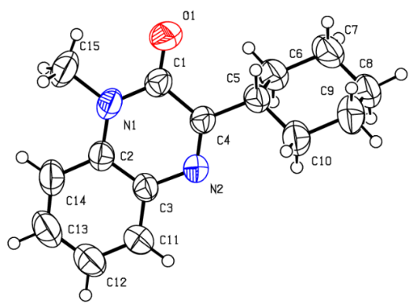

**Figure S1** Single-crystal X-ray structure of **4al**. Ellipsoids are represented at 30% probability.

**Table S1** Crystallographic data and structure refinement for **4al**

|  |  |
| --- | --- |
| CCDC | 1975822 |
| Empirical formula | C15H18N2O |
| Formula weight | 242.31 |
| Temperature, K | 296.15 |
| Wavelength, Å | 0.71073 |
| Crystal system | Triclinic |
| Space group | P-1 |
| *a*, *b*, *c*, Å | 10.391(2), 12.069(3), 12.450(3) |
| *α*, *β*, *γ*, o | 84.497(4), 69.931(4), 64.785(4) |
| Volume, Å3 | 1324.5(5) |
| *Z* | 4 |
| Calculated density, Mg/m^3 | 1.215 |
| *F* (000) | 520 |
| Theta range for data collection, o | 2.273 to 27.512 |
| Limiting indices | -13<=h<=13, -15<=k<=14, -13<=l<=16 |
| Reflections collected / unique | 7968 / 5724 [R(int) = 0.0253] |
| Absorption correction | Semi-empirical from equivalents |
| Refinement method | Full-matrix least-squares on F2 |
| Data / restraints / parameters | 5724 / 0 / 328 |
| Goodness of fit on *F*2 | 1.043 |

1. **Copies of 1H, 13C and 19F NMR Spectra**

**4a 1H NMR**

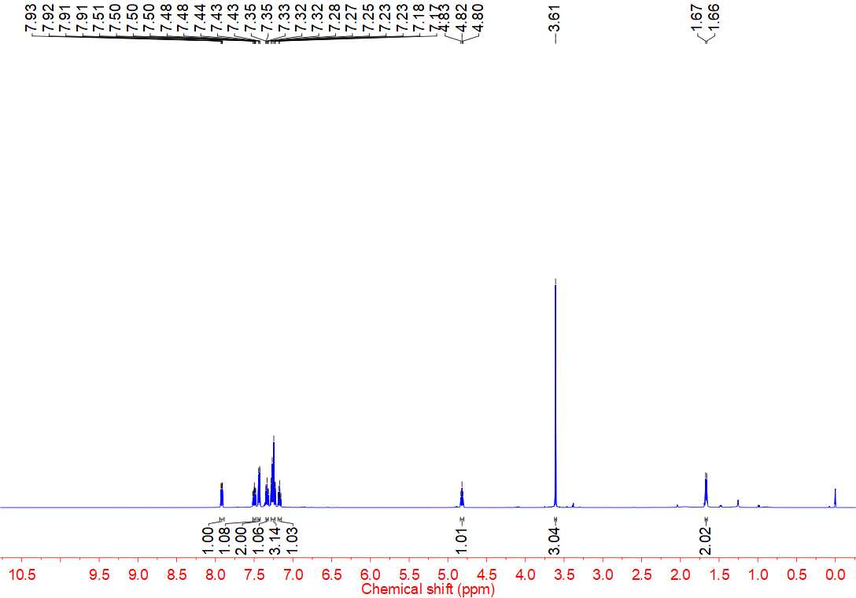



**4a 13C NMR**

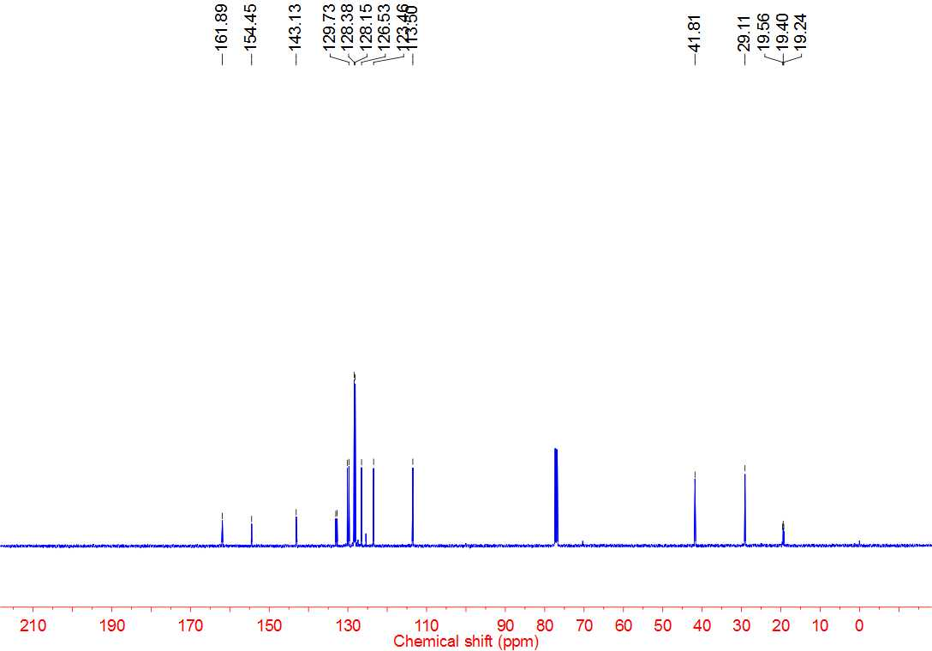



**4b 1H NMR**

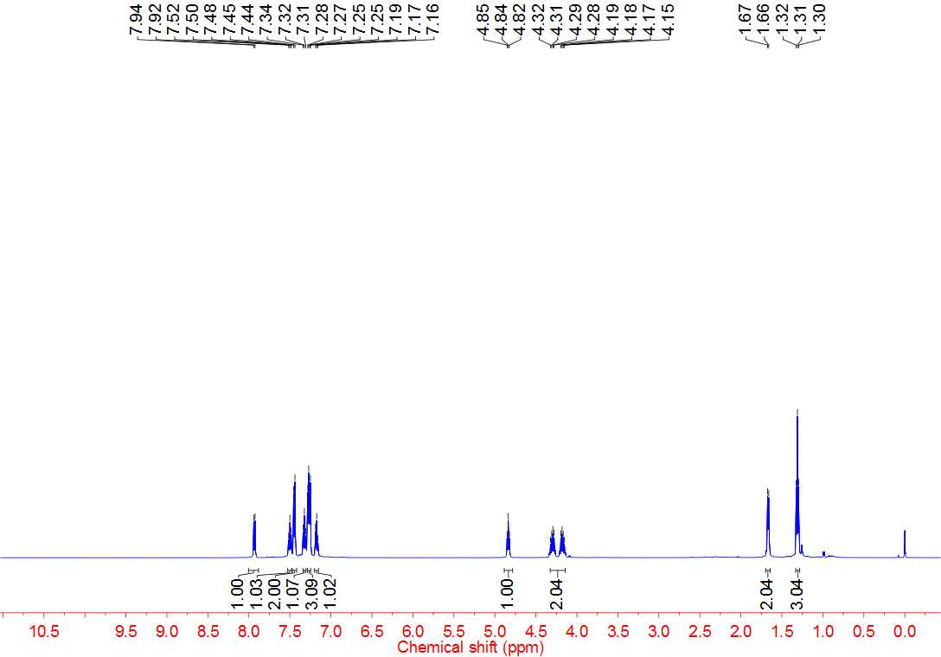



**4b 13C NMR**

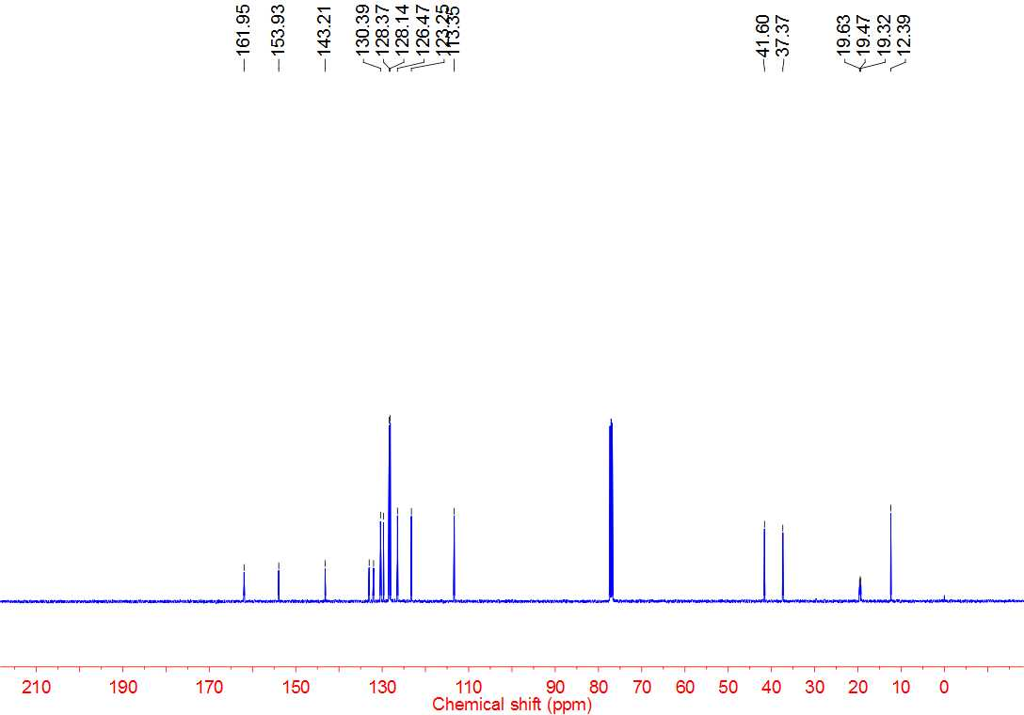



**4c 1H NMR**

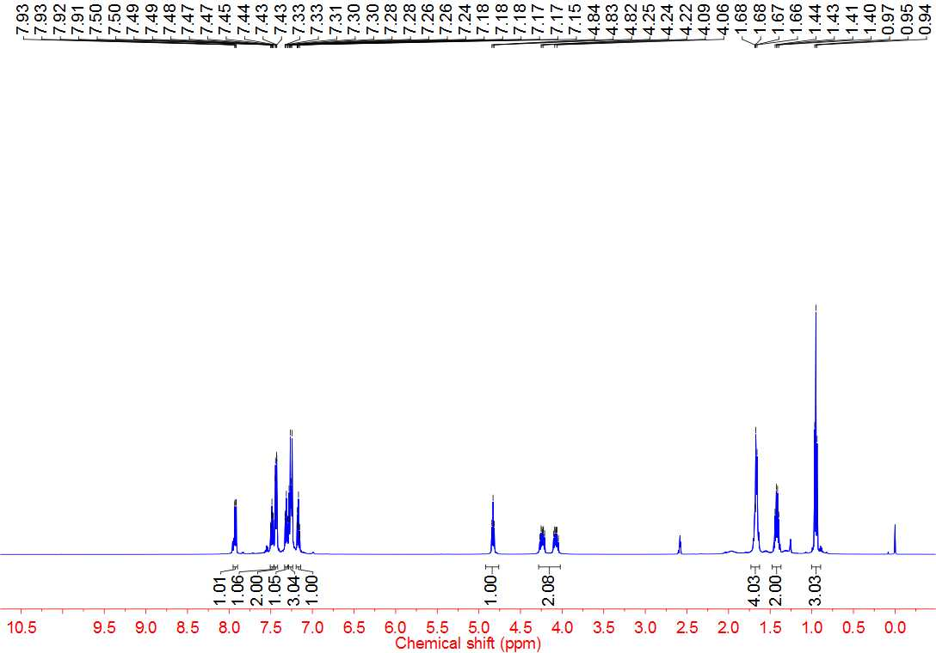



**4c 13C NMR**

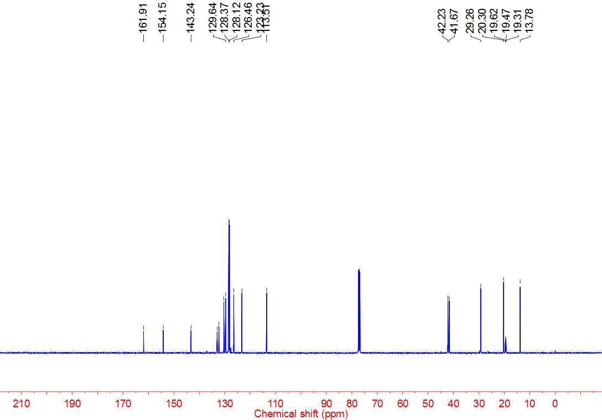



**4d 1H NMR**

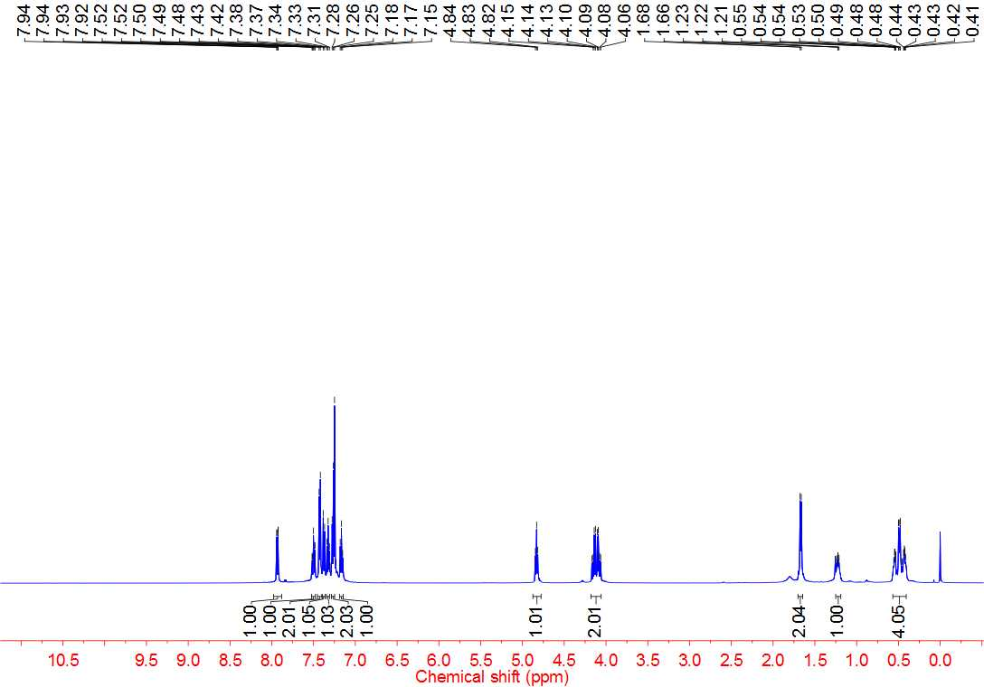



**4d 13C NMR**

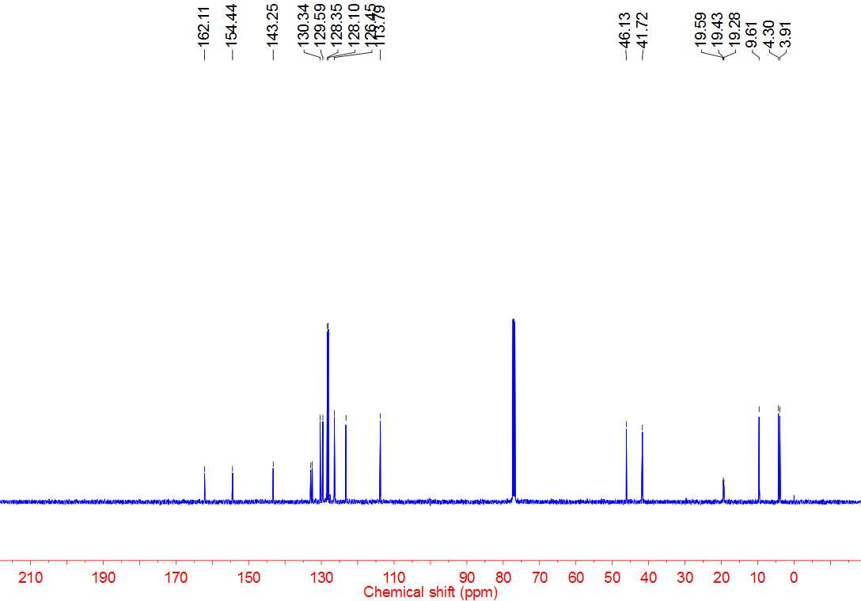



**4e 1H NMR**

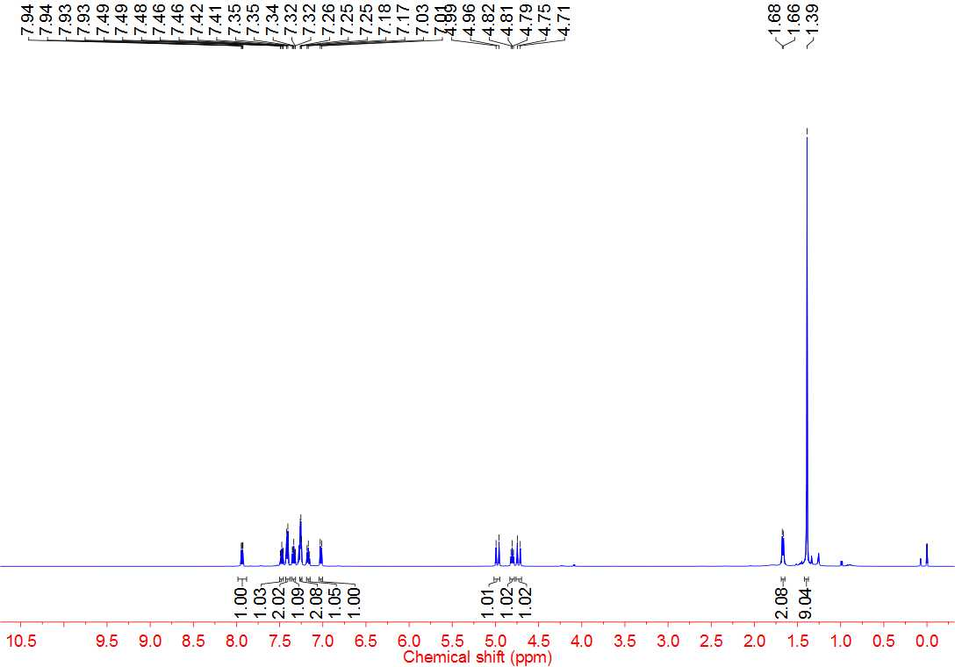



**4e 13C NMR**

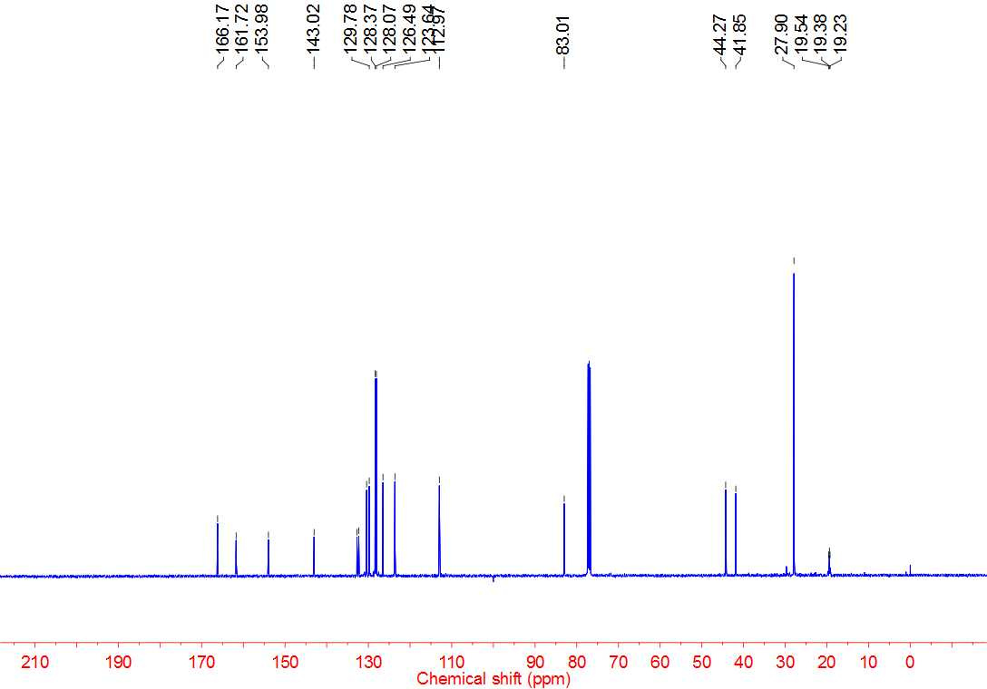



**4f 1H NMR**

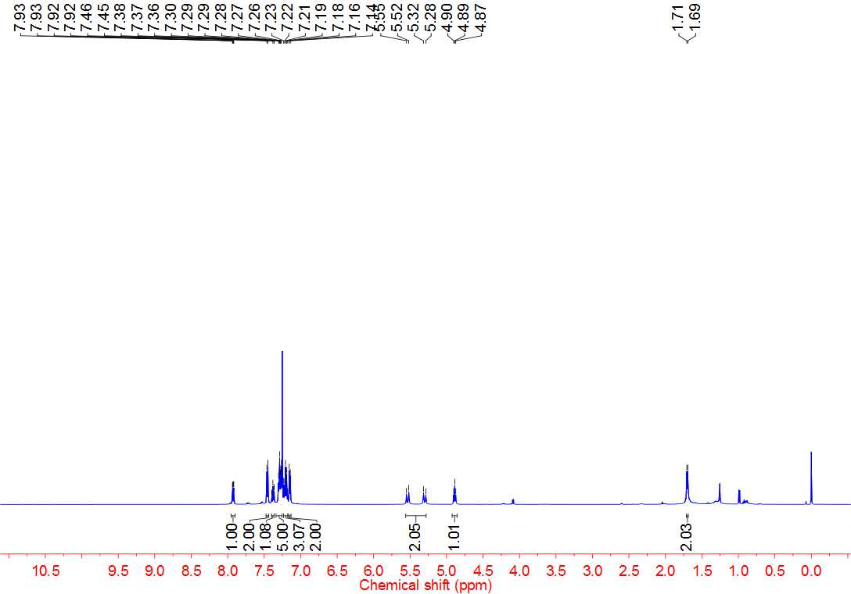



**4f 13C NMR**

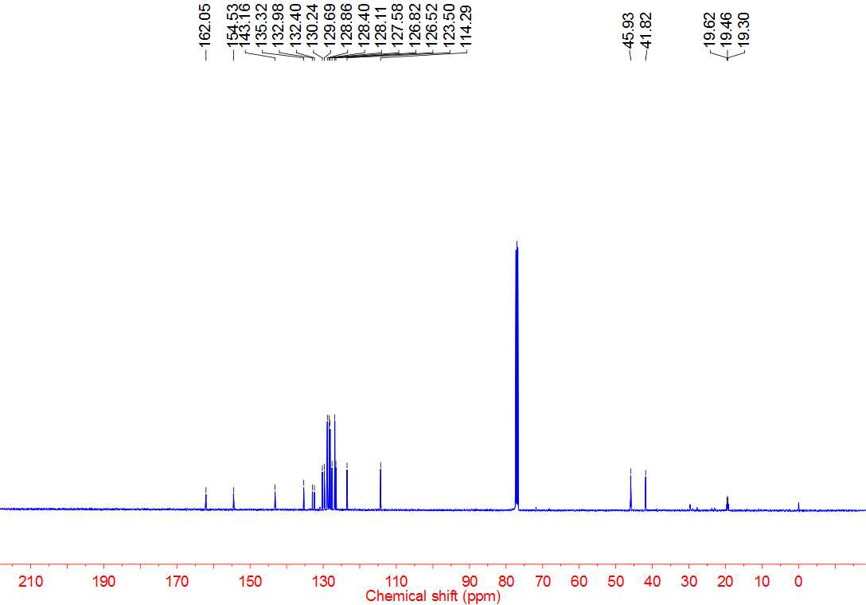



**4g 1H NMR**

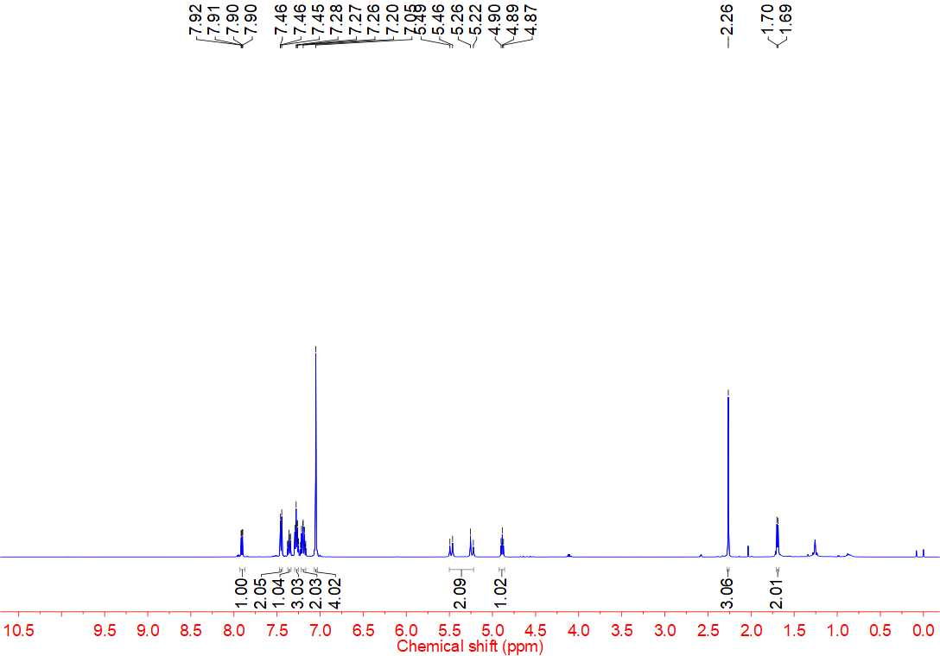



**4g 13C NMR**

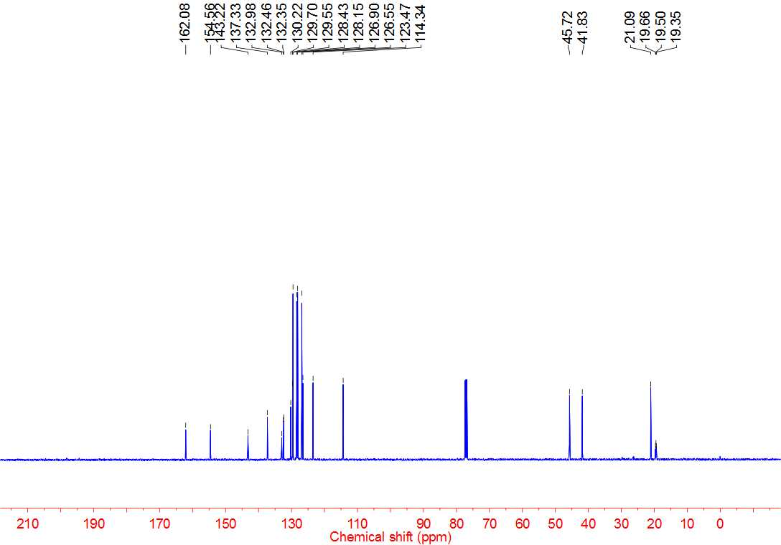



**4h 1H NMR**

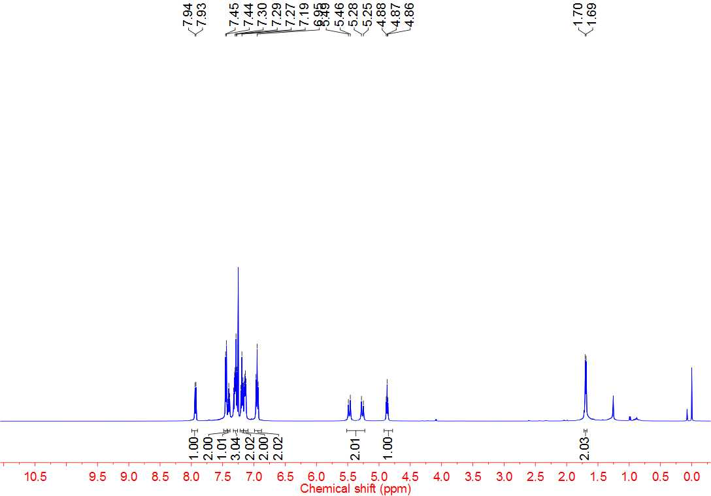



**4h 13C NMR**

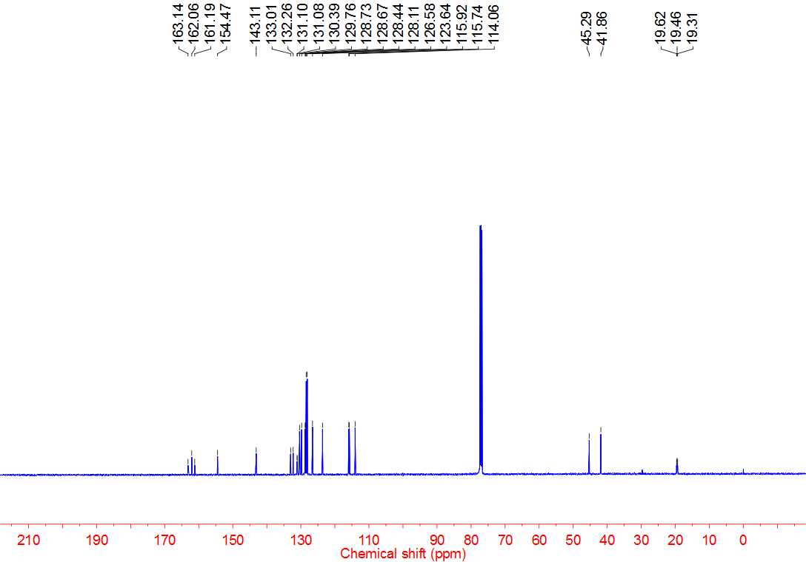



**4h 19F NMR**

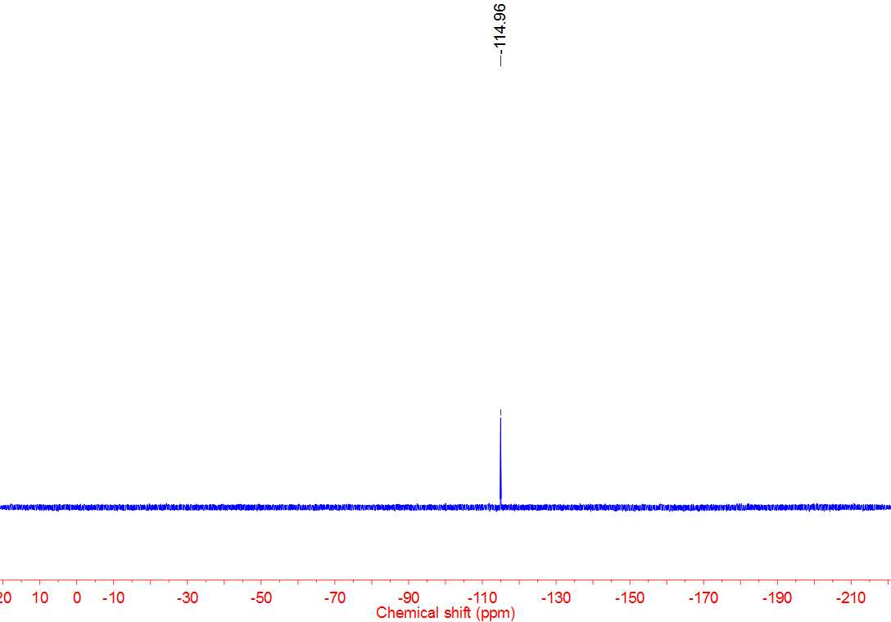



**4i 1H NMR**

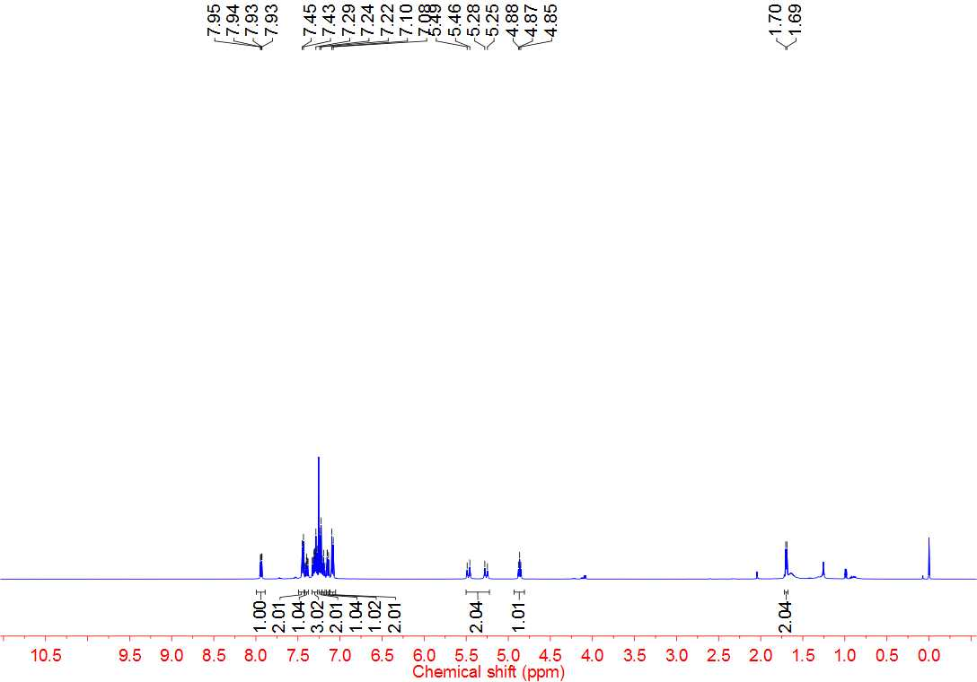



**4i 13C NMR**

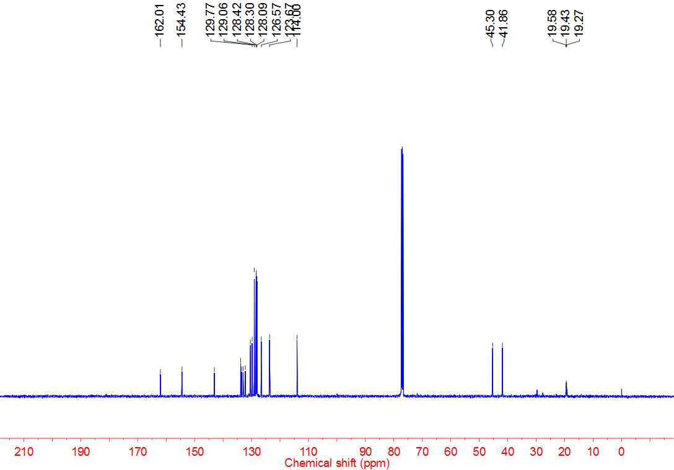



**4j 1H NMR**

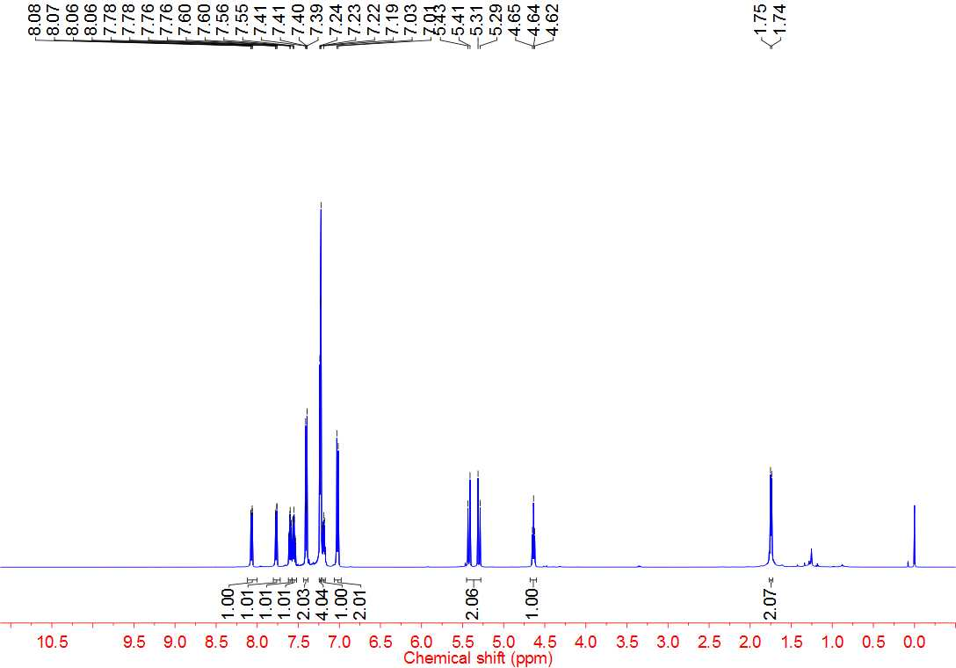



**4j 13C NMR**

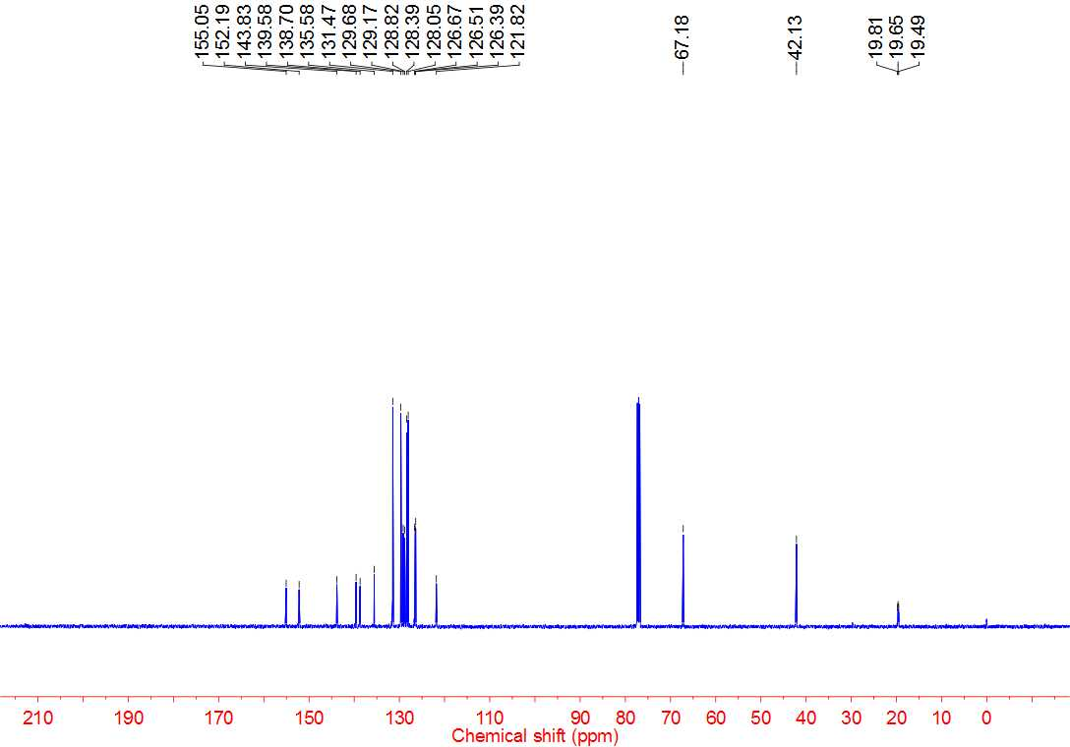



**4k 1H NMR**

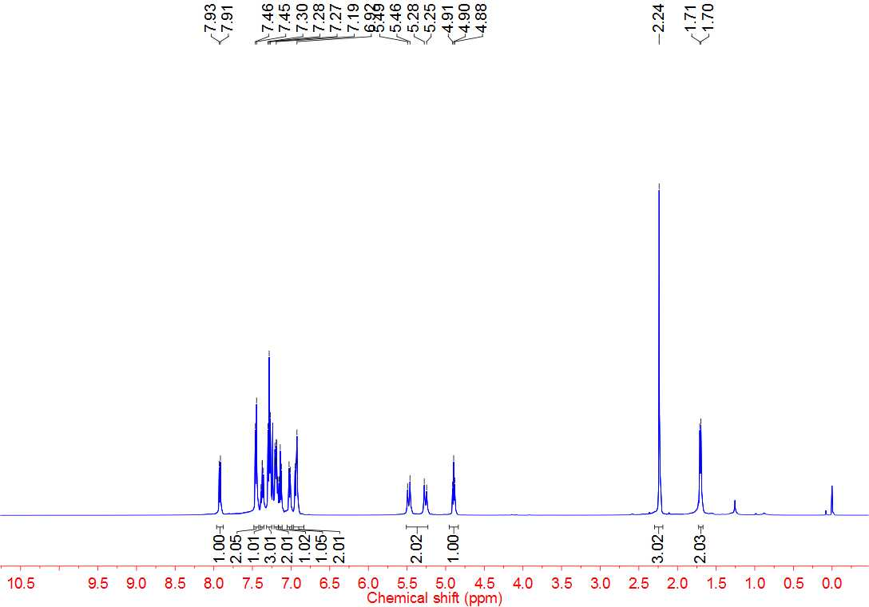



**4k 13C NMR**

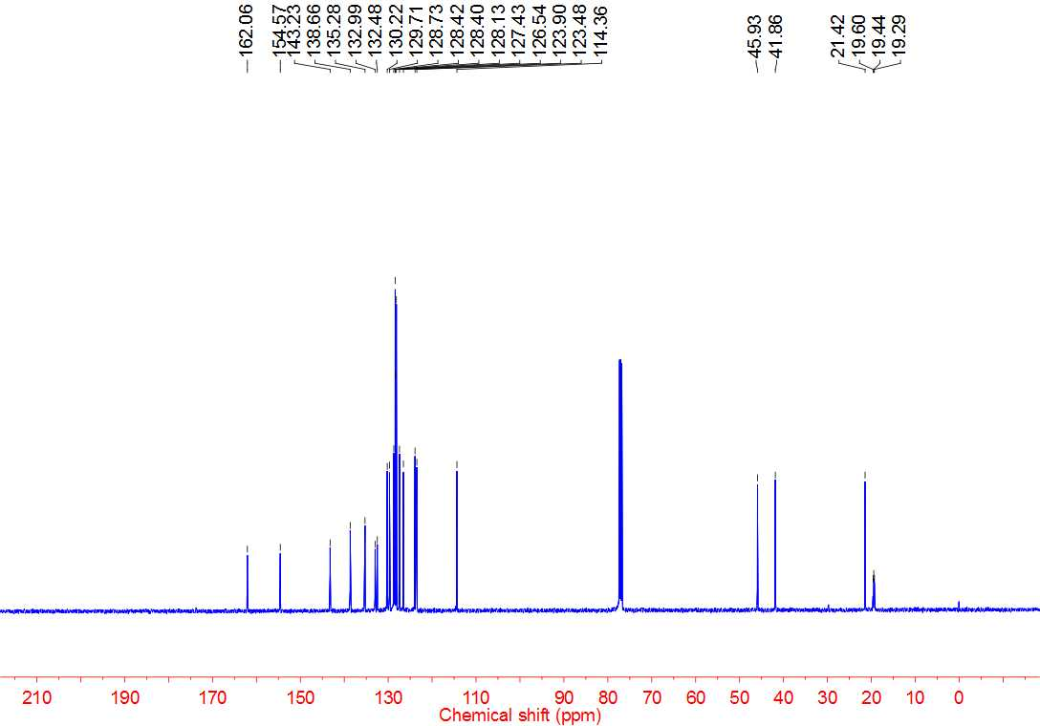



**4l 1H NMR**

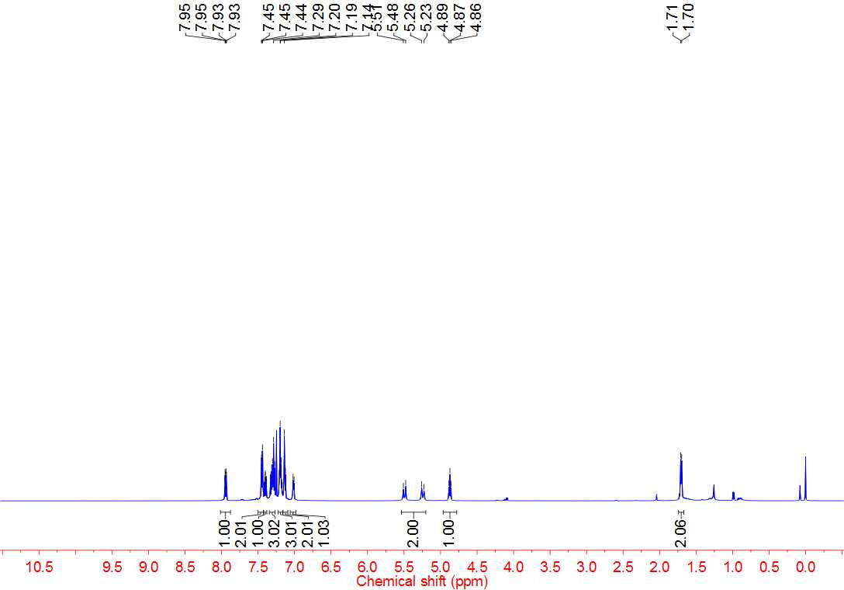



**4l 13C NMR**

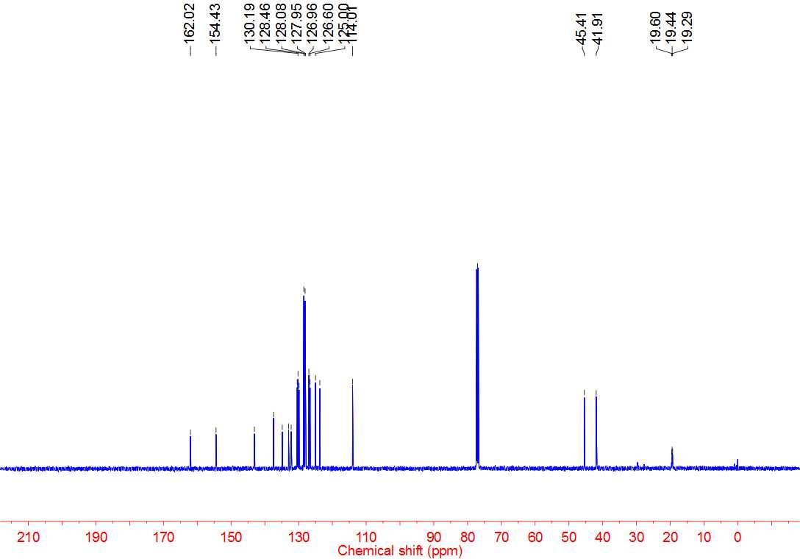



**4m 1H NMR**

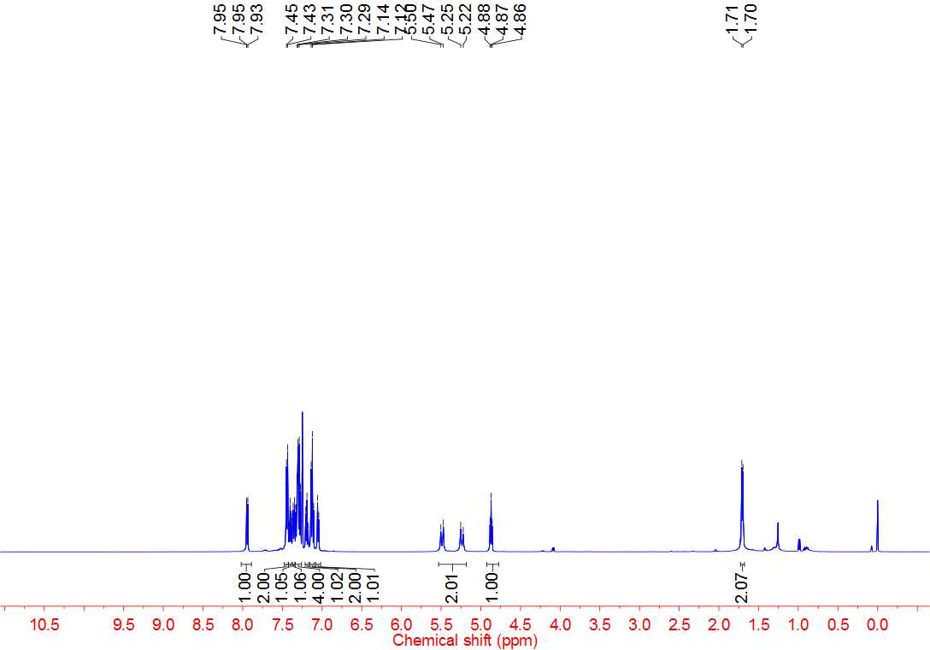



**4m 13C NMR**

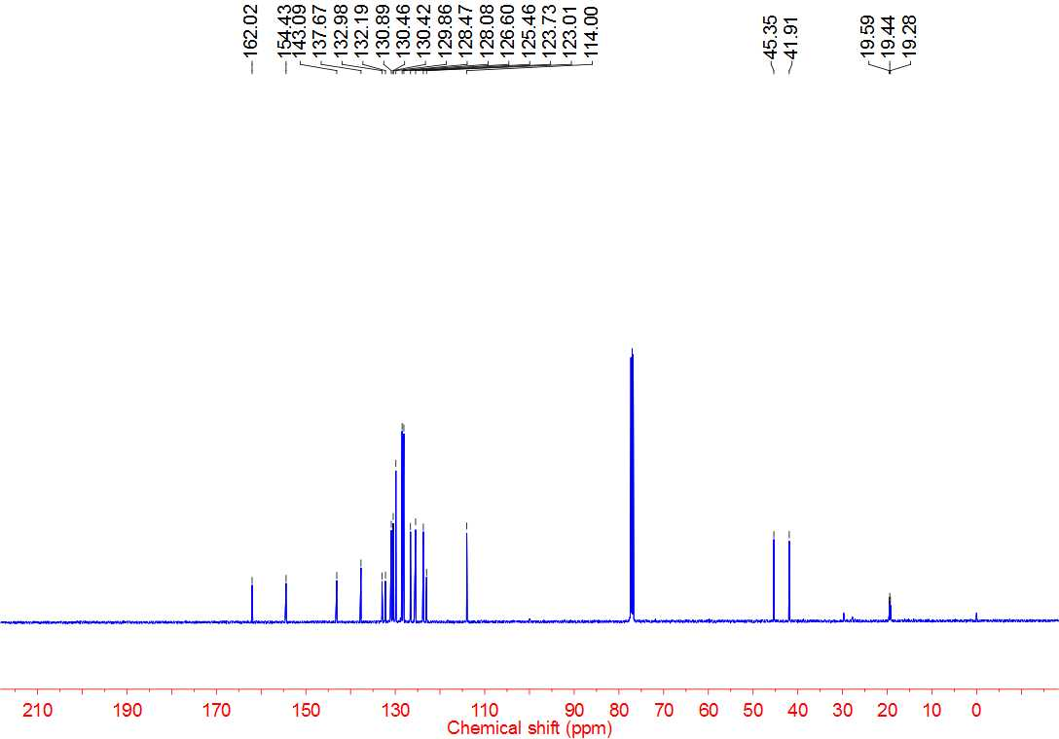



**4n 1H NMR**

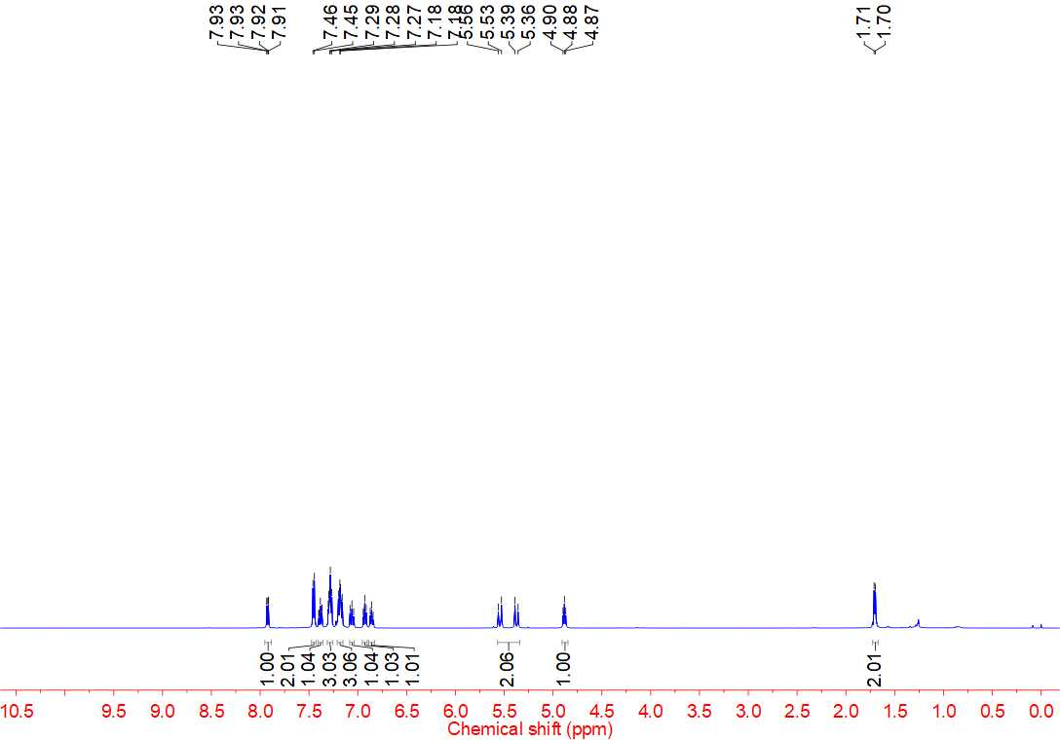



**4n 13C NMR**

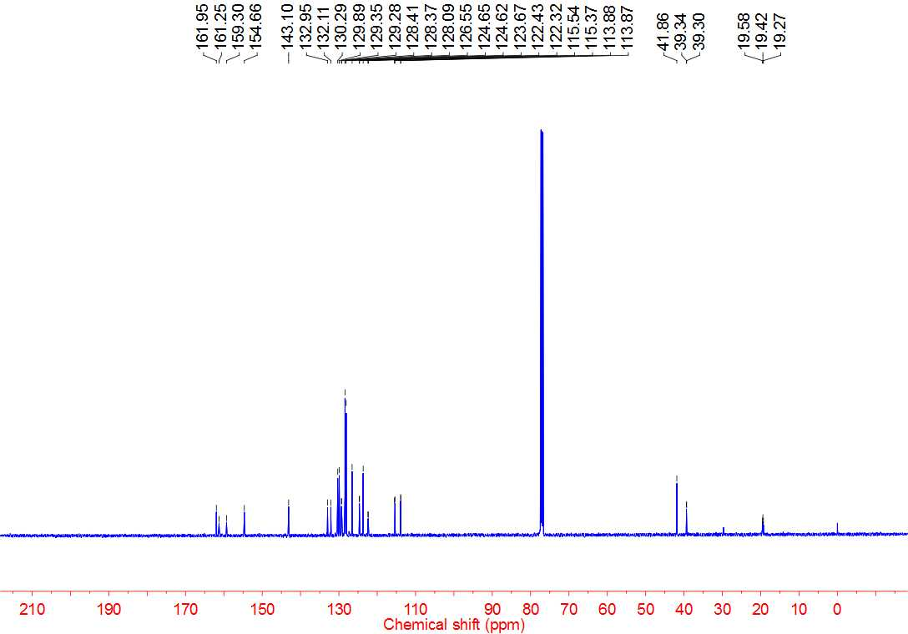



**4n 19F NMR**

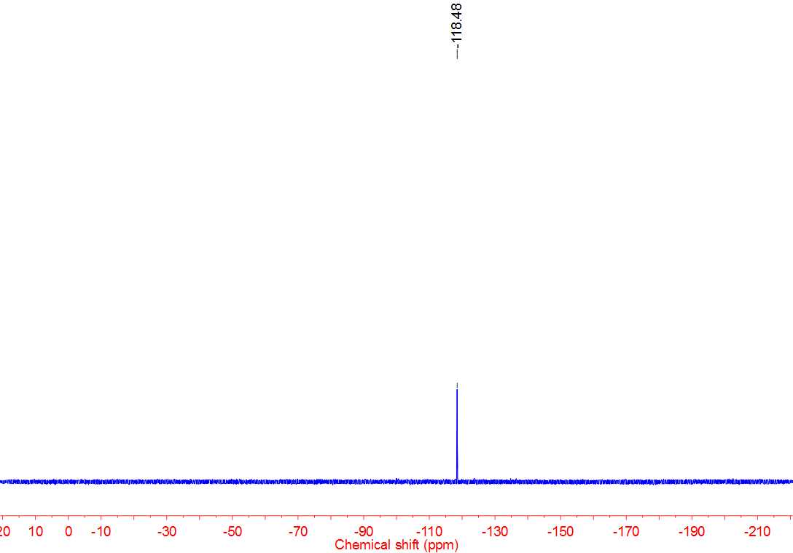



**4o 1H NMR**

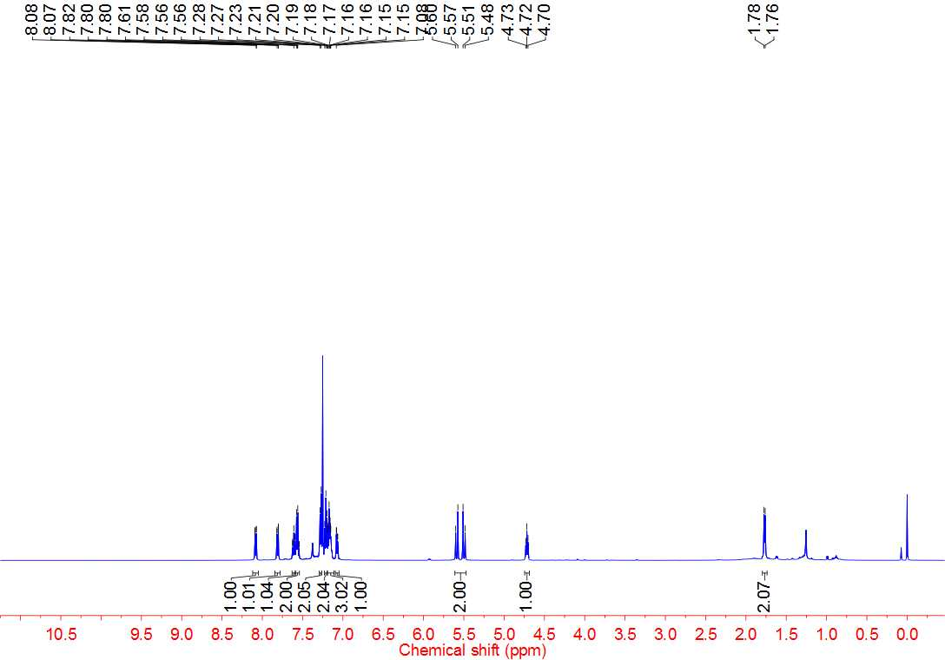



**4o 13C NMR**

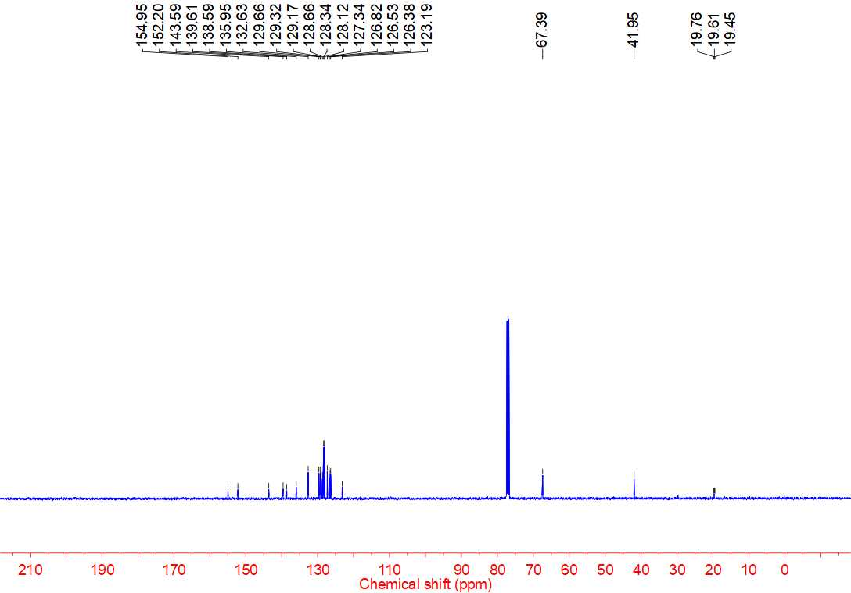



**4p 1H NMR**

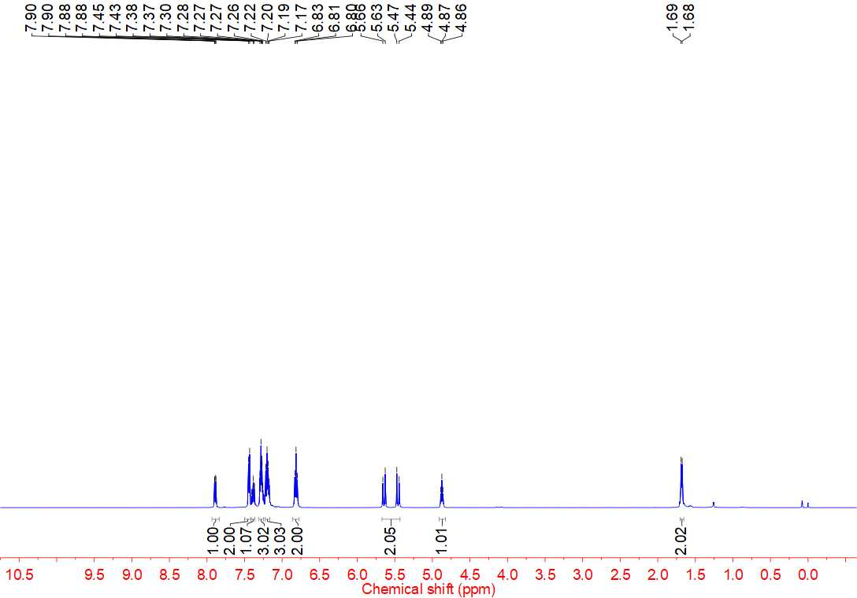



**4p 13C NMR**

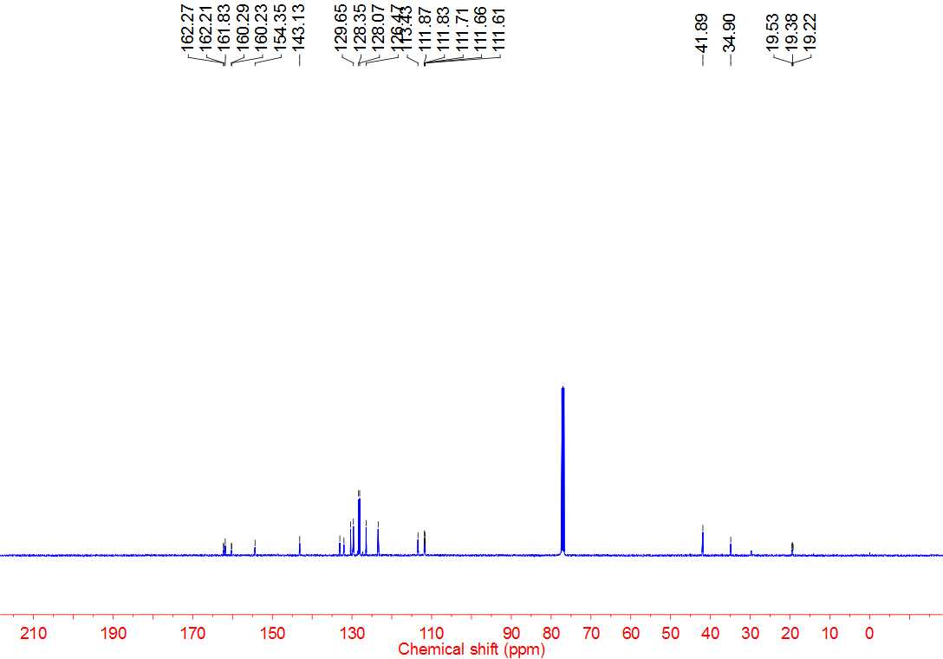



**4p 19F NMR**

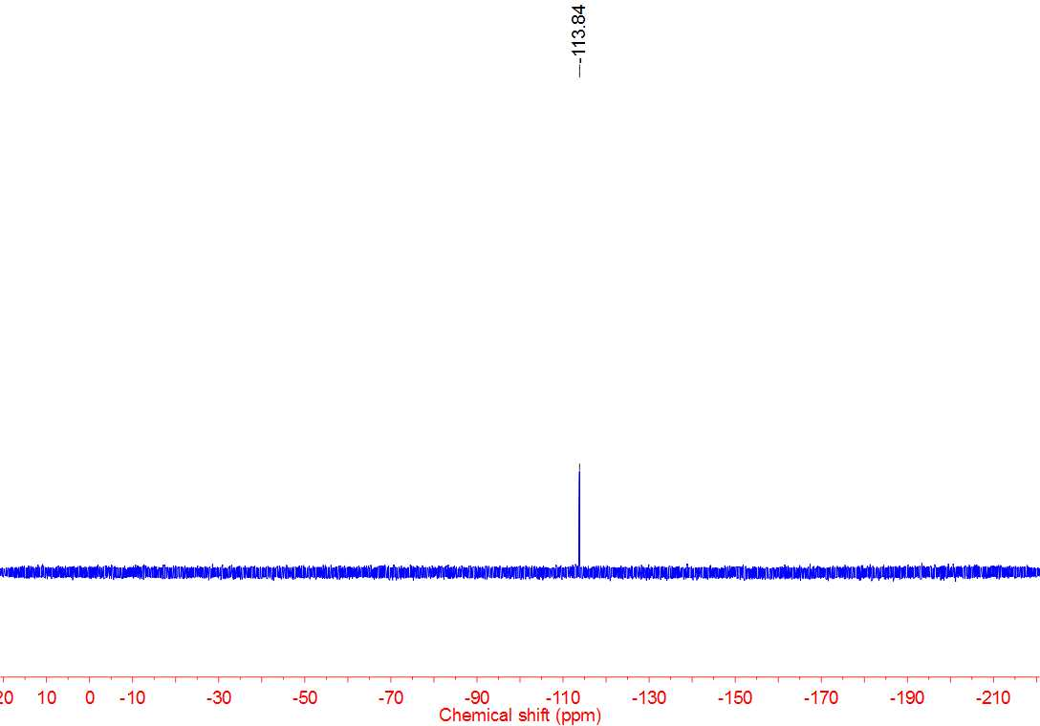



**4q 1H NMR**

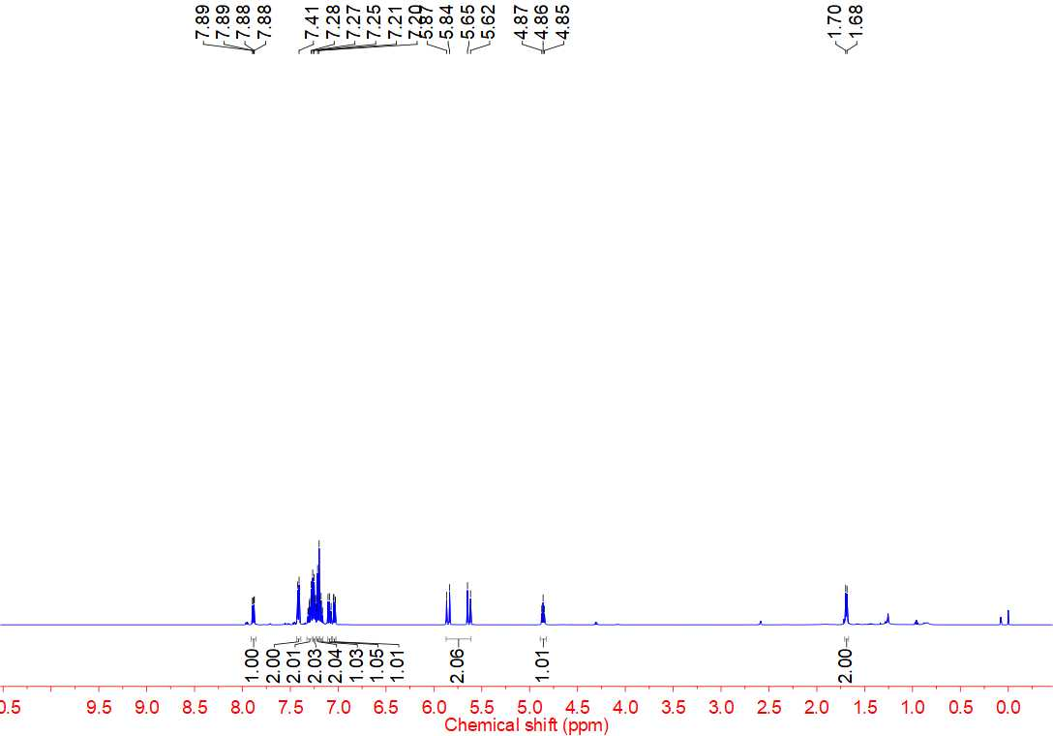



**4q 13C NMR**

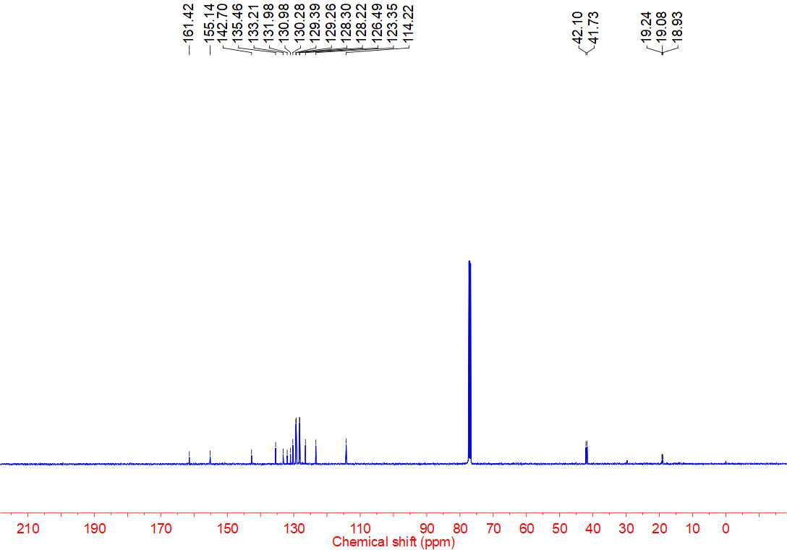



**4r 1H NMR**

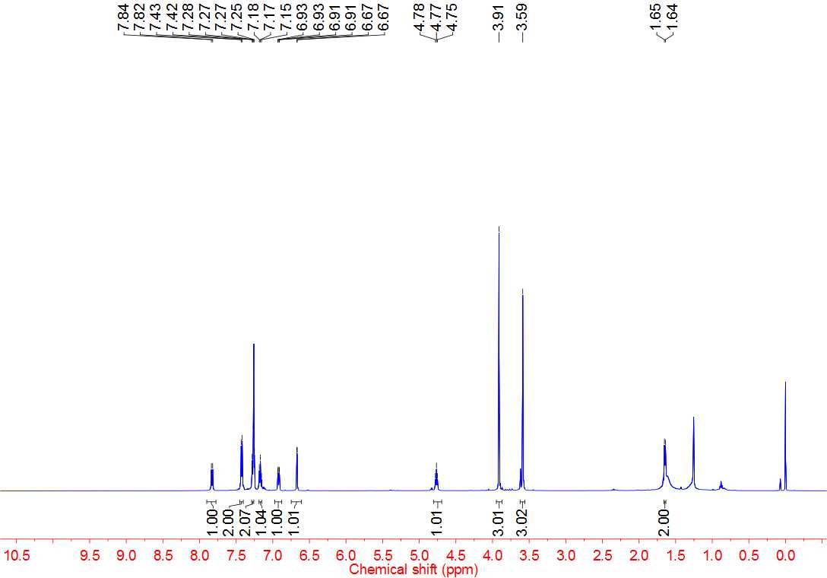



**4r 13C NMR**

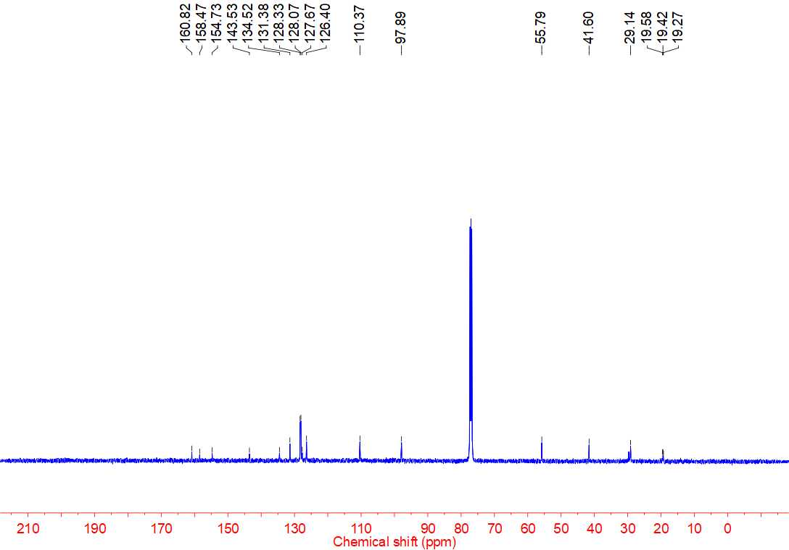



**4s 1H NMR**

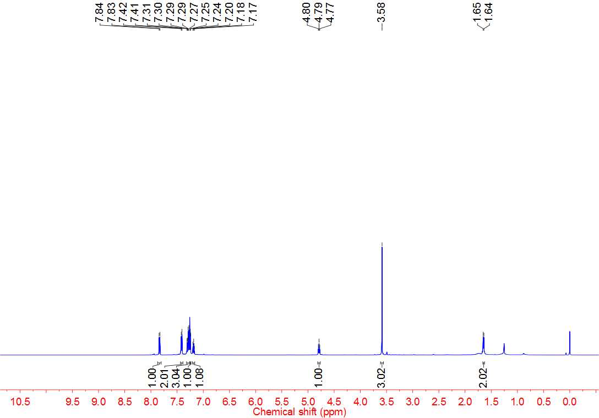



**4s 13C NMR**

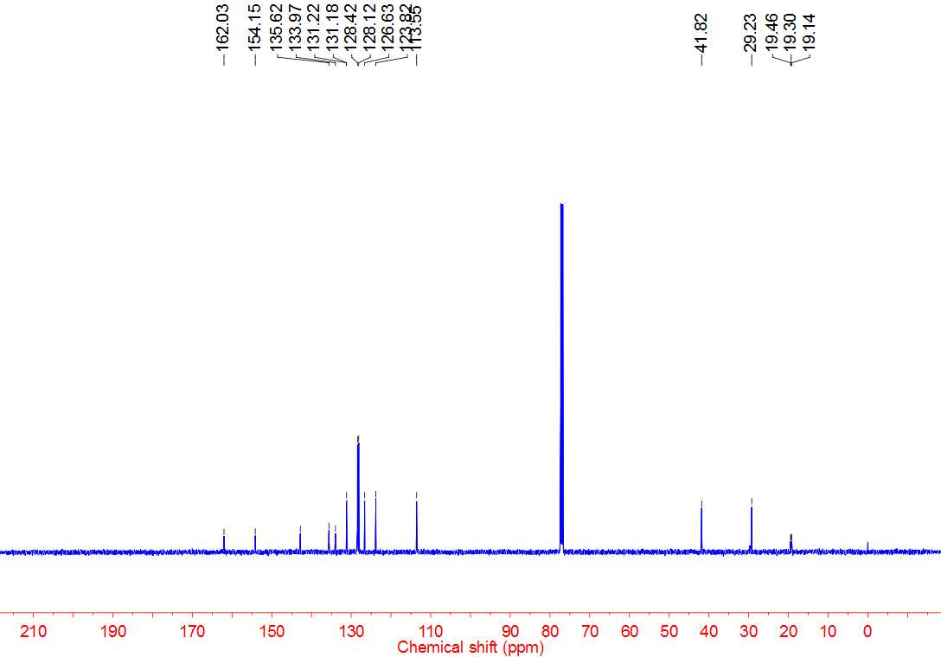



**4t 1H NMR**

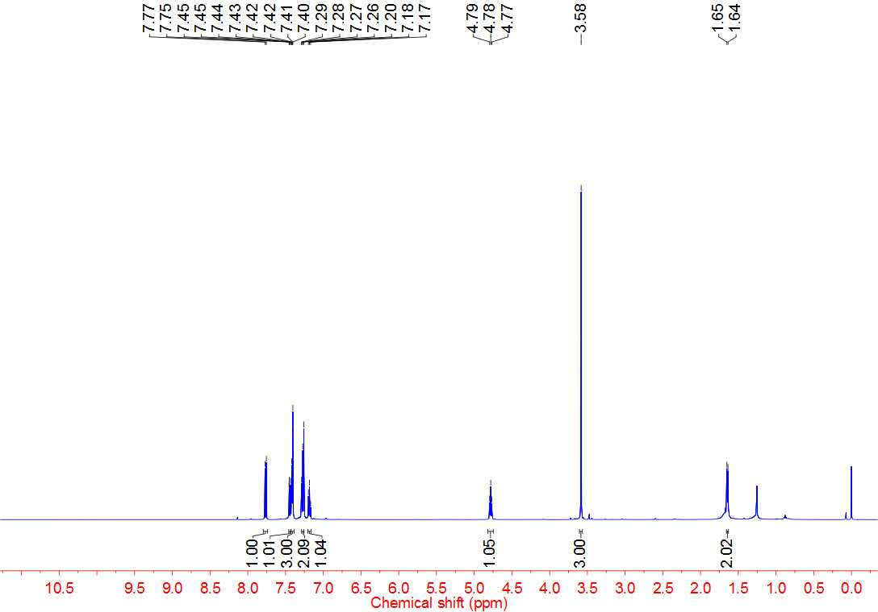



**4t 13C NMR**

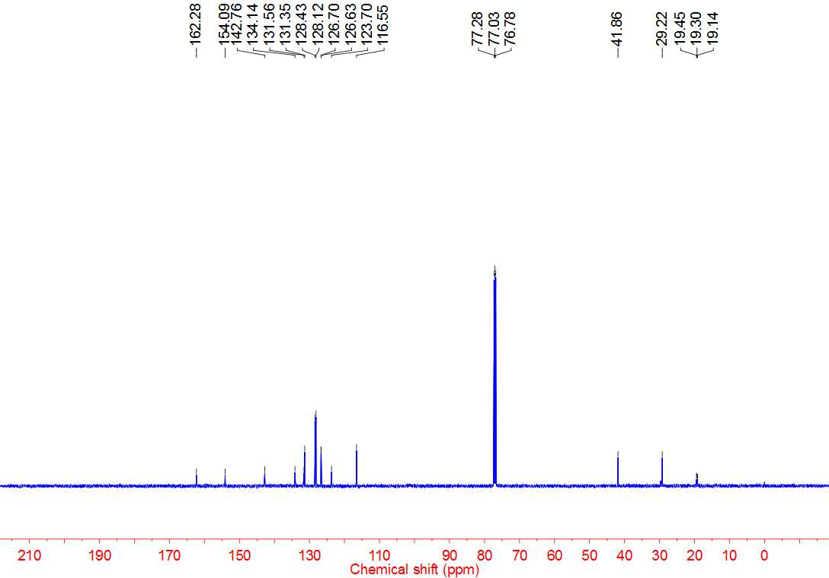



**4u 1H NMR**

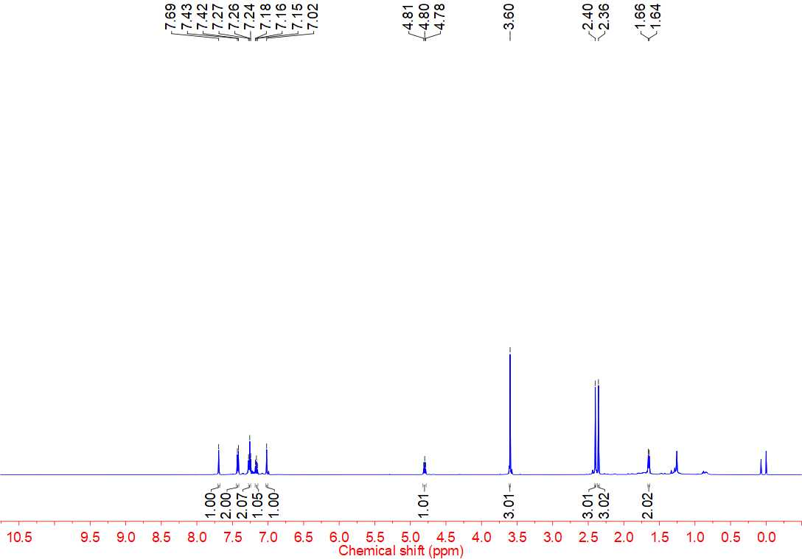



**4u 13C NMR**

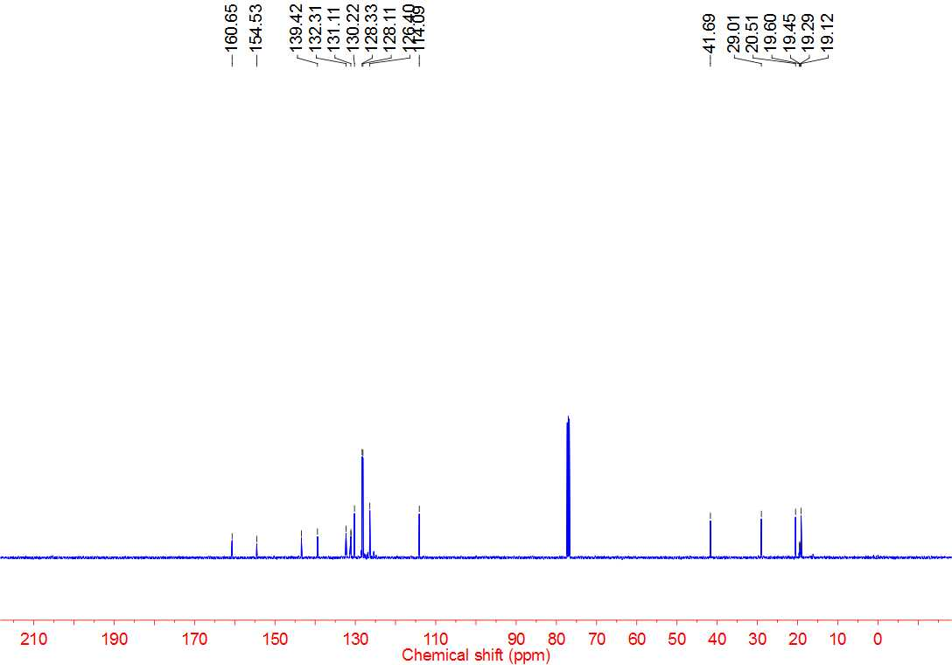



**4v 1H NMR**

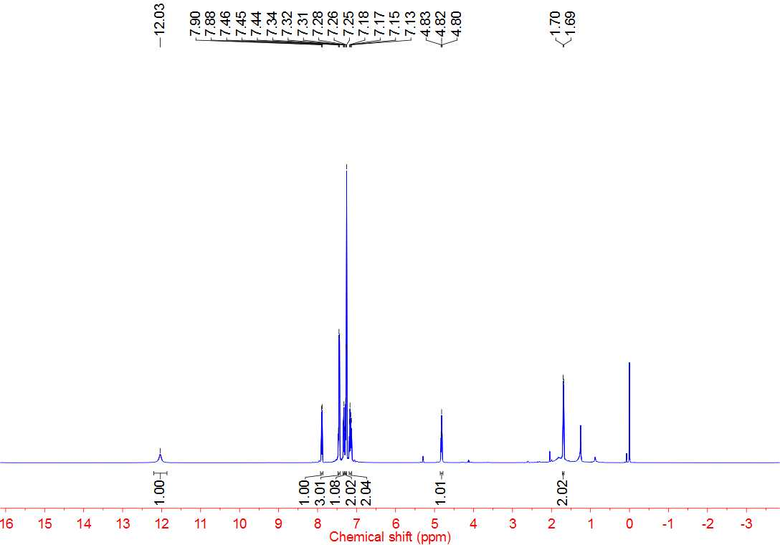



**4v 13C NMR**

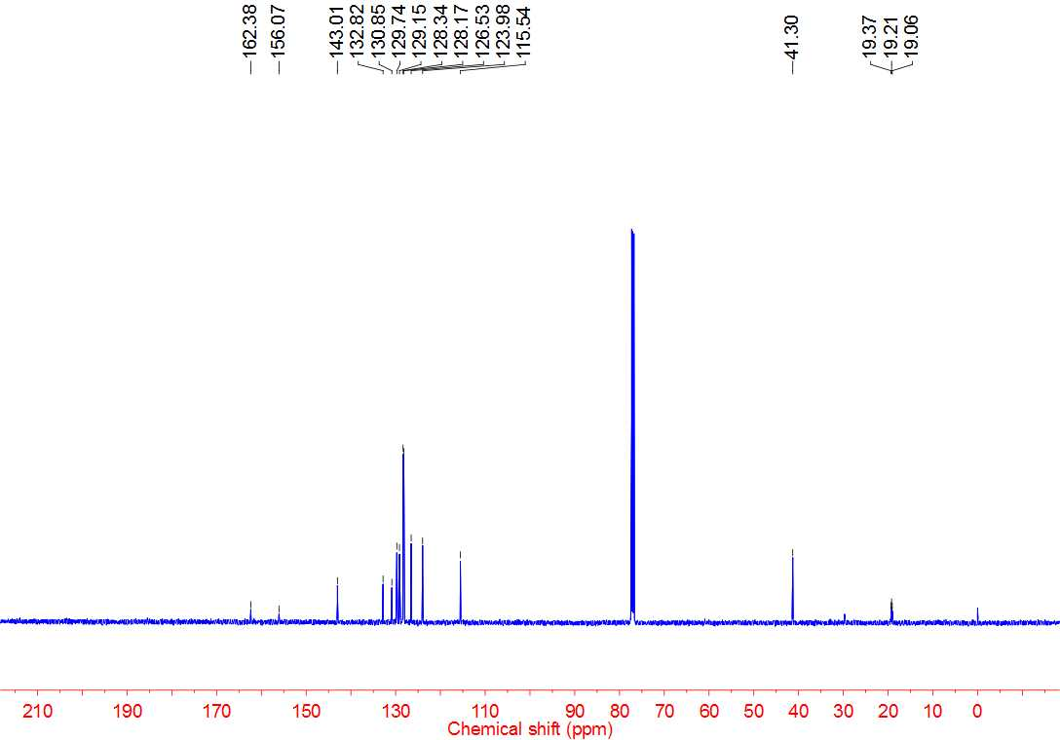



**4aa 1H NMR**

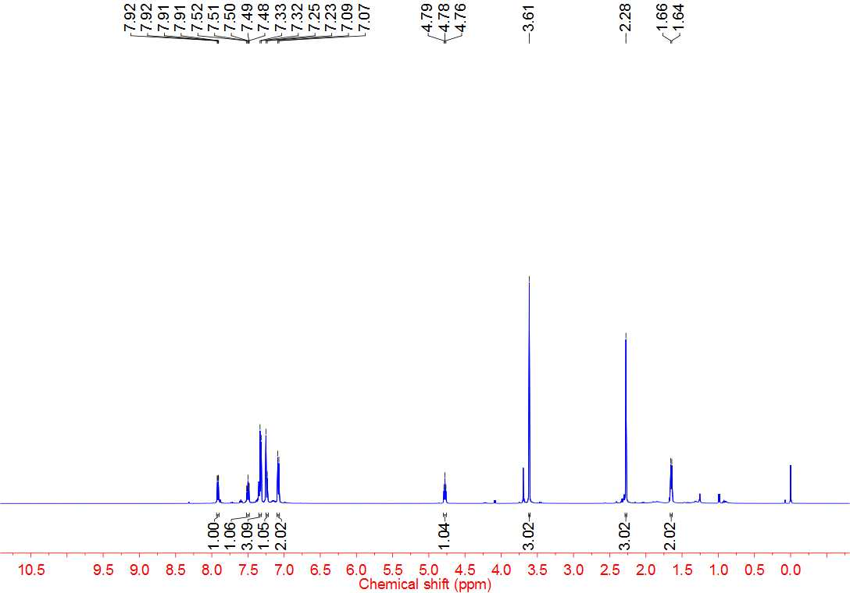



**4aa 13C NMR**

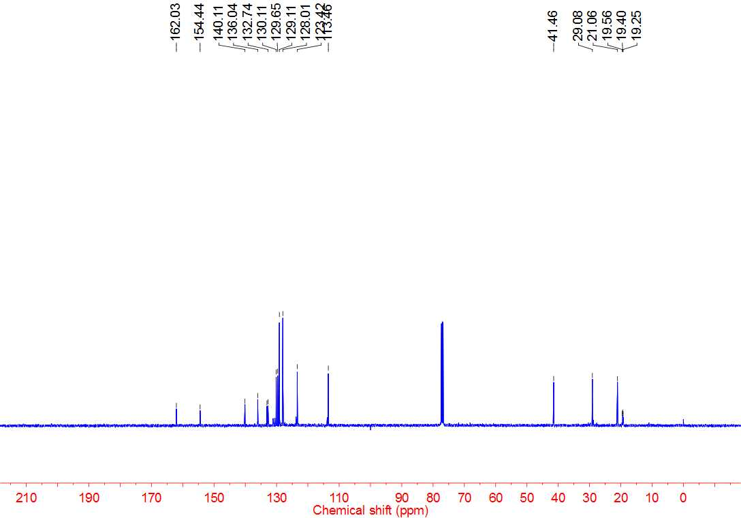



**4ab 1H NMR**

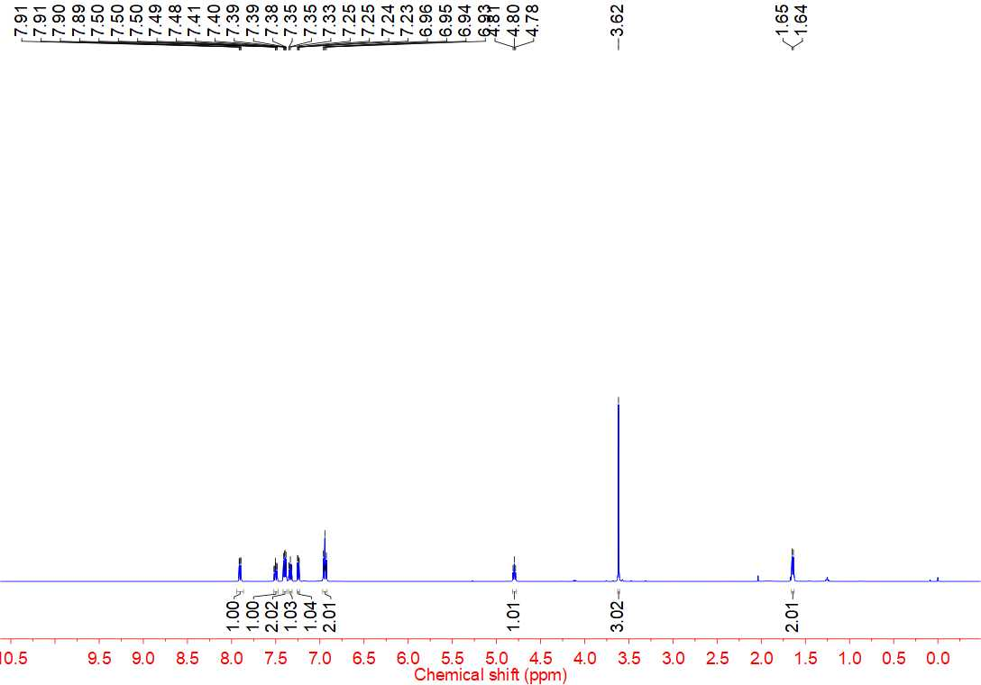



**4ab 13C NMR**

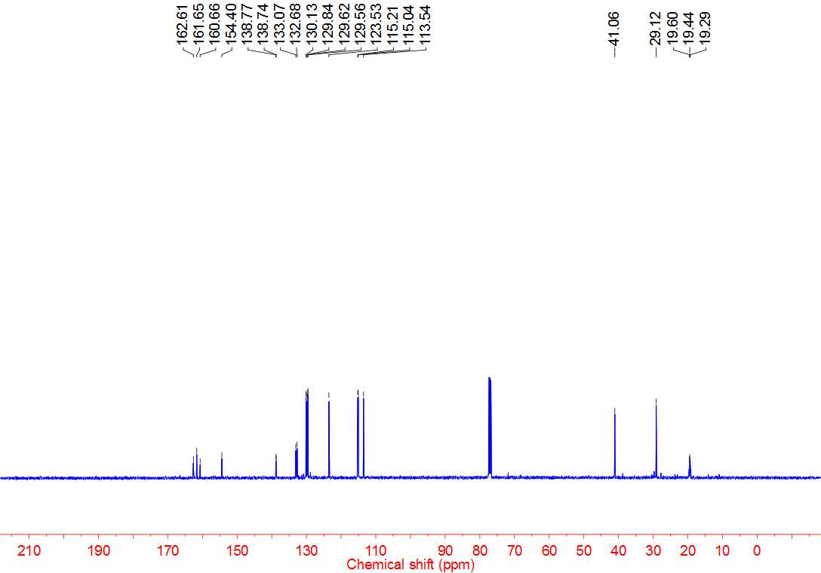



**4ab 19F NMR**

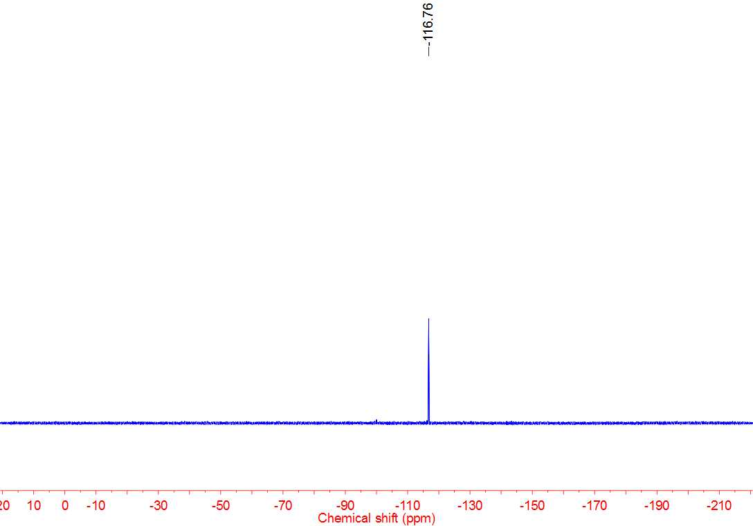



**4ac 1H NMR**

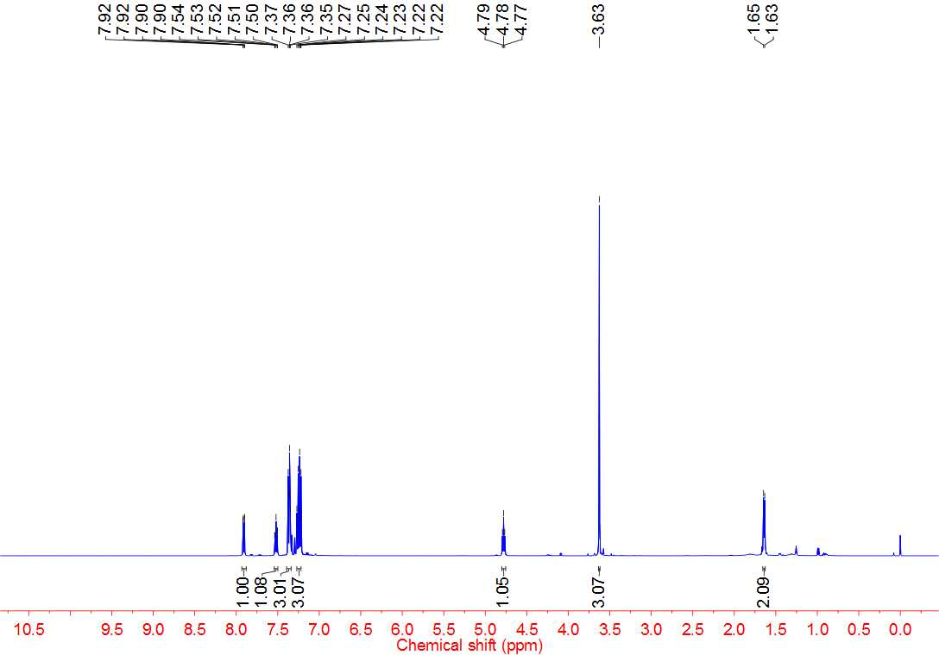



**4ac 13C NMR**

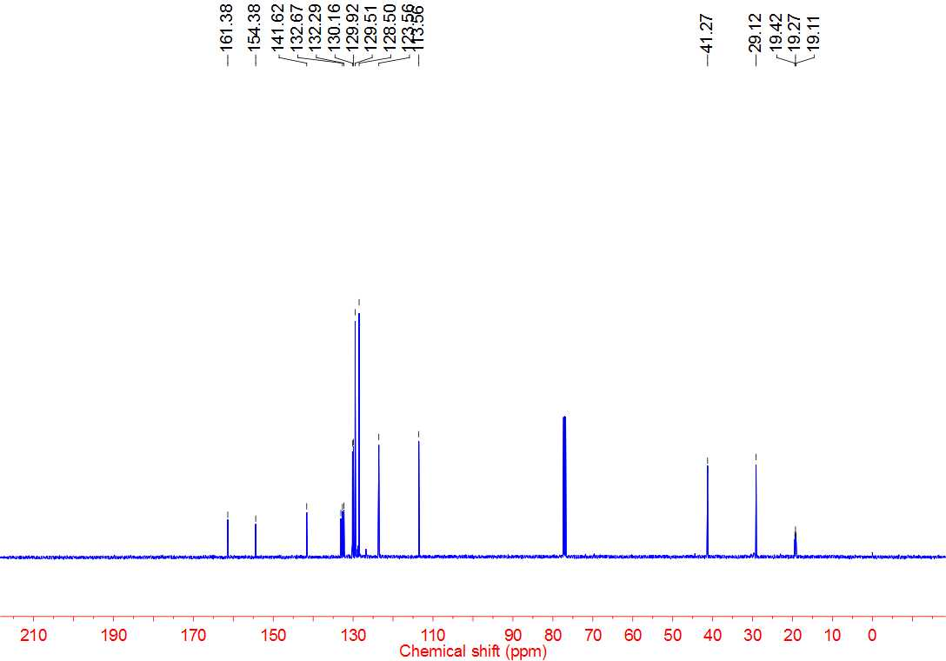



**4ad 1H NMR**

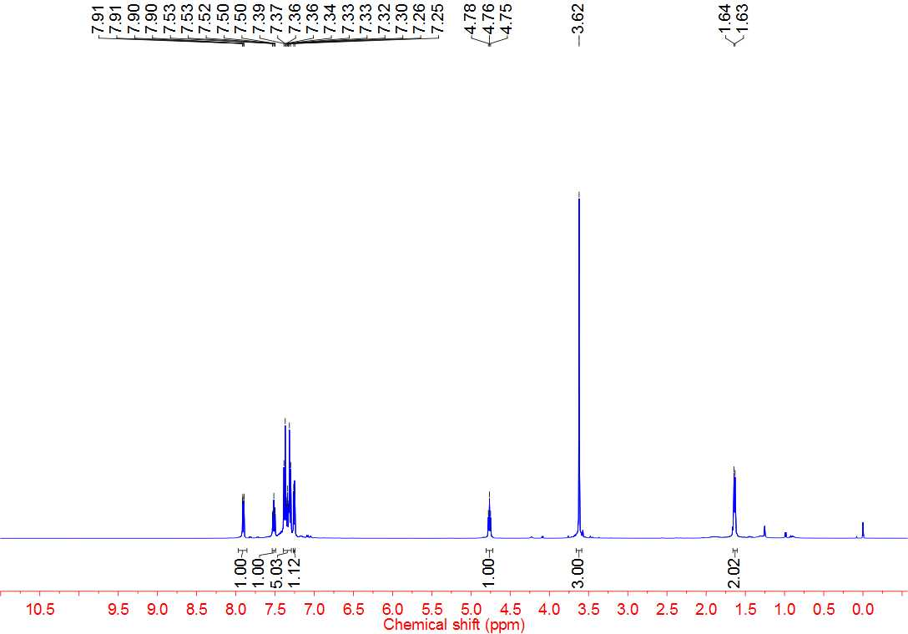



**4ad 13C NMR**

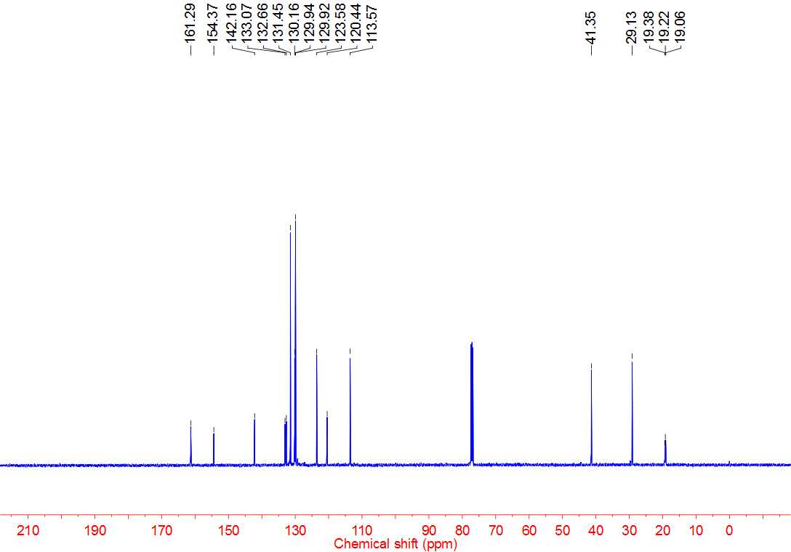



**4ae 1H NMR**

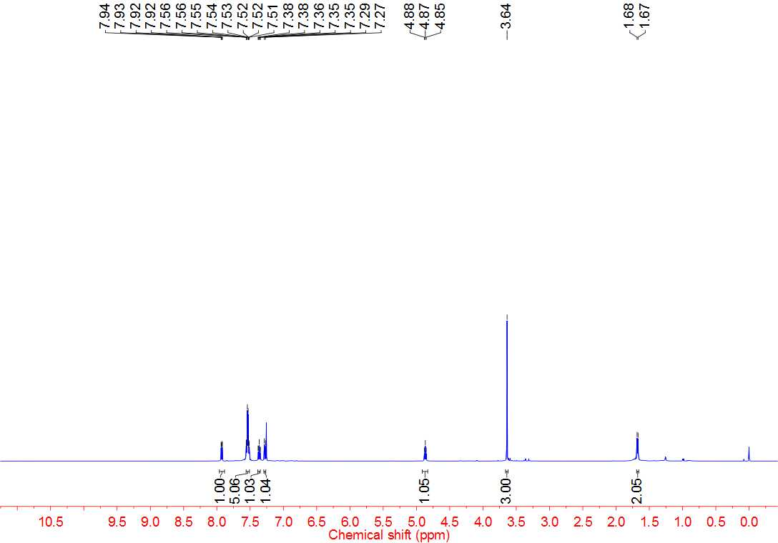



**4ae 13C NMR**

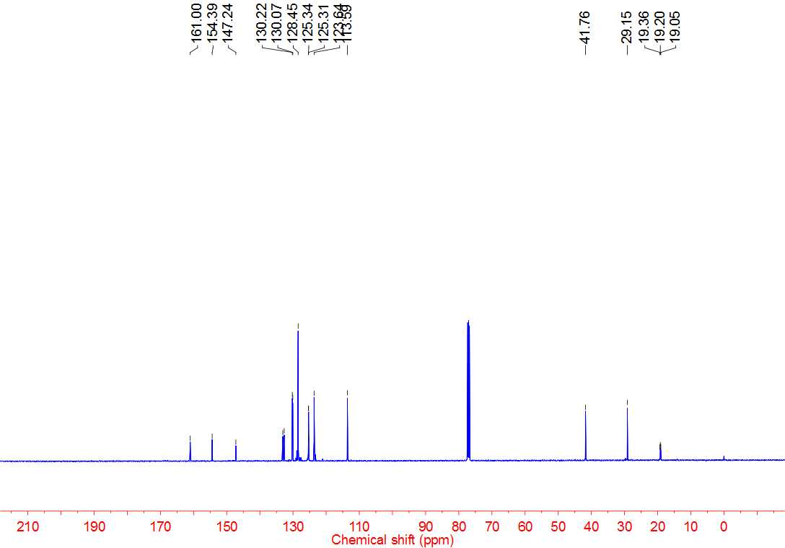



**4ae 19F NMR**

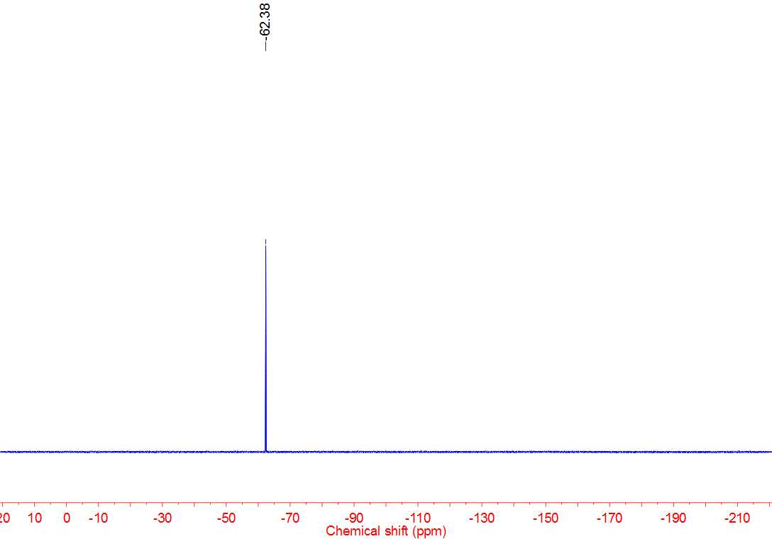



**4af 1H NMR**

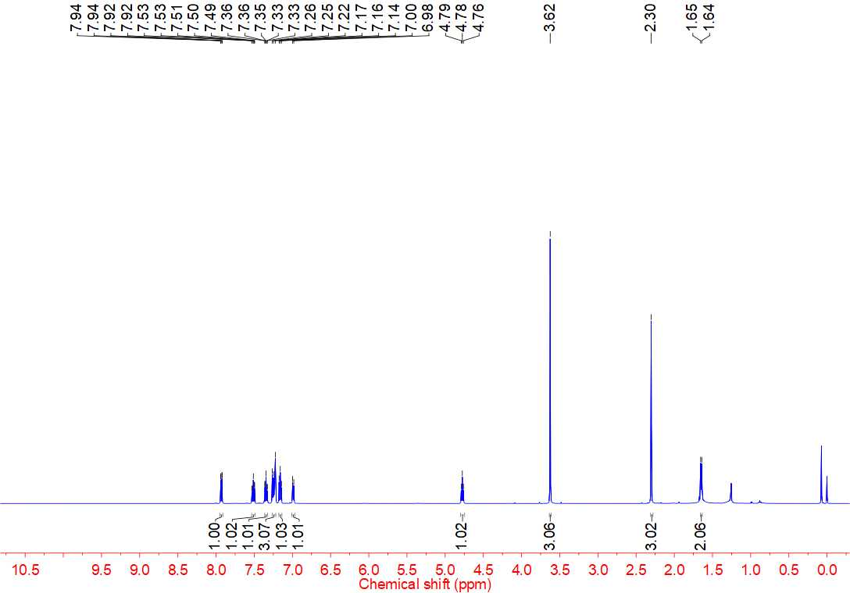



**4af 13C NMR**

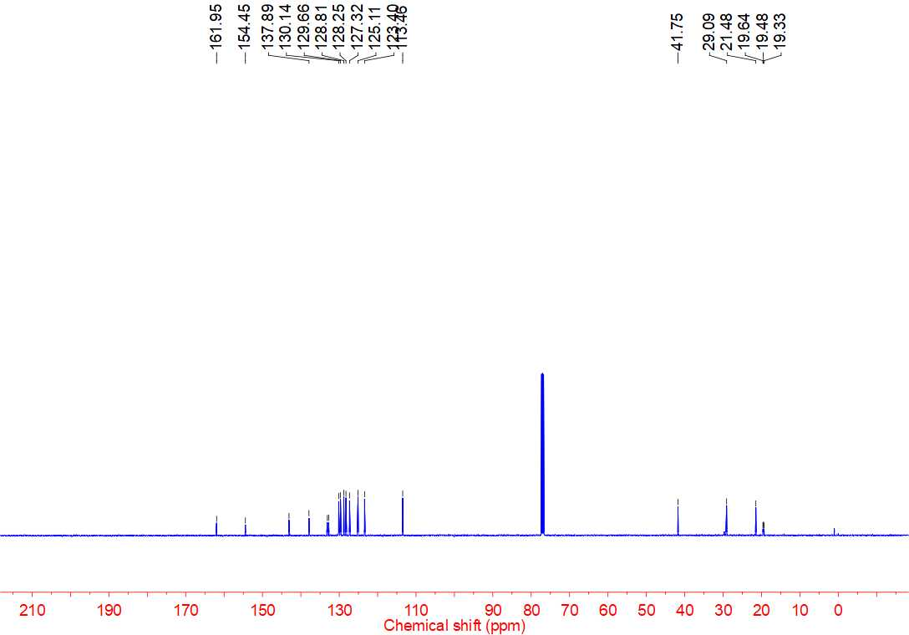



**4ag 1H NMR**

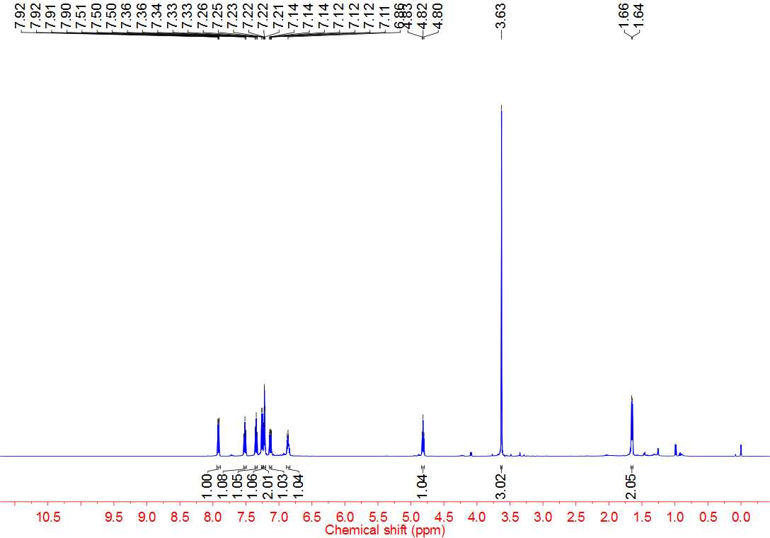



**4ag 13C NMR**

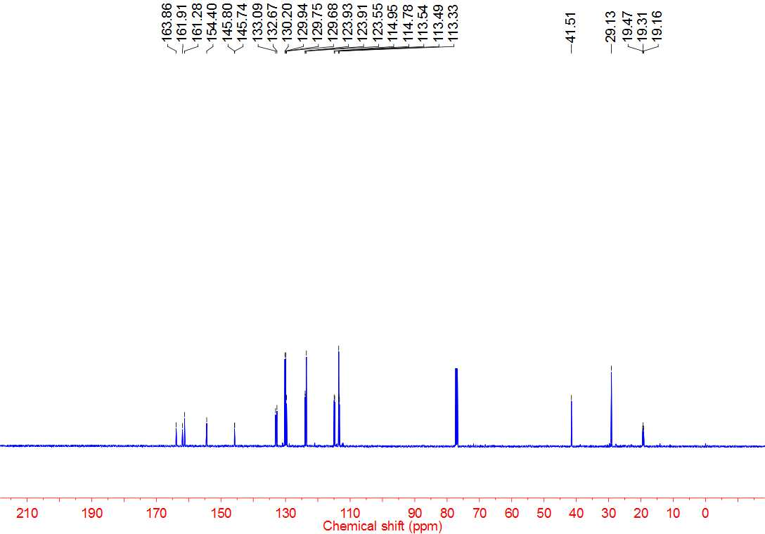



**4ag 19F NMR**

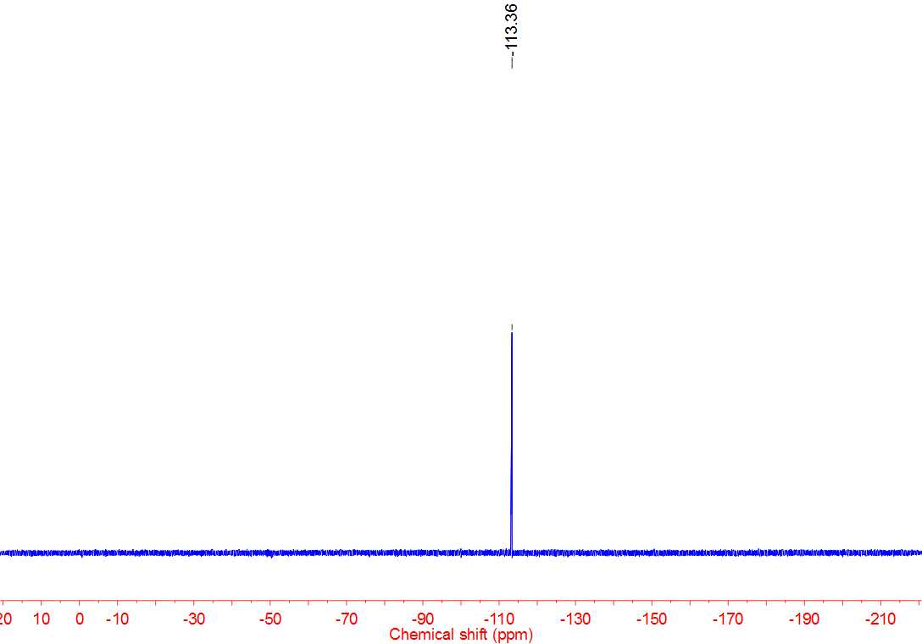



**4ah 1H NMR**

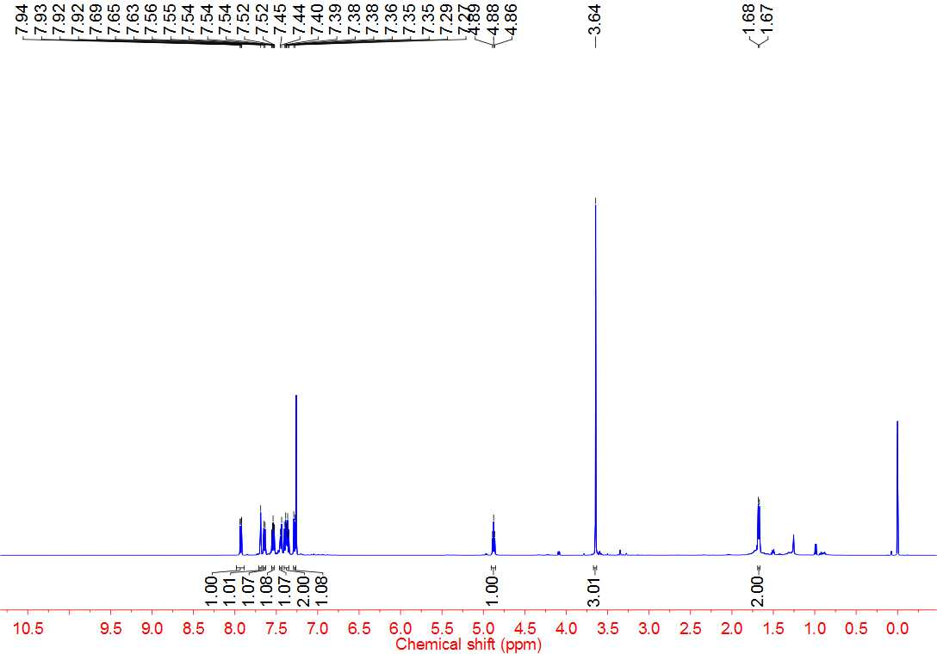



**4ah 13C NMR**

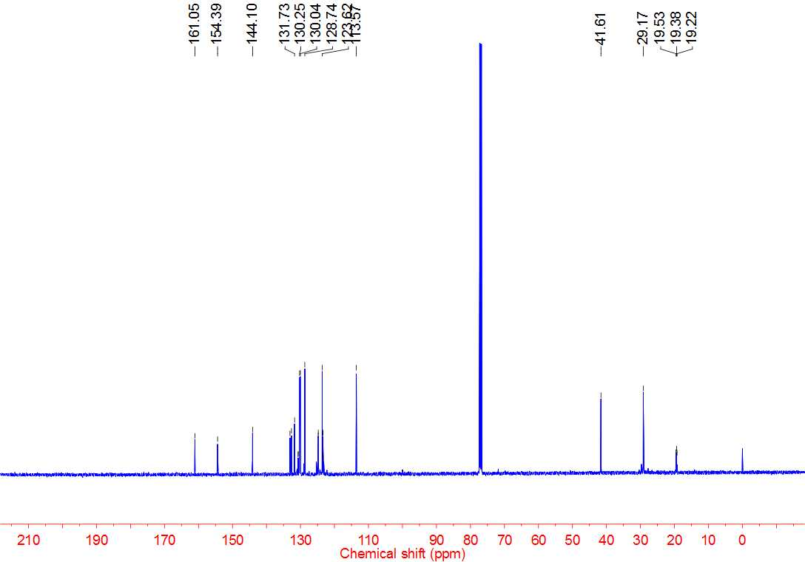



**4ah 19F NMR**

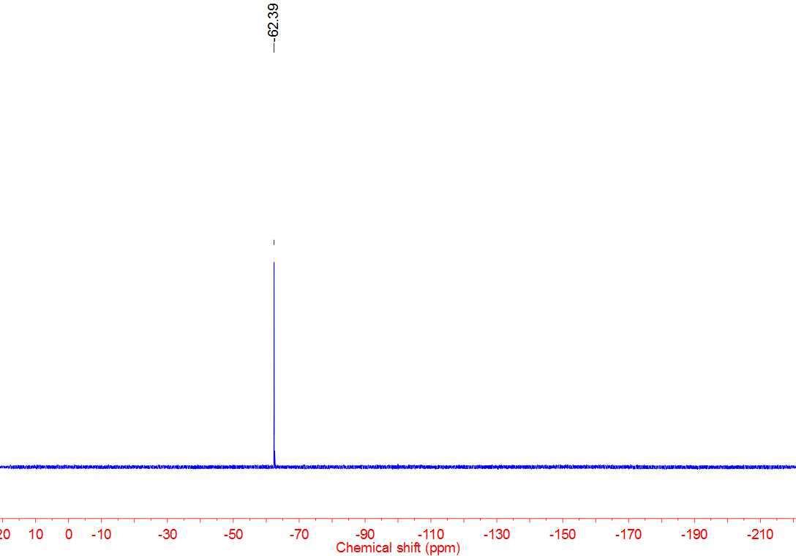



**4ai 1H NMR**

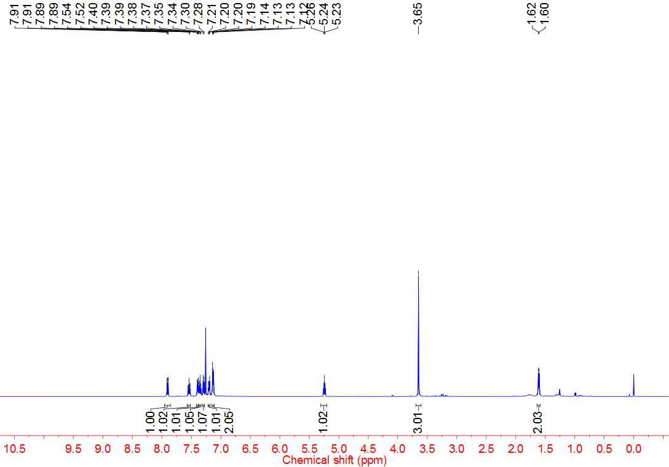



**4ai 13C NMR**

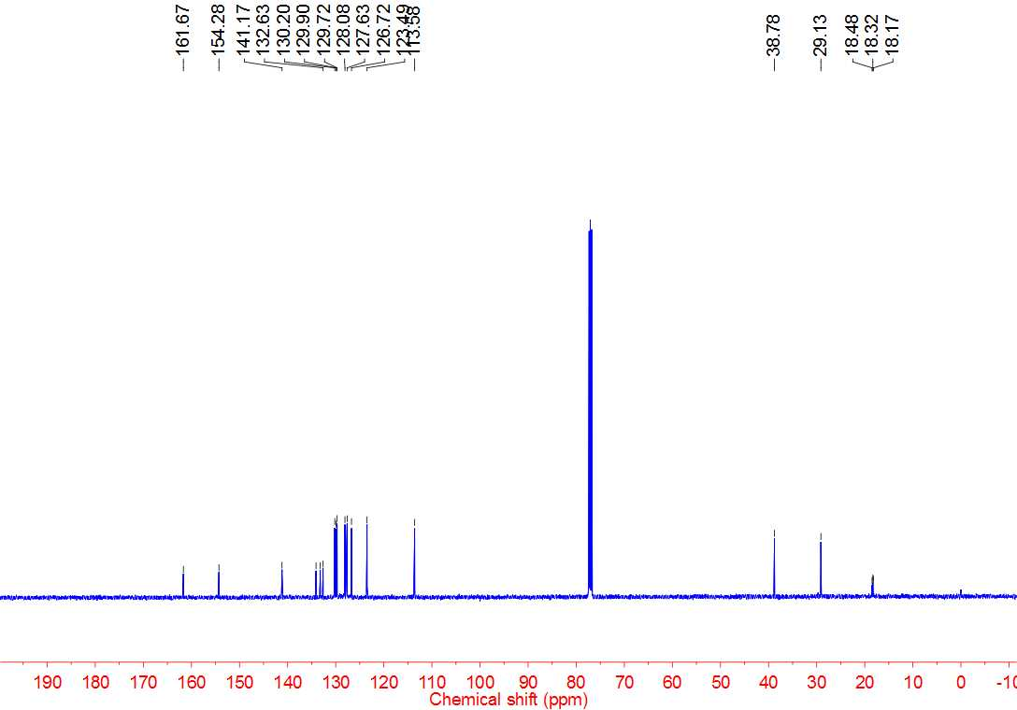



**4aj 1H NMR**

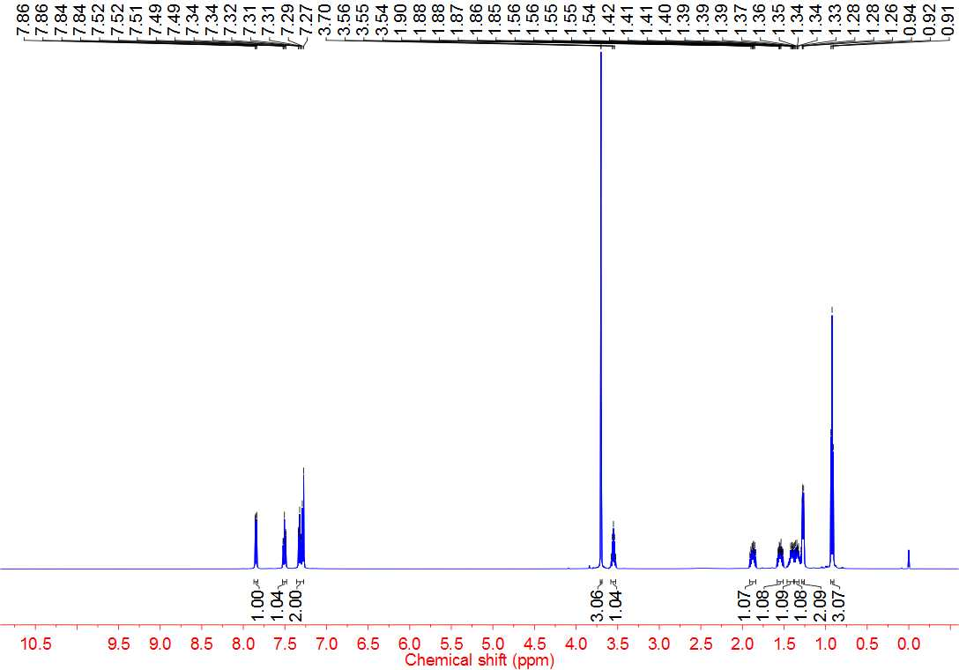



**4aj 13C NMR**

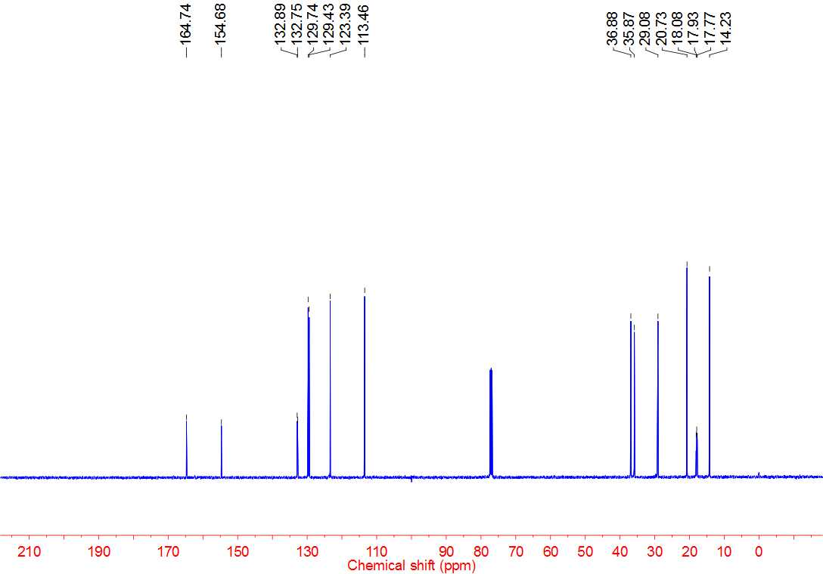



**4ak 1H NMR**

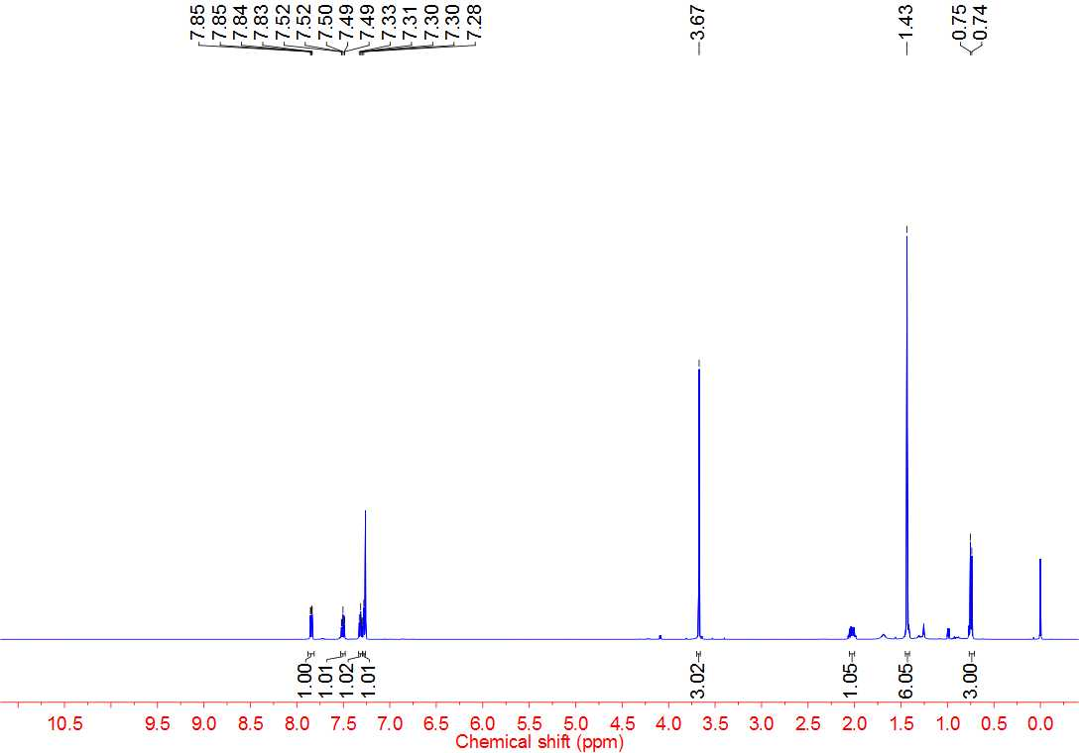



**4ak 13C NMR**

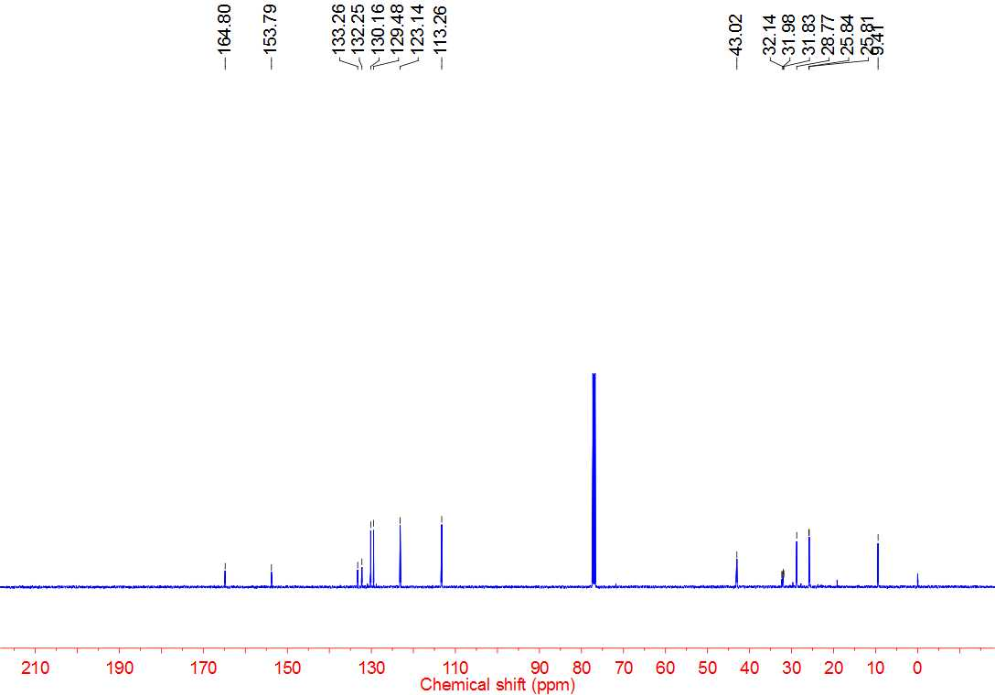



**4al 1H NMR**

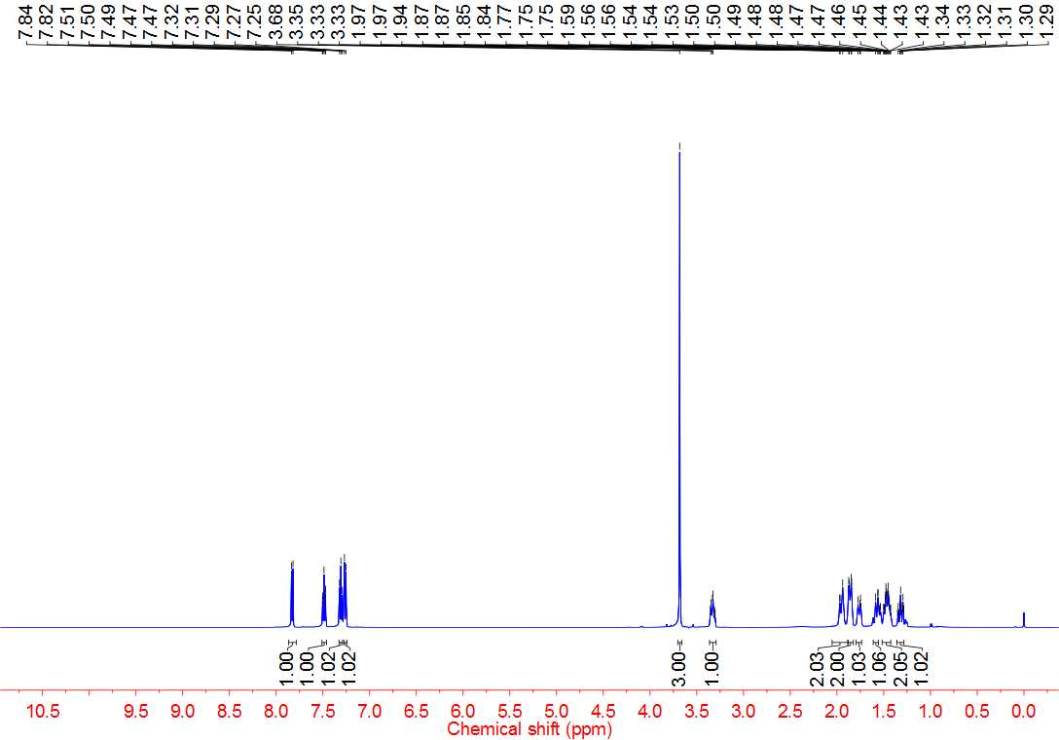



**4al 13C NMR**

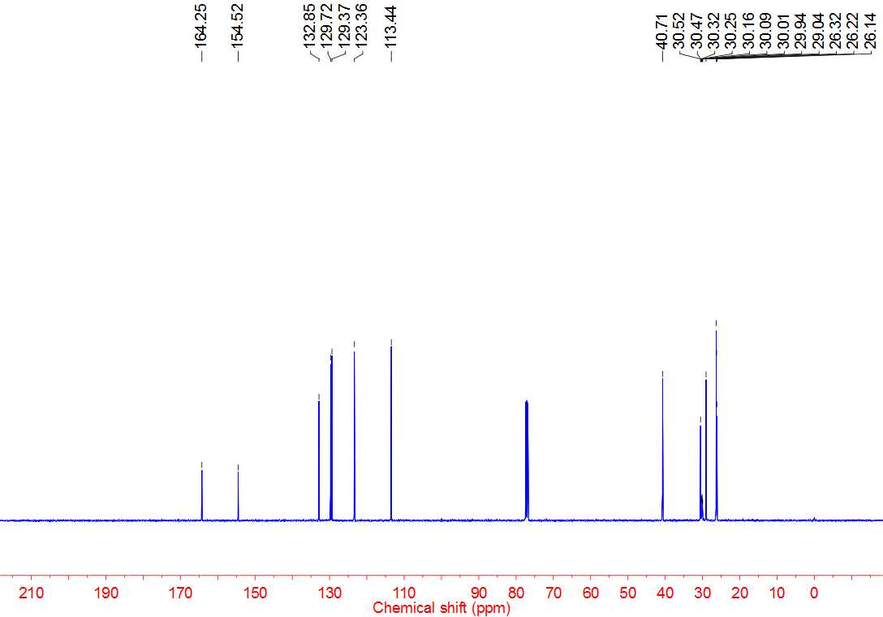



**4am 1H NMR**

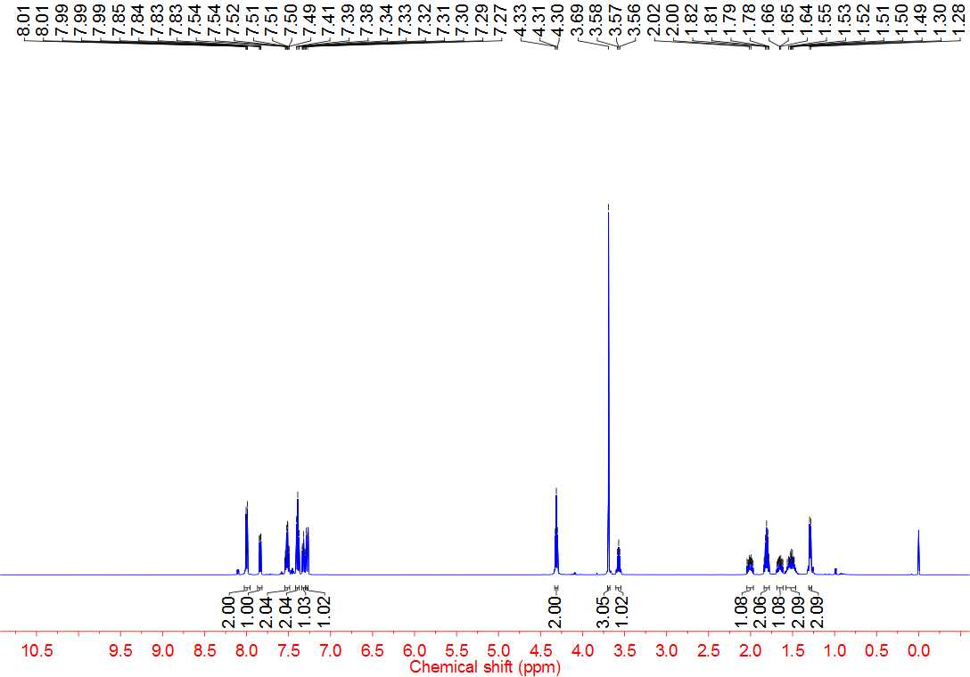



**4am 13C NMR**

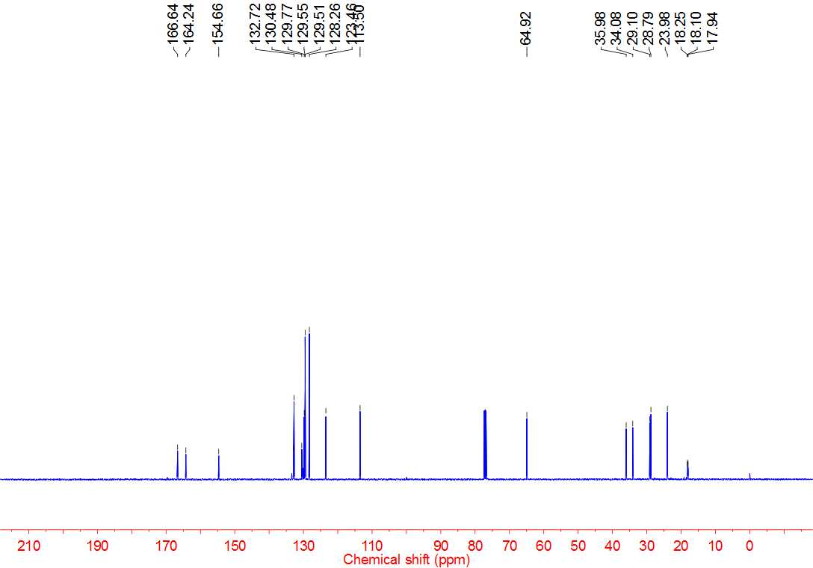



**4an 1H NMR**

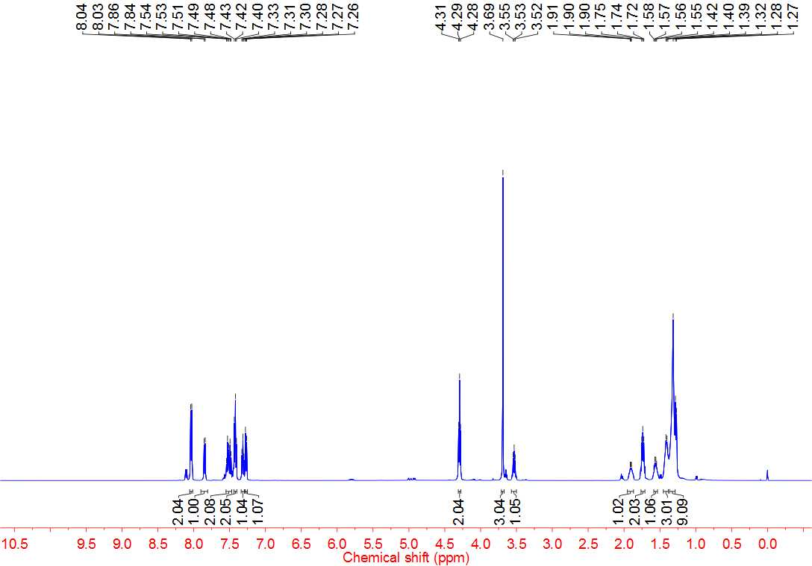



**4an 13C NMR**

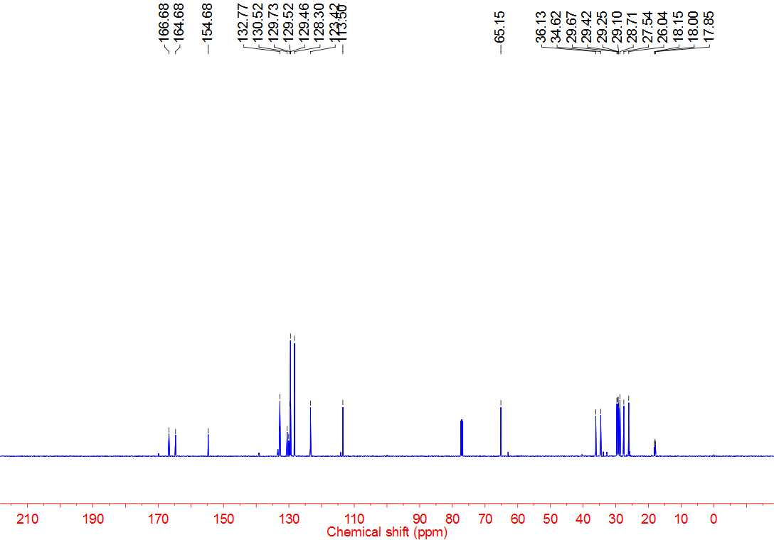



**4ao 1H NMR**

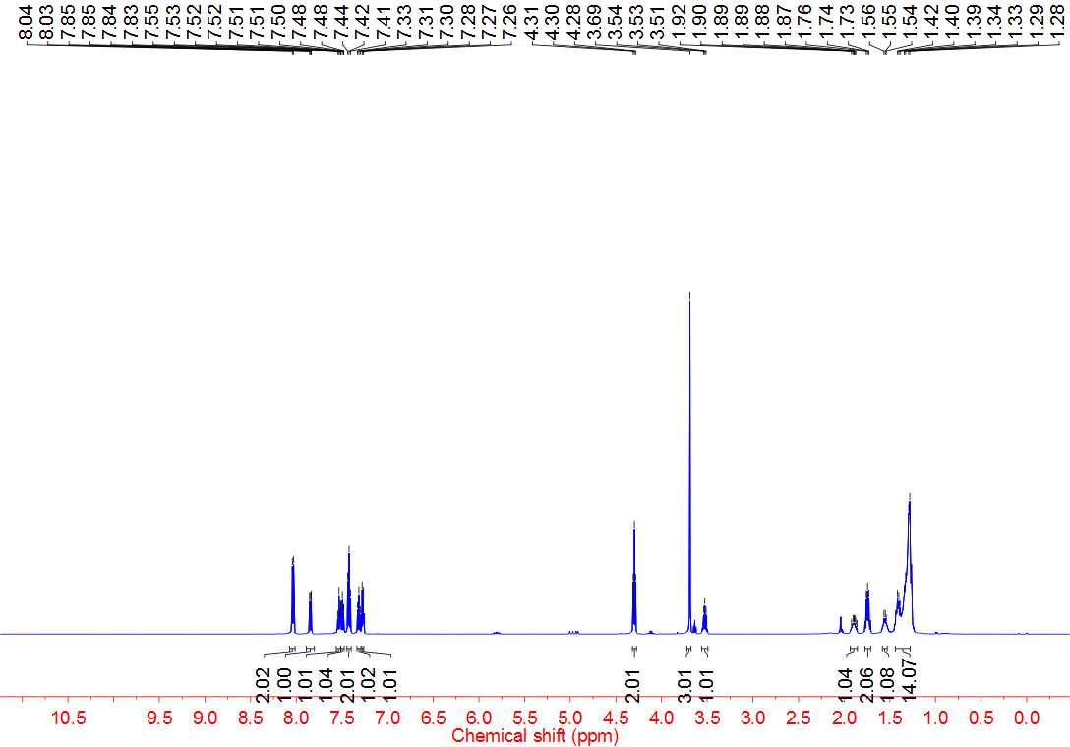



**4ao 13C NMR**

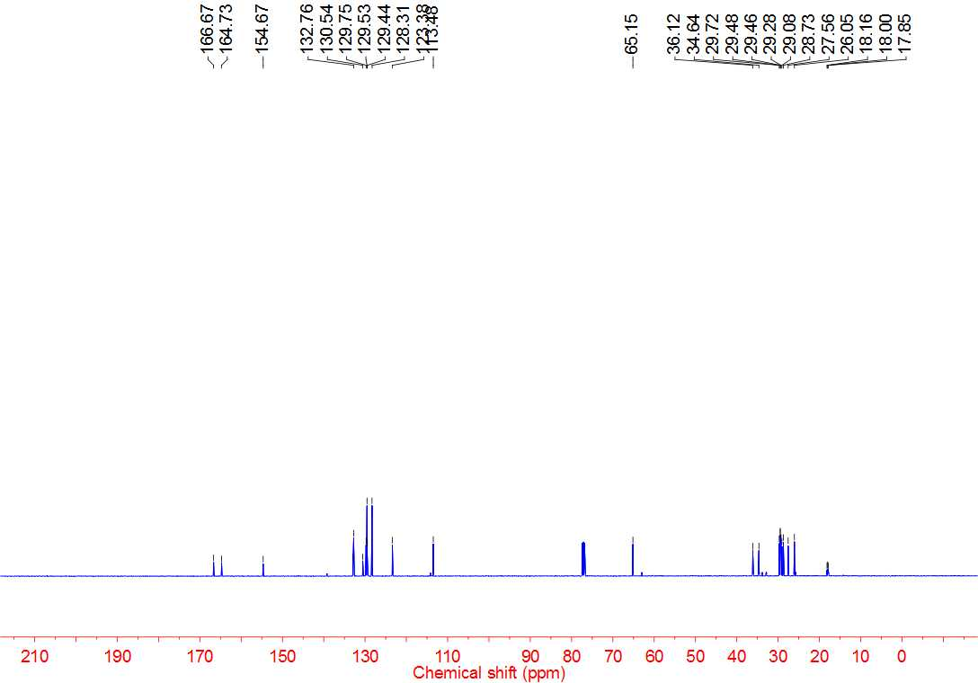



**4ap 1H NMR**

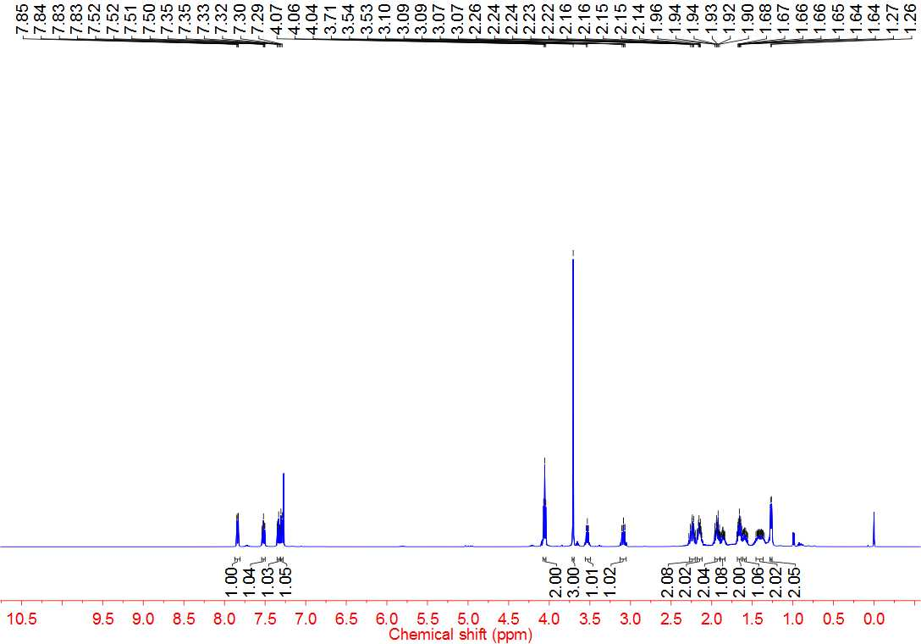



**4ap 13C NMR**

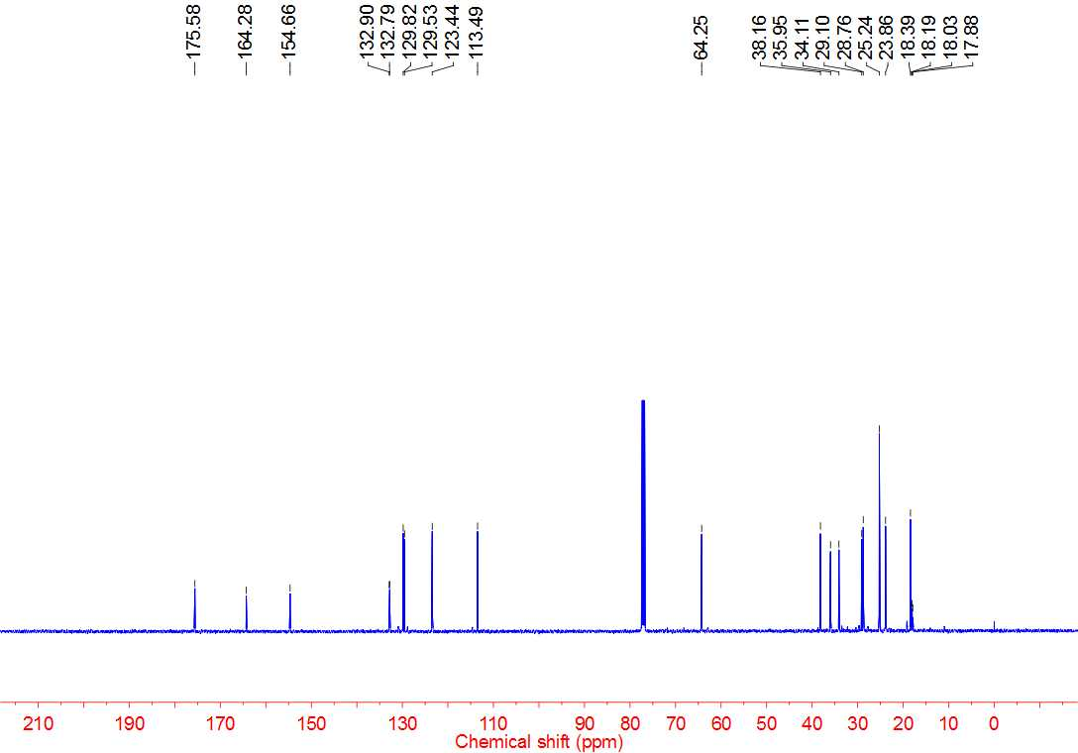



**4aq 1H NMR**

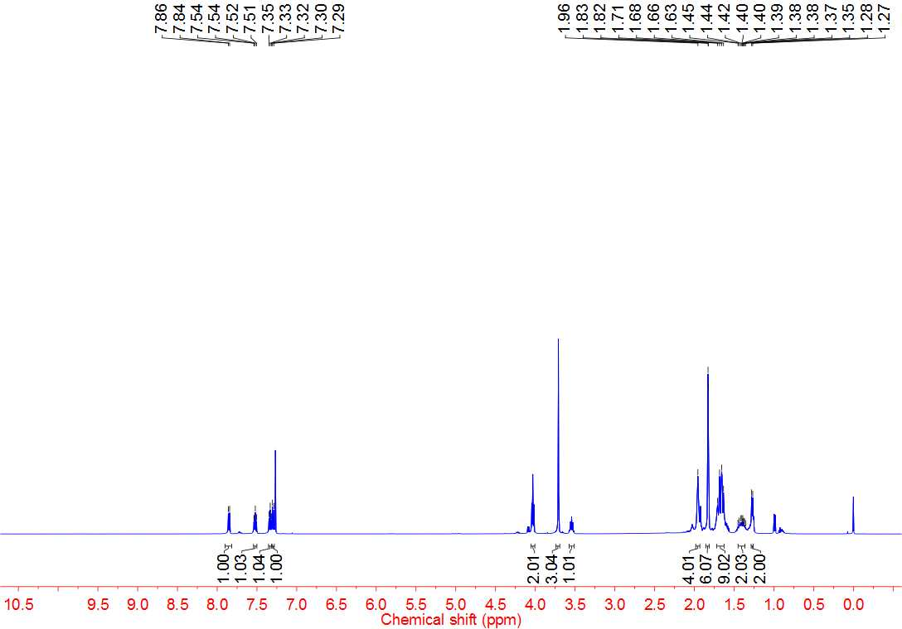



**4aq 13C NMR**

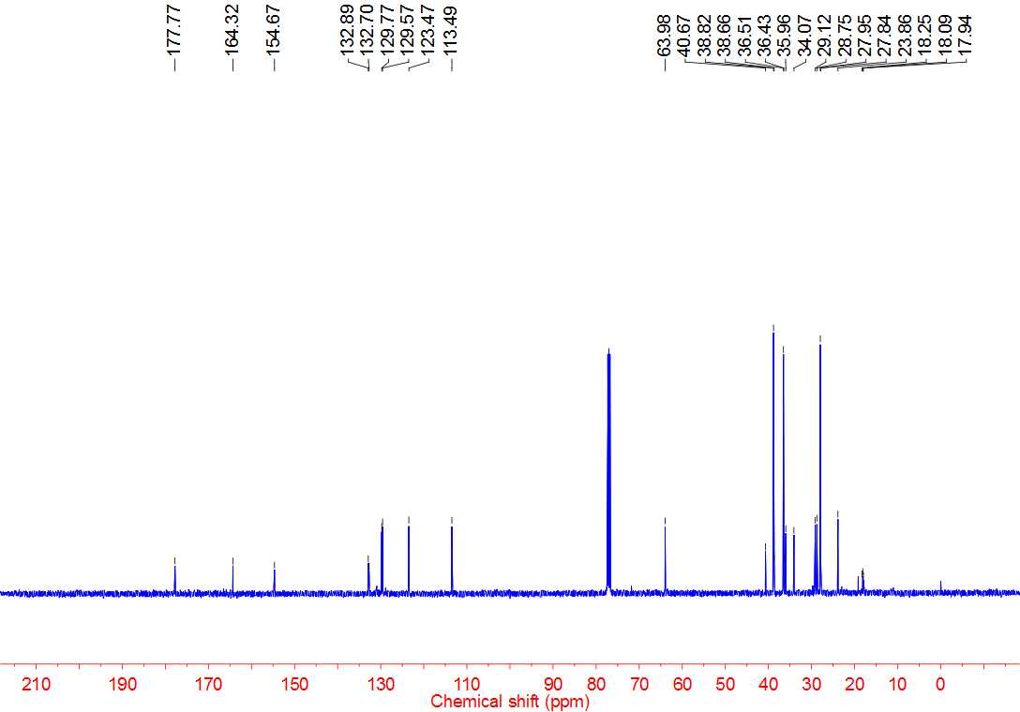



**4ar 1H NMR**

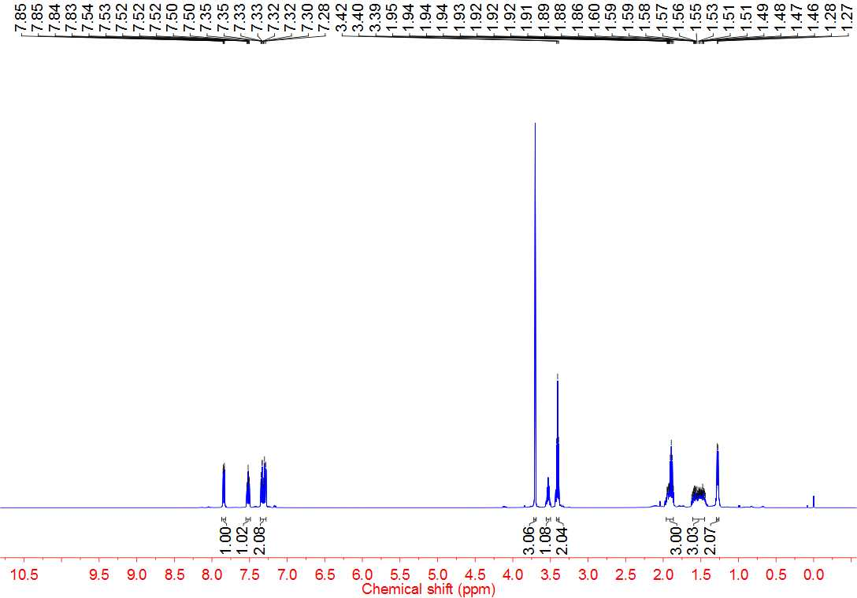



**4ar 13C NMR**

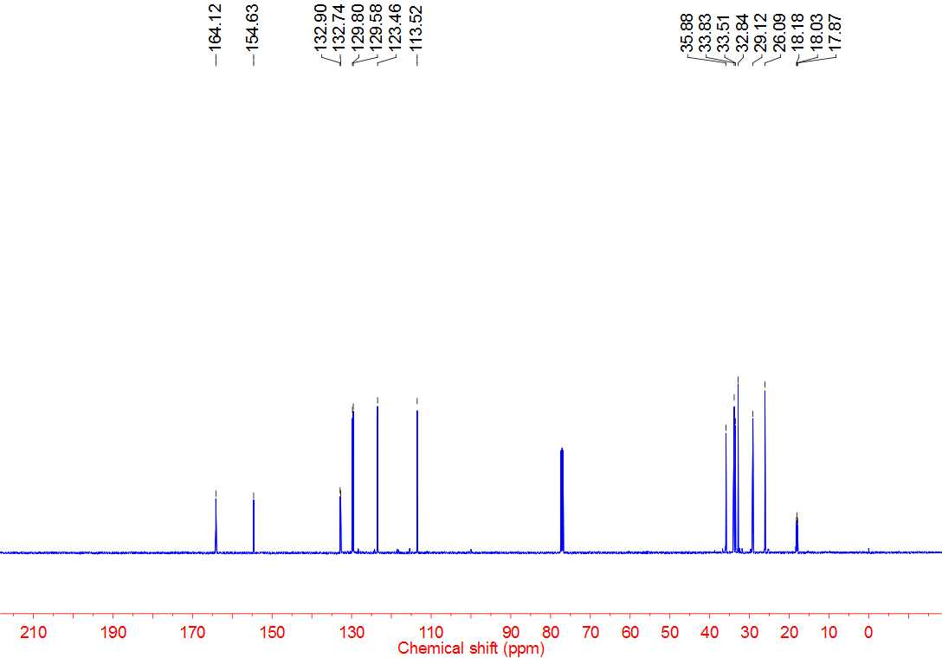



**4as 1H NMR**

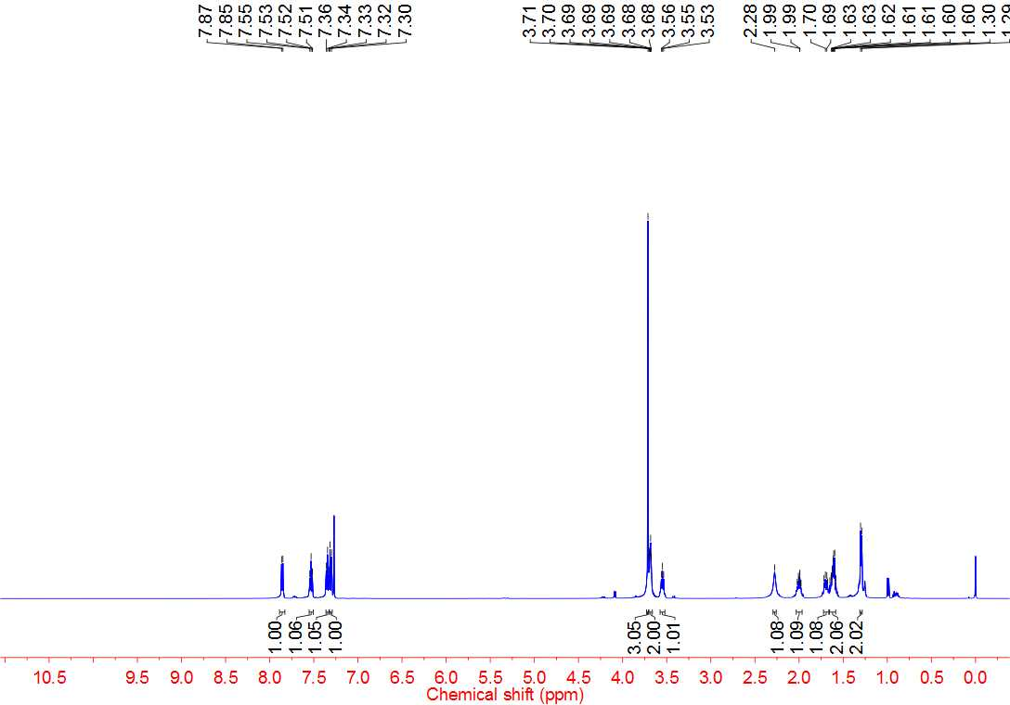



**4as 13C NMR**

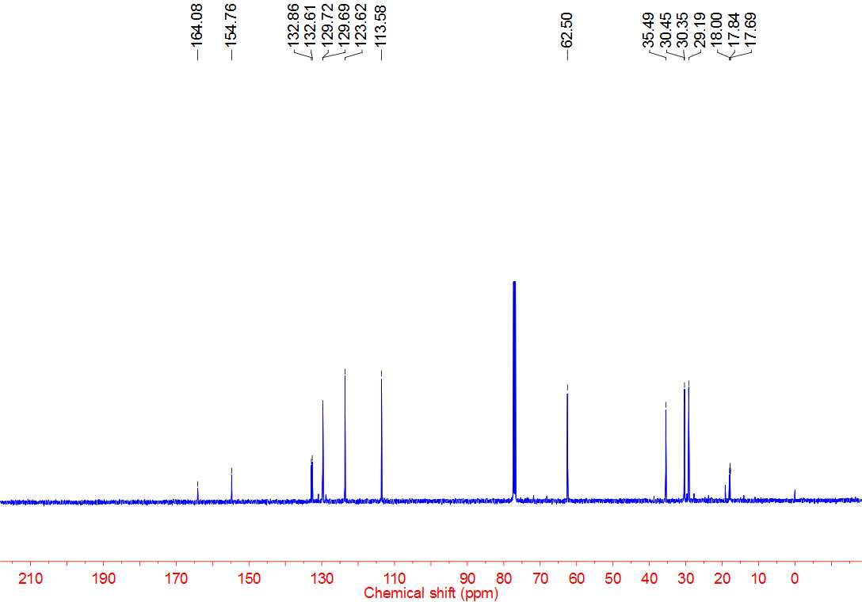



**4at 1H NMR**

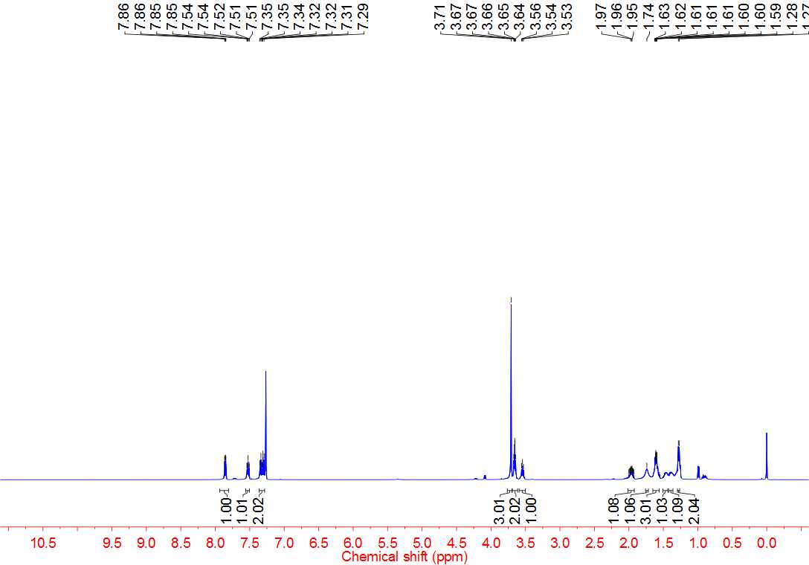



**4at 13C NMR**

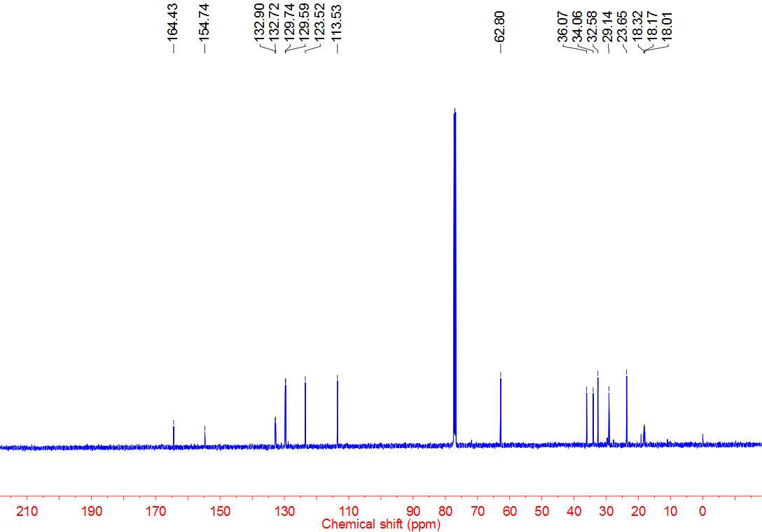



**4au 1H NMR**

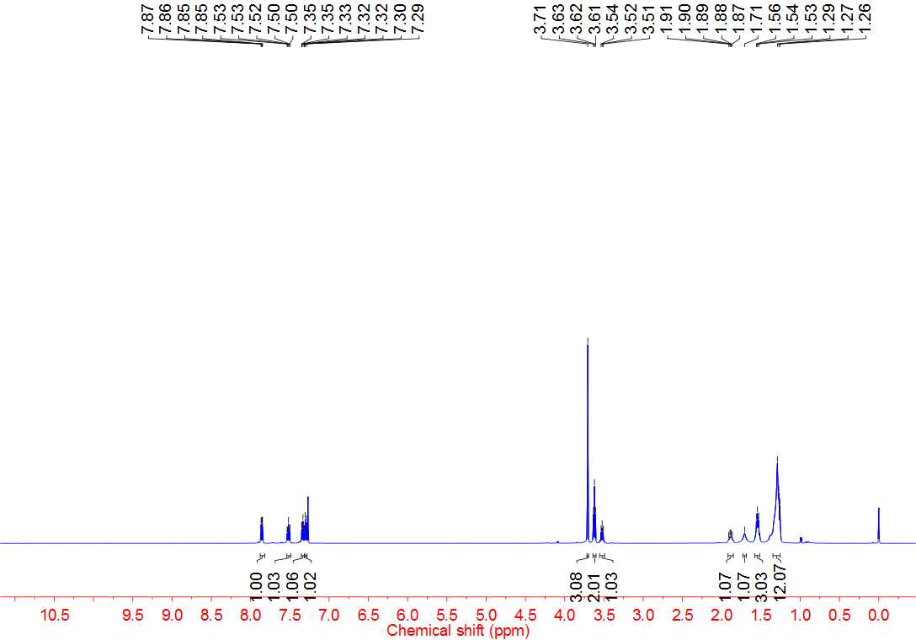



**4au 13C NMR**

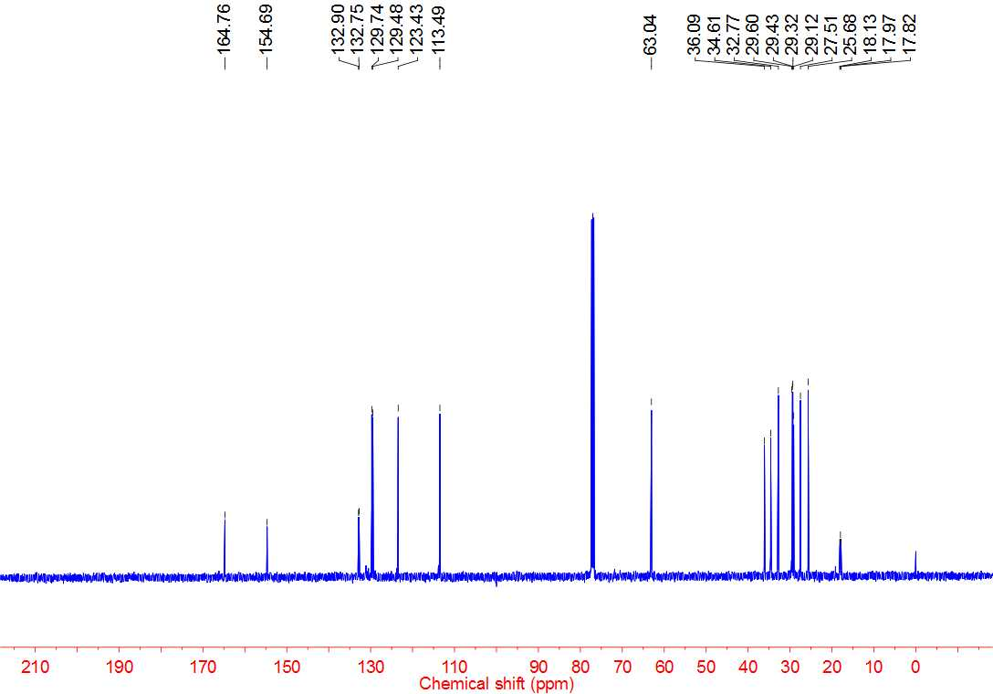



**4av 1H NMR**

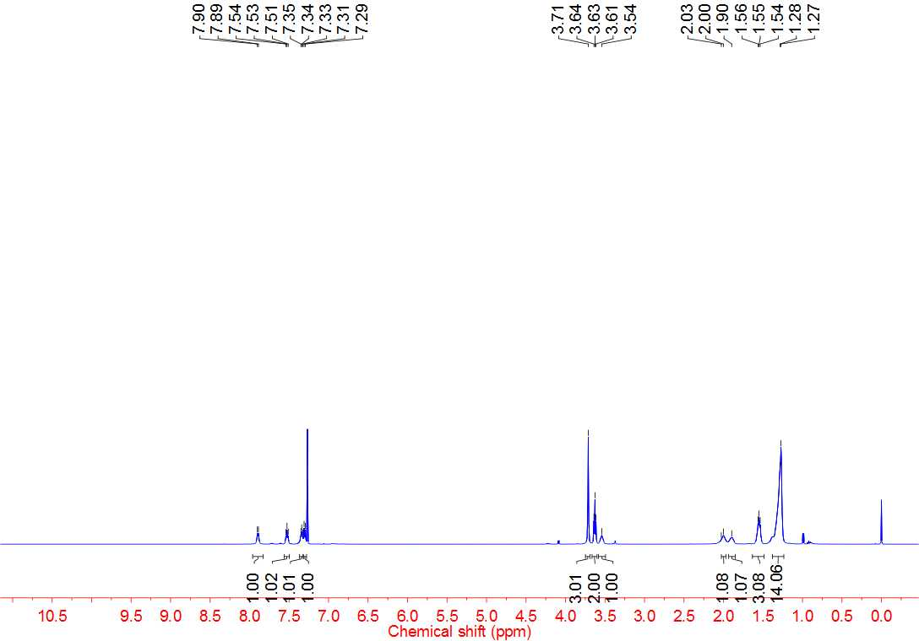



**4av 13C NMR**

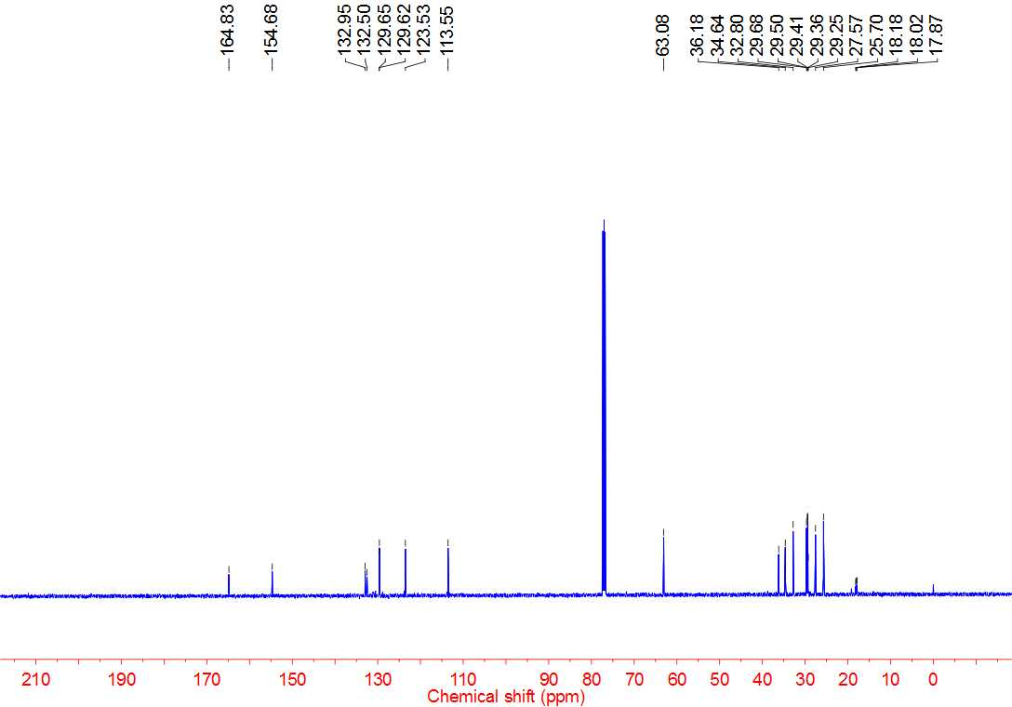



**4bb 1H NMR**

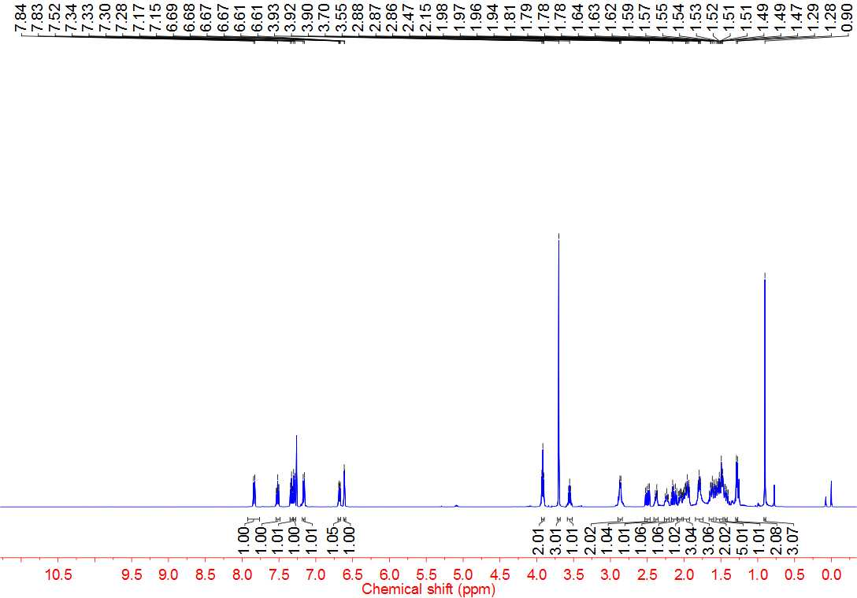



**4bb 13C NMR**

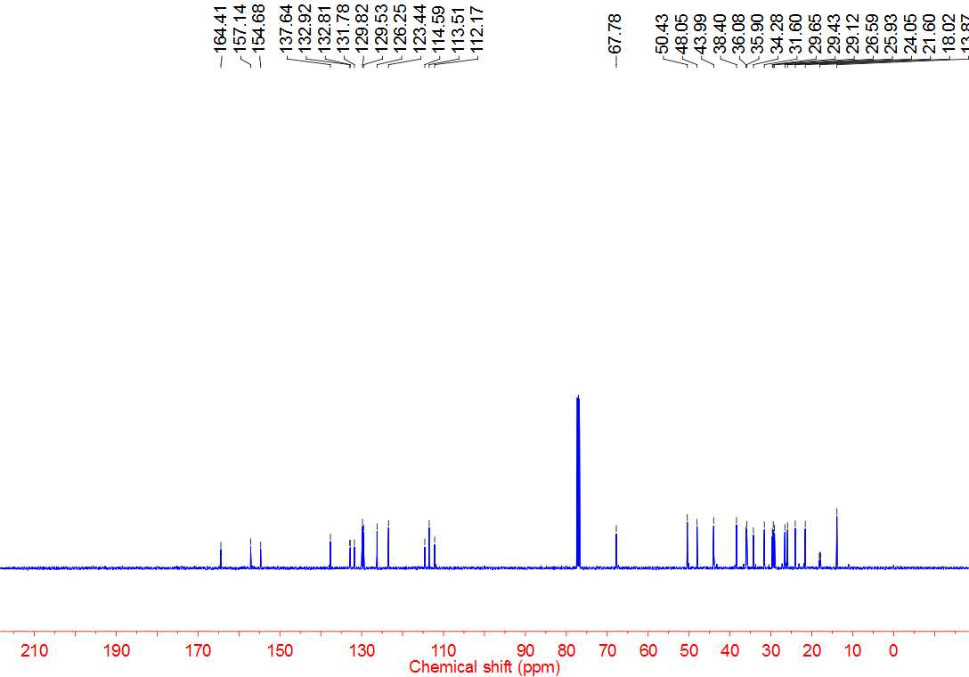



**6a 1H NMR**

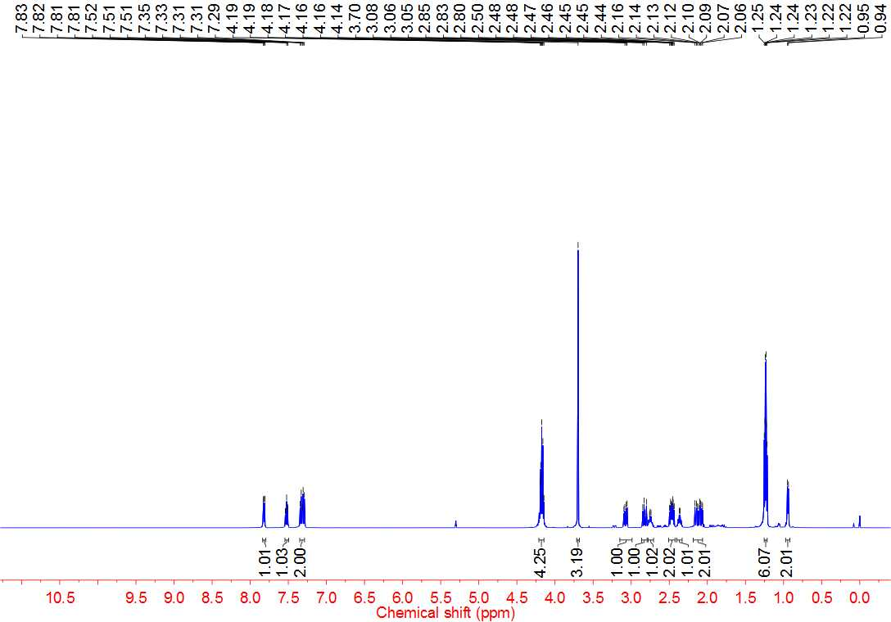



**6a 13C NMR**

