Supplementary explorative analyses

Implicit bias
Given the initially low BIAT scores, a between-factor for low and high initial scores resulting from a median split was calculated. A Repeated Measures ANOVA with the within-factor group (sensorimotor, conventional and control) and between-factors time (pre, post) and initial bias (less preference for trans men, less preference for biological men) was performed. The initial bias factor showed a significant interaction with time (F(1, 108) = 34, p < 0.001, η = 0.08; see Supplementary Figure 1), but not with group (F(2, 108) = 0.18, p = 0.838, η = 0). Holm-corrected post hoc comparisons showed a significant difference between pre and post for low (p = 0.001) and high (p < 0.001) initial bias.
In order to assess the potential effect of age and embodiment in the BIAT scores, a repeated measures ANOVA for the museum sample (excluding the control group) with the within-factor time (pre, post) and between-factor group (sensorimotor, conventional) showed a main effect of time (F(1, 67) = 4.8, p = 0.03, η = 0.02)), but not of group (F(1, 67) = 0.02, p = 0.9, η = 0)), nor of the interaction of time and group (F(1, 67) = 0.88, p = 0.887, η = 0)). There was no effect of time when controlling for participant's age (F(1, 67) = 1.8, p = 0.18, η = 0.01)) nor embodiment scores (F(1, 67) = 3.7, p = 0.06, η = 0.08)) as covariates. Repeating the above procedure while excluding participants under the median of the initial BIAT score showed no main effect of time (F(1, 33) = 0.01, p = 0.9, η = 0)), group (F(1, 33) = 0.03, p = 0.86, η = 0)), nor of the interaction of time and group (F(1, 33) = 0.3, p = 0.59, η = 0)). There was no effect of time when controlling for age (F(1, 33) = 0.06, p = 0.81, η = 0)) nor embodiment (F(1, 33) = 0.27, p = 0.61, η = 0)) as covariates.
Explicit bias
Given the generally low initial questionnaire scores, an aligned ranks transformation ANOVA for non-parametric factorial analyses was performed comparing the difference between pre and post questionnaire scores for the between-factors group (sensorimotor, conventional, control) and initial bias (low and high, respectively below and above the median of the initial questionnaire scores). There was an interaction of group and initial bias (F(2, 108) = 6.38, p < 0.01; see Supplementary Figure 2). Holm-corrected Wilcoxon rank-sum comparisons showed a significant difference only for low initial bias between the conventional group and the control group (see Supplementary Table 1).
Supplementary tables and figures

Supplementary Table 1:
Wilcoxon rank-sum comparisons between experimental groups of the questionnaire scores for participants with low and high initial bias respectively.
initial bias | comparison | W | p
low | sensorimotor - conventional | 200 | 0.71
low | sensorimotor - control | 175.5 | 0.44
low | conventional - control | 42.5 | 0.04
high | sensorimotor - conventional | 70.5 | 0.44
high | sensorimotor - control | 247.5 | 0.75
high | conventional - control | 171 | 0.44

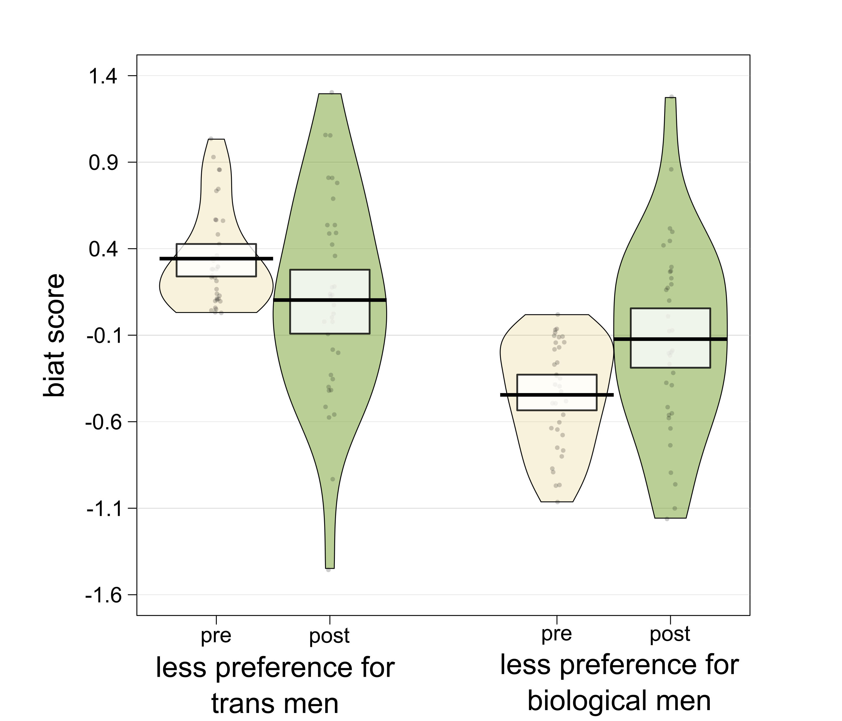
Supplementary Figure 1: Raw values, central tendencies and distribution of the BIAT score separated by initial bias (low, high) and the respective time (pre, post).
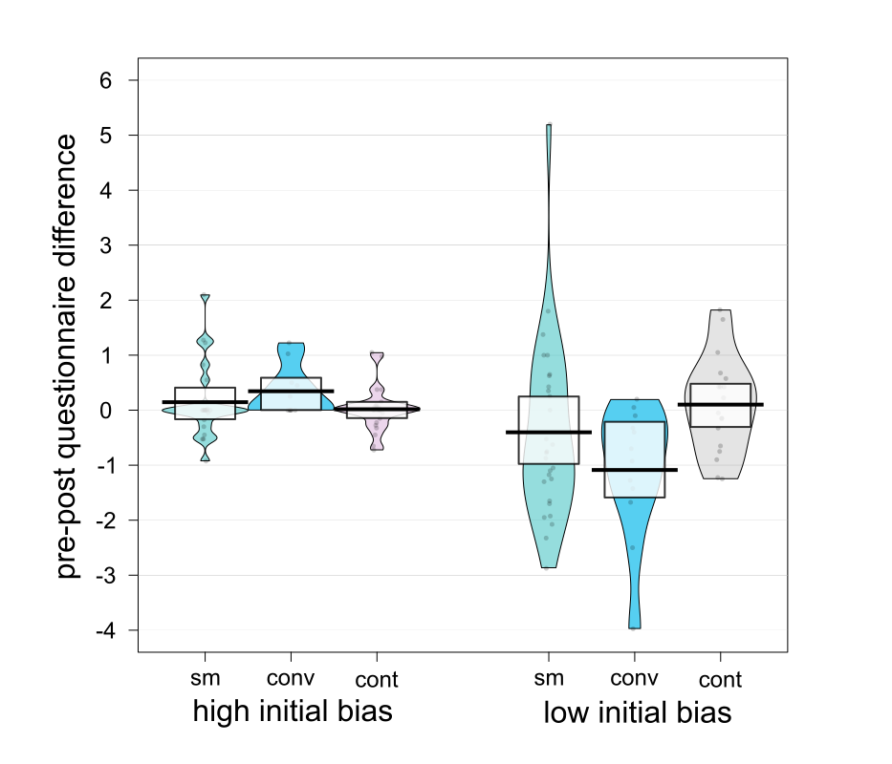
Supplementary Figure 2: Individual values, central tendencies and distribution of the pre-post difference of the questionnaire score separated by initial bias (low, high) and the respective group (sm = sensorimotor, conv = conventional, cont = control).

