Supplementary Figures

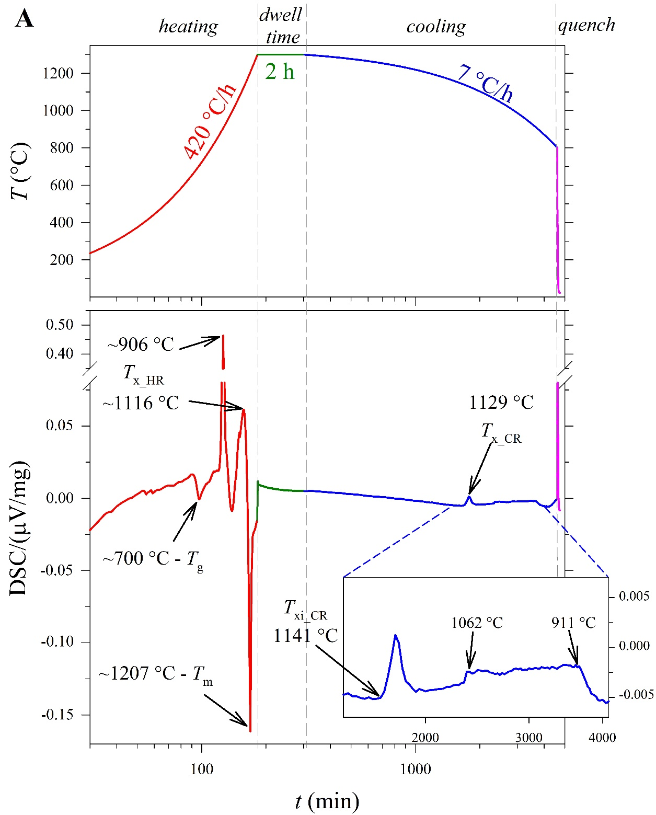

Supplementary Figure 1(A).

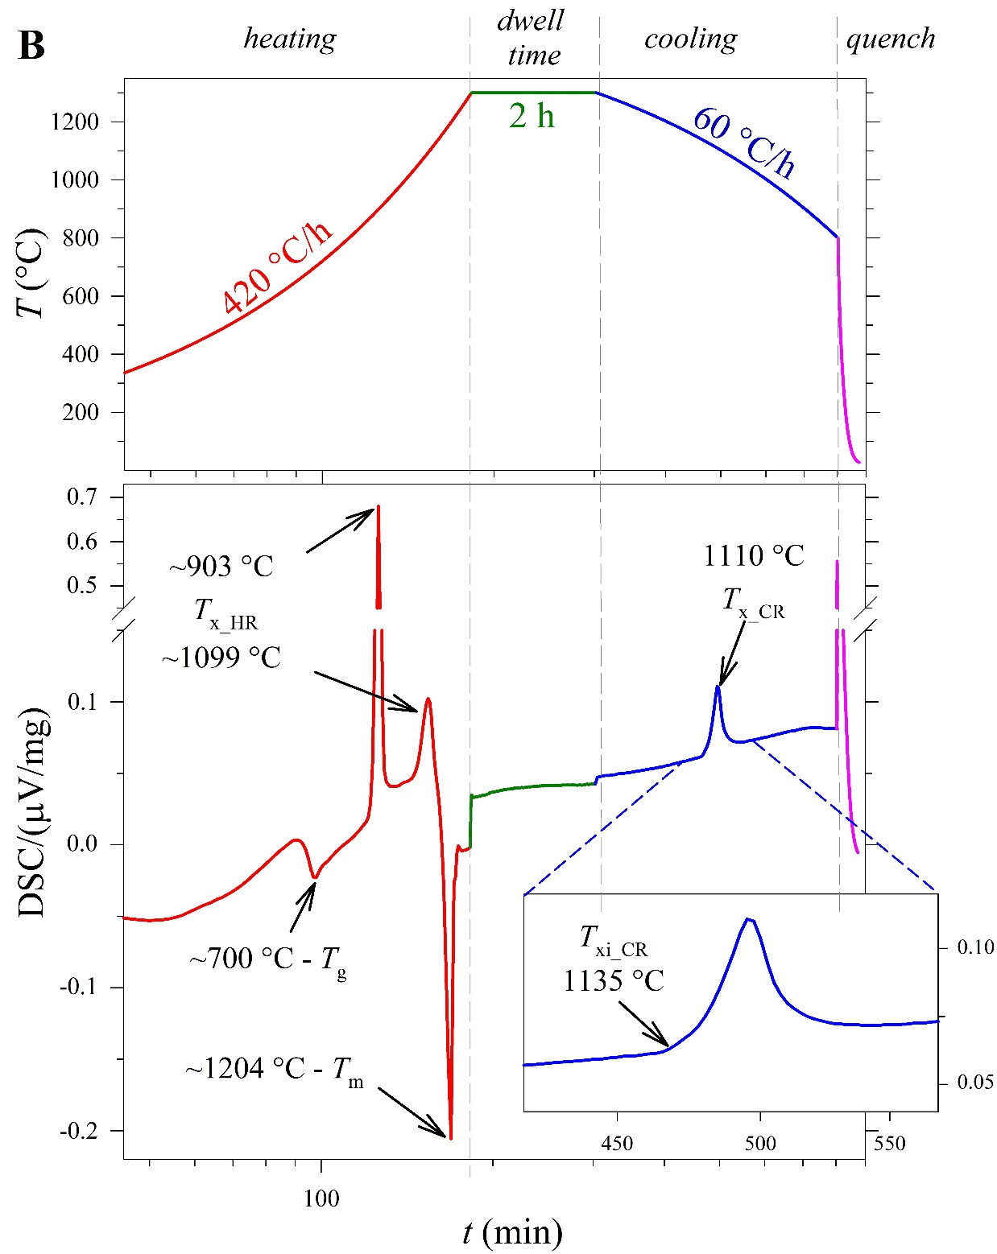

Supplementary Figure 1(B).

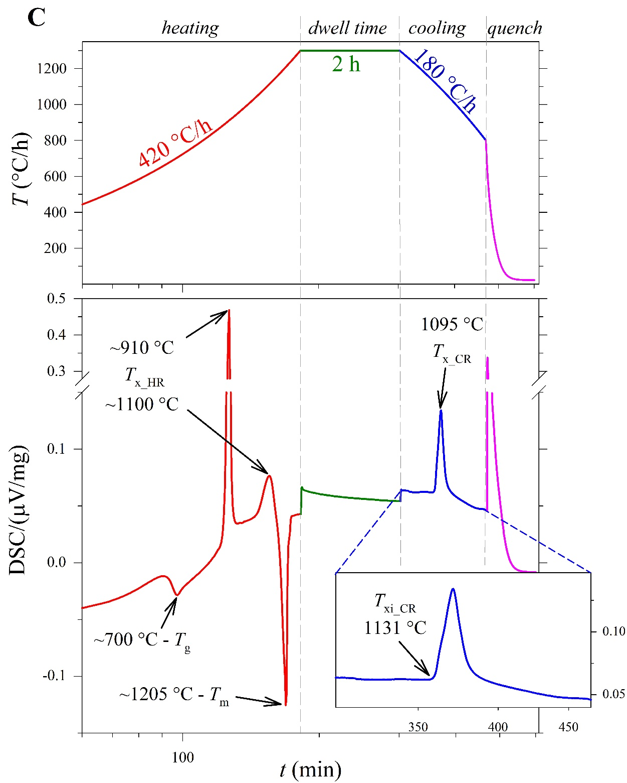

Supplementary Figure 1(C).

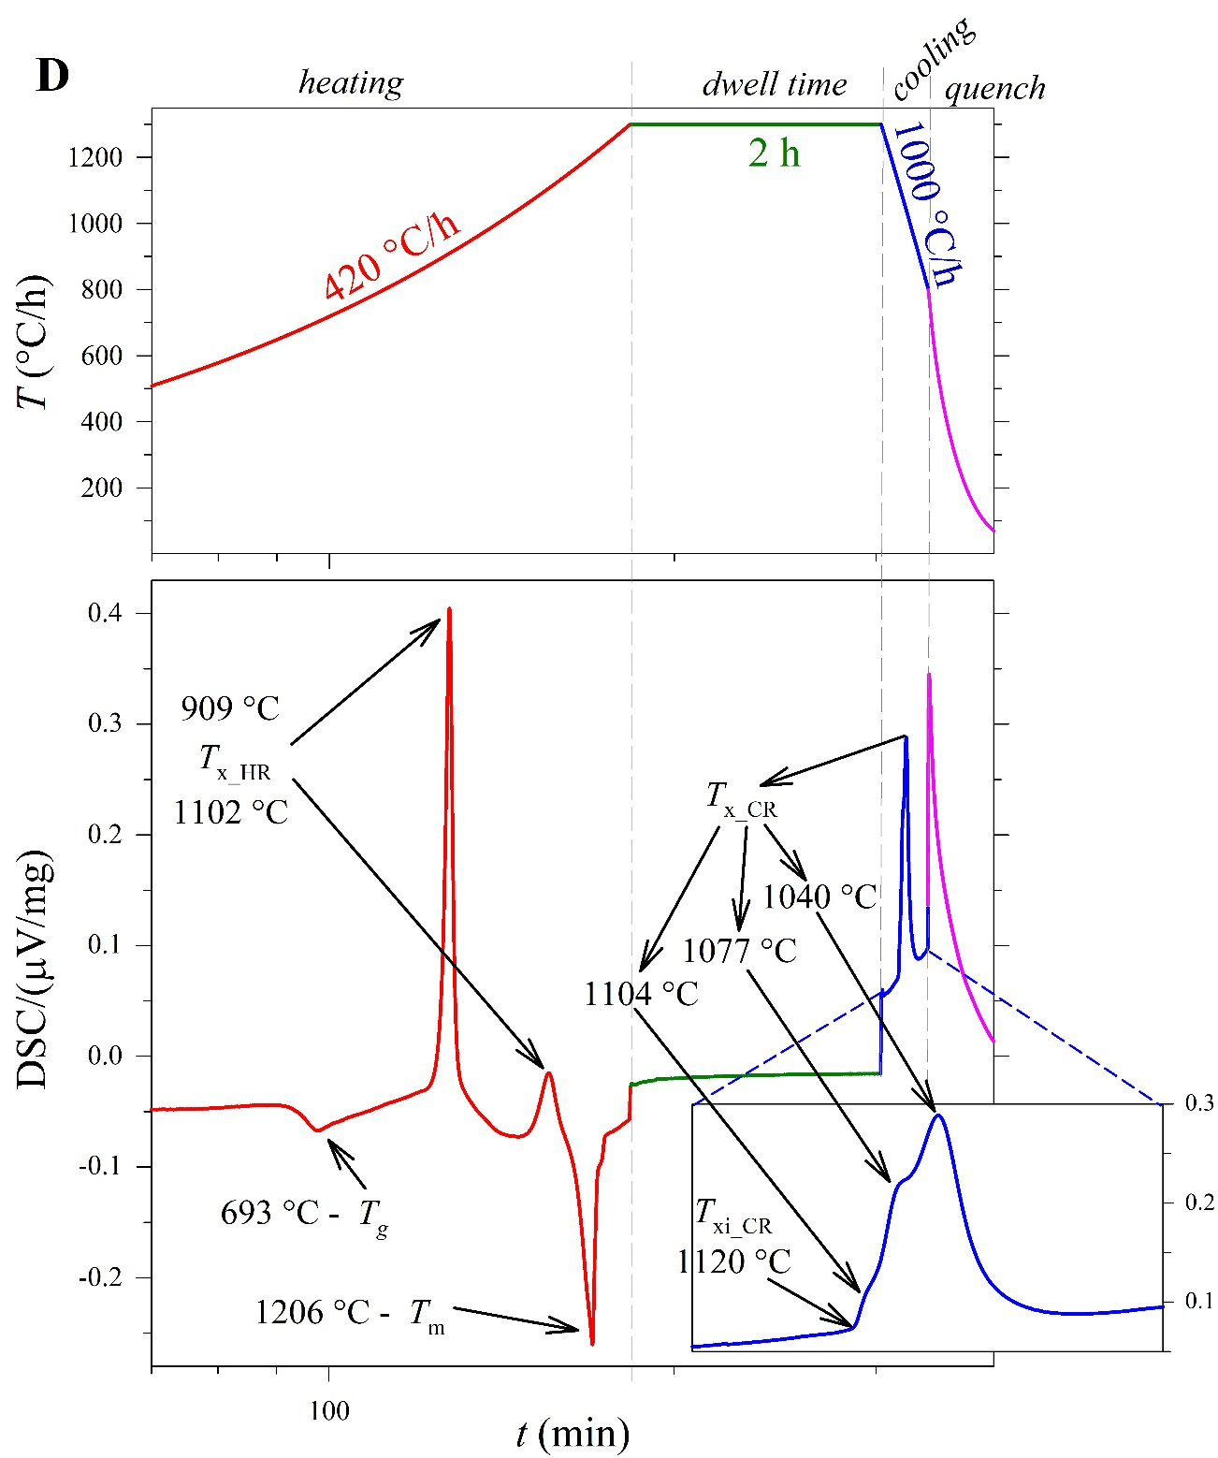

Supplementary Figure 1(D).

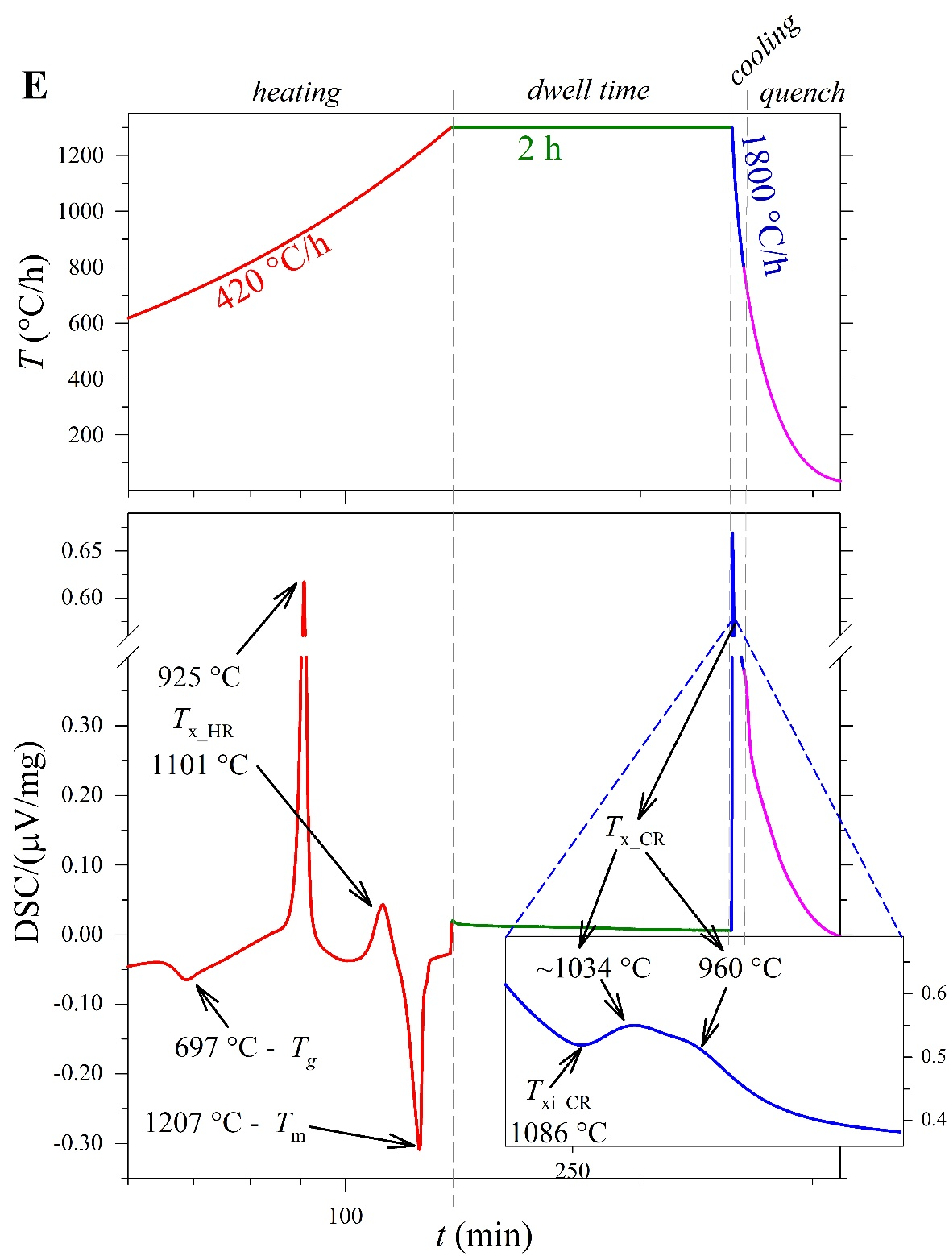

Supplementary Figure 1(E).

Supplementary Figures 1(A-E). Thermal paths (top) and DSC spectra (bottom) for a MORB melt cooled at rates of 7 (A), 60 (B), 180 (C), 1000 (D), and 1800 (E) °C/h. DSC spectra relate the DSC signal based on the differential heat flux (DSC/(µV/mg)) and T (°C). Red curves; heating treatment from ambient temperature to 1300 °C at rate of 420 °C/h. Green curves; dwell time of 2 h at 1300 °C. Blue curves; cooling rate conditions. Pink curves; quench interval from 800 °C down to ambient temperature. Insert; zoom-in of the cooling path. Glass transition temperature (T_{g}), crystallization temperature (T_{x_HR}), and melting temperature (T_{m}) were measured by in-situ DSC spectra acquired on heating. T_{x} was also measured along the cooling path of the melt (T_{x_CR}). The temperature of the onset of crystallization (T_{xi}) has been computed at 10% of the maximum intensity of the first crystallization peaks.

Table 1S. Average compositions in wt.% determined by EPMA-WDS.
ΔT/Δt (°C/h) |  | 7 | 60 | 180 | 1000 | 1800
# analytical point |  | 20 | 16 | 20 | 20 | 20
cpx | SiO₂ | 43.9 (1.0) | 43.4 (0.5) | 45.4 (2.6) | 47.7 (0.5) | 47.0 (0.9)
 | TiO₂ | 1.0 (0.2) | 0.9 (0.1) | 1.0 (0.1) | 1.0 (0.1) | 0.9 (0.1)
 | Al₂O₃ | 10.4 (0.3) | 11.0 (0.2) | 12.2 (1.8) | 15.5 (0.5) | 14.7 (1.2)
 | FeO | 10.2 (1.0) | 10.2 (0.6) | 10.1 (1.5) | 9.7 (0.5) | 10.2 (0.9)
 | Fe₂O₃ | 11.4 (1.1) | 11.3 (0.7) | 11.2 (1.7) | 10.8 (0.5) | 11.4 (1.0)
 | MgO | 13.1 (0.5) | 13.1 (0.7) | 12.1 (2.1) | 9.4 (0.6) | 10.2 (1.5)
 | CaO | 20.1 (0.7) | 19.4 (0.9) | 17.0 (1.7) | 13.5 (0.6) | 14.0 (1.5)
 | Na₂O | 0.4 (0.0) | 0.5 (0.0) | 0.9 (0.6) | 1.9 (0.2) | 1.6 (0.4)
 | total (FeO) | 99.2 (0.6) | 98.5 (0.5) | 98.9 (0.5) | 98.9 (0.4) | 98.9 (0.6)
 | total (Fe₂O₃) | 100.3 (0.6) | 99.6 (0.5) | 100.0 (0.5) | 100.0 (0.4) | 100.0 (0.6)
# analytical point |  | 20 | 14 | 6 | 9 | -
mel | SiO₂ | 25.9 (3.4) | 29.7 (4.0) | 33.6 (4.7) | 39.1 (2.7) | -
 | TiO₂ | 1.5 (0.1) | 1.5 (0.2) | 1.4 (0.2) | 1.2 (0.2)
 | Al₂O₃ | 16.2 (1.1) | 15.0 (0.4) | 12.8 (0.5) | 14.4 (0.5)
 | FeO | 26.6 (2.2) | 23.4 (2.9) | 22.0 (2.8) | 18.1 (2.0)
 | Fe₂O₃ | 29.6 (2.4) | 26.0 (3.2) | 24.4 (3.1) | 20.1 (2.2)
 | Cr₂O₃ | 0.1 (0.1) | 0.3 (0.2) | 0.2 (0.1) | 0.1 (0.0)
 | MgO | 15.4 (1.6) | 15.0 (1.3) | 14.2 (1.8) | 12.7 (0.9)
 | CaO | 11.1 (0.6) | 11.1 (0.5) | 11.0 (0.4) | 11.1 (0.5)
 | Na₂O | 0.7 (0.3) | 0.9 (0.3) | 1.1 (0.4) | 1.6 (0.2)
 | total (FeO) | 97.5 (0.5) | 96.9 (0.9) | 96.4 (0.4) | 98.5 (0.7)
 | total (Fe₂O₃) | 100.5 (0.6) | 99.5 (1.1) | 98.9 (0.5) | 100.5 (0.6)
# analytical point |  | 20 | 18 | 5 | - | 1
sp | SiO₂ | 0.3 (0.8) | 1.6 (3.5) | 2.8 (2.6) | - | 2.6
 | TiO₂ | 0.7 (0.1) | 0.6 (0.1) | 0.6 (0.1) |  | 0.4
 | Al₂O₃ | 18.1 (4.0) | 15.4 (0.8) | 14.3 (0.6) |  | 14.2
 | FeO | 55.8 (4.4) | 56.3 (2.9) | 58.6 (1.0) |  | 53.2
 | Fe₂O₃ | 62.0 (4.9) | 62.5 (3.2) | 65.1 (1.1) |  | 59.1
 | Cr₂O₃ | 1.5 (1.1) | 2.4 (1.4) | 2.2 (1.5) |  | 4.7
 | MgO | 18.9 (0.6) | 17.3 (0.6) | 15.6 (0.8) |  | 17.6
 | CaO | 0.2 (0.1) | 0.3 (0.2) | 0.8 (0.6) |  | 0.7
 | Na₂O | 0.1 (0.1) | 0.2 (0.3) | 0.3 (0.2) |  | 0.2
 | total (FeO) | 95.6 (1.0) | 94.1 (1.4) | 95.2 (1.6) |  | 93.7
 | total (Fe₂O₃) | 101.7 (0.8) | 100.3 (1.3) | 101.7 (1.6) |  | 99.6
# analytical point |  | 20 | 20 | 17 | 20 | 20
glass | SiO₂ | 60.2 (1.2) | 58.8 (1.3) | 55.9 (2.6) | 47.6 (0.5) | 47.9 (0.3)
 | TiO₂ | 1.0 (0.1) | 0.9 (0.1) | 0.8 (0.1) | 1.0 (0.1) | 1.0 (0.1)
 | Al₂O₃ | 20.6 (0.6) | 20.4 (1.0) | 19.2 (1.9) | 15.5 (0.2) | 15.6 (0.2)
 | FeO | 2.9 (0.4) | 3.7 (0.6) | 5.6 (1.9) | 10.2 (0.2) | 10.2 (0.2)
 | Fe₂O₃ | 3.3 (0.5) | 4.1 (0.7) | 6.2 (2.1) | 11.4 (0.2) | 11.3 (0.2)
 | MgO | 2.9 (0.2) | 3.6 (0.7) | 4.6 (1.4) | 9.4 (0.1) | 9.4 (0.2)
 | CaO | 8.4 (0.5) | 8.9 (0.7) | 9.4 (1.6) | 13.1 (0.2)) | 13.1 (0.3)
 | Na₂O | 3.6 (0.2) | 3.3 (0.3) | 3.2 (0.4) | 1.6 (0.1) | 1.4 (0.1)
 | total (FeO) | 99.8 (0.5) | 99.7 (0.5) | 99.0 (0.6) | 98.7 (0.6) | 98.7 (0.4)
 | total (Fe₂O₃) | 100.2 (0.5) | 100.1 (0.5) | 99.6 (0.6) | 99.8 (0.6) | 99.8 (0.4)
Footnotes: the standard deviations are reported in parenthesis and Fe₂O₃ has been computed by FeO*1.111. chemical data was selected by considering oxide totals between 99-101 wt.% for cpx and glass, 98-102 wt.% for mel and 97-103 wt.% for sp. Plg were not detectable because of their small crystal sizes.

