Supplementary Material
In this supplementary material, additional figures of results for both krill species and regions are provided. We also provide details on the analysis of archival tag and hydroacoustic data, and on model parameterization.

Supplementary figures and tables

Supplementary tables

Supplementary Table 1. Summary characteristics of scenarios and sets of Monte Carlo simulations. Scenarios were done for each region i.e., the St. Lawrence Estuary (SLE) and the northwestern Gulf of St. Lawrence (NWG) and both dominant krill species, Thysanoessa spp. (Tr) and Meganyctiphanes norvegica (Mn). Mean net energy gain and their percent change relative to baseline is given for each set of simulations. The effects on mean net energy gain were quantified using Cohen’s d (Cohen 1977). Values of 0.2, 0.5 and 0.8 indicate small, moderate and large effect sizes, respectively (Cohen 1977).

Scenario |  | Feeding depth (m) | Krill density  (g. m⁻³) | Vessel proximity (h) |  | Disturbed dive duration (min) | Mean net energy gain (MJ) | % reduction compared to baseline |  | Cohen’s d value | Cohen’s d effect size
1 Baseline | SLE_Tr | 25–45 | Depth specific – in situ | - |  | - | 1,070 | - |  | - | -
 |  | 75–85 | Depth specific – in situ | - |  | - | 206 | - |  | - | -
 |  | 115–145 | Depth specific – in situ | - |  | - | 345 | - |  | - | -
 | SLE_Mn | 50–70 | Depth specific – in situ | - |  | - | 4,526 | - |  | - | -
 |  | 80–95 | Depth specific – in situ | - |  | - | 1,268 | - |  | - | -
 | NWG_Tr | 25–40 | Depth specific – in situ | - |  | - | 675 | - |  | - | -
 |  | 55–65 | Depth specific – in situ | - |  | - | 430 | - |  | - | -
 |  | 110–130 | Depth specific – in situ | - |  | - | 487 | - |  | - | -
 |  | 145–175 | Depth specific – in situ | - |  | - | 463 | - |  | - | -
 | NWG_Mn | 50–70 | Depth specific – in situ | - |  | - | 2,099 | - |  | - | -
 |  | 80–110 | Depth specific – in situ | - |  | - | 985 | - |  | - | -
 |  | 130–150 | Depth specific – in situ | - |  | - | 887 | - |  | - | -
 |  | 170–190 | Depth specific – in situ | - |  | - | 2,772 | - |  | - | -
2 Reduction in krill density | SLE_Tr | 25–45 | -5% | - |  | - | 800 | -25.2 |  | 0.51 | moderate
 |  |  | -10% | - |  | - | 530 | -50.4 |  | 1.16 | large
 |  |  | -25% | - |  | - | 0 | -100 |  | 2.56 | large
 |  |  | -50% | - |  | - | 0 | -100 |  | 2.57 | large
 |  | 75–85 | -5% |  | - | - | 0 |  | -100 | 2.56 | large
 |  |  | -10% |  | - | - | 0 |  | -100 | 2.56 | large
 |  |  | -25% |  | - | - | 0 |  | -100 | 2.57 | large
 |  |  | -50% |  | - | - | 0 |  | -100 | 2.57 | large
 |  | 115–145 | -5% |  | - | - | 139 |  | -60 | 1.41 | large
 |  |  | -10% |  | - | - | 0 |  | -100 | 2.57 | large
 |  |  | -25% |  | - | - | 0 |  | -100 | 2.55 | large
 |  |  | -50% |  | - | - | 0 |  | -100 | 2.55 | large
 | SLE_Mn | 50–70 | -5% |  | - | - | 4,104 |  | -9.3 | 0.17 | -
 |  |  | -10% |  | - | - | 3,682 |  | -18.6 | 0.37 | small
 |  |  | -25% |  | - | - | 2,416 |  | -46.6 | 1.05 | large
 |  |  | -50% |  | - | - | 305 |  | -93.2 | 2.39 | large
 |  | 80–95 | -5% |  | - | - | 1,011 |  | -20.3 | 0.40 | moderate
 |  |  | -10% |  | - | - | 785 |  | -38 | 0.89 | large
 |  |  | -25% |  | - | - | 0 |  | -100 | 2.56 | large
 |  |  | -50% |  | - | - | 0 |  | -100 | 2.56 | large
 | NWG_Tr | 25–40 | -5% |  | - | - | 423 |  | -37.3 | 0.81 | large
 |  |  | -10% |  | - | - | 172 |  | -74.5 | 1.85 | large
 |  |  | -25% |  | - | - | 0 |  | -100 | 2.55 | large
 |  |  | -50% |  | - | - | 0 |  | -100 | 2.57 | large
 |  | 55–65 | -5% |  | - | - | 206 |  | -52 | 1.21 | large
 |  |  | -10% |  | - | - | 0 |  | -100 | 2.58 | large
 |  |  | -25% |  | - | - | 0 |  | -100 | 2.55 | large
 |  |  | -50% |  | - | - | 0 |  | -100 | 2.58 | large
 |  | 110–130 | -5% |  | - | - | 273 |  | -43.9 | 0.98 | large
 |  |  | -10% |  | - | - | 59 |  | -87.8 | 2.23 | large
 |  |  | -25% |  | - | - | 0 |  | -100 | 2.55 | large
 |  |  | -50% |  | - | - | 0 |  | -100 | 2.55 | large
 |  | 145–175 | -5% |  | - | - | 259 |  | -44 | 0.98 | large
 |  |  | -10% |  | - | - | 55 |  | -88.1 | 2.24 | large
 |  |  | -25% |  | - | - | 0 |  | -100 | 2.57 | large
 |  |  | -50% |  | - | - | 0 |  | -100 | 2.57 | large
 | NWG_Mn | 50–70 | -5% |  | - | - | 1,797 |  | -14.4 | 0.28 | small
 |  |  | -10% |  | - | - | 1,495 |  | -28.7 | 0.60 | moderate
 |  |  | -25% |  | - | - | 589 |  | -71.9 | 1.77 | large
 |  |  | -50% |  | - | - | 0 |  | -100 | 2.56 | large
 |  | 80–110 | -5% |  | - | - | 745 |  | -24.4 | 0.5 | moderate
 |  |  | -10% |  | - | - | 505 |  | -48.7 | 1.11 | large
 |  |  | -25% |  | - | - | 0 |  | -100 | 2.56 | large
 |  |  | -50% |  | - | - | 0 |  | -100 | 2.56 | large
 |  | 130–150 | -5% |  | - | - | 660 |  | -25.6 | 0.52 | moderate
 |  |  | -10% |  | - | - | 434 |  | -51.1 | 1.17 | large
 |  |  | -25% |  | - | - | 0 |  | -100 | 2.56 | large
 |  |  | -50% |  | - | - | 0 |  | -100 | 2.56 | large
 |  | 170–190 | -5% |  | - | - | 2,461 |  | -11.2 | 0.21 | small
 |  |  | -10% |  | - | - | 2,150 |  | -22.4 | 0.45 | moderate
 |  |  | -25% |  | - | - | 1,218 |  | -56.0 | 1.31 | large
 |  |  | -50% |  | - | - | 0 |  | -100 | 2.56 | large
3 Vessel proximity | SLE_Tr | 25–45‡ | Depth specific – in situ | 3 |  | 4-min limit | 1105 | + |  | -0.03 | -
 |  | 75–85‡ | Depth specific – in situ | 3 |  | 4-min limit | 500 | + |  | -0.80 | -
 |  | 115–145‡ | Depth specific – in situ | 3 |  | 4-min limit | 595 | + |  | -0.58 | -
 |  | variable† | Depth specific – in situ | 10 |  | 4-min limit | 1170 | + |  | -0.17 | -
 | SLE_Mn | 50–70‡ | Depth specific – in situ | 3 |  | 4-min limit | 3,521 | -22.2 |  | 0.34 | small
 |  | 80–95‡ | Depth specific – in situ | 3 |  | 4-min limit | 1,251 | -1.3 |  | 0 | -
 |  | variable† | Depth specific – in situ | 10 |  | 4-min limit | 1,169 | -74 |  | 1.8 | large
 | NWG_Tr | 25–40‡ | Depth specific – in situ | 3 |  | 4-min limit | 582 | -13.7 |  | 0.19 | -
 |  | 55–65‡ | Depth specific – in situ | 3 |  | 4-min limit | 408 | -5.1 |  | 0.08 | -
 |  | 110–130‡ | Depth specific – in situ | 3 |  | 4-min limit | 449 | -7.8 |  | 0.09 | -
 |  | 145–175‡ | Depth specific – in situ | 3 |  | 4-min limit | 432 | -11.3 |  | 0.09 | -
 |  | variable† | Depth specific – in situ | 10 |  | 4-min limit | 355 | -47.4 |  | 1.07 | large
 | NWG_Mn | 50–70‡ | Depth specific – in situ | 3 |  | 4-min limit | 1,578 | -24.8 |  | 0.38 | small
 |  | 80–110‡ | Depth specific – in situ | 3 |  | 4-min limit | 825 | -16.2 |  | 0.23 | small
 |  | 130–150‡ | Depth specific – in situ | 3 |  | 4-min limit | 743 | -16.2 |  | 0.23 | small
 |  | 170–190‡ | Depth specific – in situ | 3 |  | 4-min limit | 2,030 | -26.7 |  | 0.41 | moderate
 |  | variable† | Depth specific – in situ | 10 |  | 4-min limit | 405 | -85.4 |  | 2.56 | large
4 Combined effects | SLE_Tr | 25–45‡ | -5% |  | 3 | 4-min limit | 863 |  | -19 | 0.41 | small
 |  |  | -10% |  | 3 | 4-min limit | 621 |  | -42 | 0.96 | large
 |  |  | -25% |  | 3 | 4-min limit | 0 |  | -100 | 2.56 | large
 |  |  | -50% |  | 3 | 4-min limit | 0 |  | -100 | 2.56 | large
 |  | 75–85‡ | -5% |  | 3 | 4-min limit | 303 |  | + | 0 | -
 |  |  | -10% |  | 3 | 4-min limit | 106 |  | -48 | 1.12 | large
 |  |  | -25% |  | 3 | 4-min limit | 0 |  | -100 | 2.56 | large
 |  |  | -50% |  | 3 | 4-min limit | 0 |  | -100 | 2.56 | large
 |  | 115–145‡ | -5% |  | 3 | 4-min limit | 398 |  | + | 0.07 | -
 |  |  | -10% |  | 3 | 4-min limit | 202 |  | -44 | 1.07 | large
 |  |  | -25% |  | 3 | 4-min limit | 0 |  | -100 | 2.56 | large
 |  |  | -50% |  | 3 | 4-min limit | 0 |  | -100 | 2.56 | large
 |  | variable† | -5% |  | 10 | 4-min limit | 1,001 |  | -6.2 | 0.12 | small
 |  |  | -10% |  | 10 | 4-min limit | 824 |  | -23 | 0.46 | moderate
 |  |  | -25% |  | 10 | 4-min limit | 295 |  | -72 | 1.7 | large
 |  |  | -50% |  | 10 | 4-min limit | 0 |  | -100 | 2.56 | large
 | SLE_Mn | 50–70‡ | -5% |  | 3 | 4-min limit | 3,173 |  | -29.9 | 0.53 | moderate
 |  |  | -10% |  | 3 | 4-min limit | 2,825 |  | -37.5 | 0.73 | moderate
 |  |  | -25% |  | 3 | 4-min limit | 1,781 |  | -60.6 | 1.34 | large
 |  |  | -50% |  | 3 | 4-min limit | 403 |  | -91 | 2.5 | large
 |  | 80–95‡ | -5% |  | 3 | 4-min limit | 1,018 |  | -19.7 | 0.36 | small
 |  |  | -10% |  | 3 | 4-min limit | 785 |  | -38 | 0.81 | large
 |  |  | -25% |  | 3 | 4-min limit | 87 |  | -93.1 | 2.40 | large
 |  |  | -50% |  | 3 | 4-min limit | 0 |  | -100 | 2.56 | large
 |  | variable† | -5% |  | 10 | 4-min limit | 993 |  | -78 | 1.96 | large
 |  |  | -10% |  | 10 | 4-min limit | 818 |  | -81.9 | 2.07 | large
 |  |  | -25% |  | 10 | 4-min limit | 291 |  | -98 | 2.4 | large
 |  |  | -50% |  | 10 | 4-min limit | 0 |  | -100 | 2.56 | large
 | NWG_Tr | 25–40‡ | -5% |  | 3 | 4-min limit | 352 |  | -47.8 | 1.03 | large
 |  |  | -10% |  | 3 | 4-min limit | 122 |  | -81.9 | 2.01 | large
 |  |  | -25% |  | 3 | 4-min limit | 0 |  | -100 | 2.57 | large
 |  |  | -50% |  | 3 | 4-min limit | 0 |  | -100 | 2.57 | large
 |  | 55–65‡ | -5% |  | 3 | 4-min limit | 193 |  | -55.2 | 1.29 | large
 |  |  | -10% |  | 3 | 4-min limit | 0 |  | -100 | 2.58 | large
 |  |  | -25% |  | 3 | 4-min limit | 0 |  | -100 | 2.58 | large
 |  |  | -50% |  | 3 | 4-min limit | 0 |  | -100 | 2.58 | large
 |  | 110–130‡ | -5% |  | 3 | 4-min limit | 245 |  | -49.7 | 1.09 | large
 |  |  | -10% |  | 3 | 4-min limit | 42 |  | -91.3 | 2.29 | large
 |  |  | -25% |  | 3 | 4-min limit | 0 |  | -100 | 2.55 | large
 |  |  | -50% |  | 3 | 4-min limit | 0 |  | -100 | 2.55 | large
 |  | 145–175 | -5% |  | 3 | 4-min limit | 236 |  | -49 | 1.09 | large
 |  |  | -10% |  | 3 | 4-min limit | 39 |  | -91.5 | 2.31 | large
 |  |  | -25% |  | 3 | 4-min limit | 0 |  | -100 | 2.57 | large
 |  |  | -50% |  | 3 | 4-min limit | 0 |  | -100 | 2.57 | large
 |  | variable† | -5% |  | 10 | 4-min limit | 176 |  | -73.9 | 1.83 | large
 |  |  | -10% |  | 10 | 4-min limit | 0 |  | -100 | 2.58 | large
 |  |  | -25% |  | 10 | 4-min limit | 0 |  | -100 | 2.57 | large
 |  |  | -50% |  | 10 | 4-min limit | 0 |  | -100 | 2.58 | large
 | NWG_Mn | 50–70‡ | -5% |  | 3 | 4-min limit | 1,313 |  | -37.4 | 0.70 | moderate
 |  |  | -10% |  | 3 | 4-min limit | 1,049 |  | -50 | 1.04 | large
 |  |  | -25% |  | 3 | 4-min limit | 255 |  | -87.8 | 2.13 | large
 |  |  | -50% |  | 3 | 4-min limit | 0 |  | -100 | 2.55 | large
 |  | 80–110‡ | -5% |  | 3 | 4-min limit | 602 |  | -38.8 | 0.77 | moderate
 |  |  | -10% |  | 3 | 4-min limit | 379 |  | -61.5 | 1.40 | large
 |  |  | -25% |  | 3 | 4-min limit | 0 |  | -100 | 2.55 | large
 |  |  | -50% |  | 3 | 4-min limit | 0 |  | -100 | 2.55 | large
 |  | 130–150‡ | -5% |  | 3 | 4-min limit | 530 |  | -40.2 | 0.81 | large
 |  |  | -10% |  | 3 | 4-min limit | 318 |  | -64.1 | 1.47 | large
 |  |  | -25% |  | 3 | 4-min limit | 0 |  | -100 | 2.55 | large
 |  |  | -50% |  | 3 | 4-min limit | 0 |  | -100 | 2.55 | large
 |  | 170–190‡ | -5% |  | 3 | 4-min limit | 1,760 |  | -36.5 | 0.66 | moderate
 |  |  | -10% |  | 3 | 4-min limit | 1,490 |  | -46.2 | 0.92 | large
 |  |  | -25% |  | 3 | 4-min limit | 680 |  | -75.4 | 1.76 | large
 |  |  | -50% |  | 3 | 4-min limit | 0 |  | -100 | 2.55 | large
 |  | variable† | -5% |  | 10 | 4-min limit | 225 |  | -91.4 | 2.27 | large
 |  |  | -10% |  | 10 | 4-min limit | 45 |  | -98.3 | 2.50 | large
 |  |  | -25% |  | 10 | 4-min limit | 0 |  | -100 | 2.56 | large
 |  |  | -50% |  | 10 | 4-min limit | 0 |  | -100 | 2.57 | large

Note:
For scenarios where vessels are in proximity to whales during the entire foraging bout (10 h), the mean net energy gain is compared to the baseline scenario at the most beneficial depths for whales to accumulate energy.
‡ During the period when vessels are in proximity to foraging whales, feeding depth corresponds to where the highest densities are reachable within the constraint of a 4-min limit to dive duration while feeding rate is limited to 12 feeding dives. h⁻¹. At other times, i.e., when vessels are absent, feeding depth and rate are unconstrained, and are assumed to resume at the discrete values indicated in the feeding depth column.
† Whales that are disturbed for the full 10-h foraging bout are unconstrained to a specific feeding depth, but are limited 70 % of the time to 12 feeding dives·h⁻¹ and to depths that can be reached in within 4 min, i.e., 30 m or less.

Supplementary figures

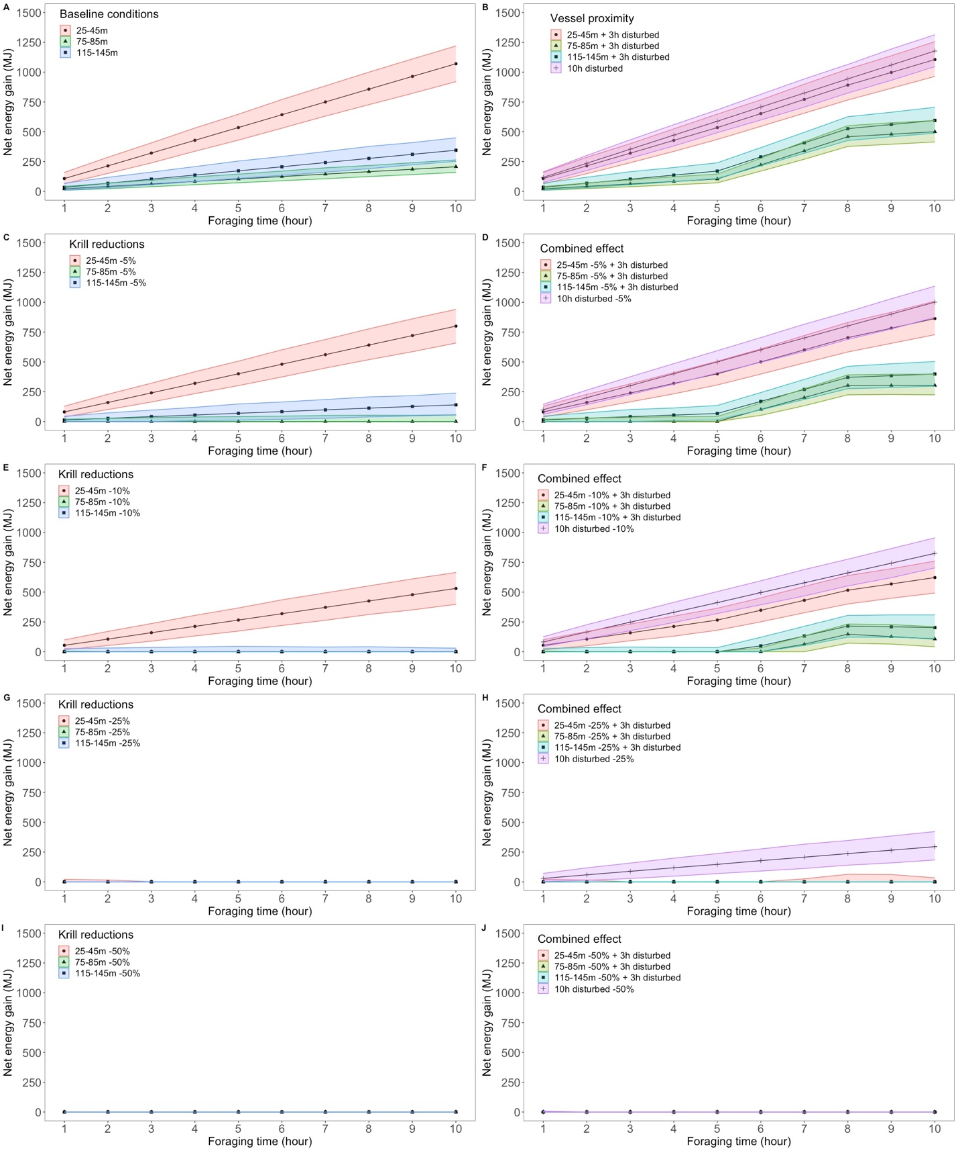
Supplementary Figure 1. Net energy gain (mean and 5–95% CI) accumulated over a 10-h foraging period when feeding at peak density depth of Thysanoessa spp. in the St. Lawrence Estuary, (A) under baseline conditions measured in situ, (B) when exposed to vessel proximity within 400 m for 3 h (from hour 5 to hour 8) and 10 h, (C, E, G, I) under krill density reductions of 5%, 10% 25% or 50% relative to baseline, and (D, F, H, J) while exposed to vessel proximity and foraging on reduced krill densities.
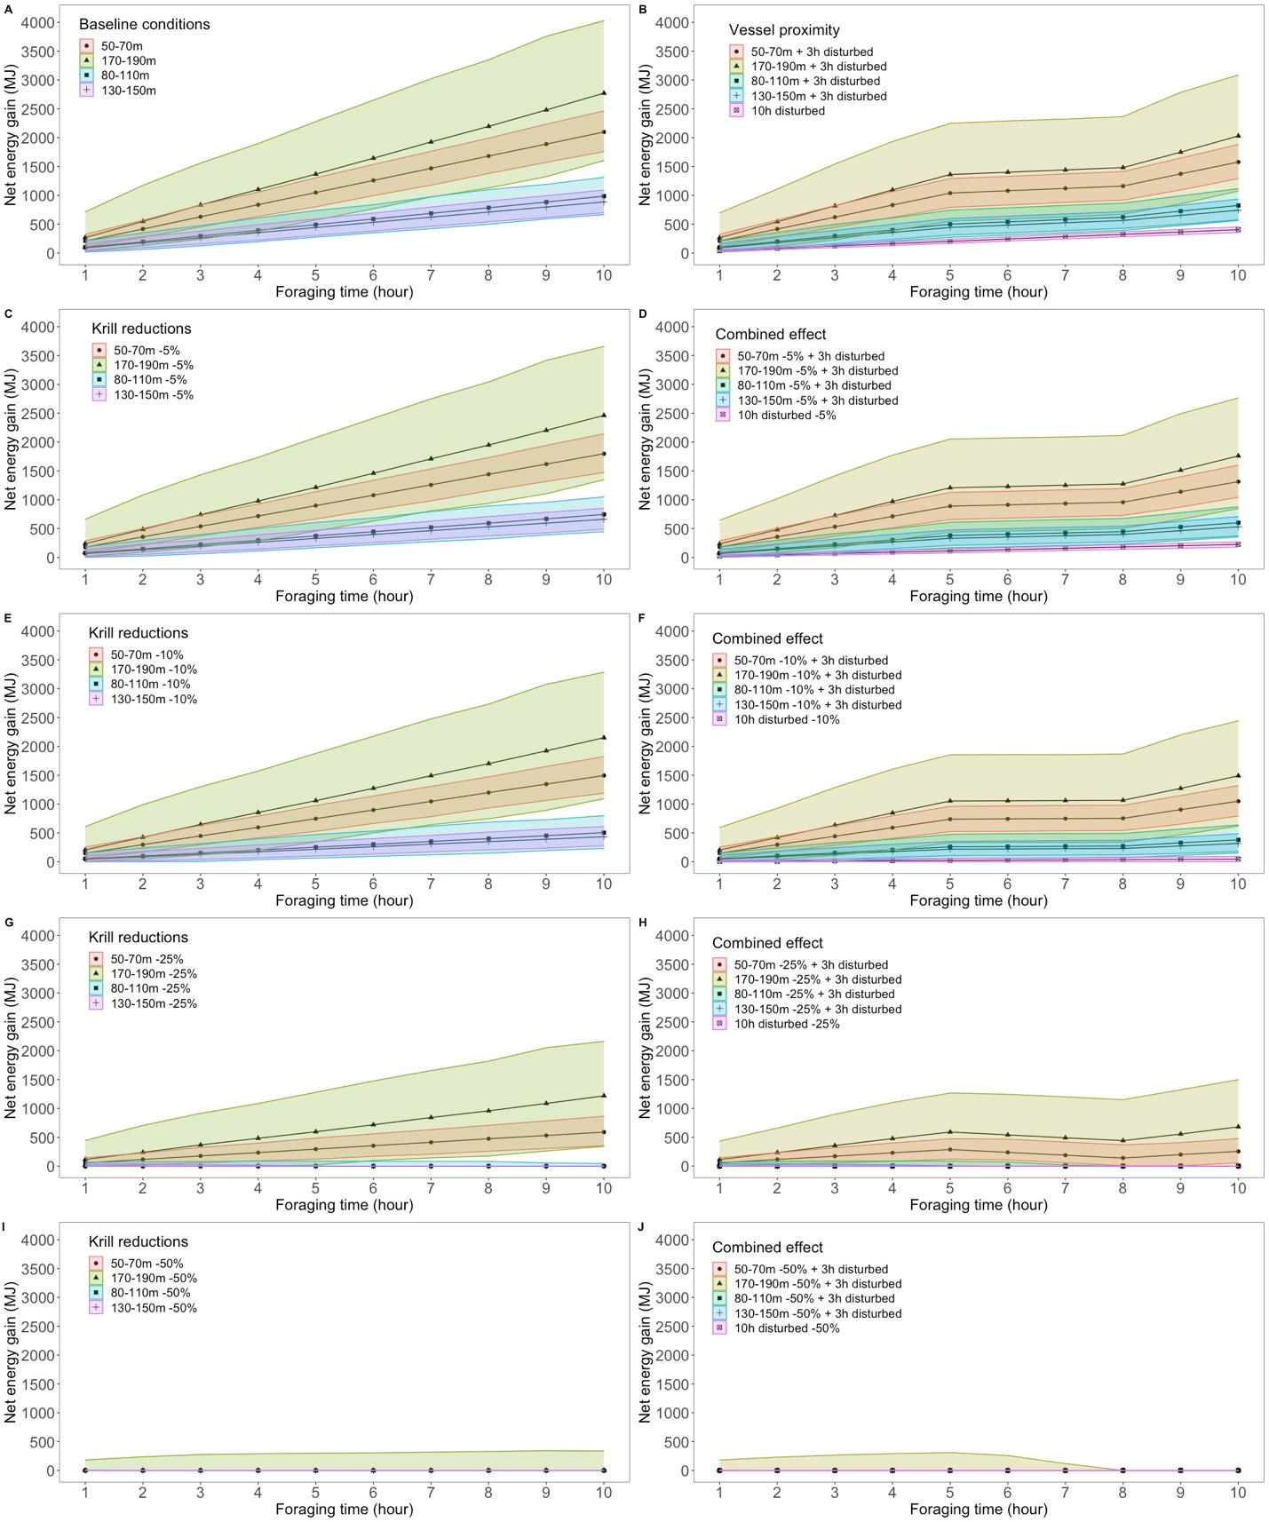
Supplementary Figure 2. Net energy gain (mean and 5–95% CI) accumulated over a 10-h foraging period when feeding at peak density depth of M. norvegica in the northwestern Gulf of St. Lawrence, (A) under baseline conditions measured in situ, (B) when exposed to vessel proximity within 400 m for 3 h (from hour 5 to hour 8) and 10 h, (C, E, G, I) under krill density reductions of 5%, 10% 25 % or 50% relative to baseline, and (D, F, H, J) while exposed to vessel proximity and foraging on reduced krill densities.
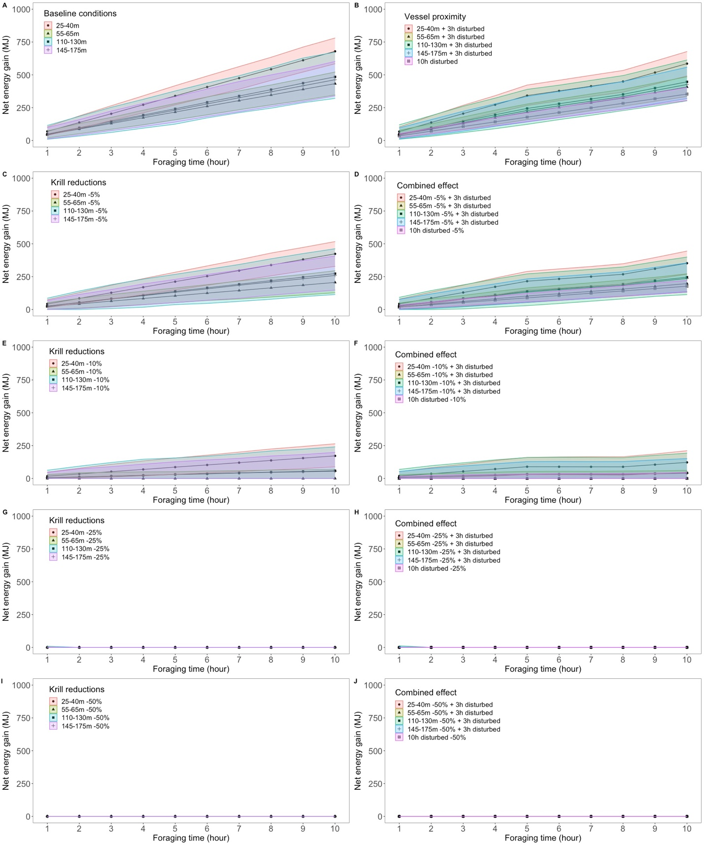
Supplementary Figure 3. Net energy gain (mean and 5–95% CI) accumulated over a 10 h foraging period when feeding at peak density depth of Thysanoessa spp. in the northwestern Gulf of St. Lawrence, (A) under baseline conditions measured in situ, (B) when exposed to vessel proximity within 400 m for 3 h (from hour 5 to hour 8) and 10 h, (C, E, G, I) under krill density reductions of 5%, 10% 25 % or 50% relative to baseline, and (D, F, H, J) while exposed to vessel proximity and foraging on reduced krill densities.

Supplementary data: model parameters
In this study, the number of lunges per dive and the number of dives·h⁻¹ are both depth-specific, and were drawn from distributions defined through the analysis of nine velocity-time-depth recorders (VTDR) from Wildlife Computers, Redmond, WA, and a D-tag (Johnson & Tyack 2003). Archival tags were deployed on ten blues whales in the St. Lawrence Estuary (Quebec, Canada, 48°18’N - 69°20’W) between July and September 2002–2009 (Doniol-Valcroze et al., 2011; 2012). Tags and radio transmitters were attached temporarily to whales with suction cups and detached via a suction release mechanism. Swim speed, depth and water temperature were sampled every second. Swim speeds from the D-tag were inferred from flow noise data sampled at 1 Hz (see procedure in Doniol-Valcroze et al. 2011). A vertical excursion > 0.25 m (greater than the depth resolution) defined a dive, and lunges were identified using a robust algorithm exploiting the acceleration and deceleration phases typical of this behaviour in large baleen whales (Doniol-Valcroze et al., 2011). Other variables including dive duration, dive depth, lunge depth, number of lunges and, descent/ascent rates were extracted from the dive data following Doniol-Valcroze et al. (2011, 2012). These dive characteristics were summarized for each individual in bins of one hour as described in Guilpin et al. (2019).

Depth-specific number of lunges per dive
The number of lunges associated with a dive of a specific duration and made at a specific depth is a pivotal parameter both of energy gain and energy expenditure, with a lunge being the most energetically costly component of a dive. A study on foraging Pacific blue whales highlighted that the number of lunges per dive change according to krill density encountered, likely to optimize energy gain or oxygen consumption (Hazen et al., 2015). In a study conducted in the St. Lawrence Estuary (eastern Canada), Doniol-Valcroze et al. (2011) showed that blue whales followed the optimal foraging theory by adjusting the number of lunges per dive to feeding depth. We determined the mean (and SD) number of lunges per dive by 10-m depth bins from empirical data. We used model predictions from Doniol-Valcroze et al. (2011) for depths where no tag data was available, i.e., beyond 130 m. The number of lunges per dive per depth bin showed variability, which is likely linked to the prey density encountered as shown by Hazen et al. (2015). The optimal model from Doniol-Valcroze et al. (2011) did not include variability, but we obtained associated standard deviations from analysis of the tag data. Therefore, for depth bins deeper than 130 m, we extrapolated the variability observed in the tag data to the model predictions (Figure S4). It allowed us to incorporate uncertainty in the number of lunges per dive inherent to inter-individual variability and foraging strategies. In our simulations, the number of lunges per dive was a mix of empirical data and model predictions. For each depth bin, the number of lunges per dive was drawn from a Gamma distribution, parameterized from the mean and standard deviation with shape = mean²/SD² and scale = SD²/mean. Gamma distributions are well suited for right-tailed strictly positive data.

Depth-specific number of dives per hour
The number of feeding dives made per hour depends on the target depth of successive dives. First, feeding dives were binned per hour for each tagged whale. We then determined the mean number of dives per hour of foraging from the analysis of tag data (Figure S5) although empirical data were restricted to depths < 100 m. We fitted a Generalized Additive Mixed Model (GAMM) to the number of dives per hour as a function of mean feeding depth using a thin plate regression spline smoother and k = 3. The model generated predictions for depths > 100 meters. The GAMM was fitted in the mgcv library (Wood 2006. Mixed GAM Computation Vehicle with Automatic Smoothness Estimation. R package version 1.8-17) in R (v3.3.3; R Development Core Team 2017). Individual whales were considered a random effect, with hours of the day and individual ID being used as factors in an autoregressive correlation structure of order 1 (corAR1) to account for temporal autocorrelation (Zuur et al., 2009). We assessed the significance of the covariate “feeding depth” by comparing model output to a null model including only a random effect using a likelihood ratio test. Homogeneity of variances in the model was assessed from plots of residuals versus fitted values, and normality of the residuals using Quantile-Quantile plots and residual histograms. Model predictions were made for depth bins > 100 m, but considering the lack of empirical data for these deeper depths, the uncertainty around the predicted values was unreliable. We chose to extrapolate the empirically-measured uncertainty to the number of dives per hour for depth bins > 100 m (Figure S6).

Depth-specific post-dive surface time
Time spent at the surface following a dive depends on target depth. This parameter and uncertainty around it were estimated from tag data (Figure S7). For depths greater than 120 m where empirical data were lacking, uncertainty around surface time was estimated by extrapolating from the empirical measurements at shallower depths (Figure S8). A Generalized Additive Mixed Model (GAMM) was fitted to the post-dive surface time as a function of mean feeding depth using a thin plate regression spline smoother and k = 3 (number of knots for the smoother parameter), and individual whales as a random effect (Zuur et al., 2009). The GAMM was fitted using the R package mgcv (Wood 2006. Mixed GAM Computation Vehicle with Automatic Smoothness Estimation. R package version 1.8-17). We assessed the effect of feeding depth on surface time by comparing model output to a null model including only the random effect using a likelihood ratio test. Homogeneity of variance was visually assessed from plots of residuals versus fitted values, whereas normality of the residuals was assessed using Quantile-Quantile plots and residual histograms. Model predictions for depth bins > 120 m were considered unreliable considering the lack of empirical data for these deeper depths.

Consecutives dives
Foraging is often organised into bouts of feeding dives of similar characteristics (Boyd et al., 1994; Sibly, Nott, & Fletcher, 1990). Consecutive dives are therefore correlated in time and in their characteristics (e.g. feeding depth). Feeding bouts were defined by Doniol-Valcroze and Lesage (unpublished data) using a bout ending criterion method (Boyd, 1996). The frequency distribution of depth difference between successive foraging dives within a bout indicated that 92% of the depth differences did not exceed 10 m (Figure S9). Therefore, we made the assumption that successive foraging dives within each hour of foraging did not differ in depth by more than 10 m.

In situ preyscape
In-situ krill densities and vertical distributions were estimated from hydroacoustic data collected during systematic surveys conducted each August from 2008 to 2015 in the Estuary and Gulf of St. Lawrence (EGSL, Québec, Canada, 49° 43’N - 65° 11’W) (Figure S10). Two main regions were defined determined according to topographical habitats (i.e. shelf, slope and channel) and the similarity in the pattern of distribution of the centre of mass of krill in each area (McQuinn et al., 2015): the St. Lawrence Estuary (SLE) and the northwestern part of the Gulf of the St. Lawrence which includes the Gaspé Peninsula (NWG). Hydroacoustic data were recorded only during daytime using a calibrated (Demer et al., 2015) Simrad® EK60 multifrequency echosounder (38, 70, 120 and 200 kHz).

Non-biological echoes and noise from the surface to the seabed reflection were edited from the hydroacoustic data. Echo-integration of the data was done by bins of 25 m on the horizontal axis by 10 m depth on the vertical axis. Prey were acoustically classified using multifrequency algorithms developed for the northwestern GSL (McQuinn et al., 2013). Biological echoes identified as krill were classified into two species, namely Thysanoessa raschii and Meganyctiphanes norvegica. Although these algorithms are specific for the two dominant species, they do not allow the differentiation between T. raschii and T. inermis (McQuinn et al., 2013), the latter being a physiologically-similar, yet much less abundant Thysanoessa species. Thus, we will be using Thysanoessa spp. when referring to krill densities from this genus.

To infer species-specific krill density (g wet weight. m⁻³) for each echo-integrated bin, we used the classified volume backscattering coefficient (sv in m². m⁻³) and its logarithmic form, the mean volume backscattering strength (MVBS or Sv in dB re 1 m². m⁻³). Krill biomass density was calculated using a weight-based target strength (TS_{W}) function:
$${TS}_{W}={TS}_{N}-10Log\left(W\right)$$

where W is the mean individual krill wet weight (g) for each species (56.2 mg and 298 mg for T. raschii and M. norvegica, respectively) (McQuinn et al., 2013). TS_{N} is the length-based modelled target strength (McQuinn et al., 2013) for each species assuming average length, and TS_{W} is -70.0 and -69.0 dB. g⁻¹ for T. raschii and M. norvegica, respectively. Krill density (D_{k}) was calculated as:
$$D_{k}=sv/{10}^{(TSw/10)}$$

Krill distribution is anisotropic in relation to the shoreline (Simard & Lavoie 1999; McQuinn et al., 2015). To account for this specificity, only transects perpendicular to the slope were used in the estimation of krill density and krill vertical distribution. A threshold of 4 g wet weight. m⁻³ was used to discriminate between weakly aggregated krill (empty bin cells included), and aggregated krill patches or layers (McQuinn et al., 2015). For each survey, the mean, maximum, minimum and various quantiles of krill density (g wet weight. m⁻³) were used to describe the vertical distributions of bins containing aggregated Thysanoessa spp. and M. norvegica. Krill, T. raschii in particular, has a strong inter-seasonal distributional variability which was not taken into account since all surveys were carried out in August (McQuinn et al., 2015). Inter-region and interannual variability in the mean overall krill density were investigated with a two-way ANOVA. Both year and region had no significant effect on mean krill density for each species (ANOVA; Thysanoessa spp.: year: p = 0.09, region: p = 0.08; M. norvegica: year: p = 0.6, region: p = 0.6) (Figure S11). Graphical analysis of the vertical distribution of both krill species in each region for all years showed different patterns of vertical density distribution (Figure 3 in main document), albeit no significant differences are detected in overall mean krill density. The differences in the density distributions within the water column lie in the vertical distribution itself, and can be explained by the specificities of habitats encompassed in each region and the depths of center of mass of each species in each region. As highlighted in McQuinn et al. (2015), the center of mass of each species is located higher in the water column in the Estuary compared to the northwestern part of the Gulf (~80 m vs. ~140 m for Thysanoessa spp. and ~110 m vs. ~160 m for M. norvegica in the Estuary and the Gulf, respectively). We then determined typical krill vertical density distributions per 10-m depth bin for each species which were considered baseline information in our scenarios. Guilpin et al. (2019) showed that blue whales need to seek out the highest densities of krill to forage efficiently. Therefore, for each depth bin, the krill density was drawn from a uniform distribution of each depth bin from the 75th to the 95th percentiles.

Supplementary Figure 4. Depth-specific distribution of the number of lunges per dive, was either calculated from tag data analysis (blue) or predicted using the model developed by Doniol-Valcroze et al. (2011) (red). Errors bars for depths 0–130 m are from tag data analysis, and are extrapolated for depths > 130 m. The grey solid line represents the model predictions from Doniol-Valcroze et al. (2011).

Supplementary Figure 5. Mean number of dives per hour as a function of feeding depth.

Supplementary Figure 6. Depth-specific distribution of foraging effort (dives per hour).

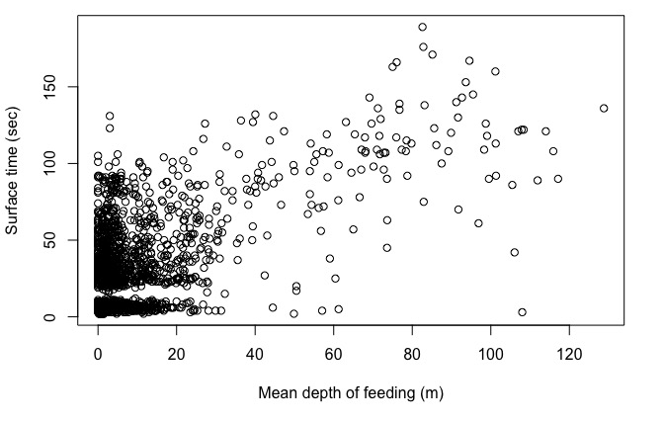
Supplementary Figure 7. Surface time (sec) as a function of feeding depth (m).

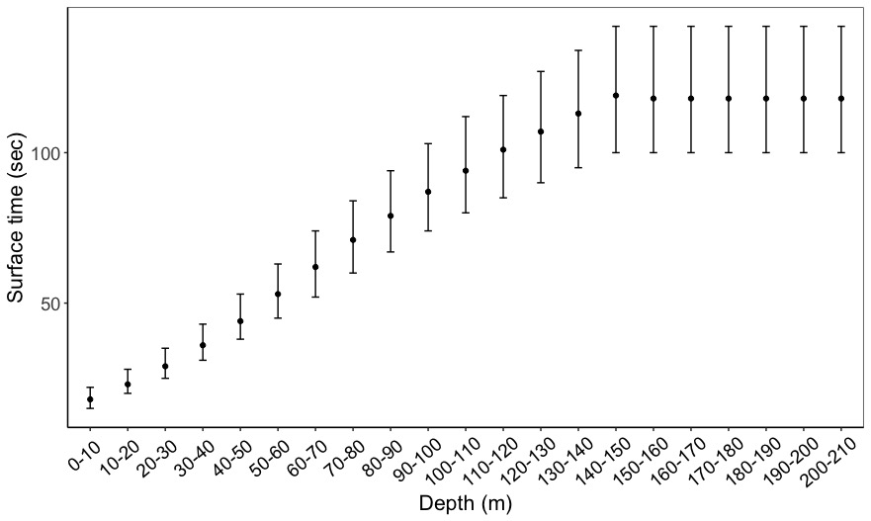
Supplementary Figure 8. Depth-specific distribution of post-dive surface times with 95% point-wise confidence intervals.
Supplementary Figure 9. Frequency distribution (percentage) of the depth difference (m) between successives feeding dives within a bout (as defined by the bout-ending criterion method (Boyd, 1996) in Doniol-Valcroze and Lesage, unpublished data).
Supplementary Figure 10. Locations of hydroacoustic surveys conducted from 2008 to 2015. Colored lines represent the transects for each survey year. The colored polygons represent the two main areas defined into regions: the St. Lawrence Estuary (dark blue) and the northwestern Gulf of St. Lawrence including the Gaspé Peninsula (yellow).

Supplementary Figure 11. Inter-annual variations in the mean (± SD) krill density (g wet weight. m⁻³) for Thysanoessa spp. (A) and Meganyctiphanes norvegica (B) from hydroacoustic surveys conducted in the northwestern Gulf of St. Lawrence and Gaspé Peninsula (NWG), and the St. Lawrence Estuary (SLE). Interannual variability was not significant (two-way ANOVAs: p-values > 0.1).

References
Boyd, I. L. (1996). Temporal Scales of Foraging in a Marine Predator. Ecology 77, 426–434. doi:10.2307/2265619.
Boyd, I. L., Arnould, J. P. Y., Barton, T., and Croxall, J. P. (1994). Foraging Behaviour of Antarctic Fur Seals During Periods of Contrasting Prey Abundance. J Anim Ecol 63, 703–713.
Demer, D. A., Berger, L., Bernasconi, M., Bethke, E., Boswell, K. M., Chu, D., et al. (2015). Calibration of acoustic instruments.
Doniol-Valcroze, T., Lesage, V., Giard, J., and Michaud, R. (2011). Optimal foraging theory predicts diving and feeding strategies of the largest marine predator. Behav Ecol 22, 880–888. doi:10.1093/beheco/arr038.
Doniol-Valcroze, T., Lesage, V., Giard, J., and Michaud, R. (2012). Challenges in marine mammal habitat modelling: Evidence of multiple foraging habitats from the identification of feeding events in blue whales. Endanger Species Res 17, 255–268. doi:10.3354/esr00427.
Guilpin, M., Lesage, V., McQuinn, I., Goldbogen, J., Potvin, J., Jeanniard-du-Dot, T., et al. (2019). Foraging energetics and prey density requirements of western North Atlantic blue whales in the Estuary and Gulf of St. Lawrence, Canada. Mar Ecol Prog Ser 625, 205–223. doi:10.3354/meps13043.
Hazen, E. L., Friedlaender, A. S., and Goldbogen, J. A. (2015). Blue whales (Balaenoptera musculus) optimize foraging efficiency by balancing oxygen use and energy gain as a function of prey density. Sci Adv 1, e1500469–e1500469. doi:10.1126/sciadv.1500469.
﻿Johnson MP, Tyack PL (2003) A digital acoustic recording tag for measuring the response of wild marine mammals to sound. IEEE J Ocean Eng 28: 3−12 doi:10.1109/JOE.2002.808212
McQuinn, I. H., Dion, M., and St. Pierre, J.-F. (2013). The acoustic multifrequency classification of two sympatric euphausiid species. ICES J Mar Sci 69, 1205–1217. doi:10.1093/icesjms/fst048.
McQuinn, I. H., Plourde, S., St. Pierre, J.-F., and Dion, M. (2015). Spatial and temporal variations in the abundance, distribution, and aggregation of krill (Thysanoessa raschii and Meganyctiphanes norvegica) in the lower estuary and Gulf of St. Lawrence. Prog Oceanogr 131, 159–176. doi:10.1016/j.pocean.2014.12.014.
Sibly, R. M., Nott, H. M. R., and Fletcher, D. . (1990). Splitting behaviour into bouts. Anim Behav 39, 63–69. doi:10.1016/S0003-3472(05)80726-2.
Simard, Y., and Lavoie, D. (1999). The rich krill aggregation of the Saguenay - St. Lawrence Marine Park: hydroacoustic and geostatistical biomass estimates, structure, variability, and significance for whales. Can J Fish Aquat Sci 56, 1182–1197. doi:10.1139/f99-063.
﻿Wood S (2006) Mixed GAM computation vehicle with auto- matic smoothness estimation. R package version 1.8-17. https: //CRAN.R-project.org/package=mgcv
﻿Zuur AF, Ieno EN, Walker NJ, Saveliev AA, Smith GM (2009) Mixed effects models and extension in ecology with R. Springer, New York

