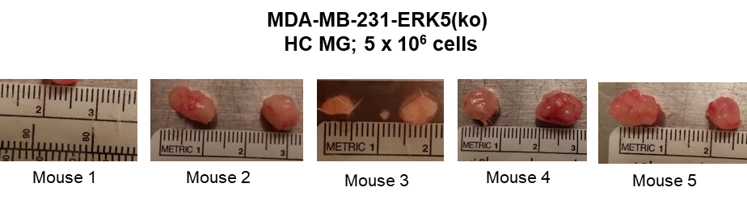
Supplementary Figure 10. Representation of tumors that were resected from SCID/Beige mice at the time of survival surgery. MDA-MB-231-ERK5-ko cells were injected with PBS and high concentration Matrigel into the MFPs of mice.

