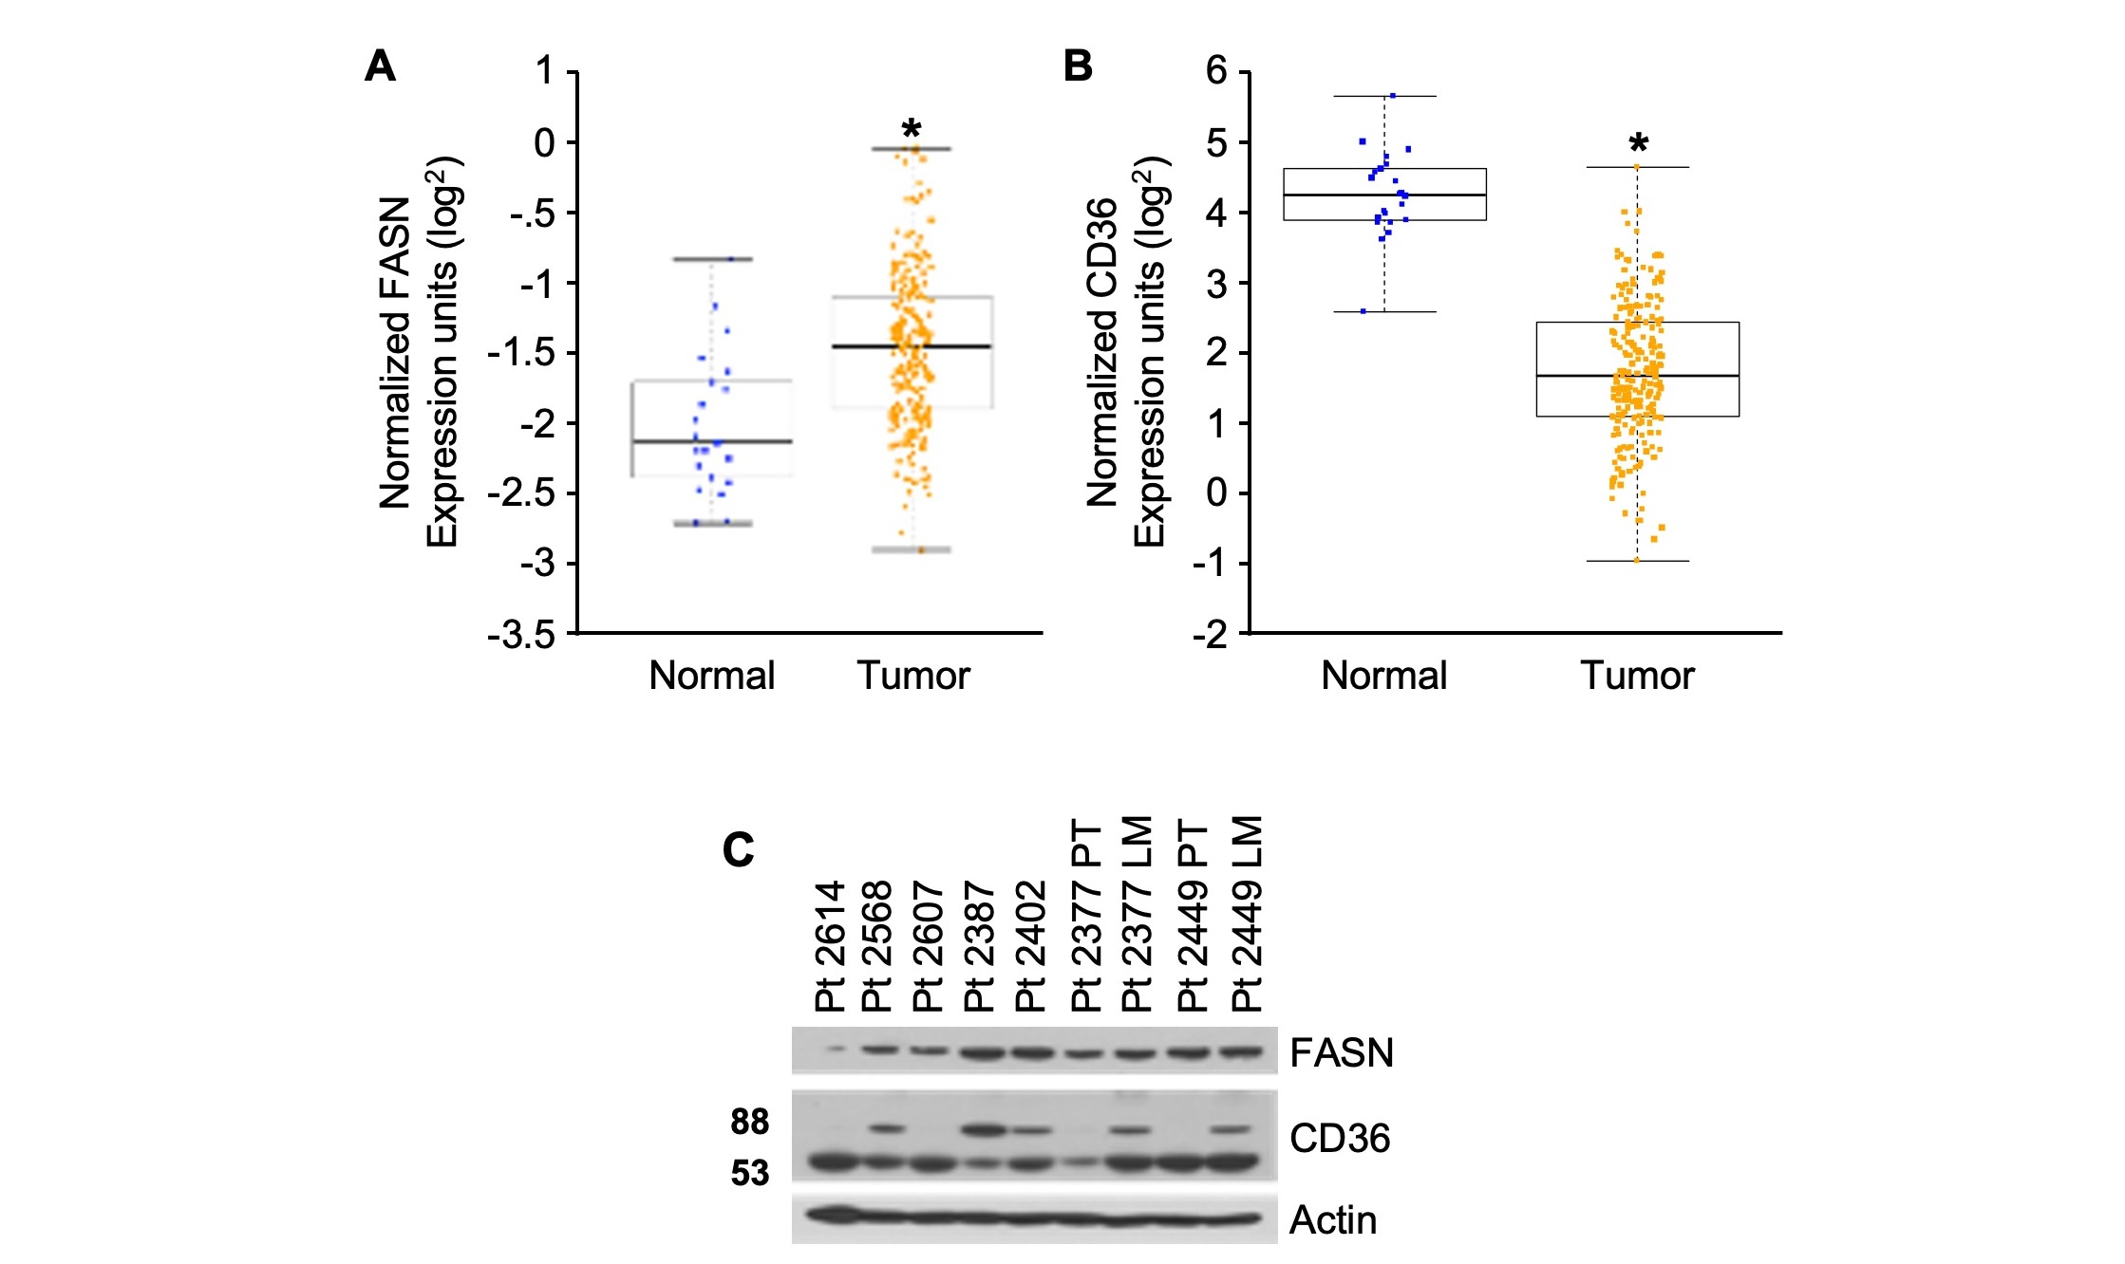
Supplementary Figure 1. (A) FASN mRNA expression is increased (*p < 0.0001) and (B) CD36 mRNA expression is decreased (*p < 0.0001) in CRC patient samples in the TCGA dataset (n=22 of normal tissues and n=215 of tumors). (C) Expression of FASN and CD36 in PDX tumor tissues.

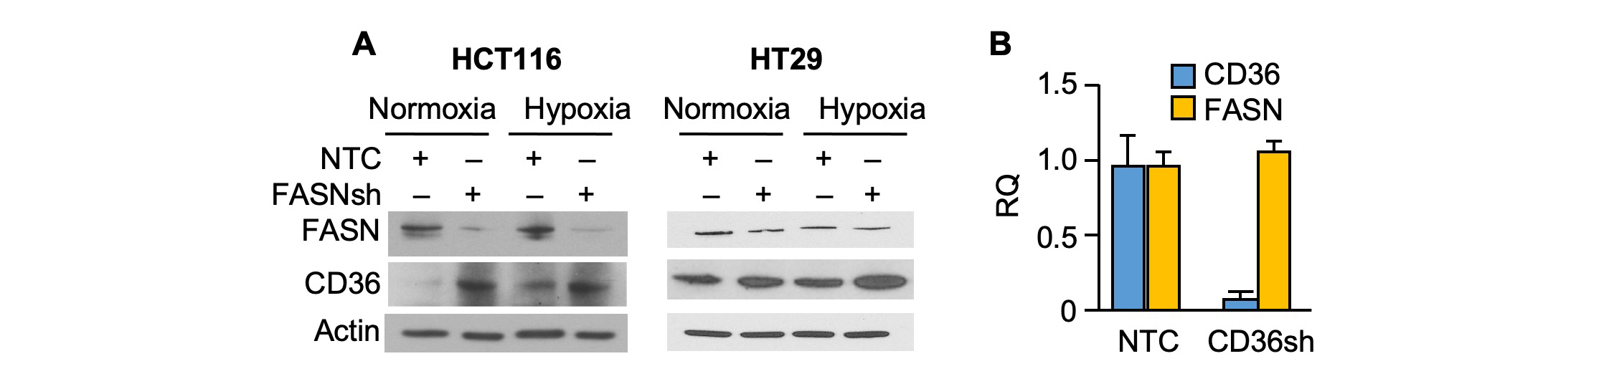
Supplementary Figure 2. Expression of CD36 is regulated by the level of de novo fatty acid synthesis in CRC. (A) Protein expression of CD36 and FASN in FASN shRNA HCT116 and HT29 cells in both normal and hypoxic conditions. (B) mRNA expression of CD36 and FASN in HT29LM3 NTC and CD36 shRNA.

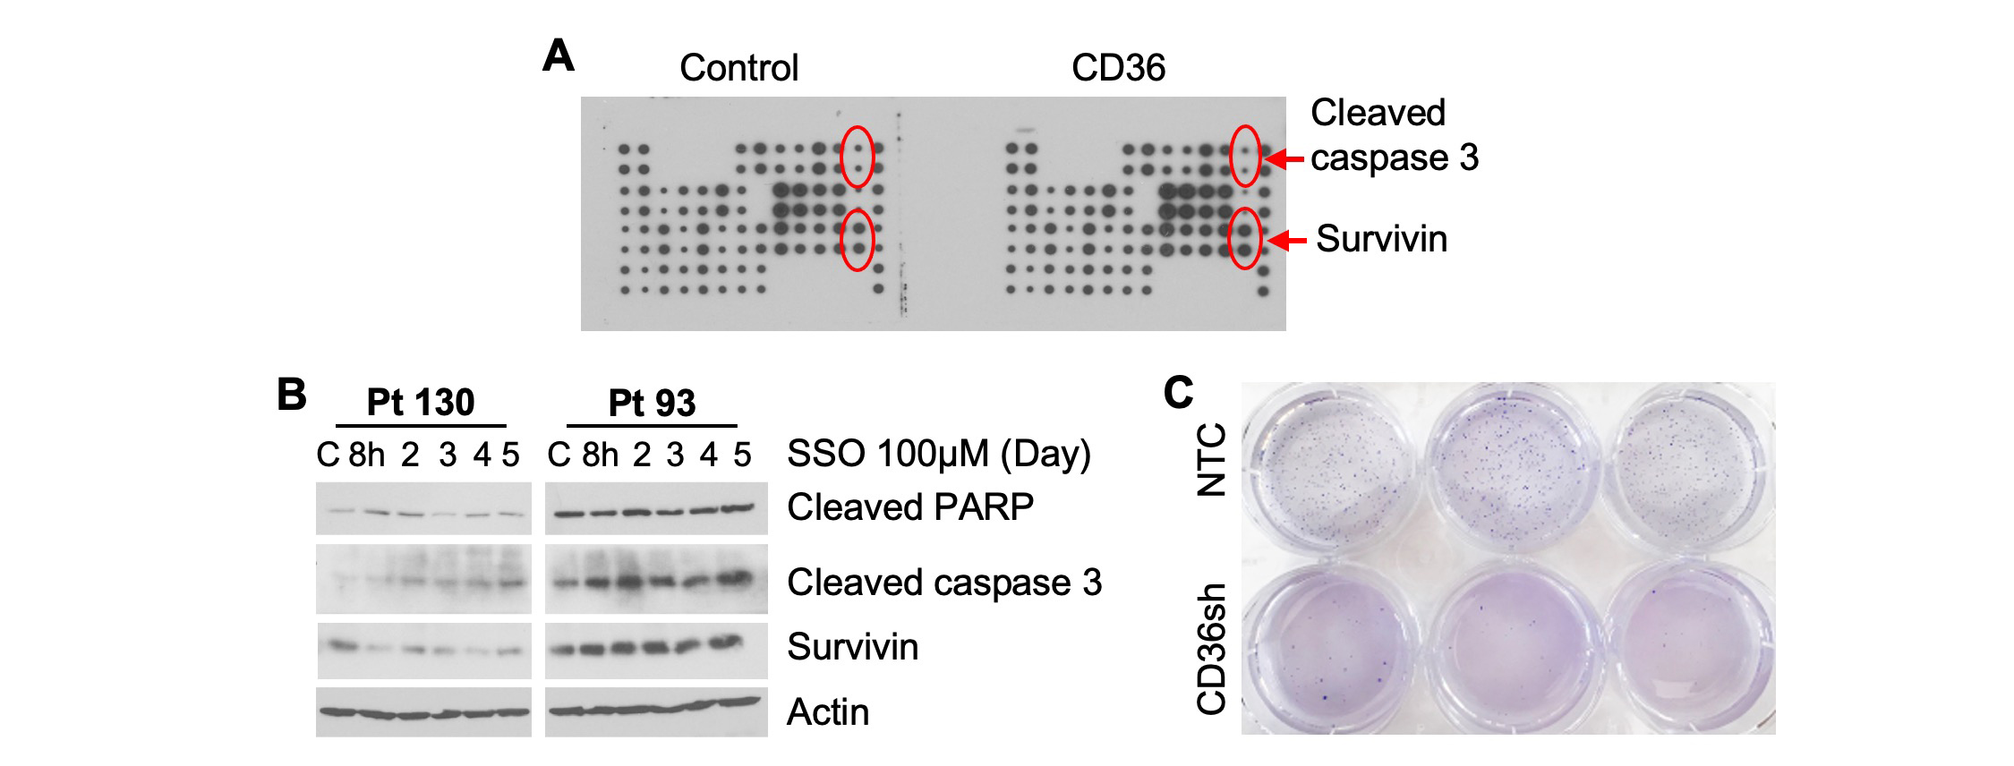
Supplementary Figure 3. CD36 upregulates survivin and inhibits apoptotic markers. (A) Effect of CD36 overexpression on apoptotic markers was assessed in HCT116 cells, control and tdTomato-CD36, using Apoptosis Antibody Array. (B) Primary Pt 130 and Pt 93 CRC cells were treated with 100μM SSO for 5 days in normal medium and expression of cleaved PARP, cleaved caspase-3, and survivin was analyzed. (C) 3 x 10⁴ HT29, NTC and CD36 shRNA #4, cells were plated in agarose and allowed to grow for 10 days.

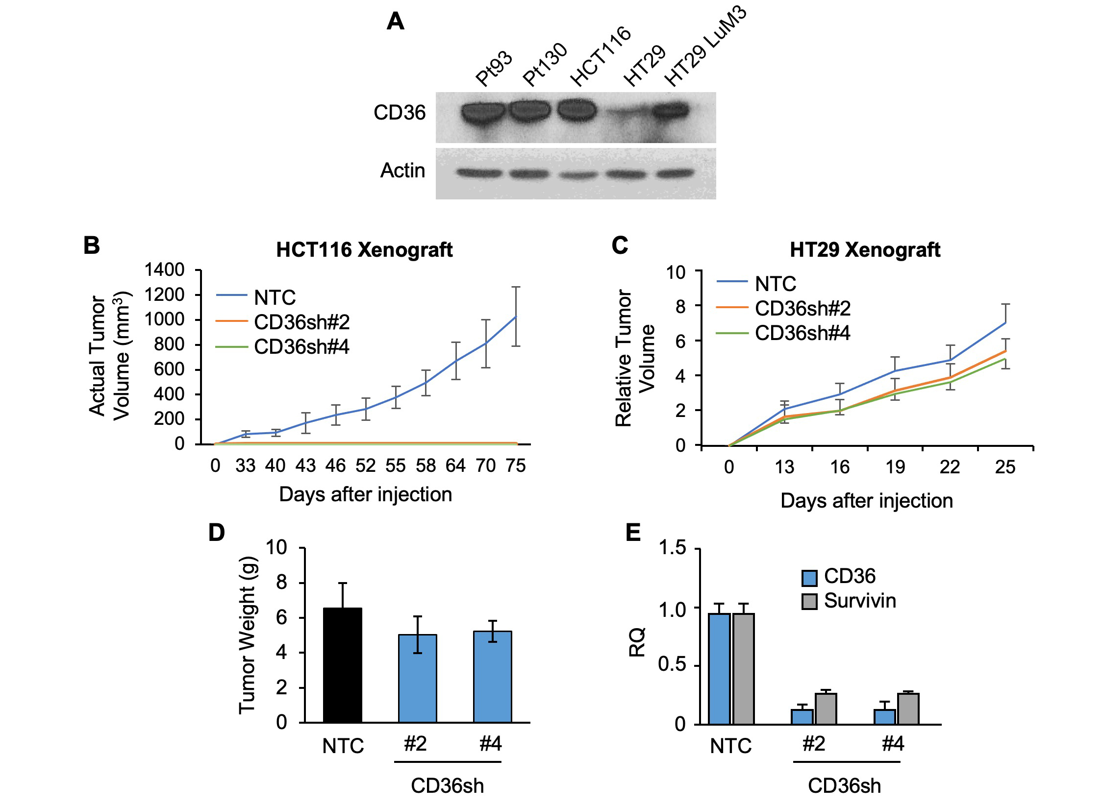
Supplementary Fig. 4. (A) Expression of CD36 in CRC cell lines. (B) Tumor volume (mm³) of HCT116, NTC and CD36 shRNA#2 and #4 xenografts shown in Figure 4C. (C) Tumor growth for HT29 NTC and CD36 shRNA #2 and #4 xenografts. 2.0 x 10⁶ cells were injected into NU/NU mice and tumor growth was measured every 3 days. (D) Tumor weight for HT29 NTC and CD36 shRNA #2 and #4 xenografts. (E) mRNA expression of CD36 and survivin in HT29 xenograft tumors.

