Supplementary Material

sarA dependent antibiofilm activity of thymol enhances the antibacterial efficacy of rifampicin against Staphylococcus aureus
Alaguvel Valliammai¹, Anthonymuthu Selvaraj¹, Udayakumar Yuvashree¹, Chairmandurai Aravindraja^{1,2} and Shunmugiah Karutha Pandian¹*

Figure S1. Effect of increasing concentrations of thymol on biofilm formation of clinical isolates of S. aureus. Error bars indicate standard deviations. Asterisks represent statistical significance (p < 0.05).
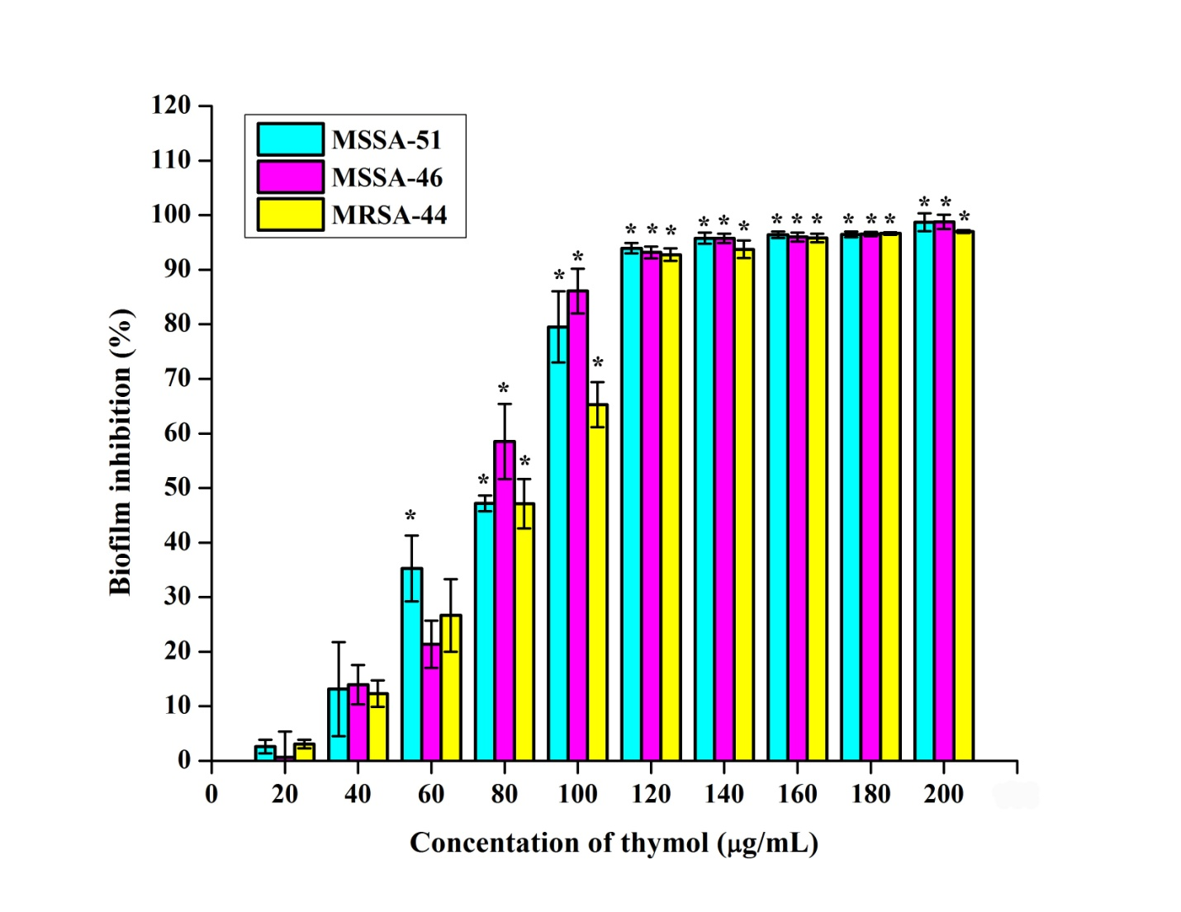

Figure S2. Effect of thymol on growth and metabolism of MRSA at BIC (100 µg/mL). (a) CFU analysis of control and thymol treated MRSA exhibiting non-antibacterial nature of thymol. (b) Alamar blue assay depicting the metabolic viability of control and thymol treated MRSA. Error bars indicate standard deviations.
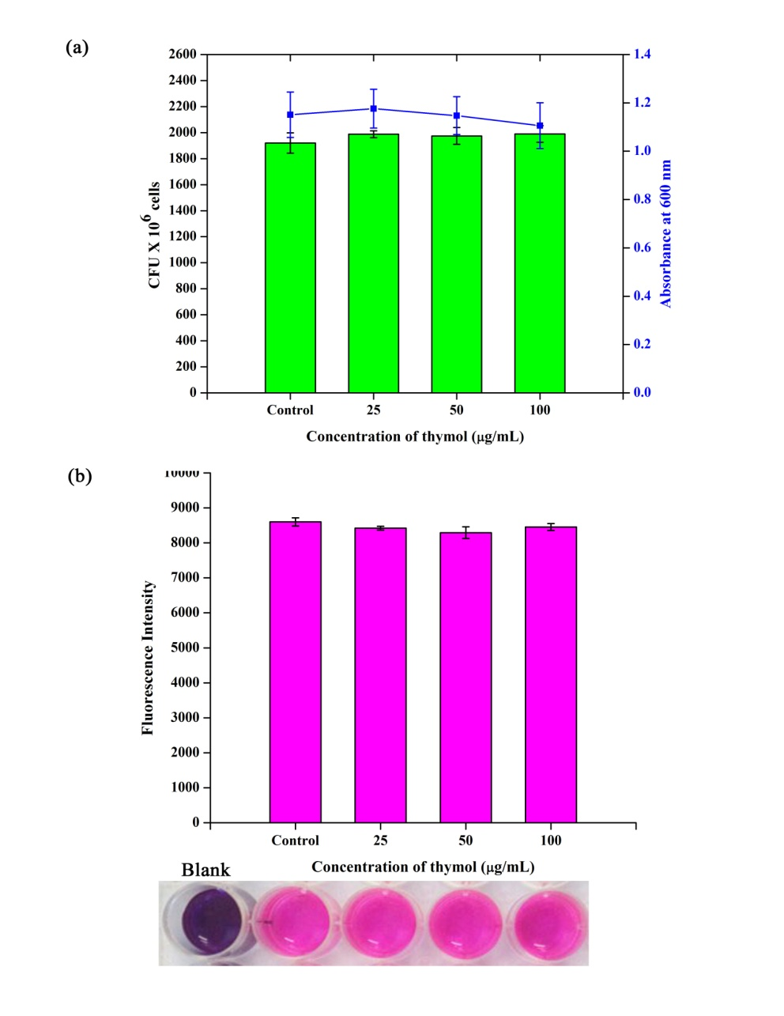
Figure S3. Determination of MIC of thymol against MRSA. Error bars indicate standard deviations. Asterisks represent statistical significance (p < 0.05).
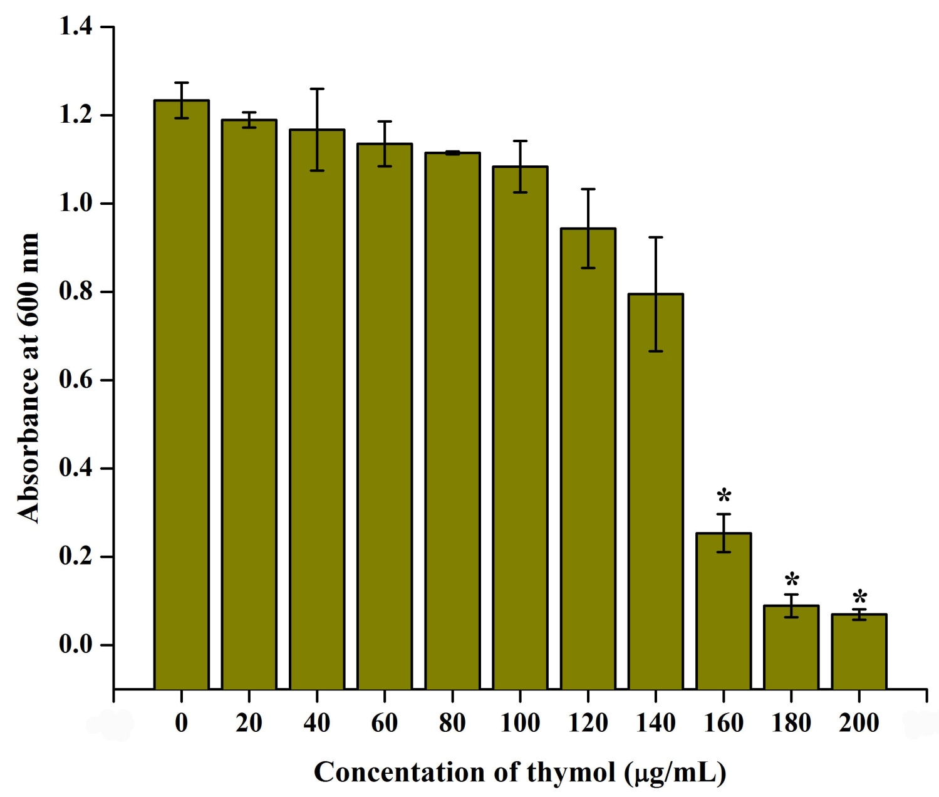

Figure S4. Determination of MIC of rifampicin against MRSA. Error bars indicate standard deviations. Asterisks represent statistical significance (p < 0.05).
