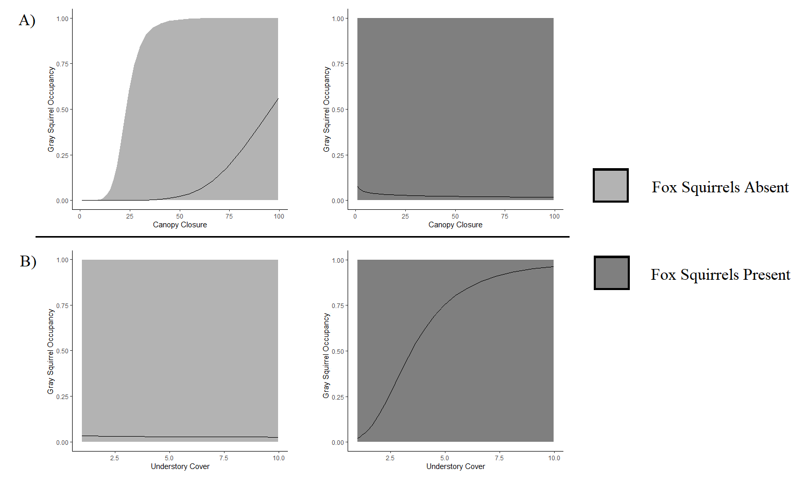
Relationship between fine scale gray squirrel occupancy probability (solid line) and 95% confidence interval (shaded area) and (a) fine scale canopy cover and (b) fine understory density, given gray squirrels are absent (light gray) or present (dark gray) in sites located in North and Central Florida, USA in 2013-2014.

