Supplementary Table 1 – Correlation matrix between macrophage related genes in leprosy patients.
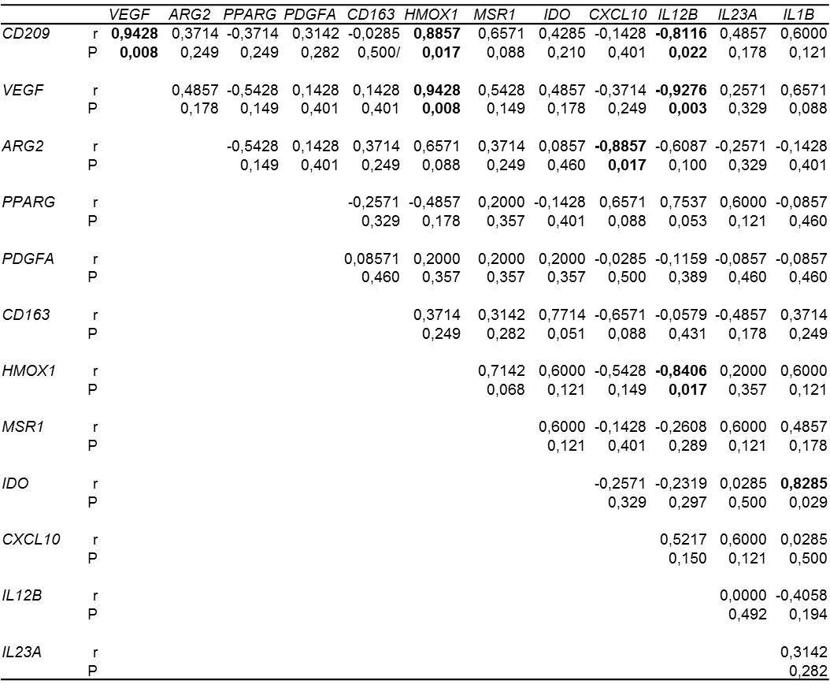

Supplementary Table 2 – Correlation matrix between macrophage related genes in HIV/leprosy patients.
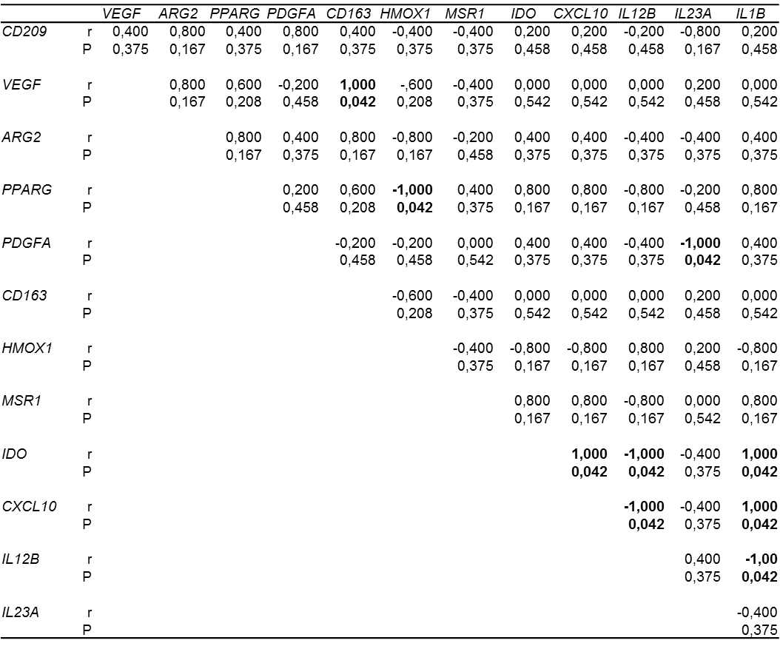

Supplementary Table 3 – Correlation matrix between macrophage related genes in leprosy patients with reverse reaction.
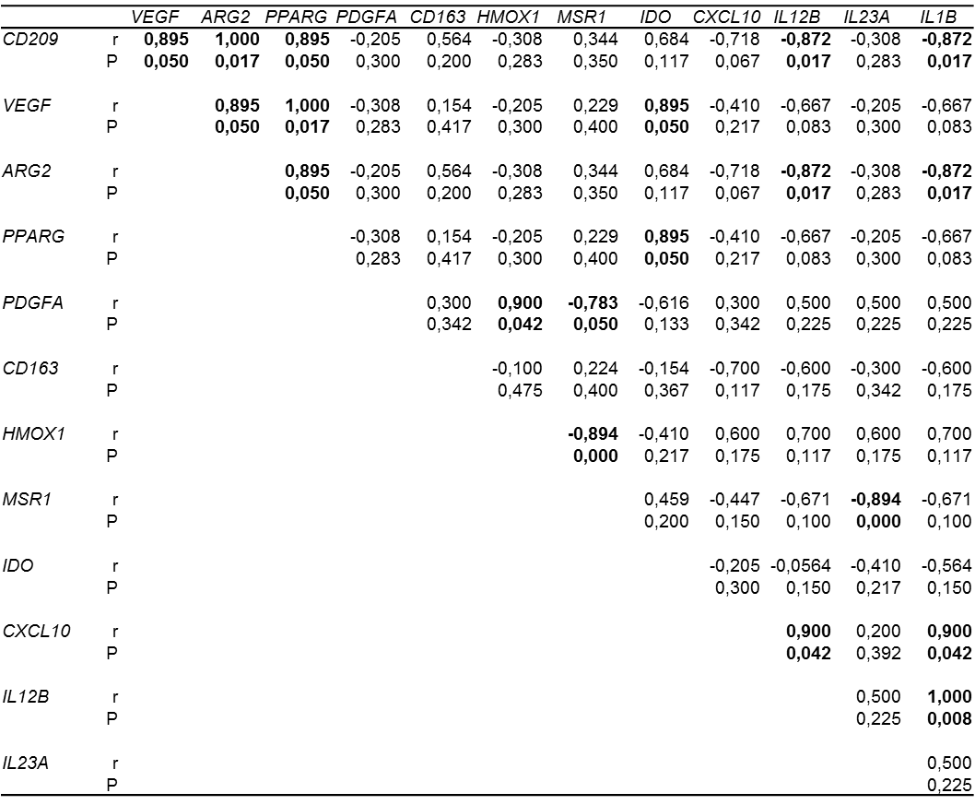

Supplementary Table 4 - Correlation matrix between macrophage related genes in HIV/leprosy patients with reverse reaction.
