Table S1. List of primers information
Gene | Sequence (5’-3’)
NRF2 | F: ACGGTATGCAACAGGACATTGAGC
 | R: TTGGCTTCTGGACTTGGAACCATG
HO1 | F: CCTCCCTGTACCACATCTATGT
 | R: GCTCTTCTGGGAAGTAGACAG
SOD1 | F: ATCCTCTATCCAGAAAACACGG
 | R: GCGTTTCCTGTCTTTGTACTTT
GST | F: TCTCCAGATTCCCATCCACTTCCC
 | R: CTGCGGCTCGGTGATGTCTTC
NRF2_M1 | F: TTATTATGATGGATTTGGAGTTGTC
 | R: CTAACCAAACGTAAAAAAAACCG
NRF2_U1 | F: ATTATGATGGATTTGGAGTTGTTGT
 | R: CTAACCAAACATAAAAAAAACCAAT
NRF2_M2 | F: TGTCGGTAAAAATGTGTTTAGTTAC
 | R: CTCAAAACTACCAAAAAATAATCCG
NRF2_U2 | F: TTGGTAAAAATGTGTTTAGTTATGG
 | R: AAAACTACCAAAAAATAATCCAAA

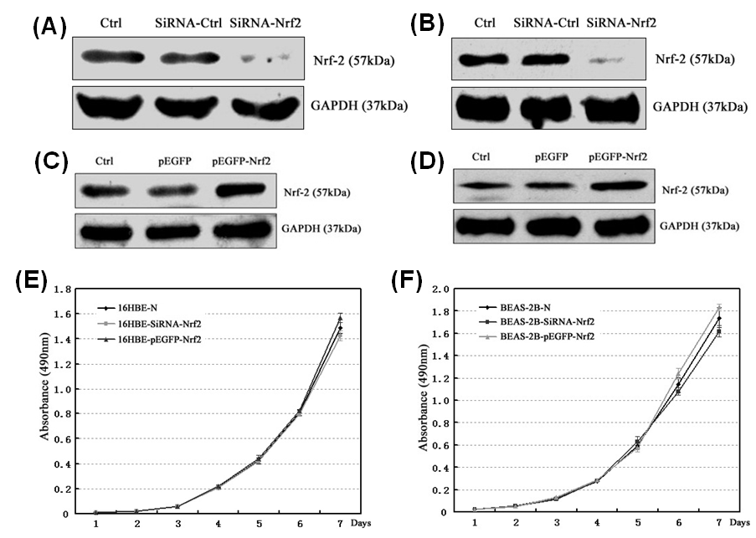
Figure S1. Knockdown and overexpression of NRF2 in human bronchial epithelial cells. Expression of NRF2 protein was identified in 16HBE cells (A and C) and BEAS-2B cells (B and D) by Western blotting. GAPDH was used as the internal control for normalization. (E-F) Line plots showing that either knockdown or overexpression of NRF2 has no effects on cell growth curve when compared with the normal cells (16HBE-N or BEAS-2B-N).

