Supplementary material
List of figures and tables:
Fig. S1. Gene ontology (GO) function significant enrichment analysis showed the distribution of DEGs in biological process, cellular component and molecular function.
Fig. S2. Boxplots of wild type N. oceanica and the mutant.
Fig. S3. Transcript expression changes involved in carbon fixation process of wild type N. and mutant ZJU700.
Fig. S4. Growth curves of five batches cultivation of mutant ZJU700 to prove the stability of the mutant’s stable growth phenotype.

Fig. S1. Gene ontology (GO) function significant enrichment analysis showed the distribution of DEGs in biological process, cellular component and molecular function.
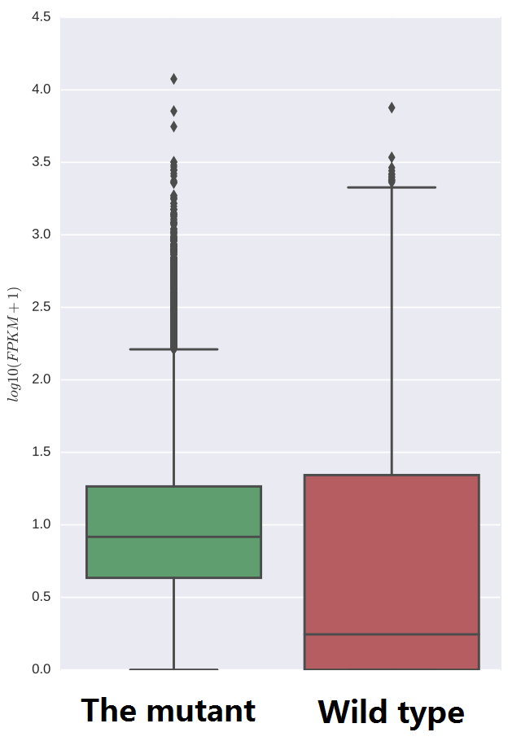
Fig. S2. Boxplots of wild type N. oceanica and the mutant.

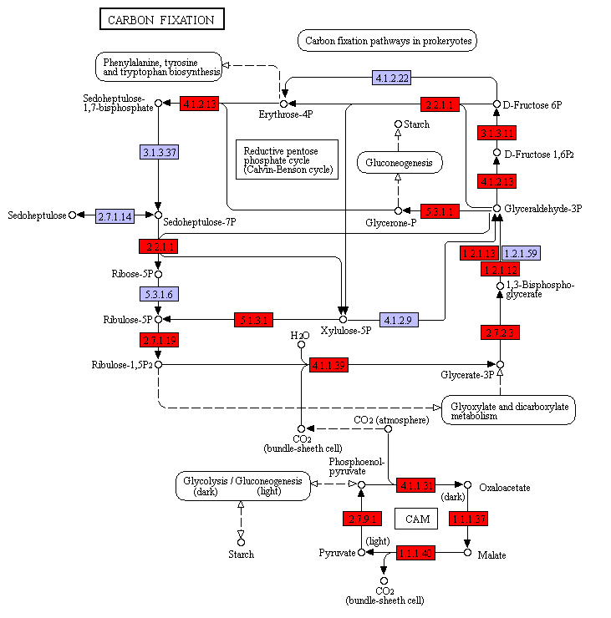
Fig. S3. Transcript expression changes involved in carbon fixation process of wild type N. and mutant ZJU700. (red coloured boxes represent up-regulated genes)

Fig. S4. Growth curves of five batches cultivation of mutant ZJU700 to prove the stability of the mutant’s stable growth phenotype.

