Supplementary Material

1. Supplementary Figures
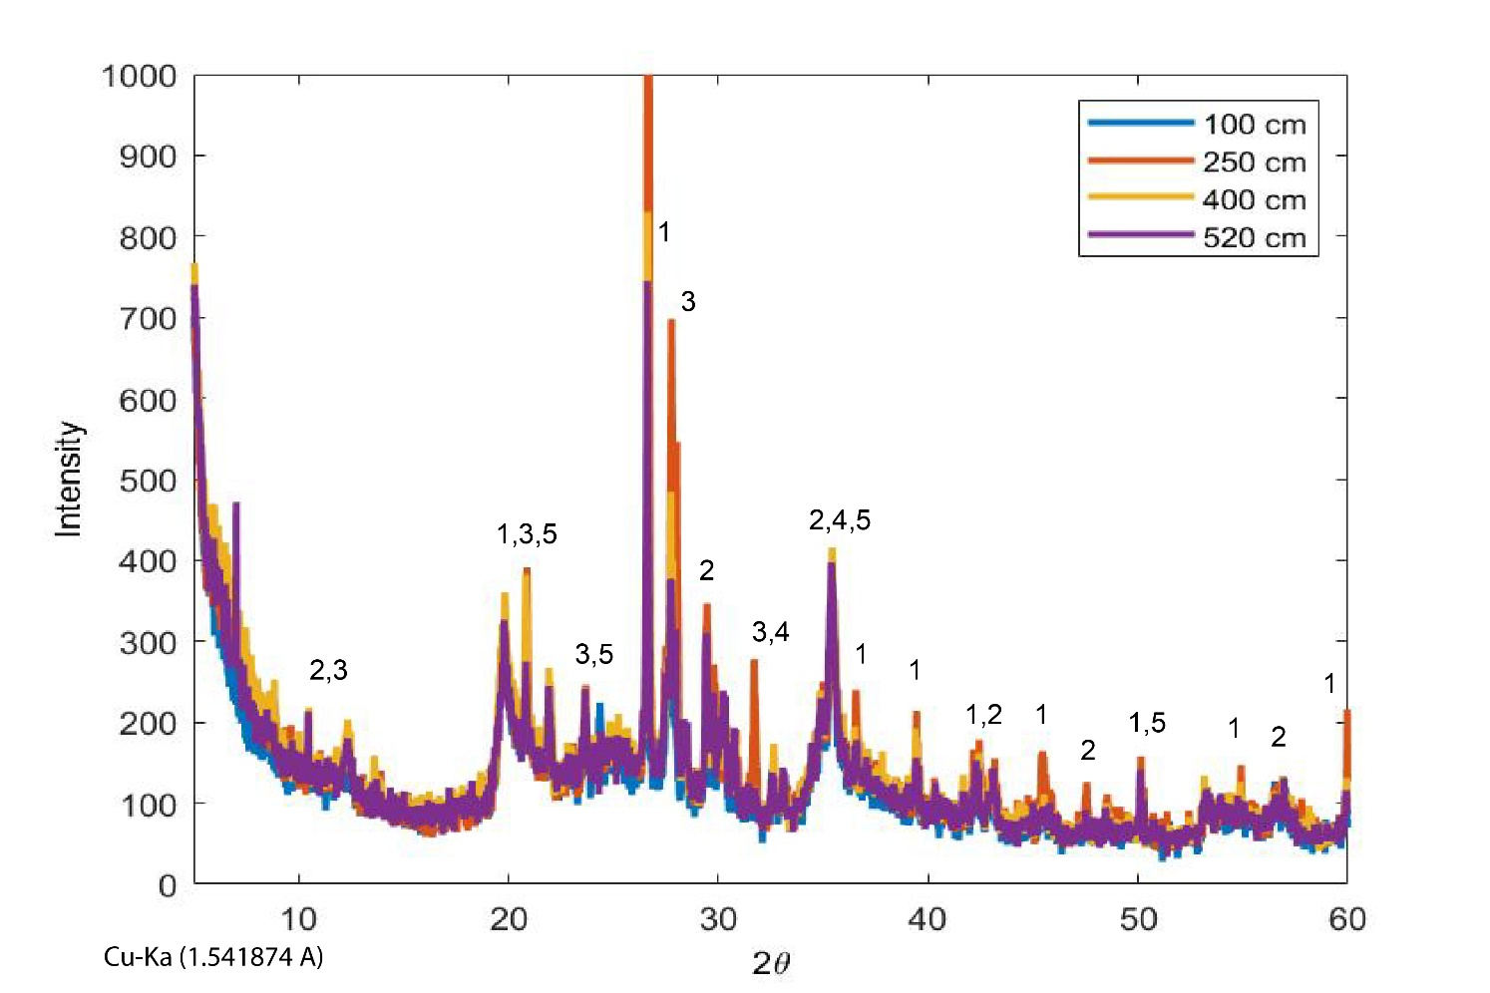

Supplementary Figure 1. XRD results of four representative samples from SG1 sediment core from depths: 100 cm (blue line), 250 cm (red line), 400 cm (orange line) and 520 cm (purple line). Results indicate the presence of quartz, calcite, clays and albite. 1- Quartz. 2- Calcite. 3- Albite. 4- Diopside. 5- Kaolinite.

