Supplementary Material
Table S1. Results of goodness of fit and predictions of the RAC-BRT models applied to European sardine (Sardina pilchardus) occurrence collected during the dermal survey (MEDITS) in the Geographical Sub-Area 06 and 07 from 2003 to 2016. D² (%) = total percentage of deviance explained by the model; rho = Pearson’s correlation index between observed and predicted values; I = Moran’s index maximum absolute value for each model and associated P-value.
GSA07
Year | RAC-BRT D² (%) | rho | Moran’s I | Moran P-value
2003 | 72 | 0.73 | 0.05 | < 2.2e⁻¹⁶
2004 | 70 | 0.76 | 0.04 | < 2.2e⁻¹⁶
2005 | 68 | 0.79 | 0.05 | < 2.2e⁻¹⁶
2006 | 63 | 0.75 | 0.06 | < 2.2e⁻¹⁶
2007 | 74 | 0.82 | 0.05 | < 2.2e⁻¹⁶
2008 | 68 | 0.77 | 0.04 | < 2.2e⁻¹⁶
2009 | 74 | 0.79 | 0.05 | < 2.2e⁻¹⁶
2010 | 54 | 0.68 | 0.05 | < 2.2e⁻¹⁶
2011 | 63 | 0.67 | 0.05 | < 2.2e⁻¹⁶
2012 | 74 | 0.82 | 0.05 | < 2.2e⁻¹⁶
2013 | 69 | 0.82 | 0.05 | < 2.2e⁻¹⁶
2014 | 73 | 0.78 | 0.05 | < 2.2e⁻¹⁶
2015 | 51 | 0.71 | 0.05 | < 2.2e⁻¹⁶
2016 | 67 | 0.64 | 0.05 | < 2.2e⁻¹⁶
GSA06
2003 | 58 | 0.69 | 0.05 | < 2.2e⁻¹⁶
2004 | 62 | 0.73 | 0.05 | < 2.2e⁻¹⁶
2005 | 62 | 0.74 | 0.05 | < 2.2e⁻¹⁶
2006 | 73 | 0.76 | 0.06 | < 2.2e⁻¹⁶
2007 | 68 | 0.78 | 0.05 | < 2.2e⁻¹⁶
2008 | 72 | 0.74 | 0.06 | < 2.2e⁻¹⁶
2009 | 69 | 0.76 | 0.05 | < 2.2e⁻¹⁶
2010 | 66 | 0.86 | 0.06 | < 2.2e⁻¹⁶
2011 | 77 | 0.93 | 0.05 | < 2.2e⁻¹⁶
2012 | 78 | 0.90 | 0.06 | < 2.2e⁻¹⁶
2013 | 50 | 0.70 | 0.05 | < 2.2e⁻¹⁶
2014 | 58 | 0.83 | 0.05 | < 2.2e⁻¹⁶
2015 | 64 | 0.80 | 0.05 | < 2.2e⁻¹⁶
2016 | 52 | 0.75 | 0.06 | < 2.2e⁻¹⁶

Table S2. Results of goodness of fit and predictions of the RAC-BRT models applied to European anchovy (Engraulis encrasicolus) collected during the dermal survey (MEDITS) in the Geographical Sub-Area 06 and 07 from 2003 to 2016. D² (%) = total percentage of deviance explained by the model; rho = Pearson’s correlation index between observed and predicted values; I = Moran’s index maximum absolute value for each model and associated P-value.
GSA07
Year | RAC-BRT D² (%) | rho | Moran’s I | Moran P-value
2003 | 65 | 0.84 | 0.06 | < 2.2e⁻¹⁶
2004 | 68 | 0.80 | 0.06 | < 2.2e⁻¹⁶
2005 | 42 | 0.66 | 0.05 | < 2.2e⁻¹⁶
2006 | 50 | 0.77 | 0.06 | < 2.2e⁻¹⁶
2007 | 62 | 0.85 | 0.05 | < 2.2e⁻¹⁶
2008 | 71 | 0.87 | 0.06 | < 2.2e⁻¹⁶
2009 | 75 | 0.82 | 0.05 | < 2.2e⁻¹⁶
2010 | 66 | 0.80 | 0.06 | < 2.2e⁻¹⁶
2011 | 72 | 0.85 | 0.05 | < 2.2e⁻¹⁶
2012 | 38 | 0.67 | 0.06 | < 2.2e⁻¹⁶
2013 | 34 | 0.62 | 0.05 | < 2.2e⁻¹⁶
2014 | 72 | 0.90 | 0.06 | < 2.2e⁻¹⁶
2015 | 59 | 0.82 | 0.05 | < 2.2e⁻¹⁶
2016 | 43 | 0.74 | 0.06 | < 2.2e⁻¹⁶
GSA06
2003 | 55 | 0.75 | 0.06 | < 2.2e⁻¹⁶
2004 | 52 | 0.74 | 0.06 | < 2.2e⁻¹⁶
2005 | 58 | 0.76 | 0.05 | < 2.2e⁻¹⁶
2006 | 53 | 0.77 | 0.06 | < 2.2e⁻¹⁶
2007 | 48 | 0.75 | 0.05 | < 2.2e⁻¹⁶
2008 | 48 | 0.73 | 0.06 | < 2.2e⁻¹⁶
2009 | 51 | 0.76 | 0.05 | < 2.2e⁻¹⁶
2010 | 66 | 0.86 | 0.06 | < 2.2e⁻¹⁶
2011 | 77 | 0.93 | 0.05 | < 2.2e⁻¹⁶
2012 | 78 | 0.90 | 0.06 | < 2.2e⁻¹⁶
2013 | 50 | 0.70 | 0.05 | < 2.2e⁻¹⁶
2014 | 58 | 0.83 | 0.06 | < 2.2e⁻¹⁶
2015 | 64 | 0.80 | 0.05 | < 2.2e⁻¹⁶
2016 | 52 | 0.75 | 0.06 | < 2.2e⁻¹⁶

Figure S1: Variable importance analysis performed by Random Forests based on the per cent increase in mean squared error- MSE for the used variables. Random Forests were performed for European sardine (Sardina pilchardus) and anchovy (Engraulis encrasicolus) abundance indexes collected during acoustic (ECOMED, PELMED and MEDIAS) and demersal (MEDITS) surveys in the Geographical Sub-Area 06 and 07 from 2003 to 2016. Predictors used were Sea Surface Temperature (SST in °C), Sea Surface Salinity (SSS in PSU) and Net Primary Productivity (NPP in mg/m3). Moreover, 12 temporal lags (from January to December) were tested to assess if the species were more influenced by the environmental features of the months previous the surveys.

Figure S2: Variable importance analysis performed by Random Forests based on the per cent increase in mean squared error- MSE for the used variables. Random Forests were performed for European sardine (Sardina pilchardus) and anchovy (Engraulis encrasicolus) biomass indexes collected during acoustic (ECOMED, PELMED and MEDIAS) and demersal (MEDITS) surveys in the Geographical Sub-Area 06 and 07 from 2003 to 2016. Predictors used were Sea Surface Temperature (SST in °C), Sea Surface Salinity (SSS in PSU) and Net Primary Productivity (NPP in mg/m3). Moreover, 12 temporal lags (from January to December) were tested to assess if the species were more influenced by the environmental features of the months previous the surveys.
Figure S3: Variable importance analysis performed by Random Forests based on the per cent increase in mean squared error- MSE for the used variables. Random Forests were performed for European sardine (Sardina pilchardus) and anchovy (Engraulis encrasicolus) official landings in the Geographical Sub-Area 06 and 07 from 2003 to 2016. Predictors used were Sea Surface Temperature (SST in °C), Sea Surface Salinity (SSS in PSU) and Net Primary Productivity (NPP in mg/m3). Moreover, 12 temporal lags (from January to December) were tested to assess if the species were more influenced by the environmental features of the months previous the catch.

Figure S4: Spatial maps of the European sardine (Sardina pilchardus) occurrence collected during the MEDITS surveys from 2003-2016 obtained with RAC-BRT models in the Geographical Sub-Area 07.

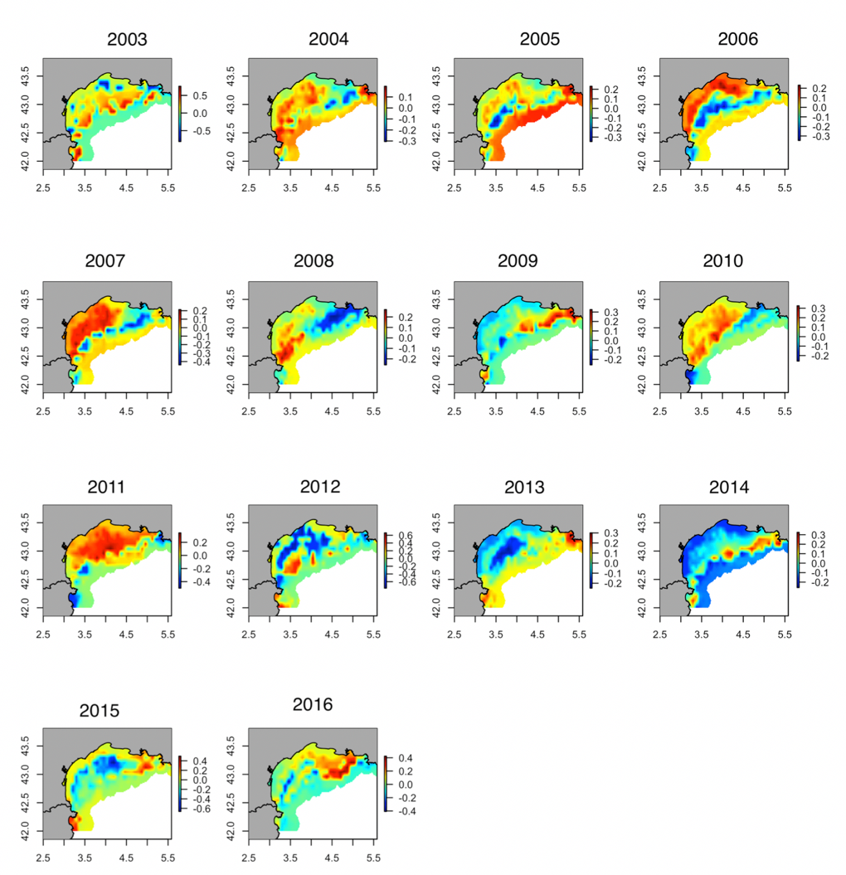
Figure S5. Spatial maps of the inter-annual deviation of the European sardine (Sardina pilchardus) occurrence collected during the MEDITS surveys from 2003-2016 obtained with RAC-BRT models in the Geographical Sub-Area 07.

Figure S6: Spatial maps of the European sardine (Sardina pilchardus) occurrence collected during the MEDITS surveys from 2003-2016 obtained with RAC-BRT models in the Geographical Sub-Area 06.

Figure S7. Spatial maps of the inter-annual deviation of the European sardine (Sardina pilchardus) occurrence collected during the MEDITS surveys from 2003-2016 obtained with RAC-BRT models in the Geographical Sub-Area 06.

Figure S8: Spatial maps of the European anchovy (Engraulis encrasicolus) occurrence collected during the MEDITS surveys from 2003-2016 obtained with RAC-BRT models in the Geographical Sub-Area 07.

Figure S9. Spatial maps of the inter-annual deviation of the European anchovy (Engraulis encrasicolus) occurrence collected during the MEDITS surveys from 2003-2016 obtained with RAC-BRT models in the Geographical Sub-Area 07.

Figure S10: Spatial maps of the European anchovy (Engraulis encrasicolus) occurrence collected during the MEDITS surveys from 2003-2016 obtained with RAC-BRT models in the Geographical Sub-Area 06.

Figure S11. Spatial maps of the inter-annual deviation of the European anchovy (Engraulis encrasicolus) occurrence collected during the MEDITS surveys from 2003-2016 obtained with RAC-BRT models in the Geographical Sub-Area 06.

Figure S12. Spatial maps of the inter-annual deviation of the European sardine (Sardina pilchardus) occurrence collected during the MEDITS surveys for the present and under IPCC scenarios in the Geographical Sub-Area 06 obtained with RAC-BRT models.

Figure S13. Spatial maps of the inter-annual deviation of the European sardine (Sardina pilchardus) occurrence collected during the MEDITS surveys for the present and under IPCC scenarios in the Geographical Sub-Area 07 obtained with RAC-BRT models.

Figure S14. Spatial maps of the inter-annual deviation of the European anchovy (Engraulis encrasicolus) occurrence collected during the MEDITS surveys for the present and under IPCC scenarios in the Geographical Sub-Area 06 obtained with RAC-BRT models.

Figure S15. Spatial maps of the inter-annual deviation of the European anchovy (Engraulis encrasicolus) occurrence collected during the MEDITS surveys for the present and under IPCC scenarios in the Geographical Sub-Area 07 obtained with RAC-BRT models.

