Supplementary Material

Supplementary Figures and Tables

Figure S1. Subcellular localization of the MdSINA2 protein. Recombinant plasmid 35S::GFP-MdSINA2 and control 35S: :GFP was transiently expressed in the epidermal cells of N. benthamiana leaves. Scale bar, 10 μm.
Figure S2. Figure S2. MdSINA2 transgenic materials were identified. (A) MdSINA2-OX calli was verified by mobility of dNA in gel electrophoresis. The recombinant plasmid of PRI-MdSINA2 was used as a positive control. (B) MdSINA2-OX calli was verified by Western blotting. The protein extract of WT calli was used as a negative control. (C) MdSINA2-OX Arabidopsis was verified by mobility of dNA in gel electrophoresis. (D) DNA sequencing proved the successful acquisition of MdSINA2^{C74S} transgenic calli.
Table S1. Primer sequences used in qRT-PCR analysis.
Table S2. Primer sequences used in Y2H assay.

Figure S1. Subcellular localization of the MdSINA2 protein. Recombinant plasmid 35S::GFP-MdSINA2 and control 35S::GFP was transiently expressed in the epidermal cells of N. benthamiana leaves. Scale bar, 10 μm.
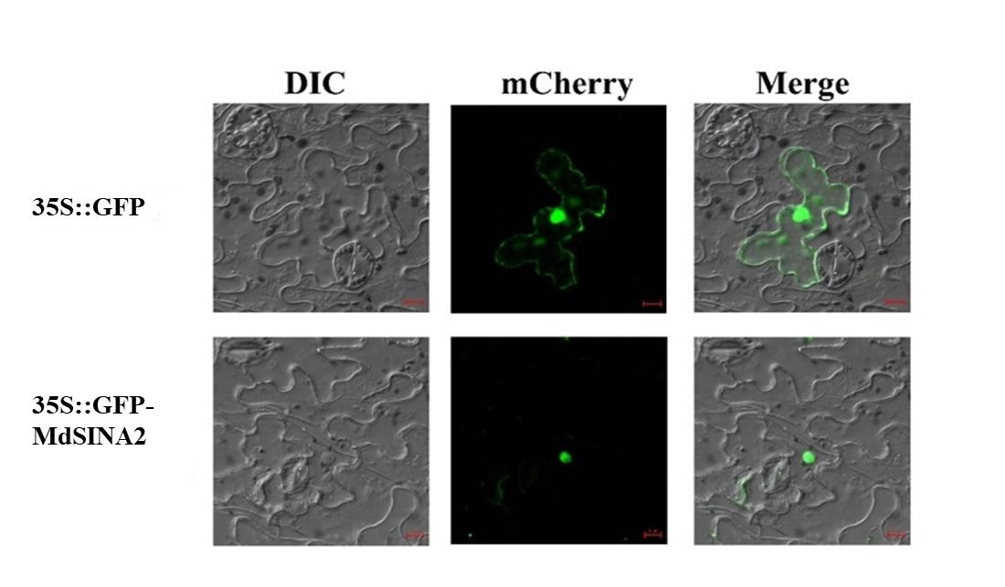

Figure S2. MdSINA2 transgenic materials were identified. (A) MdSINA2-OX calli was verified by mobility of DNA in gel electrophoresis. The recombinant plasmid of PRI-MdSINA2 was used as a positive control. (B) MdSINA2-OX calli was verified by Western blotting. The protein extract of WT calli was used as a negative control. (C) MdSINA2-OX Arabidopsis was verified by mobility of DNA in gel electrophoresis. (D) DNA sequencing proved the successful acquisition of MdSINA2^{C73S} transgenic call.
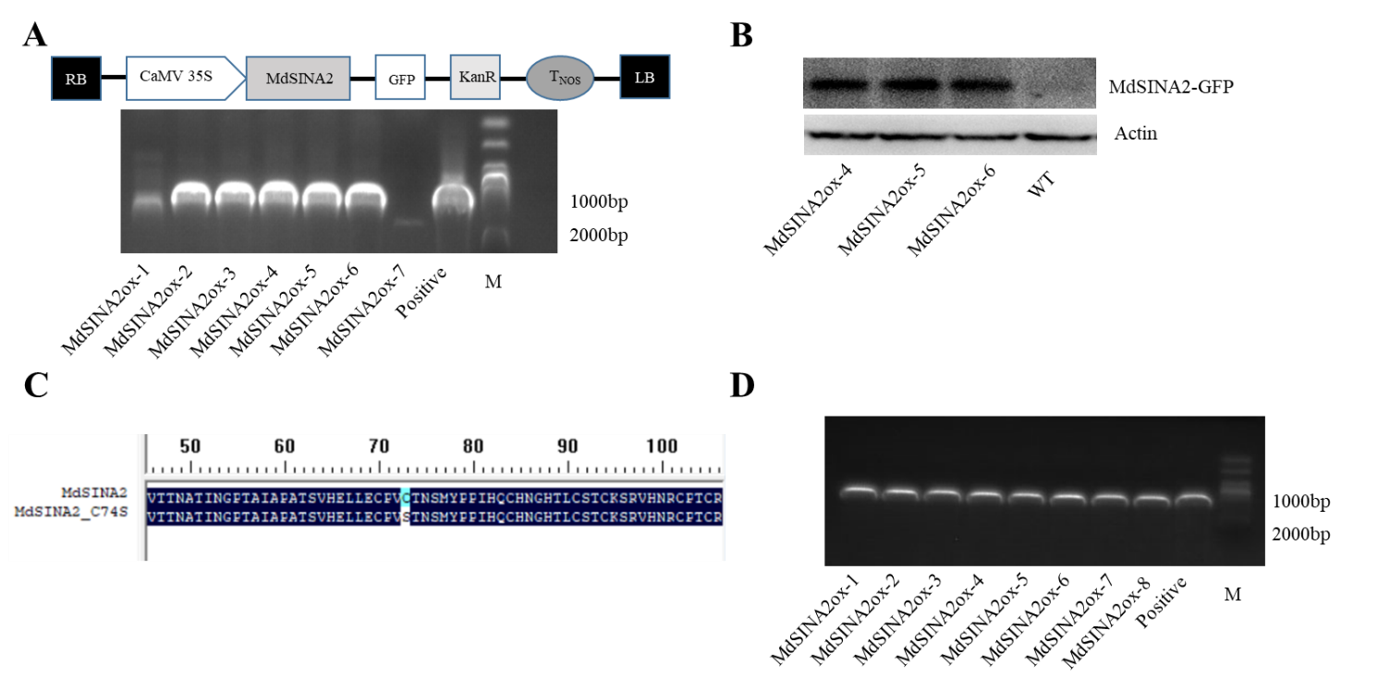

Table S1. Primer sequences used in qRT-PCR analysis.
Primer name | sequence (5’ to 3’)
MdSINA1-F  MdSINA1-R  MdSINA2-F  MdSINA2-R  MdSINA3-F  MdSINA3-R  MdSINA4-F  MdSINA4-R  MdSINA5-F  MdSINA5-R  MdSINA6-F  MdSINA6-R  MdSINA7-F  MdSINA7-R  MdSINA8-F  MdSINA8-R  MdSINA9-F  MdSINA9-R  MdSINA10-F  MdSINA10-R  MdSINA11-F  MdSINA11-R | ATAATCGGTGCCCAACGTGT  CTGAGCACCCAAGAGAGCAA  CCTTTCCTGGTTGCCCATCT  TGTTAGCATCCATGTGGCGT  AACTGCCCCTATGCTGGTTC  TGAAAGTGCTGCCATTGTGC  ATGGGTGACGATGATGAGGC  TGACTGTCACGGACCTTTCG  TCGAGAAAAACTCGGCGACA  GGATCTCCATGCACCCCAAA  TGCCCTGTGTGCTTAAATGC  TGAACCCTTGGTTTGCAACC  ATGGCCGAAAGCTGATTTGG  GAAGAAAAGCGCCATGTTGC  AGCATGAATCGGTGTGCAAC  TGAATGTGCATCCTGTGTGC  TTGGCCGTCAGTTTTGCTTG  TGCTTCGCCTCATCATCATC  TGCACTTTGAGGCTTTCCAG  TTACGGCCATTTGCACCAAC  TTTGCACTTTGAGGCCTTCC  TTACGGCCATTTGCACCAAC

Table S2. Primer sequences used in Y2H assay.
Primer name | sequence (5’ to 3’)
MdSINA1-F  MdSINA1-R  MdSINA2-F  MdSINA2-R  MdSINA3-F  MdSINA3-R  MdSINA4-F  MdSINA4-R  MdSINA5-F  MdSINA5-R  MdSINA6-F  MdSINA6-R  MdSINA7-F  MdSINA7-R  MdSINA8-F  MdSINA8-R  MdSINA9-F  MdSINA9-R  MdSINA10-F  MdSINA10-R  MdSINA11-F  MdSINA11-R | ATGGAATCAGACATCATTGAAAGTCT  AACCGCAATCGTACGCATTACTTC  ATGGACTTGGAAAGCATCGAGT  GCTACACAGGTTTGGTATGCAC  ATGGCATCTAGTAGTCCATTTTTTGA  CTGTTCCTTCCATATCCTTCCGG  ATGTCTCCTGGAGGTCGCTTCTT  GTGTTCTTTCCATATACGTCCG  ATGGAGGAGGACTGTTTTGTTGATA  GGCACTGTTGTCCTTCCAAATC  ATGGCATCCAGTAGTCCATTTTTTG  CTGTTCCTTCCATATCCTTCCGG  ATGGAATCAGACATCATTGAAAGTT  GCTACAGAGAGGTATGCAGGTC  ATGGACTTGGAAAGCATCGAGTGT  GCTACACAGGTTTGCTATGCA  ATGTCTCCTGGAGGTCGCTTCTG  GTGTTCTTTCCATATACGGCCG  ATGGCAATCACAAAGTCAGAGACA  TTCTTCTTTCCATATACGGCCAG  ATGGCAATCGCTAAGTCGGA  TTCTTCTTTCCATATACGGCCAG

