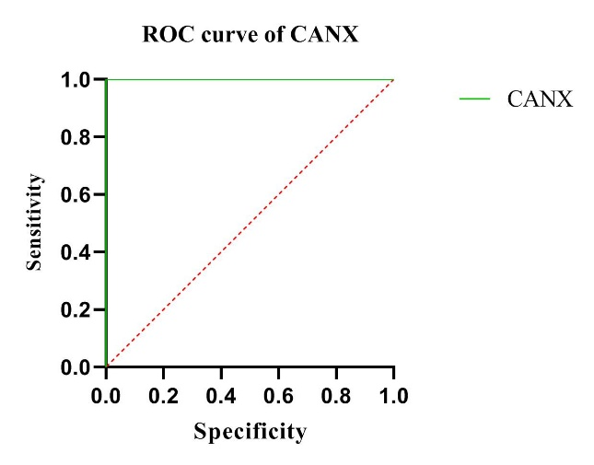

Supplementary figure 1. The ROC analysis of CANX to detect the metastatic from non-metastatic stages of breast cancer patients. The AUC of CANX was 1 (p < 0.05).

