Three Proteins (Hpa2, HrpF and XopN) Are Concomitant Type III Translocators in Bacterial Blight Pathogen of Rice
Xuyan Mo, Liyuan Zhang, Yan Liu, Xuan Wang, Jiaqi Bai, Kai Lu, Shenshen Zou, Lei Chen and Hansong Dong

Supplementary Material

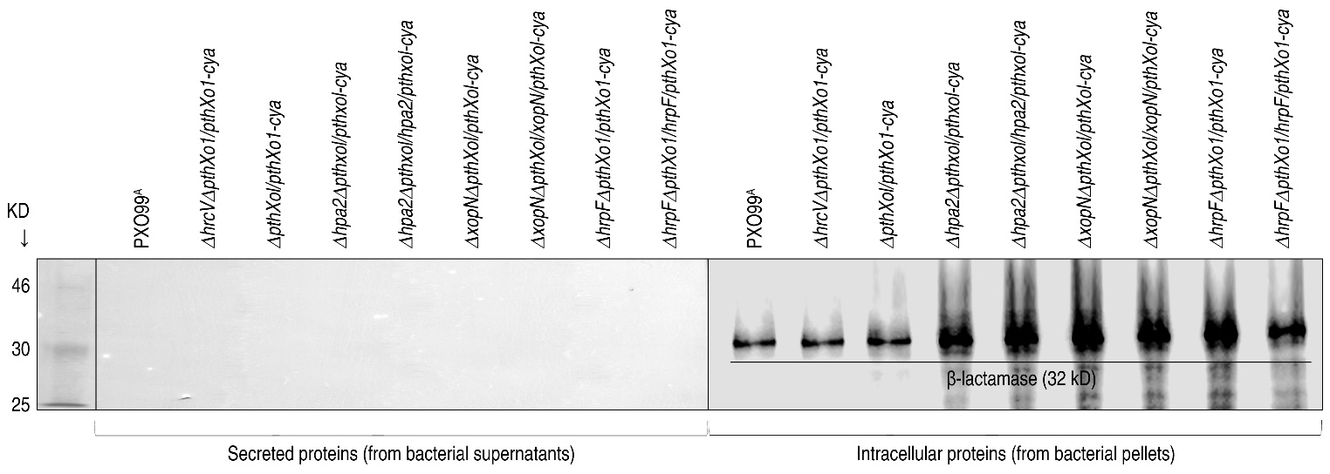
SUPPLEMENTAL FIGURE 1 | Immunoblotting of bacterial proteins hybridized in blots with the specific antibody against β-lactamase that is a cytosolic protein used as a lysis control.

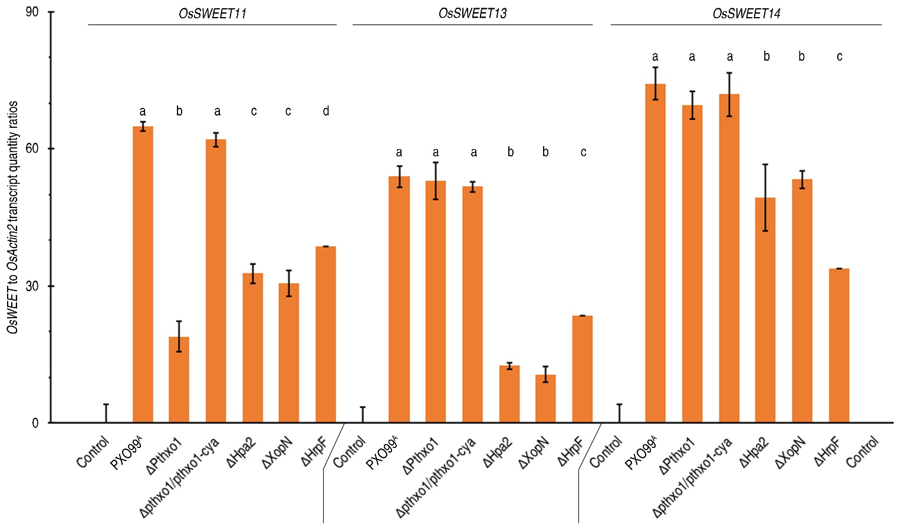
SUPPLEMENTAL FIGURE 2 | Expression of three OsSWEET genes in leaves of rice plants inoculated with the Xoo strain PXO99^{A} and the genetically recombinant strains, respectively. Leave of 30-day-old Nipponbare plants were inoculated by leaf top clipping with clinical scissors dipped in a bacterial suspension of every strain. After 24 hours, inoculated leaves were excised and used in RNA extraction. Isolated leaf RNAs were analyzed by RT-qPCR using the constitutively expressed OsActin2 gene as a reference. “Control” was the reaction without supply of leaf RANs. Data shown are mean values ± standard deviation estimates. Different letters on bar graphs indicate significant differences of data obtained from the experiments performed on the different bacterial strains (ANOVA and Duncan’s test, P < 0.001).

SUPPLEMENTAL TABLE 1 | Bacterial strains and plasmids used in this study
Strains or plasmids | Relevant characteristics | Source/reference
Strains
Escherichia coli
DH5α | F– 80dlacZ M15(lacZYA-argF) U169 endA1 deoR recA1 hsdR17(r_{K}– m_{K}⁺) phoA supE44 λ– thi-l gyrA96 relA1 | This lab
BL21(DE3) | F– ompT hsdSB (r_{B}– m_{B}–) gal dcm (DE3) | Novagen
X. oryzae pv. oryzae
PXO99^{A} | Philippine race 6 (PXO99) modified to carry an azacytidine-resistant gene, virulent to the rice cultivar Nipponbare | This lab
PXO99^{A} mutants
Δhpa2  ΔxopN  ΔhrpF  ΔpthXo1  Δhpa2ΔpthXo1  ΔxopNΔpthXo1  ΔhrpFΔpthXo1  ΔhrcV  Δhpa2/hpa2  ΔxopN/xopN  ΔhrpF/hrpF  ΔpthXo1/pthXo1  Δhpa2ΔpthXo1/hpa2/pthXo1  ΔxopNΔpthXo1/xopN/pthXo1  ΔhrpFΔpthXo1/hrpF/pthXo1  ΔpthXo1/pthXo1-cya  Δhpa2ΔpthXo1/pthXo1-cya  ΔxopNΔpthXo1/pthXo1-cya  ΔhrpFΔpthXo1/pthXo1-cya  Δhpa2ΔpthXo1/hpa2/pthXo1-cya  ΔxopNΔpthXo1/xopN/pthXo1-cya  ΔhrpFΔpthXo1/hrpF/pthXo1-cya  ΔhrcVΔpthXo1/pthXo1-cya  Δhpa2/hpa2-cya  ΔxopN/xopN-cya  ΔhrpF/hrpF-cya  ΔhrcVΔhpa2/hpa2-cya  ΔhrcVΔxopN/xopN-cya  ΔhrcVΔhrpF/hrpF-cya  Δhpa2ΔhrpFΔpthXo1/pthXo1-cya  Δhpa2ΔxopNΔpthXo1/pthXo1-cya  ΔhrpFΔxopNΔpthXo1/pthXo1-cya  Δhpa2ΔhrpFΔxopNΔpthXo1/pthXo1-cya | hpa2 unmarked mutant  xopN unmarked mutant  hrpF unmarked mutant  pthXo1 unmarked mutant  hpa2pthXo1 double unmarked mutant  xopNpthXo1 double unmarked mutant  hrpFpthXo1 double unmarked mutant  hrcV knock-out mutant  hpa2 mutant complemented with hpa2  xopN mutant complemented with xopN  hrpF mutant complemented with hrpF  pthXo1 mutant complemented with ppthXo1  hpa2pthXo1 mutant complemented with hpa2pthXo1  xopNpthXo1 mutant complemented xopNpthXo1  hrpFpthXo1 mutant complemented with hrpFpthXo1  pthXo1 mutant complemented with pthXo1-cya  hpa2pthXo1 mutant complemented with pthXo1-cya  xopNpthXo1 mutant complemented with pthXo1-cya  xopNpthXo1 mutant complemented with pthXo1-cya  hpa2pthXo1 mutant complemented with hpa2pthXo1-cya  xopNpthXo1 mutant complemented with xopNpthXo1-cya  hrpFpthXo1 mutant complemented with hrpFpthXo1-cya  hrcVpthXo1 mutant transformed with pthXo1-cya  hpa2 mutant complemented with hpa2-cya  xopN mutant complemented with pHMxopN-cya  hrpF mutant complemented with hrpF-cya  hrcVhpa2 mutant transformed with hpa2-cya  hrcVxopN mutant transformed with xopN-cya  hrcVhrpF mutant transformed with hrpF-cya  hpa2hrpFpthXo1 mutant transformed with pthXo1-cya  hpa2xopNpthXo1 mutant transformed with pthXo1-cya  hrpFxopNpthXo1 mutant transformed with pthXo1-cya  hpa2hrpFxopNpthXo1 mutant transformed with pthXo1-cya | This study  This study  This study  This lab  This study  This study  This study  This lab  This study  This study  This study  This lab  This study  This study  This study  This lab  This study  This study  This study  This study  This study  This study  This lab  This study  This study  This study  This study  This study  This study  This study  This study  This study  This study
Plasmids
pK18sacB  pHM1  pZWpthXo1  pZWpthXo1-cya  pMD18-T simple  pMS107  pET30a (+)  pET41a (+) | Suicide vector derivative from pK18mobGII, sacB⁺, Km^{R}  Broad-host range vector with pUC19 polylinker, Sp^{R}  PthXo1 fused to lacZ promoter of pBluescript II KS(+)  Cya tag inserted in the Sac I site of pZWpthXo1  pUC ori, cloning vector, Amp^{R}  pLC20H containing the PCR fragment of cyaA from nucleotide 4 to nucleotide 1221, Amp^{R}  pBR322 origin, T7 promoter His-tag, Km^{R}  pBR322 origin, T7 promoter His-tag, GST-tag, Km^{R} | This study  This study  Yang et al., 2006  This study  Takara  This lab  Novagen  Novagen

SUPPLEMENTARY TABLE 2 | Information on genes tested and primers used in this study
Gene (Locus number) | Primers / product size (bp) / subjects
hpa2 (ACD56759.1) | 5’-GTGTTGCGTGCCATTGCCTG-3’, 5’-CTATTCACCAATCACACCAC-3’ / 327 / coding sequence cloning by PCR
 | 5’-CGTGACGATTCCTCTCTGAT-3’, 5’-CTATTCACCAATCACACCAC-3’ / 1238 / promoter + coding sequence
Upstream homologous arm:
5’-GgaatccCCCCGATCAAACAGTAGAAG-3’ (EcoRI),
5’-ACGCgtcgacCCAAGGGTTGACGTGCTGAT-3’ (SalI) / 524,
Downstream homologous arm:
5’-CcccgggGGCAAGTGATCCTGCAGGGA-3’ (SmaI),
5’-GCtctagaTACAAGGTCATTGCCGGCAC-3’ (XbaI) / 541 / deletion
5’-CGggatccCGTGACGATTCCTCTCTGAT-3’ (BamHI),
5’-CGggatccCTATTCACCAATCACACCAC-3’ (BamHI) / 1238 / complemention
xopN (ACD61453.1) | 5’-TTGACCGATGCCGCCACT-3’, 5’-TTACGCCGGCGGCAGTGCCCGATCCTCCT-3’ / 2205 / coding sequence cloning by PCR
 | 5’-AGAACGCACGCTGGGTCAAC -3’, 5’-TTACGCCGGCGGCAGTGCCCGATCCTCCT-3’ / 3234 / promoter + coding sequence
Upstream homologous arm:
5’-GgaatccATGCGGCACCCGCT-3’ (EcoRI),
5’-ACGCgtcgacATCTGGCTTGGCACA-3’ (SalI) / 500,
Downstream homologous arm:
5’-ACGCgtcgacGGCTCACAATCGGAATCT-3’ (SalI) ,
5’-GCtctagaATGGCCGCTGCCGGGTAAT-3’ (XbaI) / 500 / deletion
5’-CCaagcttAGAACGCACGCTGGGTCAAC-3’ (HindIII),
5’-CCaagcttTTACGCCGGCGGCAGTGCCCGATCCTCCT’ (HindIII) / 3234/ complemention
hrpF (ACD56731.1) | 5’-ATGTCGCTCAACATGCTTTC-3’, 5’-TTATCTGCGACGTATCCTGA-3’ / 2409 / coding sequence cloning by PCR
5’-ATACACGAAGTTGGGCGCAT -3’,
5’-TTATCTGCGACGTATCCTGA-3’ / 4429 / promoter + coding sequence
Upstream homologous arm:
5’-GgaatccTGAGGTATTCACTATCTGCG -3’ (EcoRI),
5’-ACGCgtcgacATAGGCGGCCTCGCGAATGA-3’ (SalI) / 510
Downstream homologous arm:
5’-ACGCgtcgacCGCGCTTACCACAGCGAGGTTGCGTTAG-3’ (SalI),
5’-GCtctagaTACTGCGATGCGACTGCCAT-3’ (XbaI) / 520/ deletion
5’-CCaagcttATACACGAAGTTGGGCGCAT-3’ (HindIII),
5’-CCaagcttTTATCTGCGACGTATCCTGA-3’ (HindIII) / 4429 / complemention
hpa2:cya | 5’-GCgagctctaaacttatacgaaggtgctctgccaattctgtcattcgcgaggccgccta (hpa2)  GGGCAGCAATCGCATCAGGCT (cya)-3’ (SacI),  5’-GCgagctcaagcttTTAGCTGTCATAGCCGGAATCC-3’ (SacI-HindIII) / 1221 / complementation, secretion, and translocation (Cya reporting)
xopN:cya | 5’-GCgagctcgaggtcatcgtgcagatcggggaggaggatcgggcactgccgccggcgtaa (xopN)  GGGCAGCAATCGCATCAGGCT (cya)-3’ (SacI),  5’-GCgagctcaagcttTTAGCTGTCATAGCCGGAATCC-3’ (SacI-HindIII) / 1221 / complementation, secretion, and translocation
hrpF:cya | 5’-GCgagctcgagggagacgtgcggcagaatctgcgcaatgtcaggatacgtcgcagataa (hrpF)  GGGCAGCAATCGCATCAGGCT (cya)-3’ (SacI),  5’-GCgagctcaagcttTTAGCTGTCATAGCCGGAATCC-3’ (SacI-HindIII) / 1221 / complementation, secretion, and translocation
pthXo1 (AY495676) | Upstream homologous arm:  5’-CGggatccCTATTCGGATTTCGTGCTGTAC-3’ (BamHI),  5’-CAAACTGCTATGCCCAGGCTTATCGTTGTGCTCGTCCCTTTTG-3’ / 513  Downstream homologous arm:  5’-CAAAAGGGACGAGCACAACGATAAGCCTGGGCATAGCAGTTTG-3’,  5’-GCtctagaATCGTGGAATTCGCCAAGGAAT-3’ (XbaI) / 605 / deletion
OsSWEET11 (AK070510) | 5’-TGGTTCTGCTACGGCCTCTT-3’, 5’-GGTACCAGAAGTAGAGCCCCATCT-3’ / 103 / real-time RT-PCR
OsSWEET13 (AK242853) | 5’-GCCTGTCCCTGCAGCATC-3’, 5’-CTCCGTCGACTTGCTCTTGTAG-3’ / 122 / real-time RT-PCR
OsSWEET14 (AK101913) | 5’-CATCGTGGTTCTTGGTTGGG-3’, 5’-GAGAACGGCATGAACTCCAC-3’ / 114 / real-time RT-PCR
OsActin2 | 5’-CCCCTGAGGAGCACCCAGTTCTA-3’, 5’-CATACCCCTCGTAGATTGGCACAG-3’ / 219 / real-time RT-PCR

