**SUPPLEMENTARY INFORMATION**

# Car tire crumb rubber: Does leaching produce a toxic chemical cocktail in coastal marine systems?

Claudia Halsband1*, Lisbet Sørensen2, Andy M. Booth2, Dorte Herzke3

1. Akvaplan-niva, Tromsø, Norway
2. SINTEF Ocean, Environment and New Resources, Trondheim, Norway
3. NILU, Norwegian Institute of Air Research, Tromsø, Norway

*Corresponding author: [claudia.halsband@akvaplan.niva.no](mailto:claudia.halsband@akvaplan.niva.no)

**Methods**

*GC-MS analysis*

All analyses were performed with a GC-MS system comprising an Agilent 7890A GC equipped with an Agilent 5975C Mass Selective Detector (MSD) fitted with an EI ion source. The inlet was set to 250 °C, the transfer line to 300 °C, the ion source to 230 °C and the quadrupole to 150 °C. The carrier gas was helium, at a constant flow of 1.1 mL min-1. 1 μL of sample was injected by pulsed splitless injection. The GC-column was an Agilent DB5-MS ultra-inert column (30 m, 0.25 μm film thickness, 0.25 mm internal diameter). The GC oven was held at 40 °C (2 minute), ramped by 6 °C min-1 to 320 °C (20 min hold). Mass spectra were recorded after a 12 minutes hold time. For non-target screening analysis, the MS was operated in fullscan mode, 50-500 *m/z* scan range. For target analysis of PAHs and benzothiazole, the MS was operated in SIM mode and analytes were identified according to their respective molecular and fragment masses (SI). Chromatograms and mass spectra were recorded using Chemstation software, investigated in Masshunter Qualitative Navigator B.08.00, further processed using Masshunter Unknowns Analysis ("Unknowns") followed by export to csv format using Python and data processed in R.

*ICP-MS analysis*

The first approach involved decomposing the samples using HNO3, HCl and H2O2 in a Milestone Ethos microwave at 220 °C for 20 min. Aqueous samples were diluted in MilliQ and 103Rh and 115In were added as internal standards. Analysis was performed using an Agilent 8800 Triple Quadrupole ICP-MS (ICP-QQQ) fitted with a SPS 4 Autosampler and quantification achieved using standards obtained from Inorganic Ventures. In the second method, digestion of CRG was performed with a microwave high pressure reactor (UltraCLAVE, Milestone, Italy). Between 0.1-0.23 g of rubber pellets was weighed accurately on a Mettler PG503 balance and 5 mL HNO3 s.p. and 3 mL deionised water was added to each sample. The samples were extracted following a 65 minutes stepwise temperature programme, with a maximum temperature of 250oC and a hold time at this temperature of 15 min. After cooling, extracts were quantitatively transferred to polyethylene containers and diluted to 50 mL with deionized water. The diluted extracts were split into two aliquots, with BrCl added to the aliquots used for determination of Hg. Determination of Hg was performed using cold vapor atomic fluorescence spectrophotometry (CV-AFS; Tekran, Canada) according to method US-EPA-1631. Measurement of the other metals was performed using Agilent 7700x ICP-MS (Agilent, USA). In was used as internal standard and added to all samples, CRM and blanks prior analysis.

**Tables**

**Supplementary Table 1.** CRG concentrations used to produce the leachates for assessment in toxicity experiments.

|  |  |  |  |
| --- | --- | --- | --- |
| **Rubber ID** | **Concentration (g L-1)** | **Leaching period [d]** | **vol in experiment [mL L**-1**]** |
| TOS1 stock  dilutions  TOS2 stock  dilutions | 100.00  50.00  35.00  15.00  5.00  10.00  1.00  0.10  0.01 | 15  18 | 1000  500  350  150  50  -  100  10  10 |
| TRD stock  dilutions | 10.00  1.00  0.10  0.01 | 14 | -  100  10  1 |
| RGS stock  dilutions | 10.00  1.00  0.10  0.01 | 14 | -  100  10  1 |

**Supplementary Table 2.** Organic compounds tentatively identified in the RGS CRG materials and its corresponding aqueous leachate based on a ≥90% match to NIST.17 library reference spectra specified. Data were generated by non-target GC-MS screening analysis. n.d.=not detected.

|  |  |  |  |  |
| --- | --- | --- | --- | --- |
|  | **Compound** | **CAS** | **Match (%)** | |
| **CRG** | **Leachate** |
| 1 | 1,4-Benzenediamine, *N*-(1,3-dimethylbutyl)-*N*'-phenyl- | 793-24-8 | 99 | n.d. |
| 2 | Phthalimide | 85-41-6 | 99 | 90 |
| 3 | Benzothiazole | 95-16-9 | 98 | 99 |
| 4 | 1,3-Diphenylpropane | 1081-75-0 | 97 | n.d. |
| 5 | Pyrene | 129-00-0 | 97 | n.d. |
| 6 | Quinoline, 1,2-dihydro-2,2,4-trimethyl- | 147-47-7 | 96 | n.d. |
| 7 | 4-*tert*-octylphenol | 140-66-9 | 96 | n.d. |
| 8 | 2(3H)-Benzothiazolone | 934-34-9 | 96 | 98 |
| 9 | Phenanthrene | 85-01-8 | 96 | n.d. |
| 10 | Diphenylamine | 122-39-4 | 94 | n.d. |
| 11 | 2,4-Diphenyl-4-methyl-2(E)-pentene | 22768-22-5 | 94 | n.d. |
| 12 | Acenaphthylene | 208-96-8 | 93 | n.d. |
| 13 | Acetic acid *n*-octadecyl ester | 822-23-1 | 93 | n.d. |
| 14 | 3-*tert*-Butylphenol | 585-34-2 | 92 | n.d. |
| 15 | Cyclohexyl disulfide | 2550-40-5 | 92 | n.d. |
| 16 | 2-Mercaptobenzothiazole | 149-30-4 | 92 | n.d. |
| 17 | Methyl stearate | 112-61-8 | 91 | n.d. |
| 18 | *n*-Cyclohexylformamide | 766-93-8 | n.d. | 97 |
| 19 | Phthalic anhydride | 85-44-9 | n.d. | 96 |

**Supplementary Table 3.** Thermal desorption chromatograms and pyrograms of the RGS and TRD rubber. In addition to BTEX (benzene, toluene, ethylbenzene, xylenes) and C4-C6 alkylbenzenes, styrene, aniline, small ketones, alkenes and cycloalkenes eluting early in the chromatogram (particularly visible in the pyrogram), the following compounds were identified and are annotated: 1) benzothiazole, 2) 1,4-Benzenediamine, N-(1,3-dimethylbutyl)-N'-phenyl-3) methylethylidene-bisphenol, 4) d-limonene, 5) trimethyltetrahydroquinoline, 6) dimethylquinoline.

|  |  |  |
| --- | --- | --- |
| **Sample** | **Thermal desorption analysis** | **Pyrolysis** |
| RGS |  |  |
| TRD |  |  |

**Figures**

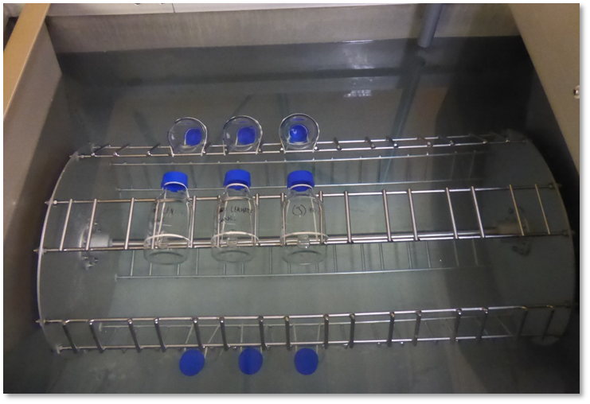

**Supplementary Figure 1.** Copepod exposure setup using a slowly rotating (0.26 rpm) plankton wheel that maintains the exposure bottles submerged in 8°C seawater.

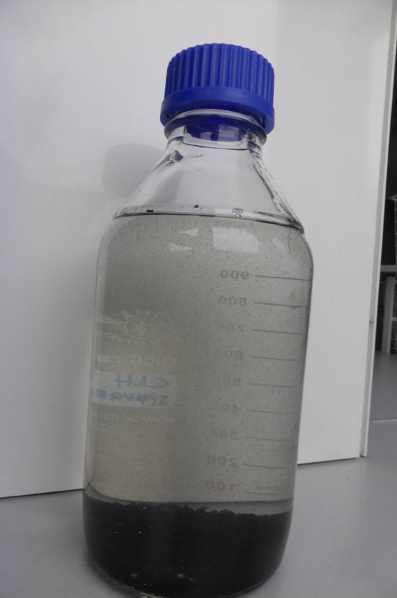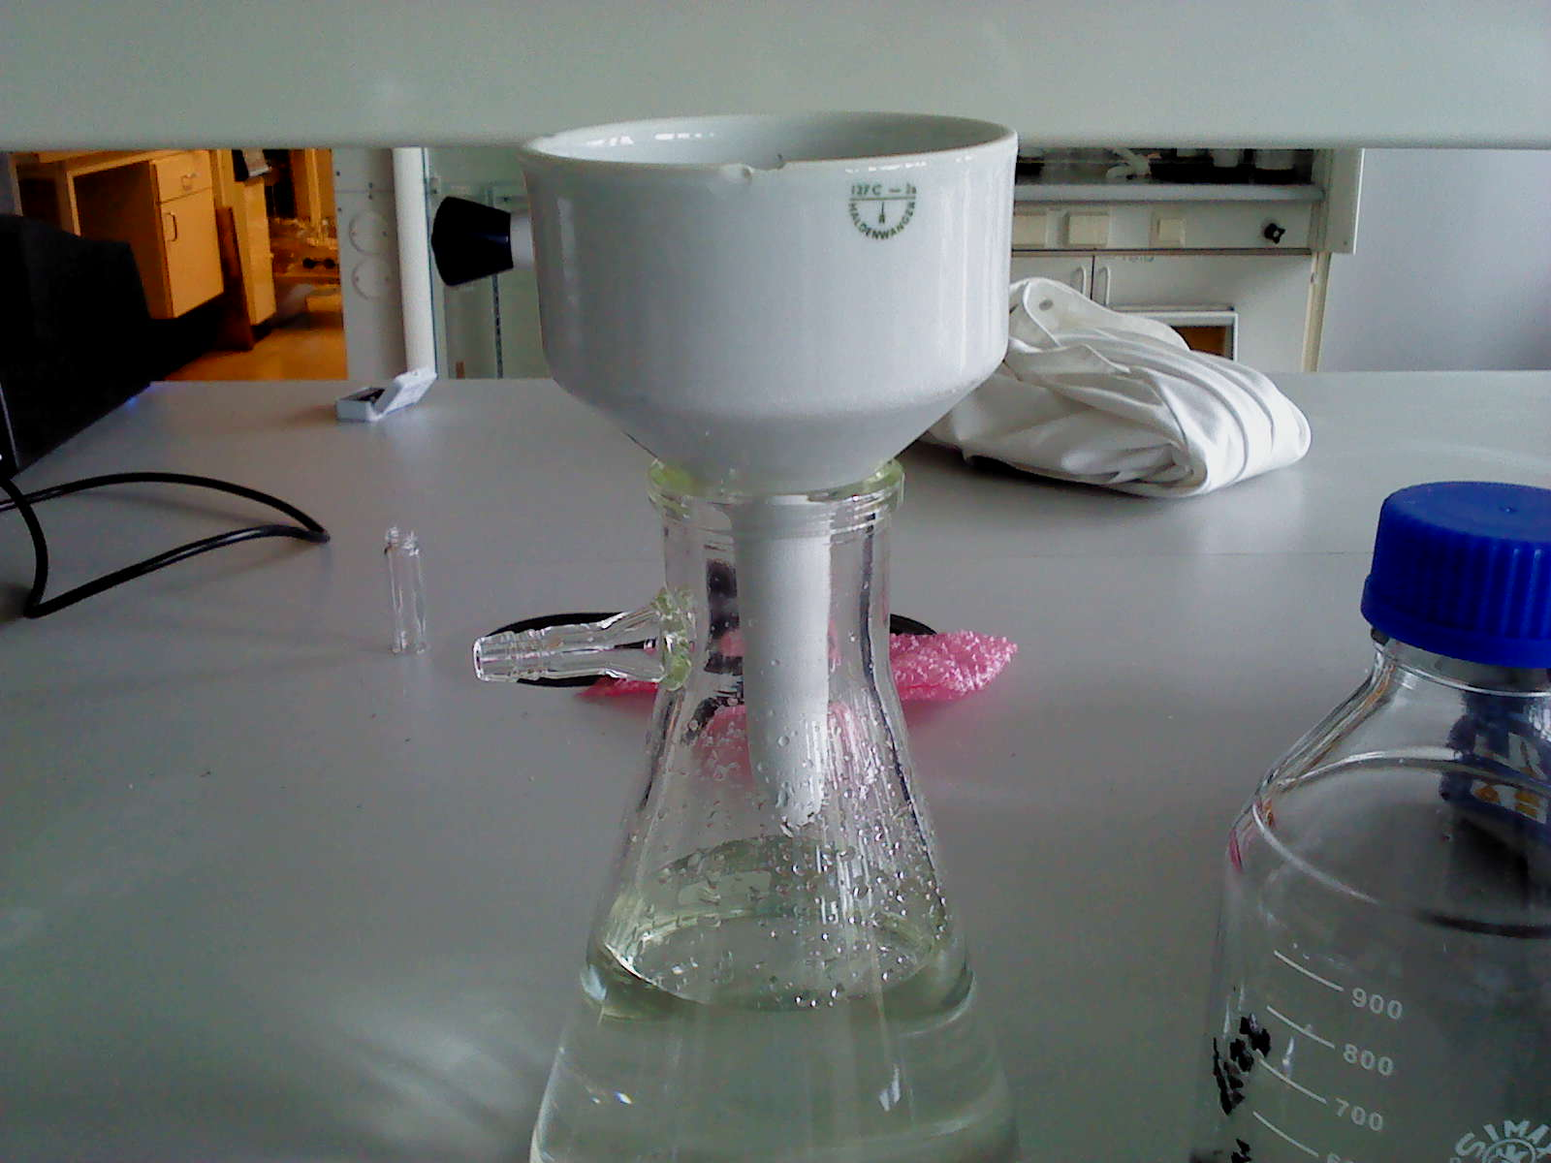

**Supplementary Figure 2.** Image of the CRG leachate produce after 14 days, showing discoloration of the water phase with leached chemicals and fine particulate material. The latter was subsequently removed using filtration to ensure only dissolved components were present in the final leachate solution.

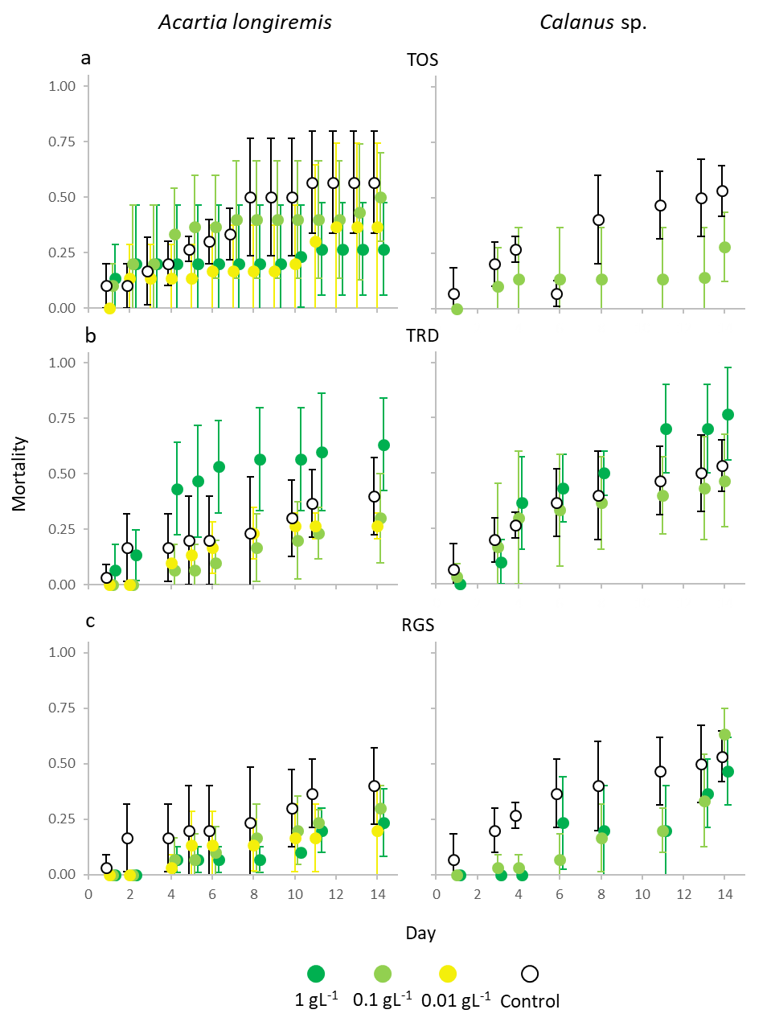

**Supplementary Figure 3.** Mortality of *Acartia longiremis* (left panels) and *Calanus* sp. (right panels) exposed to low concentrations (cf. Experiment 3) of three CRG types, a) pre-use CRG from Tromsø (TOS), b) weathered CRG from Trondheim (TRD), and c) pristine CRG from the manufacturer (RGS).