SUPPLEMENTAL: Stabilization of HIF-1α in human retinal endothelial cells modulates expression of miRNAs and pro-angiogenic growth factors

Francesca Lazzara¹*, Maria Consiglia Trotta²*, Chiara Bianca Maria Platania¹*, Michele D’Amico², Francesco Petrillo², Marilena Galdiero², Carlo Gesualdo⁴, Settimio Rossi⁴, Filippo Drago^{1,3} and Claudio Bucolo^{1,3#}.
¹Department of Biomedical and Biotechnological Sciences, School of Medicine, University of Catania, Catania, Italy; ²Department of Experimental Medicine, Division of Pharmacology, University of Campania “Luigi Vanvitelli”, Naples, Italy; ³Center for Research in Ocular Pharmacology-CERFO, University of Catania, Catania, Italy; ⁴Eye Clinic, Multidisciplinary Department of Medical, Surgical and Dental Sciences, University of Campania “Luigi Vanvitelli”, Naples, Italy.

*these authors have contributed equally to the work

# corresponding author: Prof. Claudio Bucolo. Via Santa Sofia 97. 95125 Catania, Italy. Telephone: +390954781196. E-mail: claudio.bucolo@unict.it

Figure 1S Hif-1α westernblot

Figure 2S Ponceau of membrane after gel transfer
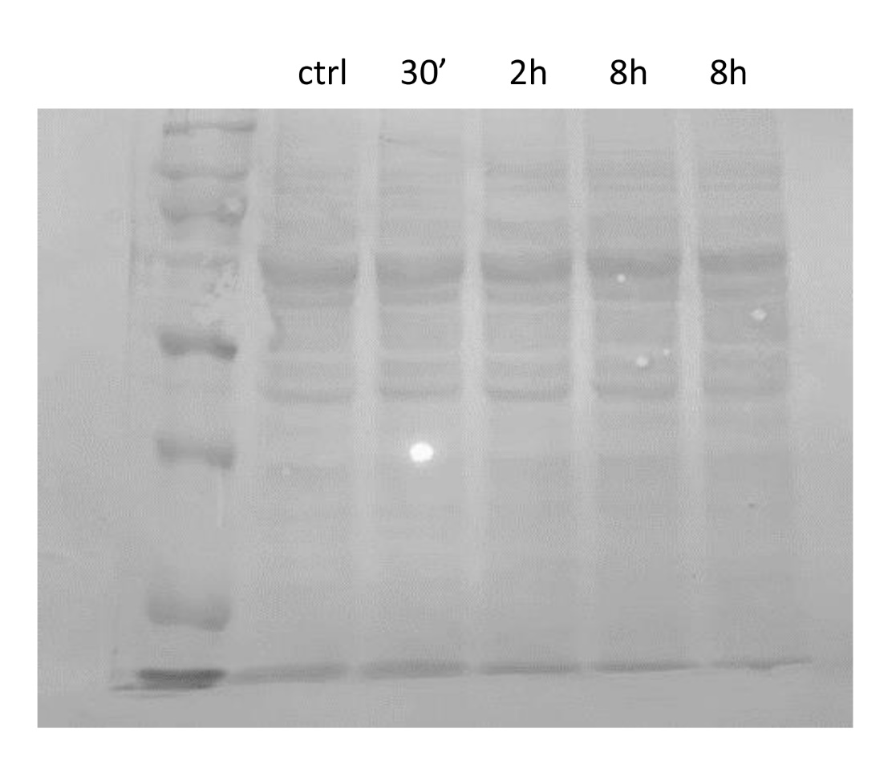

Figure 3S Whole membranes after immunoblotting for HIF1α and GAPDH
Figure 4S: MTT assay. Effects of CoCl₂ (100-200 μM for 6 and 24 h) on primary microglia HRECs. Bars are mean ± SD of at least three independent experiments.

Table 1S: Ct values for GAPDH (used as control for TGFβ signaling pathway) and Cel-miR-39-3p (used as control for miRNAs) obtained from qRT-PCR analysis. Ct values for GAPDH and Cel-miR-39-3p were not significantly modified in HRECs exposed to CoCl₂ (200 μM) for 2 or 8 hours, in comparison to control cells. Data are reported as mean ± SD of four independent experiments.

 | CTRL | CoCl2 2h | CoCl2 8h
GAPDH | 22,61 ± 0,3 | 22,44 ± 0,4 | 22,31 ± 0,6
Cel-miR-39-3p | 19,73 ± 0,5 | 19,91 ± 0,6 | 19,80 ± 0,3

