Supplementary file 1a. Rate of nitrate uptake (µmol NO₃⁻ g⁻¹ FW h⁻¹) in Gluyas Early (V1) and B.T.Schomburgk (V2) seedlings after incubation in nitrate concentrations 0.06mM, 0.6mM and 60mM for 2 hours
 | V1 | V2
0.06 | 2.2±0.1 | 2.55±0.12
0.6 | 10.33±0.67 | 14.19±1.21
60 | 1772.3±22 | 2533.4±14

Supplementary file 1b. Comparison of leaf and root nitrate reductase activity (µmol NO₂⁻ reduced g⁻¹ FW h⁻¹) of twenty days old seedlings of Gluyas Early (V1) and B.T.Schomburgk (V2) seedlings grown with 5mM nitrate supply for 15 days under hydroponic culture.
 | V1 | V2
Leaf | 0.07±0.01 | 0.14±0.01
Root | 0.1±0.007 | 0.05±0.001

Supplementary file 2. Representative images showing set up used for experiment I (trays) (a) and experiment II (pots) (b, c). Wheat genotypes were grown inside growth chambers maintained at CO₂ Ambient (CA, 400±10 µl/l) or CO₂ Elevation (CE, 700±10 µl/l) conditions and different nitrate levels. V1 –Gluyas early, V2-B.T.Schomburgk

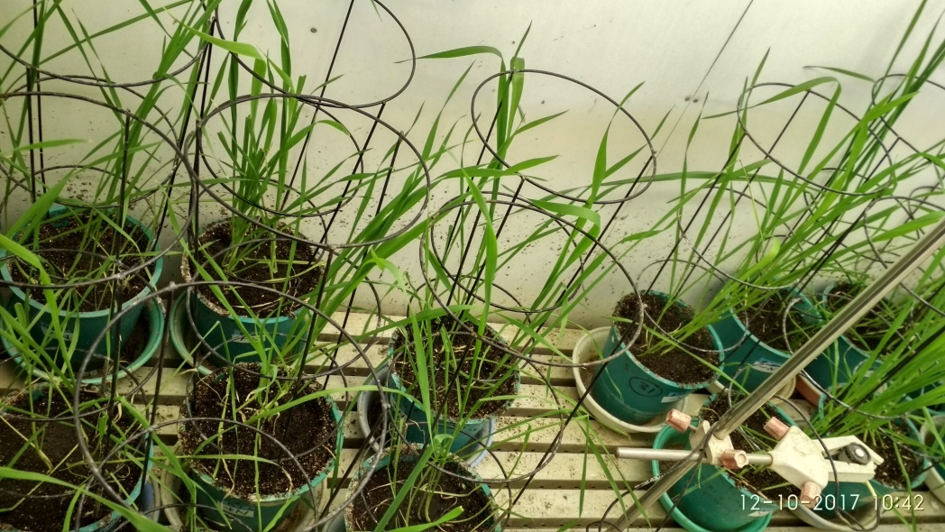
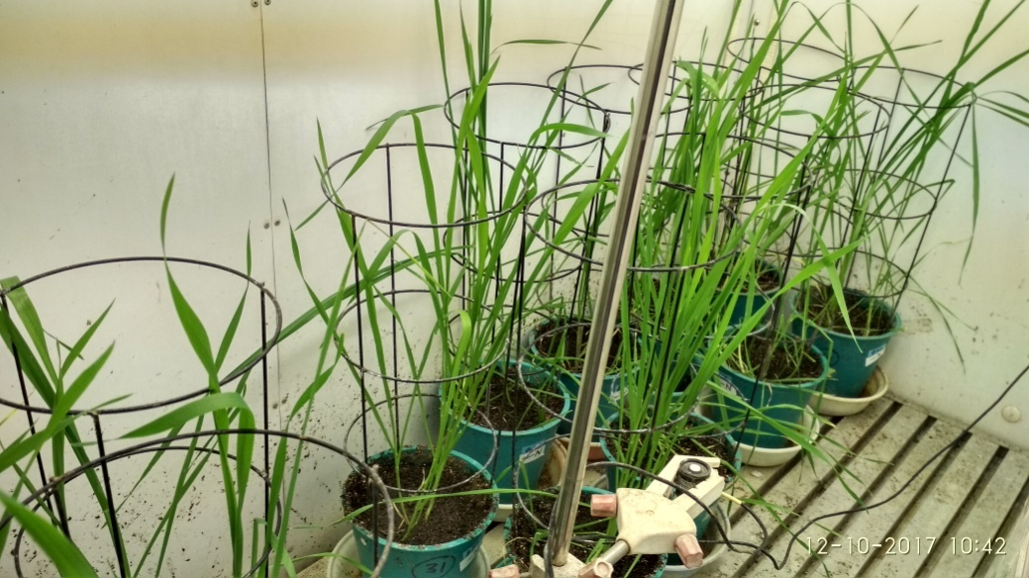
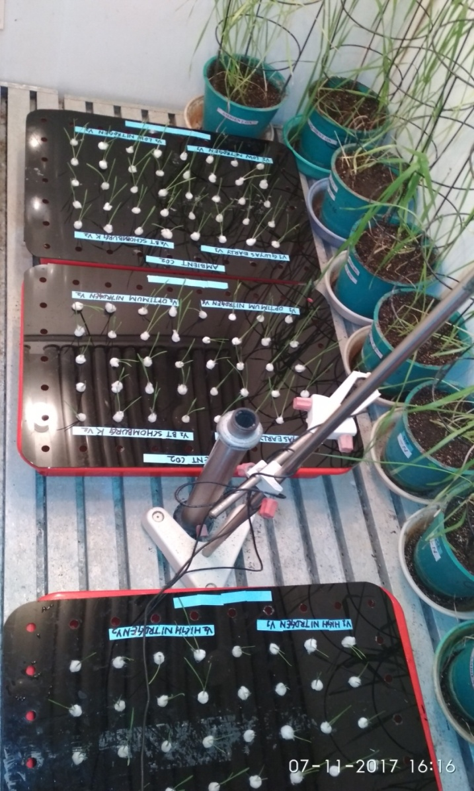
c
b
a

Supplementary file 3. List of primes used to study qRT-PCR expression of nitrate transporters gene

Sl. No. | Gene Id | Primer Name | Sequence
1 | TraesCS3A02G304400 | TaNPF1.1 -F | TCCTGTTCACGTCGTTCCT
2 |  | TaNPF1.1 -R | CCAGCACGGTGTAGTACCA
3 | TraesCS5A02G004400 | Ta TaNPF2.1 -F | CAGGACCTGGACGAGGGT
4 |  | Ta TaNPF2.1 -R | CGTCATCGAGCCCAACATC
5 | TraesCS5A02G037900 | Ta TaNPF2.2 -F | CTACGCGAGCGGTCTAA
6 |  | Ta TaNPF2.2 -R | GACGACGTTCACTGCGG
7 | TraesCS2A02G045500 | Ta TaNPF2.3 -F | GAAGGGAGGGTGGACCTATT
8 |  | Ta TaNPF2.3 -R | CAGCTTTCTTTGAGCTTTCGTC
9 | TraesCS3A02G418700 | Ta TaNPF2.4 -F | CACAAGCTGGTTGACAGATG
10 |  | Ta TaNPF2.4 -R | TCTGCTTCCGCCTCTTCC
11 | TraesCS6A02G263500 | TaNPF7.1-F | GGAGTGTCGGAAGTGATGA
12 |  | TaNPF7.1-R | ATGGACATCATGCACAGCG
13 | TraesCS7A02G301700 | TaNPF6.1-F | CGGATTCTTCGTCAGCTCG
14 |  | TaNPF6.1-R | GTAGAGCTCGCCCTTGTTG
15 | TraesCS1A02G210900 | TaNPF6.2 -F | TCACGGTGTTCCTGCTCAT
16 |  | TaNPF6.2 -R | CCTTGTGCACGATGGTTACT
17 | TraesCS1A02G031300 | TaNPF6.5 -F | GGCAGCTGGACTTCTTCAT
18 |  | TaNPF6.5 -R | CAAGGCGGCTGTGATTGAT
19 | TraesCS5A02G409600 | TaNPF6.6 -F | GGACCGTCGCCTCAATG
20 |  | TaNPF6.6 -R | AGACAAGGCCCGTTCCTAC
21 | TraesCS2A02G130600 | Ta Fd-GOGAT-F | GGTGCCACCCAGCGAAGA
22 |  | Ta Fd-GOGAT-R | GCTCGTTTCCAGAAGATGCCTTG
23 | TraesCS2A02G50040 | TaGS2-F | ACACTGAGCATGCGCGAAG
24 |  | TaGS2-R | AGCTGTCTCGTGTAGCCCT

