**SUPPLEMENTARY DATA**

**Mycovirus-induced tenuazonic acid production in a rice blast fungus *Magnaporthe* *oryzae***

Akihiro Ninomiya,1 Syun-ichi Urayama,1, 2 Rei Suo,3 Shiro Itoi,3 Shin-ichi Fuji,4 Hiromitsu Moriyama,5 Daisuke Hagiwara1, 2*

1Faculty of Life and Environmental Sciences, University of Tsukuba, 1-1-1 Tennodai, Tsukuba, Ibaraki 305-8577, Japan.

2Microbiology Research Center for Sustainability, University of Tsukuba, 1-1-1 Tennodai, Tsukuba, Ibaraki 305-8577, Japan.

3College of Bioresource Sciences, Nihon University, 1866 Kameino, Fujisawa, Kanagawa 252-0880, Japan.

4Faculty of Bioresource Sciences, Akita Prefectural University, 241-386 Kaidobata Nishi, Nakano, Shimoshinjo, Akita 010-0195, Japan.

5Department of Applied Biological Sciences, Tokyo University of Agriculture and Technology, 3-5-8 Saiwaicho, Fuchu, Tokyo 183-8509, Japan.

*Corresponding author

+81-29-853-2672, hagiwara.daisuke.gb@u.tsukuba.ac.jp

**Figures**

Figure S1. HRESIMS spectrum of tenuazonic acid (**1**).

Figure S2. Secondary metabolite profiles of APU10-199A and APU10-199A_P cultured in soy sauce-sucrose medium containing 1% dimethyl sulfoxide.

Figure S3. Colonies of the strains used in this study grown on PDA.

Figure S4. Secondary metabolite profiles of RI strains.

Figure S5. Electrophoresis of total double-stranded RNAs isolated from the strains used in this study.

**Tables**

Table S1. 1H and 13C NMR data (CD3OD) for tenuazonic acid (**1**).

Table S2. Sequences of primers used in this study.

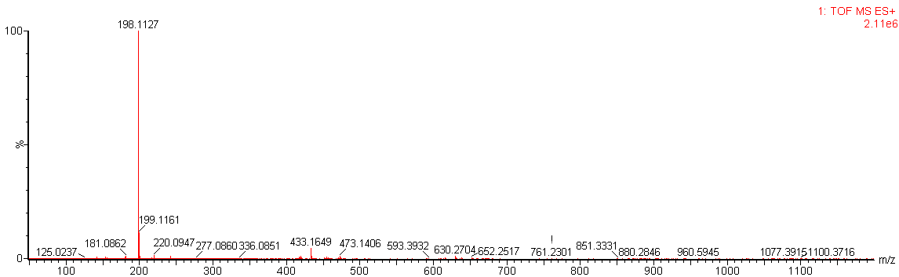

Figure S1. HRESIMS spectrum of tenuazonic acid (**1**).

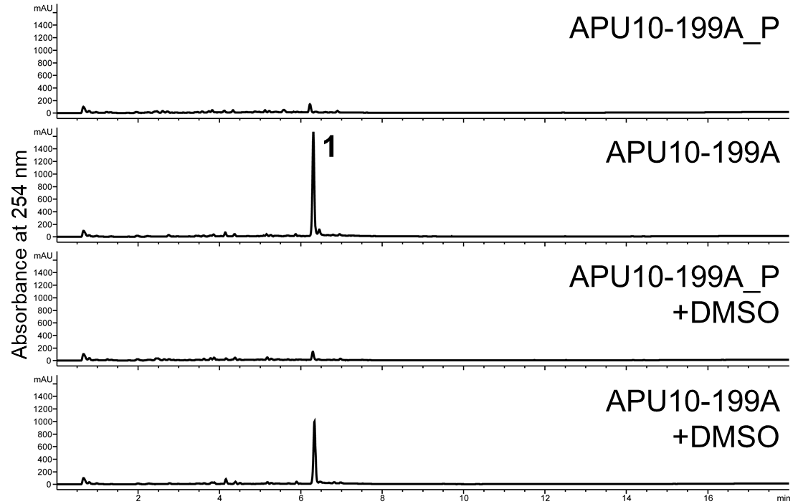

Figure S2. Secondary metabolite profiles of APU10-199A and APU10-199A_P cultured in soy sauce-sucrose medium containing 1% dimethyl sulfoxide. Production of tenuazonic acid in APU10-199A_P was not induced by addition of dimethyl sulfoxide. This data shows a representative profile from three independent culture experiments.

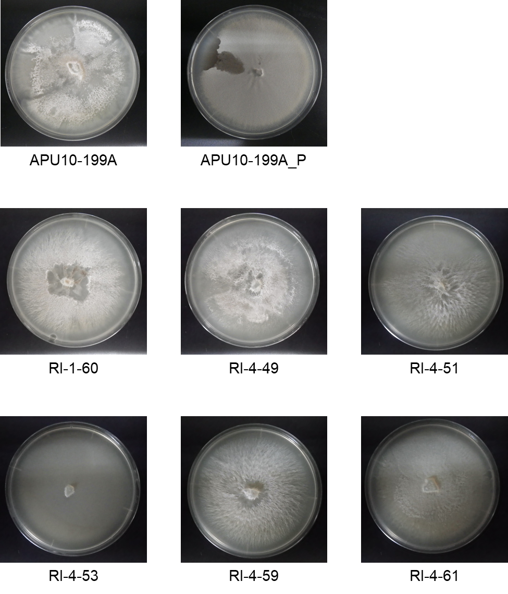

Figure S3. Colonies of the strains used in this study grown on PDA.

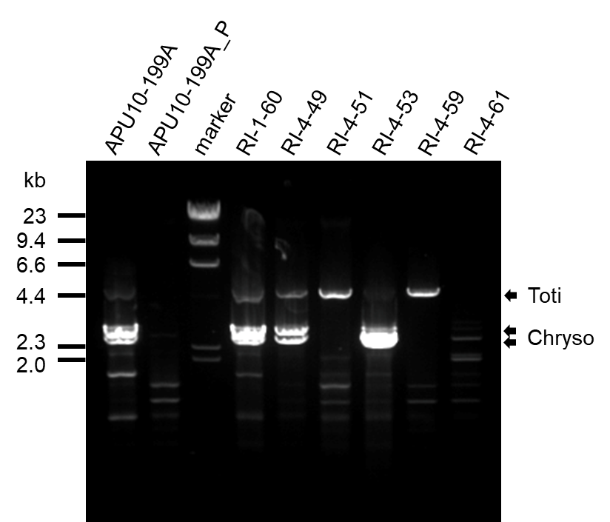

Figure S4. Electrophoresis of total double-stranded RNAs isolated from the strains used in this study.

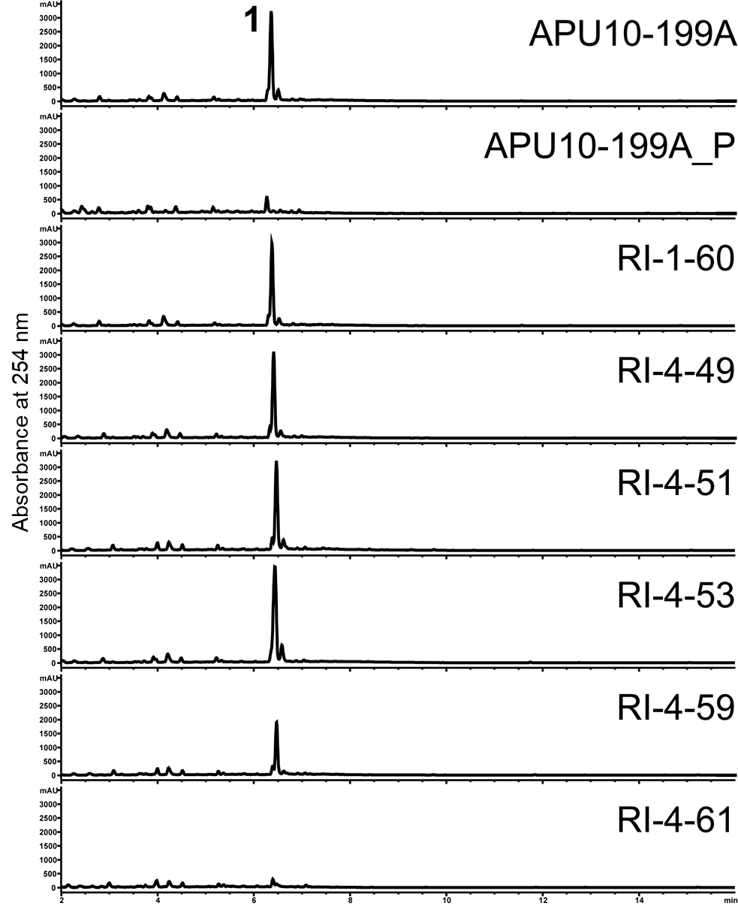

Figure S5. Secondary metabolite profiles of RI strains.

Table S1. NMR data for tenuazonic acid (**1**) in CD3OD.





Table S2. Sequences of primers used in this study.

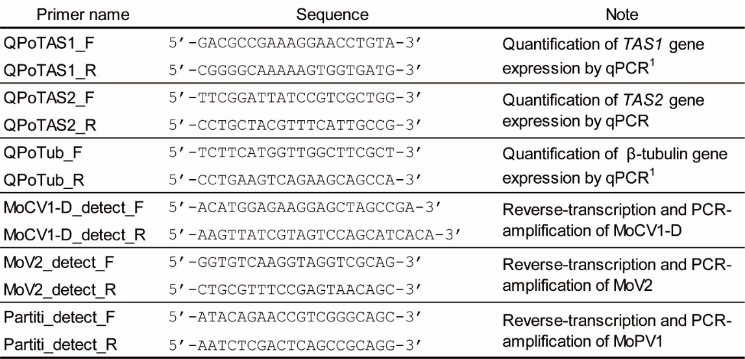

Reference 1: Yun C-S, Motoyama T, Osada H. Biosynthesis of the mycotoxin tenuazonic acid by a fungal NRPS-PKS hybrid enzyme. *Nat* *Commun* 2015;**6**:8758.