Supplementary Material

Supplementary Figures

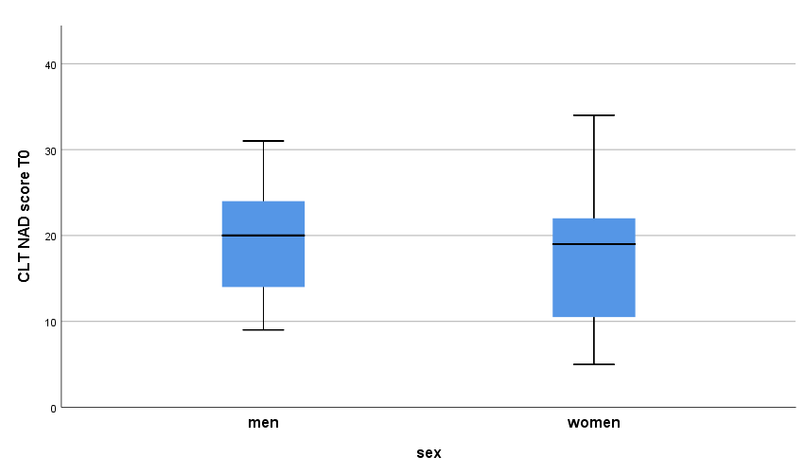
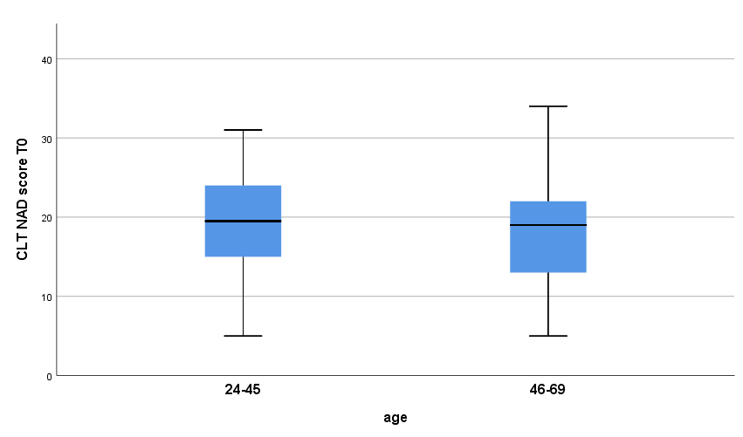
1a) 1b)
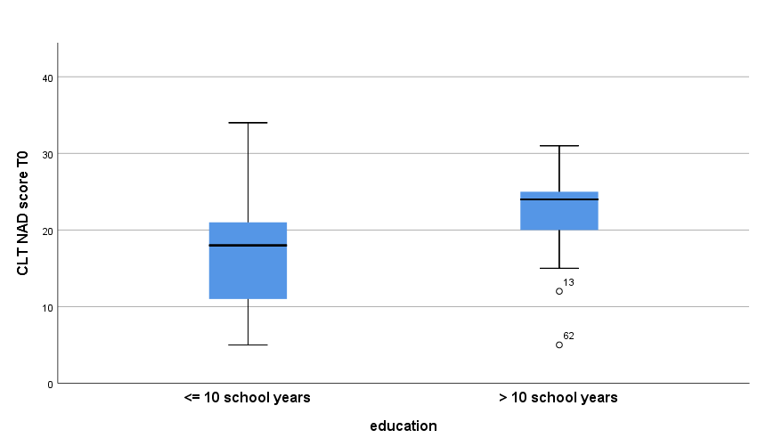
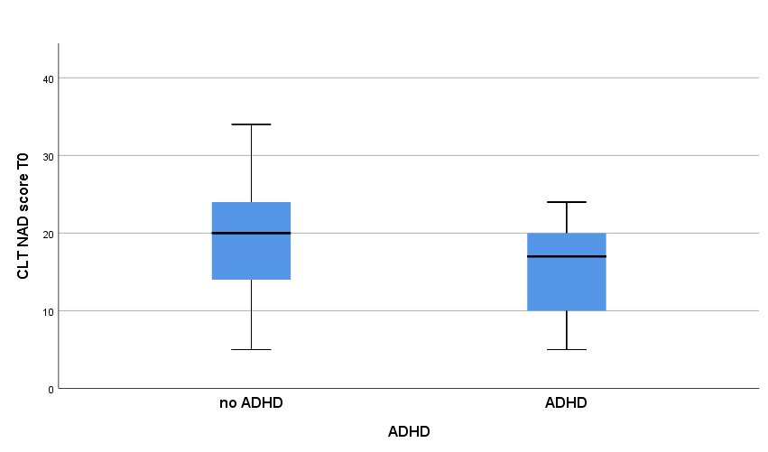
1c) 1d)
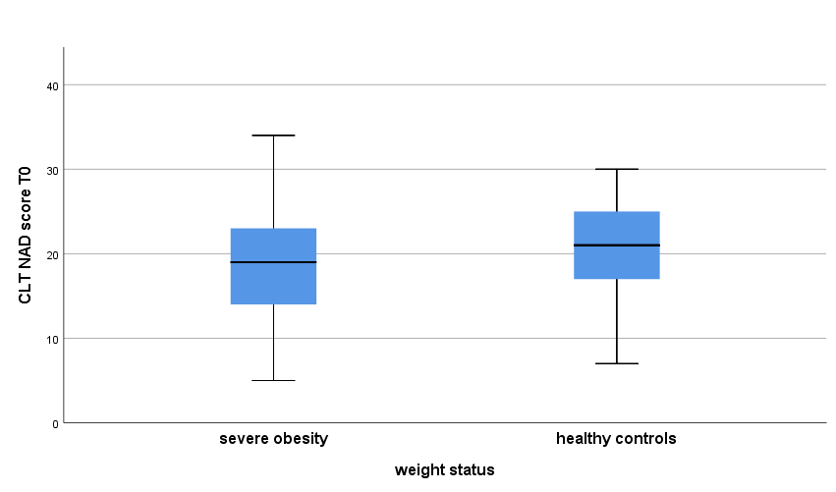
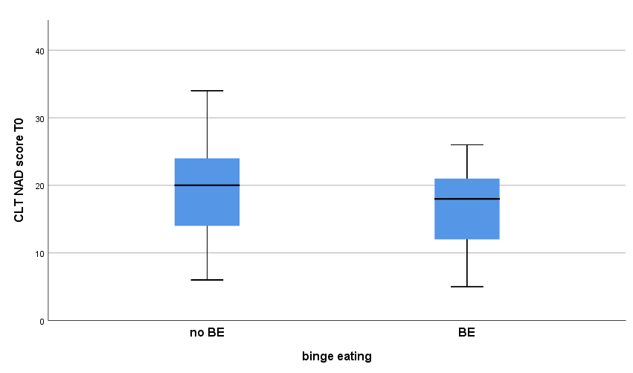
1e) 1f)

1g)
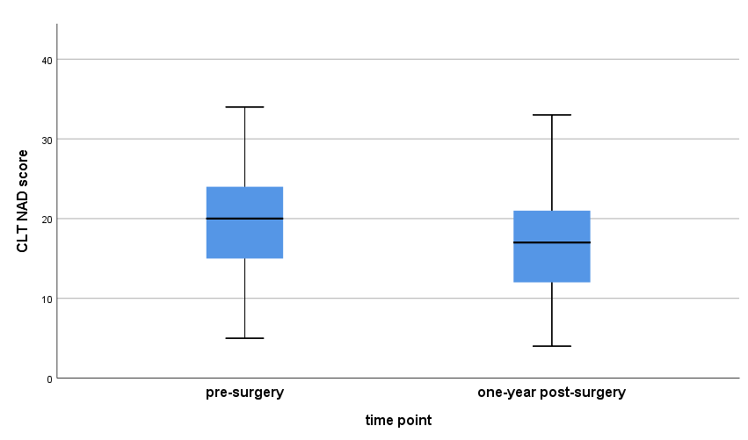

Supplementary Figures 1a-g. Differences in CLT performance depending on sociodemography (1a-1c), clinical group assignment (1d-1f), and assessment point in patients with obesity surgery (sensitivity to change, 1g). ADHD = Attention-Deficit/Hyperactivity Disorder; BE = Binge Eating; CLT = Cards and Lottery Task; NAD = Number of Advantageous Decisions.

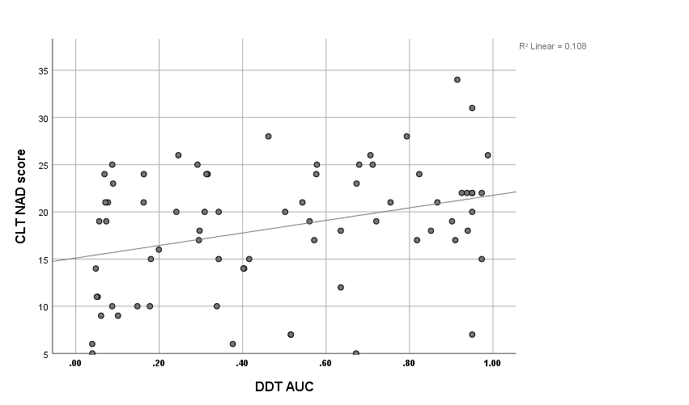
2a)

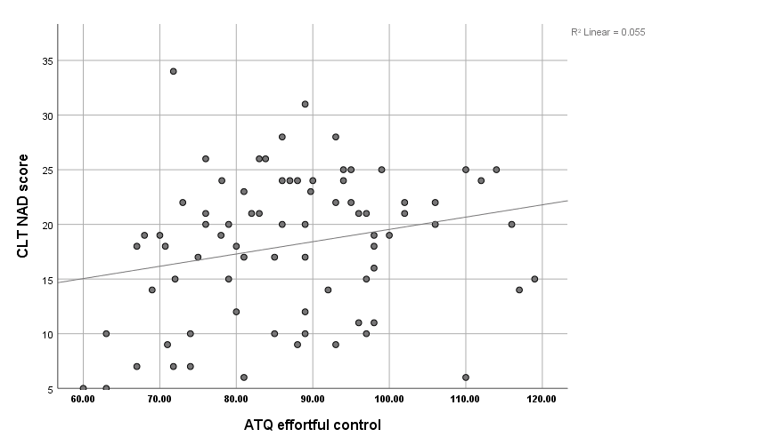
2b)

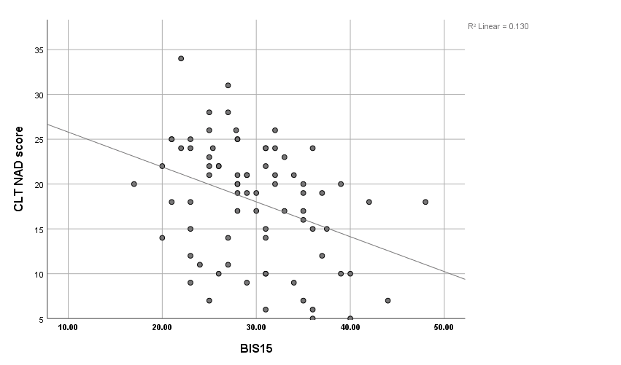
2c)

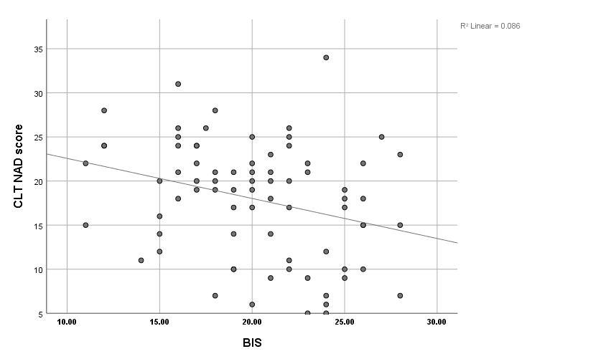
2d)

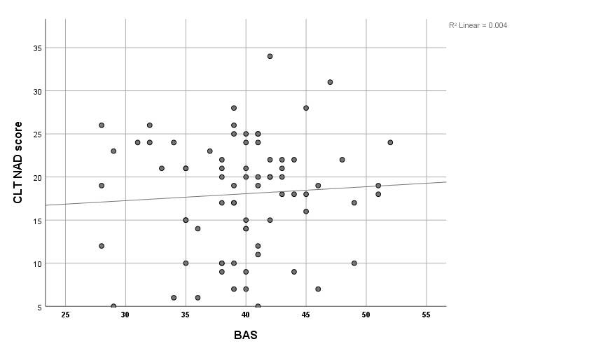
2e)

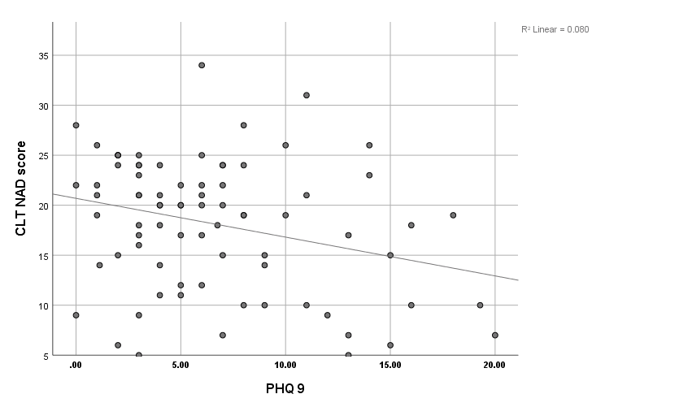
2f)

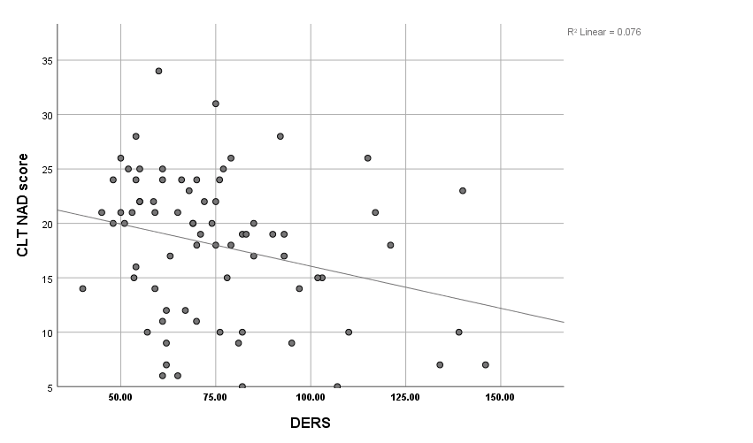
2g)

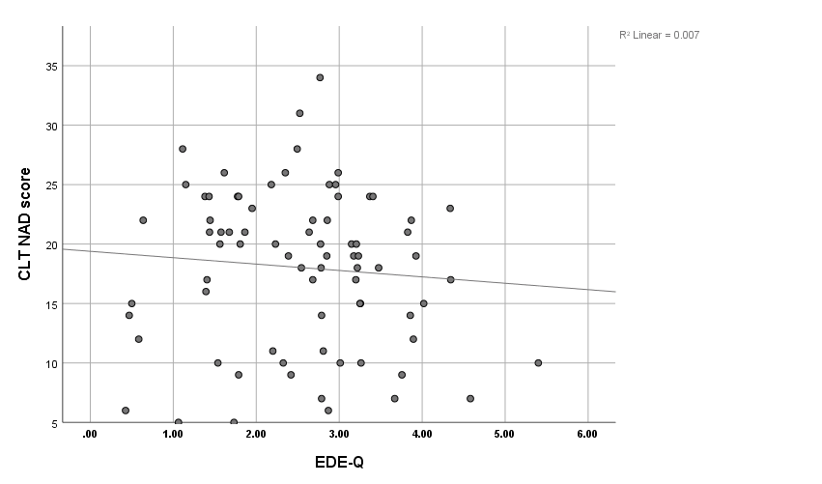
2h)

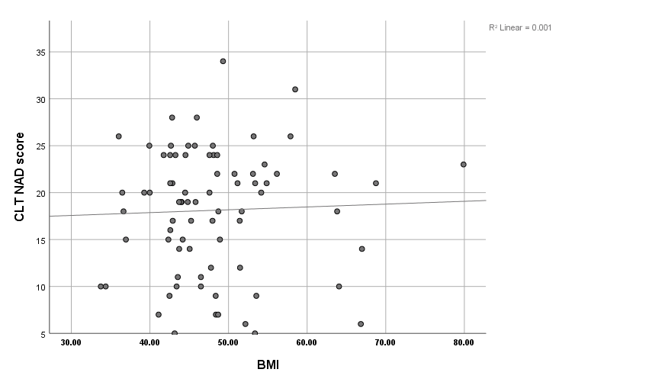
2i)

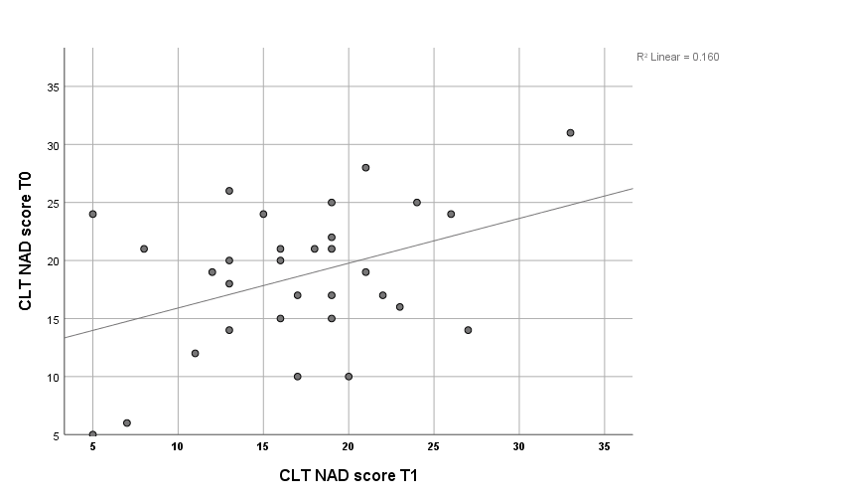
2j)

Supplementary Figures 2a-j. Scatterplots of Pearson correlations between baseline CLT performance and other measures of impulsivity (2a-2e) and clinical variables (2f-2i), and test-retest-correlation at 1-year follow-up (2j). ATQ = Adult Temperament Questionnaire; BAS = Behavioral Activation System; BIS = Behavioral Inhibition System; BIS-15 = Barratt Impulsiveness Scale – short version; BMI = Body Mass Index; CLT = Cards and Lottery Task; DERS = Difficulties in Emotion Regulation Scale; DDT = Delay Discounting Task; EDE-Q = Eating Disorder Examination-Questionnaire; NAD = Number of Advantageous Decisions; PHQ-9 = Patient Health Questionnaire Depression Scale.

Supplementary Table
Table S3. Correlations between Number of Advantageous Decisions of the Cards and Lottery Task (CLT NAD), Delay Discounting Task (DDT), Barrett Impulsiveness Scale (BIS-15), Behavioral Inhibition System (BIS) and Behavioral Activation System (BAS), Effortful Control subscale of the Adult Temperament Questionnaire-Short Form (ATQ-EC), Attention-Deficit/Hyperactivity Disorder Self-Rating Scale (ADHD-SR), Patient Health Questionnaire Depression Scale (PHQ-9), Difficulties in Emotion Regulation Scale (DERS,) and Eating Disorder Examination-Questionnaire (EDE-Q).
 | CLT NAD | DDT | BIS-15 | BIS | BAS | ATQ-EC | ADHD-SR | PHQ-9 | DERS | EDE-Q
CLT NAD | 1 | .33** | -.36** | -.29** | .07 | .23* | -.28* | -.28* | -.28* | -.09
DDT |  | 1 | -.09 | -.03 | .23 | -.02 | -.02 | .01 | .06 | .05
BIS-15 |  |  | 1 | .10 | -.12 | -.36** | .45*** | .40*** | .41*** | .12
BIS |  |  |  | 1 | -.05 | -.36** | .33** | .39*** | .58*** | .48***
BAS |  |  |  |  | 1 | .01 | -.06 | -.27* | -.09 | .07
ATQ-EC |  |  |  |  |  | 1 | -.41*** | -.25* | -.50*** | -.10
ADHD-SR |  |  |  |  |  |  | 1 | .52*** | .46*** | .29**
PHQ-9 |  |  |  |  |  |  |  | 1 | .65*** | .60***
DERS |  |  |  |  |  |  |  |  | 1 | .50***
EDE-Q |  |  |  |  |  |  |  |  |  | 1
* p < .05, ** p < .01, *** p < .001

