Table S1.Fagopyrum species used in this study
wild species number | Latin | Collection place | Deposited location
1 | F. esculentum ssp. ancestrale | Lijiang County, Yunnan Province | ICS, CAAS, BEIJING
2 | F. cymosum-Jianshui | Jianshui County, Yunnan Province | ICS, CAAS, BEIJING
3 | F. cymosum-Hutiaoxia | Shangri-La City, Yunnan Province | ICS, CAAS, BEIJING
4 | F. cymosum-Lijiang | Lijiang City, Yunnan Province | ICS, CAAS, BEIJING
5 | F. cymosum-Luojishan | Liangshan Prefecture, Sichuan Province | ICS, CAAS, BEIJING
6 | F. cymosum-Dali | Dali City, Yunnan Province | ICS, CAAS, BEIJING
7 | F. cymosum-Sun | Dali City, Yunnan Province | ICS, CAAS, BEIJING
8 | F. esculentum-Yuqiao | Yulin City, Shanxi Province | ICS, CAAS, BEIJING
9 | F. esculentum-Zhongqiao Number One.01 | Beijing | ICS, CAAS, BEIJING
10 | F. tartaricum | Liangshan Prefecture, Sichuan Province | ICS, CAAS, BEIJING
11 | F. Wild tataricum | Aba Prefecture, Sichuan Province | ICS, CAAS, BEIJING
12 | F. wenchuanense | Aba Prefecture, Sichuan Province | ICS, CAAS, BEIJING
13 | F. gracilipes var. odontopterum | Liangshan Prefecture, Sichuan Province | ICS, CAAS, BEIJING
14 | F. luojishanense | Liangshan Prefecture, Sichuan Province | ICS, CAAS, BEIJING
15 | F. rubifolium | Aba Prefecture, Sichuan Province | ICS, CAAS, BEIJING
16 | F. capillatum | Aba Prefecture, Sichuan Province | ICS, CAAS, BEIJING
17 | F. macrocarpum | Aba Prefecture, Sichuan Province | ICS, CAAS, BEIJING
18 | F. lineare | Dali City, Yunnan Province | ICS, CAAS, BEIJING
19 | F. urophyllum | Lijiang City, Yunnan Province | ICS, CAAS, BEIJING
20 | F. leptopodum | Liangshan Prefecture, Sichuan Province | ICS, CAAS, BEIJING
21 | F. jinshaense | Lijiang City, Yunnan Province | ICS, CAAS, BEIJING
22 | F. gracilipes | Liangshan Prefecture, Sichuan Province | ICS, CAAS, BEIJING

Table S2. Primers nucleotide sequences and cycling conditions used for DNA analysis
PCR region | Primer Sequences | Initial  denaturation | No. of  cycles |  | Cycling parameters |  |  | Final extension | References
 |  |  |  | Denaturation |  | Denaturation | Extension
ITS | F: TCC TCC GCT TAT TGA TAT GC  R: TCC GTA GGT GAA CCT GCG G | 94 °C  (5 min) | 35 | 94 °C  (30 s) |  | 52.5°C  (45 s) | 72°C  (1 min) | 72 °C  ( 8 min) | Zheng et al. [24]
matK | F: ATG GAG GAA TTC CAA GGA TAT TTA  R: TCA ATC ATT ATG ACT GGC CAA A | 94 °C  (5 min) | 35 | 94 °C  (30 s) |  | 55 °C  (45 s) | 72°C  (90 s ) | 72 °C  ( 8 min)
trnH-psbA | F: CGC GCA TGG TGG ATT CAC AAT CC  R: GTT ATG CAT GAA CGT AAT GCT C | 94 °C  (5 min) | 35 | 94 °C  (1 min) |  | 59 °C  (1 min) | 72°C  (1 min) | 72 °C  ( 8 min)
BM463 | F: AAA GAT GCC GAG ATA CAA CAG A  R: AGA AAT CGT GGA TGG GAG TTG G | 94 °C  (5 min) | 30 | 94 °C (30 s) |  | 55 °C  (30 s) | 72°C  (1 min) | 72 °C  ( 7 min) | Shi et al.  [26]
BM469 | F: AGT CCC AGT CAT GGT CTC AAG C  R: TAC AAC AAG AAT GGA GGG AGG A
BM517 | F: TGG GAC CAA CAA GAG TGA CAA C  R: GAC CCG TGC TTT ACT CTT TAC C.

Table S3. Genomic information used in phylogenetic analysis based on chloroplast genome
Section name | Genus name | Species name | GeneBanK Number
Polygonaceae | Fagopyrum | Fagopyrum esculentum | EU254477
Polygonaceae | Fagopyrum | Fagopyrum tataricum | KM201427
Polygonaceae | Fagopyrum | F. cymosum | KY275181
Polygonaceae | Fagopyrum | F. luojishannse | KY275182
Polygonaceae | Rheum | Rheum palmatum | KR816224
Polygonaceae | Rumex | Rumex acetosa | KC817303
Polygonaceae | Rheum | Rheum nobile | NC_046506.1
Polygonaceae | Rheum | Rheum acuminatum | MN514858.1

Table S4. Genomic information used in hierarchical cluster analysis based on ITS, matK, trnhH-psbA.
wild species number | Latin | ITS GeneBanK Number | matK GeneBanK Number | trnhH-psbA GeneBanK Number
1 | F. esculentum ssp. ancestrale | MT644598 | MT668917 | MT668925
2 | F. cymosum-Jianshui | HM357907.1 | AB093078.1 | NC_037705.1
3 | F. cymosum-Hutiaoxia | JF708196.1 | AB093074.1 | MF491390.1
4 | F. cymosum-Lijiang | AB000327.1 | JF829983.1 | KY206921.1
5 | F. cymosum-Luojishan | JN083791.1 | JN012073.1 | KY275181.1
6 | F. cymosum-Dali | FJ503008.1 | AB093081.1 | MH196562.1
7 | F. cymosum-Sun | AB000324.1 | AB093075.1 | EU554044.1
8 | F. esculentum-Yuqiao | KY945281.1 | JN012075.1 | EF653736.1
9 | F. esculentum-Zhongqiao Number One.01 | KY945315.1 | EU840460.1 | KY206922.1
10 | F. tartaricum | KY945293.1 | JN012074.1 | KX085498.1
11 | F. Wild tataricum | KY945296.1 | JF829984.1 | KY206928.1
12 | F. wenchuanense | JF829996.1 | JF829982.1 | JQ807576.1
13 | F. gracilipes var. odontopterum | MT672487 | JF829974.1 | MT668927
14 | F. luojishanense | MT644599 | MT668923 | MT668928
15 | F. rubifolium | MT644600 | MT668924 | MT668929
16 | F. capillatum | AB000323.1 | MT668920 | MT668930
17 | F. macrocarpum | MT644601 | MT668921 | MT668931
18 | F. lineare | AB000335.1 | MT668922 | KY206926.1
19 | F. urophyllum | AB000342.1 | MT668919 | KY206929.1
20 | F. leptopodum | AB000334.1 | JF829978.1 | KY206925.1
21 | F. jinshaense | MT644602 | MT668918 | MT668926
22 | F. gracilipes | AB000332.1 | JN012076.1 | KY206924.1
23 | Polygonum bistorta | FJ503009.1 | AF204859.1 | EU554046.1

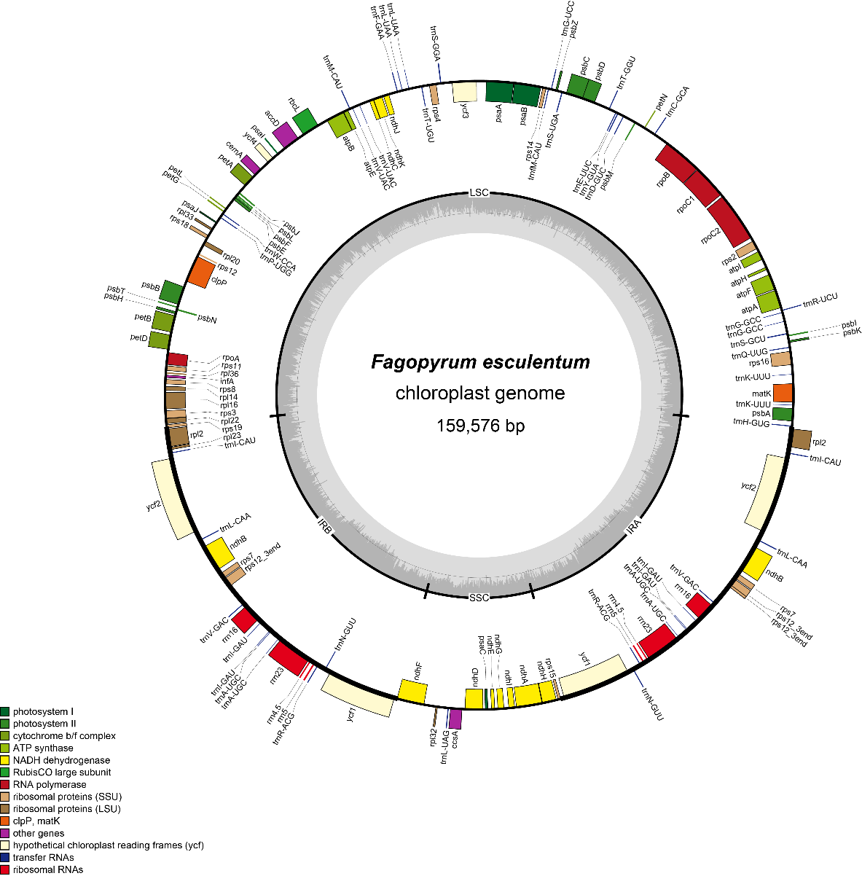
Fig S1. Gene map of F. esculentum. The genes shown outside of the circle are transcribed clockwise, while those inside are counte clockwise.

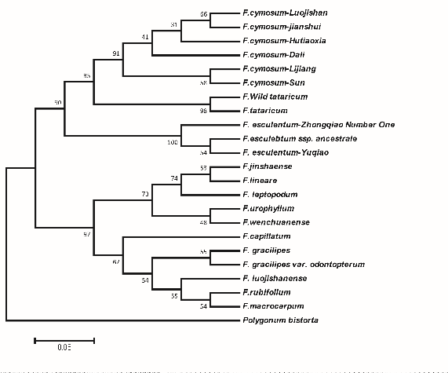
Fig S2. Dendrogram of 23 Fagopyrum species based on ITS using hierarchical cluster analysis

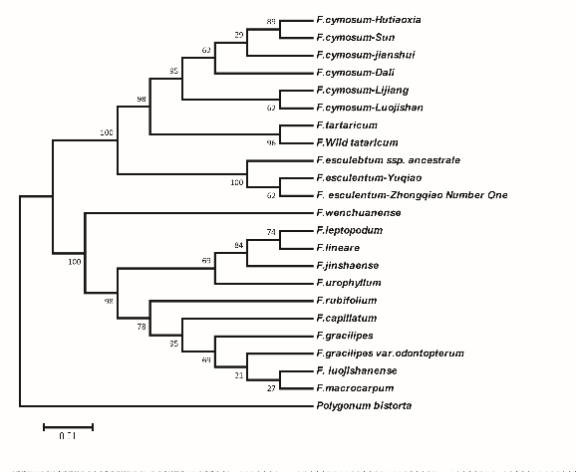
Fig S3. Dendrogram of 23 Fagopyrum species based on matK using hierarchical cluster analysis

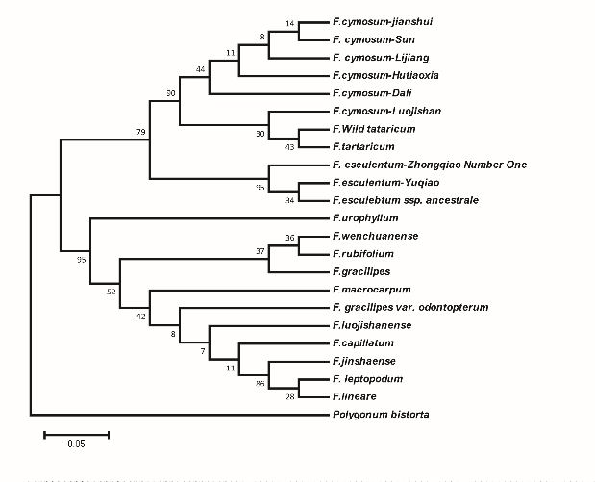
FigS4. Dendrogram of 23 Fagopyrum species based on trnhH-psbA using hierarchical cluster analysis

Fig S5. Polymorphism between three buckwheat species using SSR molecular markers, a: F. cymosum, b: F. esculentum ssp. ancestrale, c: F. esculentum

