Supplementary Material Associated with “Silicon isotopic composition of dry and wet-based glaciers in Antarctica”

Supplementary Information on Potter Peninsula Basins
In Antarctica, the climatic characteristics influences the hydrologic basin behaviour. However, the water contributions are also dependent on the permafrost aspects, snow precipitation and glacial melt. Silva Busso et al., (2009) proposed a triangular diagram to classify water basins according to their contribution water process:
Glacier contribution water basins (CG): These are characterized by the glacial melt being the most important water source. The glacier type (cold, polythermal or temperate) has a large influence on the runoff and groundwater discharge.
Snow contribution water basins (CL): Snow ablation is the most important contribution to the basin. This is true of basins where there are no glacial melt contributions in the summer and discontinuous permafrost (or talik areas) are present.
Permafrost contribution water basins (CP): These basins have continuous or discontinuous permafrost which contribute water to the streams. The thawing of the active layer in summer allows the development of supra-permafrost aquifer.
There are optimal conditions for continuous permafrost development on Potter Peninsula at 100 m.a.s.l., with an annual isotherm of -2°C (Ermolin and Silva Busso, 2014). At lower elevations the development of permafrost is discontinuous and sporadic, depending on the relationship with the local free aquifers and the formation of cryopeg in the coastal area. In the Potter Peninsula all basins contain continuous and discontinuous permafrost and the Fourcade Glacier (Warszawa Icefield) is the most important water contribution in the basins directly related to its glacier discharge. In basins where there is no direct contribution, surface and sub-surface hydrological processes are observed to be strongly influenced by the present glacial retreat and active permafrost. The variety of periglacial landforms and cryogenic phenomena determine the permafrost and groundwater development with the basins (Table 1).

Table 1. Cryogenic processes in Potter Peninsula (Ermolin and Silva-Busso, 2008)
Geomorphology | Cryogenic conditions | Surface and groundwater
Present bottom and terminal moraine | Newly formed permafrost: icing, injection ice blister, frost jacking | Streams, outlets of subglacial and supra-permafrost water
Holocene lateral moraine | Continuous permafrost: cryogenic landslide, thermokarst | Supra-permafrost water, evidence of rock avalanche
Holocene bottom moraine | Continuous permafrost: frost jacking, sorted stripe | Outlets of inter-permafrost water, temporal stream
Talus and gravity slope | Continuous permafrost; cryogenic landslide, frost jacking | Temporal streams, evidence of groundwater avalanche
Bedrock outcrop | Continuous permafrost: frost action, cryoeluvium formation | Supra-permafrost water
Fluvio-glacial plain | Discontinuous permafrost: sorted stripe thermoerosion, injection ice blister, icing | Temporary streams, outlet of intra-permafrost water
Wetland | Discontinuous permafrost: sorted stripe, frost jacking | Puddles, outlet of supra-permafrost water
Beach | Permafrost limit, freezing temporal layer | Puddles and temporal channel, supra-permafrost water
The basins in Potter Peninsula has a surface drainage system and subsurface supra-permafrost and inter-permafrost waters related to drawdown and thickness of the active layer and local divergence of permafrost.
In recent years, geoelectrical studies have been carried out in different parts of Potter Peninsula, particularly over the Matías Basin (Silva-Busso, 2009). The temporary nature of the hydrologic and groundwater regimes in this basin are related to the topographic slope and in particular to the recharge and discharge processes in relation with the local permafrost characteristics. The continuous and discontinuous permafrost presence and the meagre development of the active layer and cryogenic processes in the area during the southern summer accompanies the development of the hydrogeology processes. In the summer, the unconfined supra-permafrost aquifer hydrodynamically controls the hydrologic system across the basin, particularly on the wetlands. This characteristic is very typical in permafrost quaternary sediments and can be found also in other areas or islands of the South Shetland Islands (Ermolin and Silva-Busso, 2008).

Supplementary Tables
Supplementary Table 1: Summary of samples collected from Commonwealth Stream and Potter Peninsula. For locations see Figure 1 in main text.
Stream |  | Date | Time | Q (L s⁻¹) | DSi (µM) | δ³⁰Si (‰) | D:M* (µeq)
Commonwealth | Gauge | 25/11/14 | 16:10 | 0.45 | 14.1 | 0.86 | -
 | Gauge | 19/12/14 | 12:35 | 64.19 | 13.0 | 0.69 | 3.87
 | Gauge | 30/12/14 | 16:00 | 79.35 | 9.41 | 0.79 | 12.4
 | Gauge | 27/01/15 | 09:42 | 21.08 | 16.3 | 1.14 | 11.0
 | Gauge | 24/11/15 | 15:33 | 0.03 | 15.8 | 0.71 | -
 | Gauge | 04/12/15 | 15:24 | 355.19 | 8.71 | 0.65 | -
 | Gauge | 19/01/16 | 14:01 | 220.25 | 17.0 | 0.74 | -
 | Gauge | 21/12/16 | 14:30 | 51.97 | 9.56 | 0.27 | 3.66
 | Gauge | 29/12/16 | 16:00 | 32.15 | 14.6 | 0.59 | 3.76
 | Gauge | 12/01/17 | 15:20 | 12.02 | 15.9 | 0.61 | 3.04
 | Gauge | 03/02/17 | 12:55 | 73.07 | 34.5 | 0.41 | 2.76
 | Mouth | 01/01/16 | 12:45 | 147.30 | 23.2 | 0.38 | 0.44
 | Mouth | 01/01/16 | 13:30 | 172.37 | 24.5 | 0.34 | 0.31
 | Mouth | 01/01/16 | 14:15 | 158.05 | 29.2 | -0.12 | 0.33
 | Mouth | 01/01/16 | 15:00 | 209.37 | 29.5 | -0.27 | 0.28
 | Mouth | 01/01/16 | 15:45 | 234.12 | 33.4 | -0.40 | 0.31
 | Mouth | 01/01/16 | 16:15 | 205.70 | 41.3 | -0.39 | 0.28
Potter Peninsula | W19 | 25/02/12 | 10:00 | - | 58.0 | 1.23 | 1.44
 | W20 | 25/02/12 | 10:00 | - | 46.7 | 0.63 | 0.84
 | W21 | 26/02/12 | 11:38 | - | 33.2 | 0.63 | 2.98
 | W22 | 26/02/12 | 12:15 | - | 37.8 | 0.61 | 1.72
 | W23 | 27/02/12 | 10:00 | - | 25.9 | -0.23 | 0.46
 | W24 | 27/02/12 | 10:00 | - | 19.4 | 0.72 | 1.31
 | W25 | 29/02/12 | 18:00 | - | 40.4 | 1.02 | 1.32
 | W35 | 26/01/13 | 14:30 | - | 26.4 | 0.22 | 0.51
 | W39 | 06/02/13 | 17:27 | - | 15.5 | 0.38 | 1.04
 | W40 | 07/02/13 | 17:00 | - | 19.3 | 0.35 | 0.84
 | W41 | 08/02/13 | 11:05 | - | 39.9 | 0.80 | 1.64
 | W45 | 14/02/13 | 13:36 | - | 33.1 | 0.81 | 1.21
 | W49 | 01/03/13 | 11:15 | - | 11.1 | 0.01 | 1.44
 | W50 | 01/03/13 | 11:27 | - | 17.7 | 0.37 | 0.40

Supplementary Table 2: Comparison between uncorrected major ion concentrations and major ion concentrations for atmospheric deposition.
 |  | Uncorrected Concentrations (µeq L⁻¹) |  |  |  |  |  | Corrected Concentrations (µeq L⁻¹)
Sample |  | Na⁺ | K⁺ | Mg²⁺ | Ca²⁺ | SO₄²⁻ | Cl⁻ |  | Na⁺* | K⁺* | Mg²⁺* | Ca²⁺* | SO₄²⁻*
Commonwealth | Gauge | 429 | 27.3 | 165 | 381 | 75.1 | 642 |  | - | 15.3 | 40.5 | 357 | 52.9
 | Gauge | 117 | 11.6 | 38.0 | 108 | 31.8 | 111 |  | 21.6 | 9.6 | 16.4 | 104 | 28.0
 | Gauge | 163 | 14.0 | 54.5 | 154 | 41.8 | 186 |  | 2.9 | 10.5 | 18.3 | 147 | 35.4
 | Gauge | 160 | 17.9 | 86.8 | 259 | 53.7 | 171 |  | 13.2 | 14.7 | 53.6 | 252 | 47.8
 | Gauge | 382 | 26.4 | 102 | 246 | 82.6 | 474 |  | - | 17.5 | 10.7 | 228 | 66.3
 | Gauge | 142 | 14.5 | 41.5 | 102 | 40.9 | 171 |  | - | 11.3 | 8.3 | 95.6 | 35.0
 | Gauge | 181 | 18.4 | 75.5 | 163 | 98.6 | 238 |  | - | 14.0 | 29.3 | 154 | 90.5
 | Gauge | 102 | 12.5 | 35.1 | 103 | 33.0 | 93.7 |  | 21.1 | 10.7 | 16.8 | 99.5 | 29.8
 | Gauge | 155 | 18.2 | 63.9 | 177 | 42.5 | 134 |  | 40.2 | 15.7 | 37.9 | 172 | 37.9
 | Gauge | 170 | 18.7 | 80.0 | 187 | 50.4 | 126 |  | 61.9 | 16.3 | 55.5 | 183 | 46.0
 | Gauge | 142 | 17.1 | 66.8 | 153 | 42.8 | 100 |  | 56.2 | 15.2 | 47.3 | 149 | 39.4
 | Mouth | 721 | 52.0 | 112 | 194 | 68.0 | 239 |  | 516 | 47.5 | 65.5 | 185 | 59.8
 | Mouth | 807 | 56.0 | 98.0 | 166 | 66.0 | 232 |  | 608 | 51.7 | 52.9 | 157 | 58.0
 | Mouth | 755 | 54.0 | 92.0 | 160 | 78.0 | 295 |  | 502 | 48.5 | 34.6 | 148 | 67.8
 | Mouth | 735 | 54.0 | 76.0 | 140 | 64.0 | 247 |  | 523 | 49.4 | 28.0 | 130 | 55.5
 | Mouth | 671 | 52.0 | 72.0 | 142 | 56.0 | 219 |  | 483 | 47.9 | 29.4 | 133 | 48.5
 | Mouth | 698 | 51.0 | 72.0 | 136 | 54.0 | 227 |  | 503 | 46.8 | 27.9 | 127 | 46.2
Potter Peninsula | W19 | 2229 | 48.1 | 612 | 996 | 290 | - |  | 622 | 14.3 | 137 | 779 | 275
 | W20 | 2287 | 39.4 | 502 | 556 | 284 | - |  | 639 | 11.7 | 113 | 434 | 270
 | W21 | 449 | 3.6 | 81 | 458 | 186 | - |  | 125 | 1.1 | 18.2 | 358 | 176
 | W22 | 872 | 12.3 | 220 | 482 | 115 | - |  | 243 | 3.7 | 49.7 | 376 | 109
 | W23 | 1336 | 27.6 | 266 | 149 | 137 | - |  | 373 | 8.2 | 60.0 | 116 | 130
 | W24 | 170 | 3.0 | 48.2 | 66.8 | 17.8 | - |  | 47.3 | 0.9 | 10.8 | 52.3 | 16.9
 | W25 | 446 | 4.8 | 98.2 | 184 | 42.6 | - |  | 124 | 1.4 | 22.1 | 144 | 40.4
 | W35 | 3716 | 74.8 | 866 | 444 | 304 | - |  | 1037 | 22.3 | 194 | 348 | 288
 | W39 | 381 | 4.8 | 67.2 | 123 | 34.8 | - |  | 106 | 1.4 | 15.1 | 96.5 | 33.1
 | W40 | 463 | 9.1 | 69.2 | 121 | 45 | - |  | 129 | 2.7 | 15.6 | 95.1 | 42.8
 | W41 | 465 | 4.4 | 100 | 246 | 54.2 | - |  | 130 | 1.3 | 22.7 | 192 | 51.5
 | W45 | 810 | 20.8 | 208 | 300 | 129 | - |  | 226 | 6.2 | 47.0 | 234 | 12
 | W49 | 241 | 3.1 | 37.8 | 115 | 7.6 | - |  | 67.3 | 0.9 | 8.5 | 89.9 | 7.1
 | W50 | 3500 | 74.1 | 810 | 276 | 368 | - |  | 977 | 22.1 | 182 | 215 | 348

Supplementary Table 3: Comparison between silicon isotopic (δ³⁰Si) composition of 0.45µm-filtered and ultra-filtered samples from Potter Peninsula.
Sample | Date | 0.45µm δ³⁰Si (‰) | 0.45µm δ³⁰Si (‰) Ext. Error (2SD) | Ultra-filtered δ³⁰Si (‰) | Ultra-filtered δ³⁰Si (‰) Ext. Error (2SD)
W35 | 26/01/13 | 0.22 | 0.06 | 0.24 | 0.09
W39 | 06/02/13 | 0.38 | 0.08 | 0.40 | 0.03
W40 | 07/02/13 | 0.35 | 0.15 | 0.26 | 0.08
W41 | 08/02/13 | 0.80 | 0.08 | 0.94 | 0.11
W45 | 14/02/13 | 0.81 | 0.08 | 0.79 | 0.08

Supplementary Figures
Supplementary Figure 1: Discharge record from Commonwealth Stream. Discharge calculated from gauging station on Commonwealth Stream (see Fig. 1) for November – February 2014 – 2017, data from MCM-LTER record, http://mcmlter.org (McKnight et al., 1999). Black (closed) circles show the timing of samples silicon isotope (δ³⁰Si) composition samples collected at discharge gauge station (site 1), and black (open) circles show the timing of samples collected near to the stream mouth (site 2).

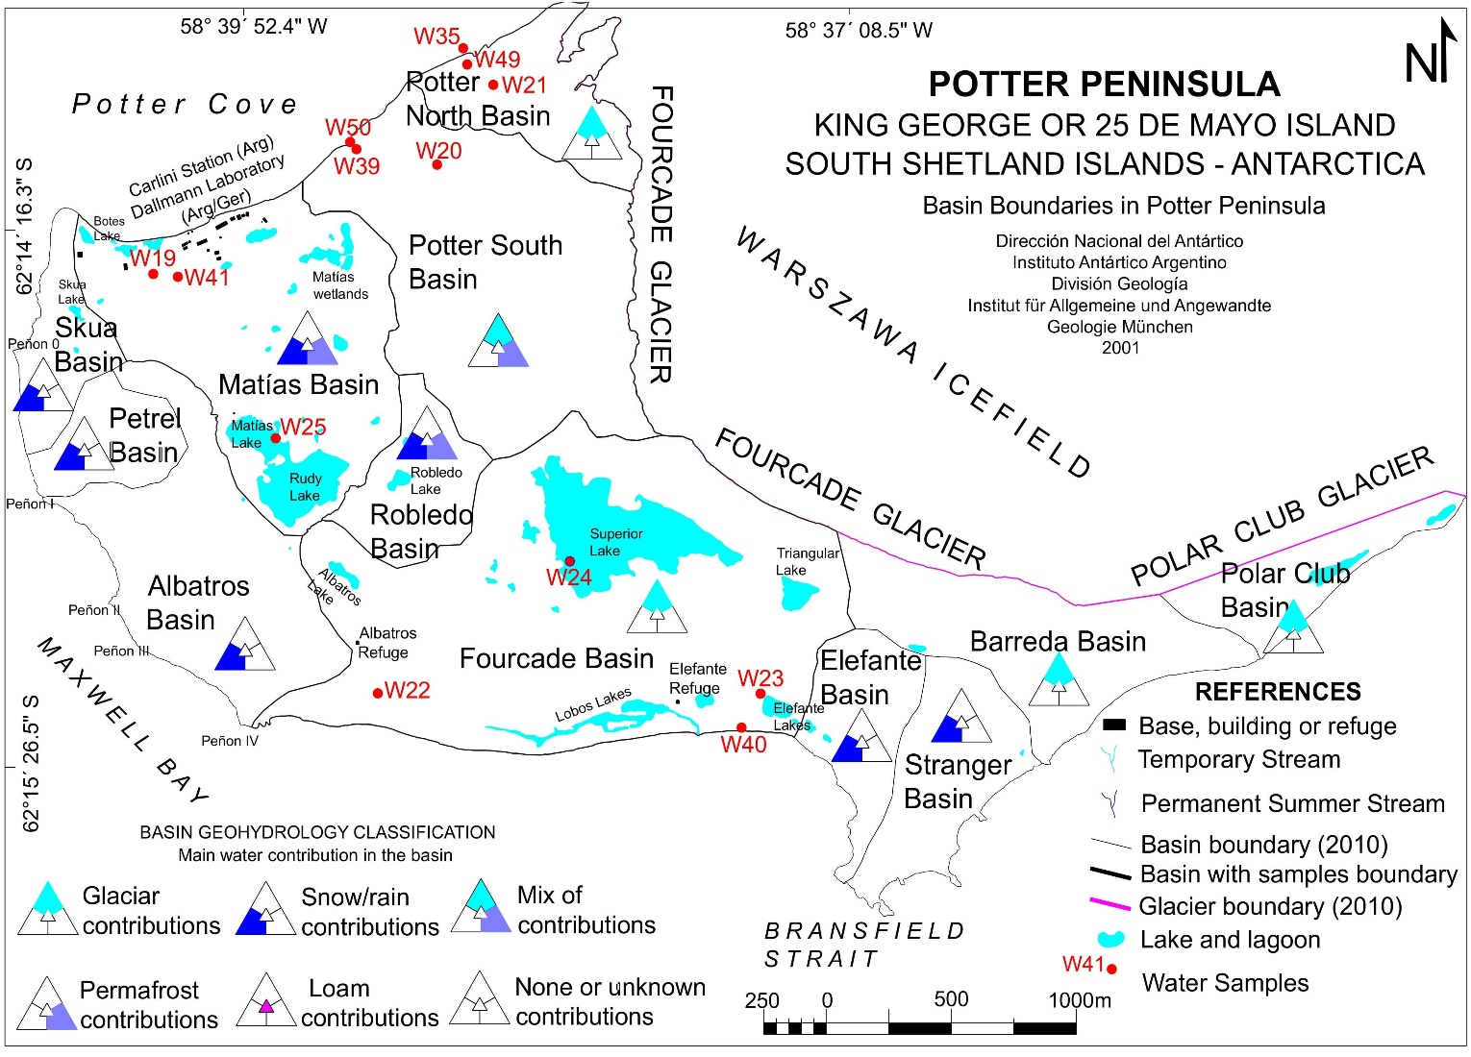
Supplementary Figure 2: Geohydrology classification and water contribution in Potter Peninsula basins. Base map from Lusky et al. (2001), modified using field observations to show the hydrogeological basins on Potter Peninsula, with the main water contribution to each basin shown using the coloured triangles (Silva-Busso, 2009). Sample locations in this study are in red. The glacier and basin boundaries are correct as of 2010.

Supplementary Figure 3: Three isotope plot of all the measurements presented within this study. Plot showing δ²⁹Si versus δ³⁰Si of samples and standards, with a gradient of 0.5130. Error bars are calculated from the 2SD of the external error of triplicated measurements, with an average of 0.07‰.
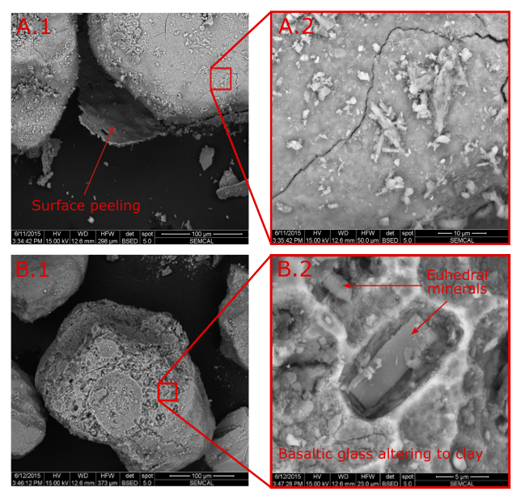
Supplementary Figure 4: SEM images of weathered rock and mineral grains from Commonwealth stream bed sediments. A.1: Rounded mineral grains covered in clays and clay sized mineral fragments. The surface layer cracked and peeled away in the vacuum of the SEM. A.2: cracked hydrous surface and fine grained (< 5 µm) particles on the surfaces. EDX analysis of the surface layer indicates an altered mafic composition (Si, Al, Fe, Mg, K, Na, Ti), which suggests smectite or zeolite type composition. B.1: Weathered basaltic glass forming fine grained clays on the particle surfaces. B.2: Dissolution of the glass reveals euhedral crystals within the glass that do not appear to be extensively altered.

References

ERMOLIN, E. & SILVA-BUSSO, A. 2008. Interaction between permafrost and groundwater on the Potter Peninsula, King George Island, (Isla 25 de Mayo), Antarctica. In: WIENCKE, C., FERREYRA, G. A., ABELE, D. & MARENSSI, S. (eds.) The Antarctic ecosystem of Potter Cove, King-George Island (Isla 25 de Mayo). Synopsis of research performed 1999-2006 at the Dallmann Laboratory and Jubany Station Alfred Wegener Institute and the Instituto Antartico Argentino - DNA (AWWI-DNA). .
LUSKY, J., VALLVERDÚ, E., GÓMEZ, I., DEL VALLE, R. & FELSKE, H. 2001. Map of Potter Peninsula. King George (25 de Mayo) Island, South Shetland Islands, Antarctica. . Instituto Antártico Argentino-Institut für Allgemeine und Angewandte, Münich, Deutshland. .
MCKNIGHT, D. M., NIYOGI, D. K., ALGER, A. S., BOMBLIES, A., CONOVITZ, P. A. & TATE, C. M. 1999. Dry Valley Streams in Antarctica: Ecosystems Waiting for Water. BioScience, 49, 985-995.
SILVA-BUSSO, A. 2009. Aguas Superficiales Y Subterràneas en el Area Norte da la PenÍnsula Antaràrtica. In: SILVA-BUSSO, A. (ed.) El agua en el Norte de la Península Antártica. Vazquez Mazzini.

