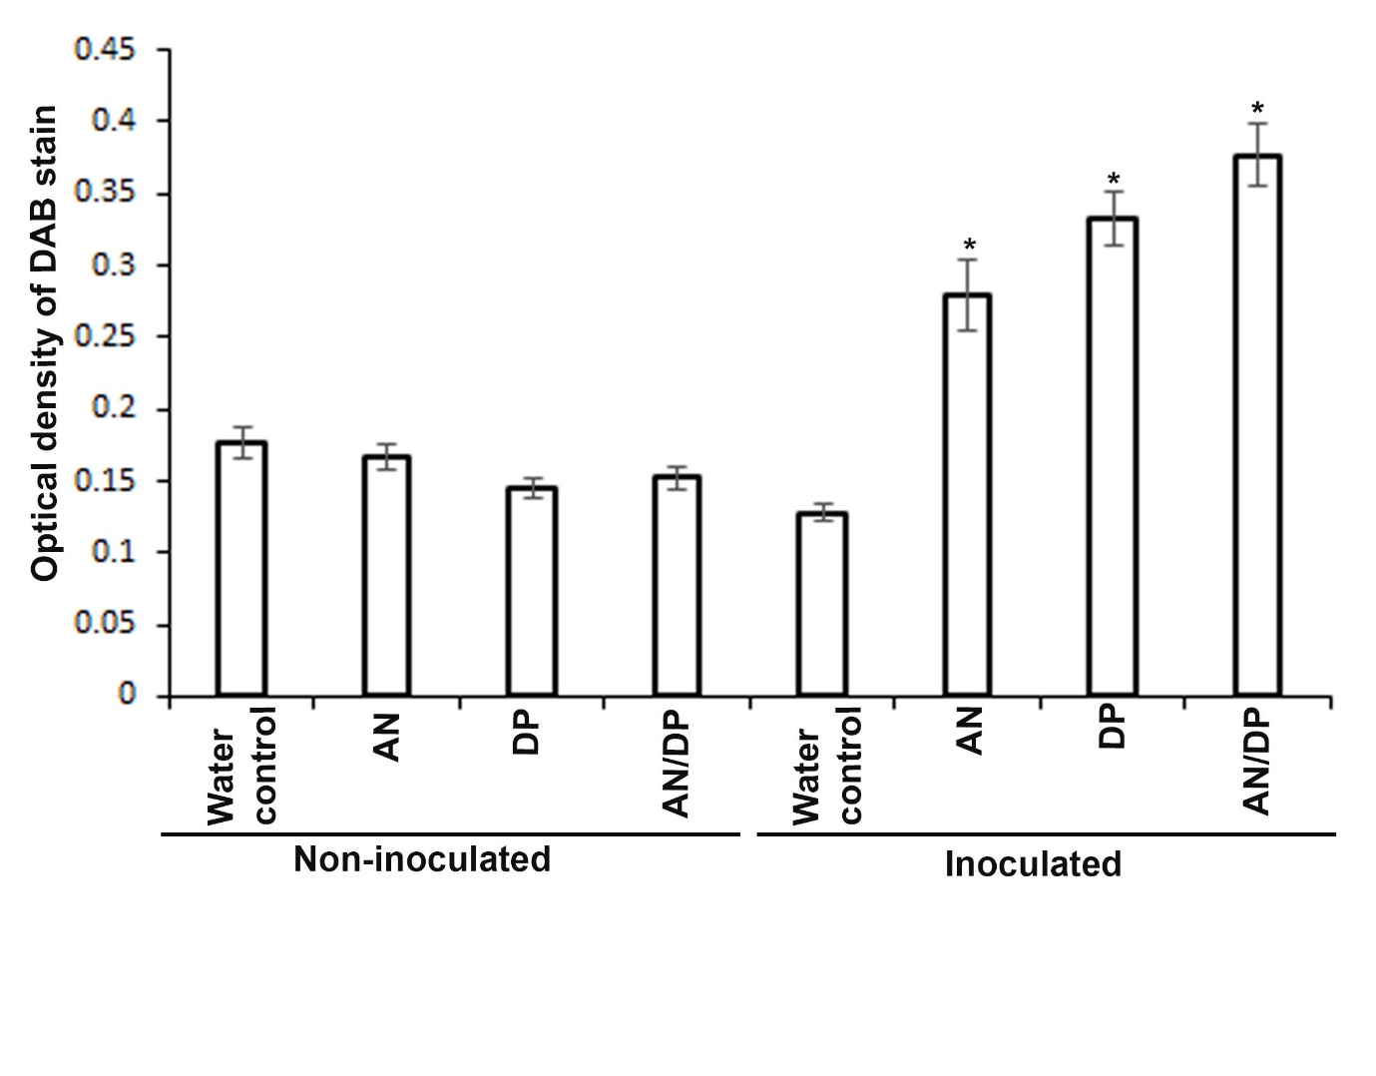Supplementary Figure 15. Quantitation of ROS production at 12 hpi in roots of A. thaliana treated with seaweed extracts (AN, DP and AN/DP) and then inoculated with P. cinnamomi. DAB stain density in roots grown with indicated seaweed extracts and water as a control. * denotes significant difference compared to non-inoculated control of the respective treatment as well as the water treated control at P=0.05 according to Duncan’s multiple range test.

