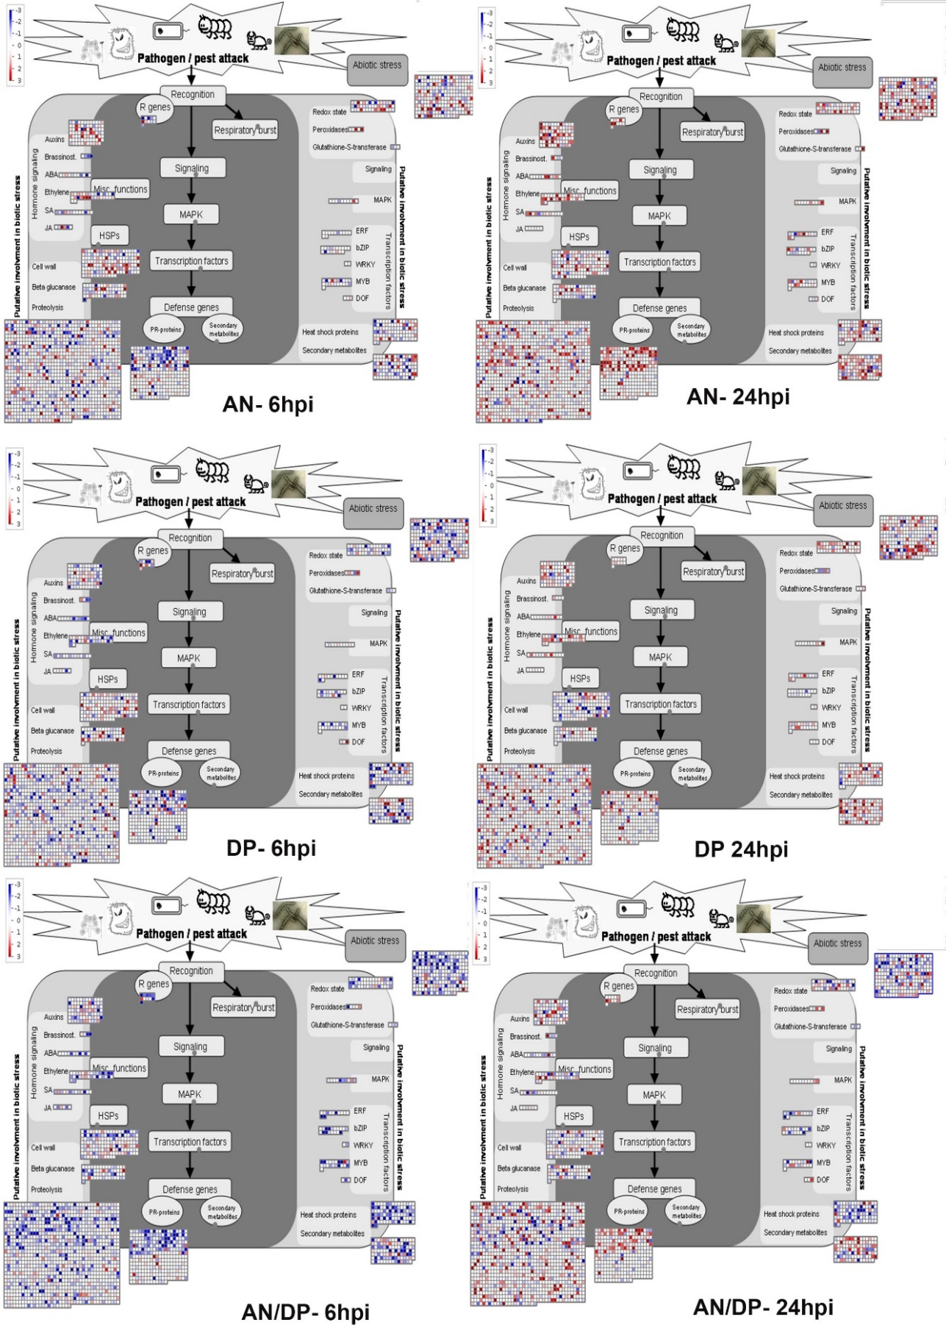
Supplementary Figure 14. MapMan overview of DEGs affected by each seaweed extract treatment (AN, DP and AN/DP) followed by infection with P. cinnamomi (at 6 and 24 hpi) related to biotic stress. Average fold change of gene expression is indicated by the colour scale (red represents up-regulated gene expression and blue represents down-regulated gene expression)

