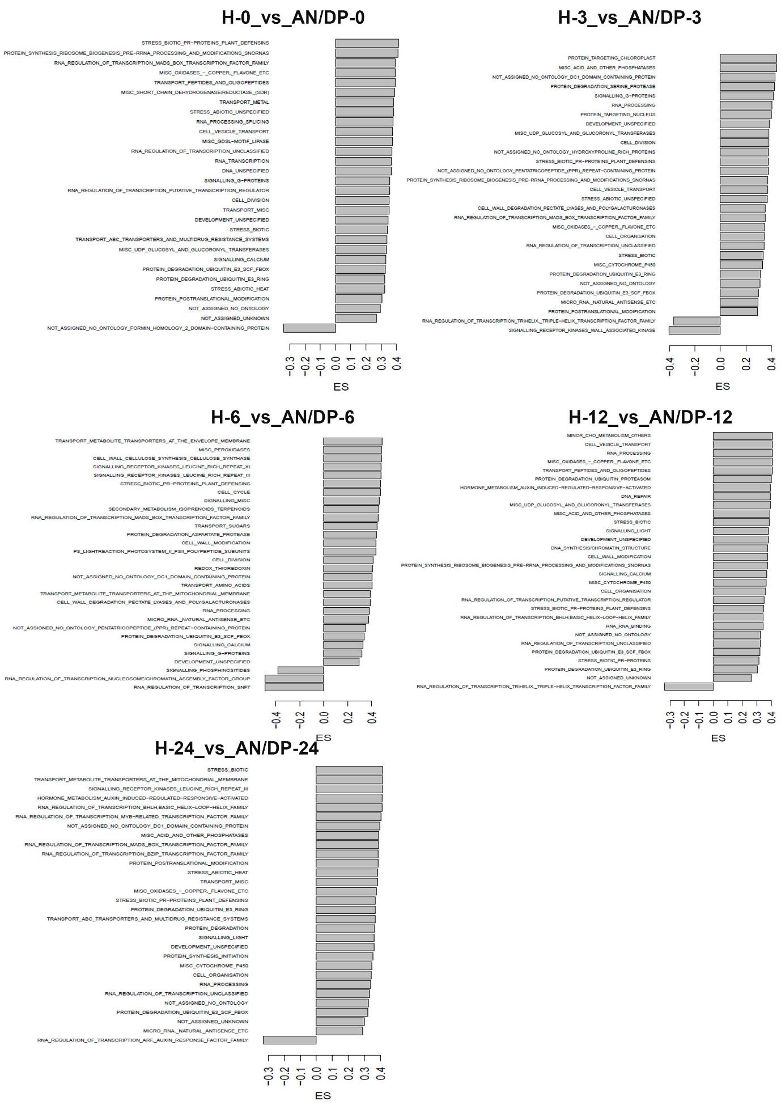
Supplementary Figure 13. Overview of enriched functional groups extracted from GSEA using the MapMan database for DEGs following treatment of plants with AN/DP and at different time points after inoculation with P. cinnamomi. ES= Enrichment score.

