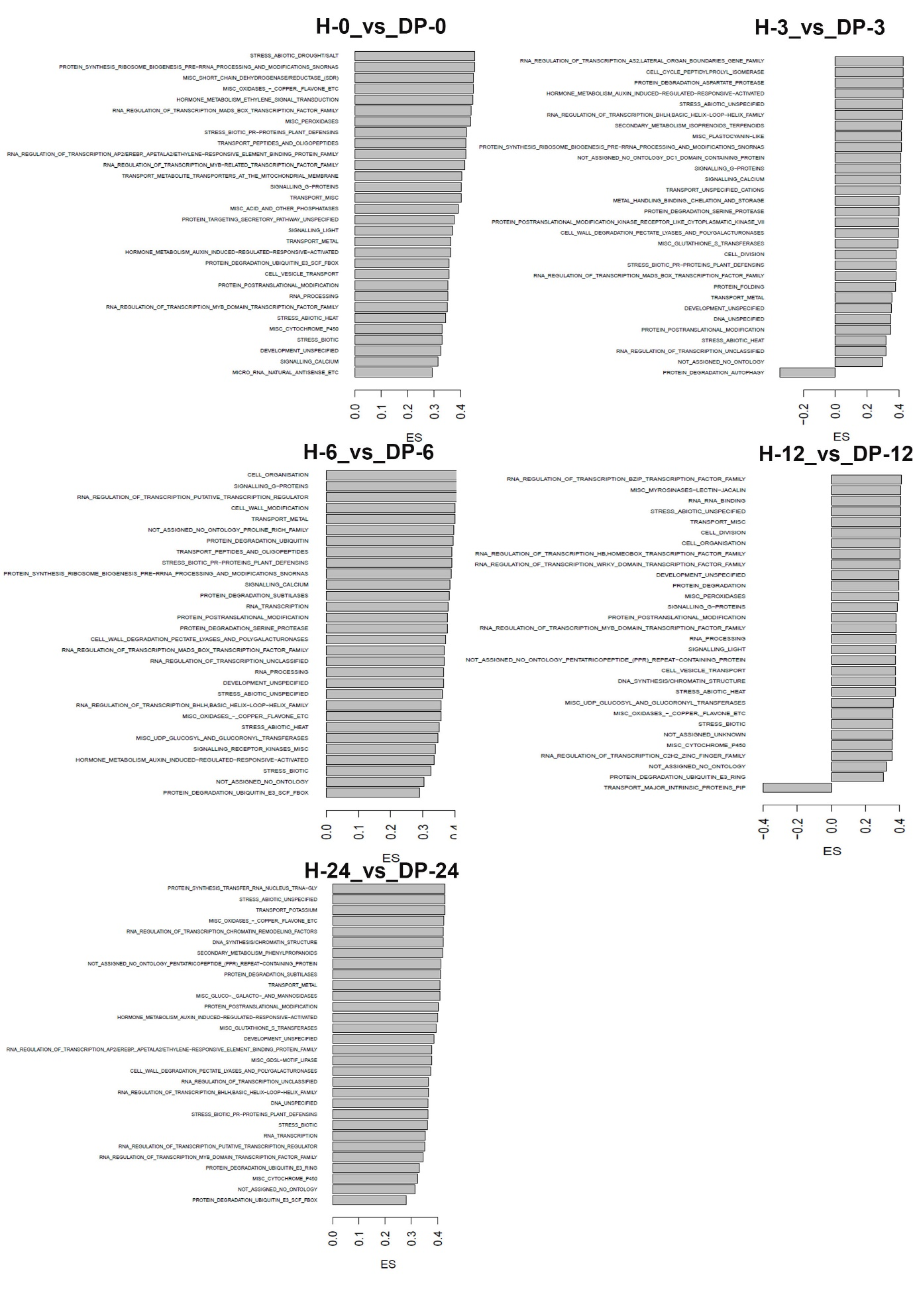
Supplementary Figure 12. Overview of enriched functional groups extracted from GSEA using the MapMan database for DEGs following treatment of plants with DP and at different time points after inoculation with P. cinnamomi. ES= Enrichment score.

