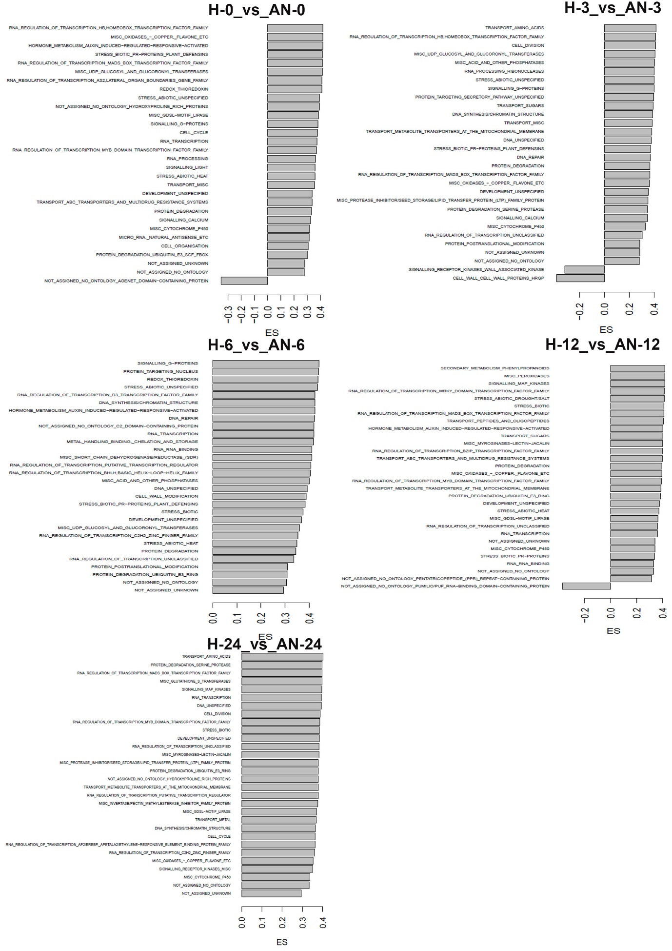
Supplementary Figure 11. Overview of enriched functional groups extracted from GSEA using the MapMan database for DEGs following treatment of plants with AN and at different time points after inoculation with P. cinnamomi. ES= Enrichment score.

