The chromatograms of herb.
Angelica sinensis (Danggui)
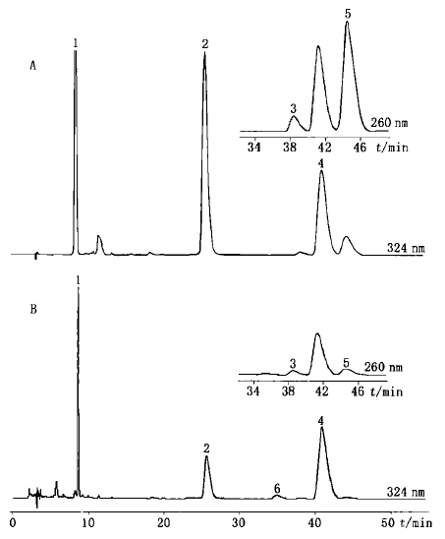
Figure 1 HPLC chromatograms of mix standards (A) and sample (B). 1. Ferulic acid 2. Coniferyl ferulate 3. E-3-butylidenephthalide 4. Z-ligustilide 5. Z-3-butylidenephthalide 6. E-ligustilide.
Cinnamomi ramulus (Guizhi)
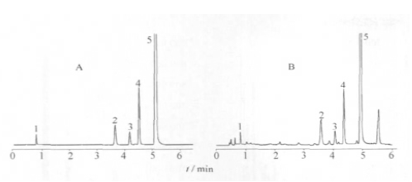
Figure 2 UPLC chromatograms of mix standards (A) and sample (B). 1. Protocatechuic acid 2. Coumarin 3. Cinnamic alcohol 4. Cinnamic acid 5. Cinnamaldehyde.
Paeonia albiflora (Baishao)
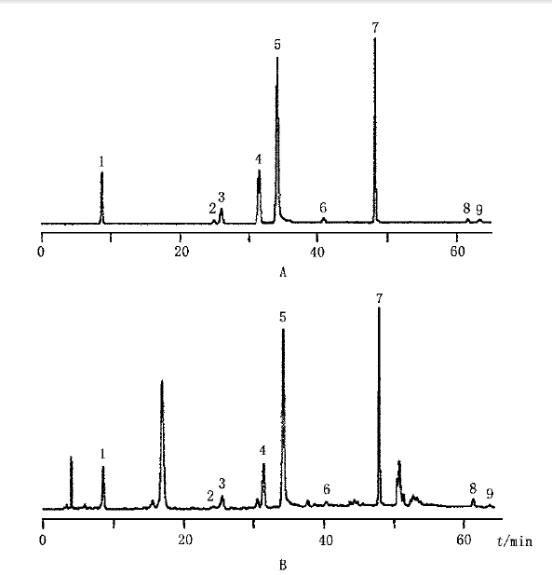
Figure 3 HPLC chromatograms of mix standards (A) and sample (B). 1. Gallic acid 2. Hydroxyl-paeoniflorin 3. Catechin 4. Albiflorin 5. Paeoniflorin 6. Benzoic acid 7 1, 2, 3, 4, 6 -pentagalloylglucose 8. Benzoyl -paeoniflorin 9. Paeonol.
Asarum sieboldii (Xixin)
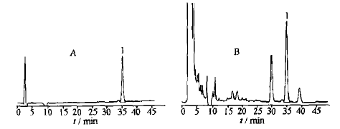
Figure 4 HPLC chromatograms of standards (A) and sample (B). 1. Aristolochic acid A.
Glycyrrhiza uralensis (Gancao)
Figure 5 HPLC chromatograms of mix standards (A) and sample (B).
Medulla tetrapanacis (Tongcao)
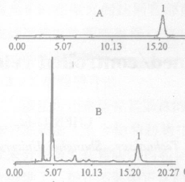
Figure 6 RP-HPLC chromatograms of standards (A) and sample (B). 1. Calceolar ioside B.
Jujubae fructus (Dazao)
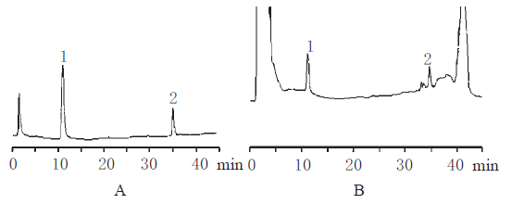
Figure 7 HPLC chromatograms of mix standards (A) and sample (B). 1. Rutin 2. Quercetin 3. Isorhamnetin.
Aconiti lateralis radix praeparata (Fuzi)
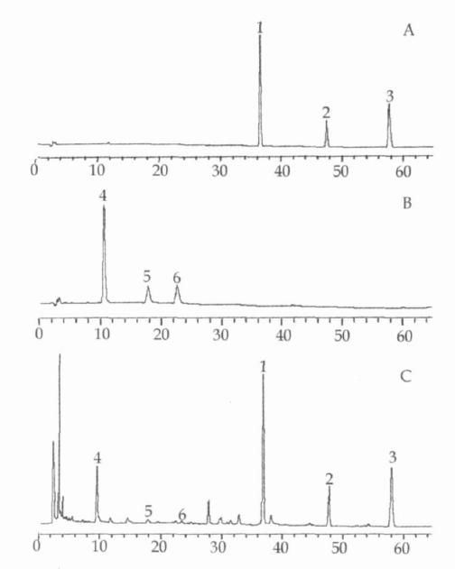
Figure 8 HPLC chromatograms of mix standards (A, B) and sample (C). 1. mesaconitine 2. aconitine 3. hypaconitine 4. benzoylm esaconin 5. Benzoylaconine 6. Benzoylhy paconine.
Zingiber officinale roscoe (Shengjiang)
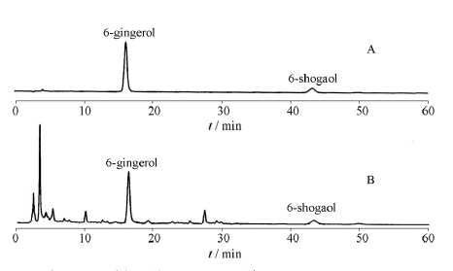
Figure 9 HPLC chromatograms of mix standards (A) and sample (B).
Astragalus membranaceus (Huangqi)
Figure 10 HPLC chromatograms of mix standards (A) and sample (B). 1. Campanulin 4. Formononetin.

