Supplementary Material

Supplementary Figure 1. Gating strategy to identify neutrophils in the spleen, mesenteric lymph nodes (MLN) and peritoneum of wt and C5ar1^{-/-} mice. Representative dot plots depict neutrophil populations in (A) spleen (CD3/CD19⁻Ly6G⁺), (B) MLN CD3/CD19/NK1.1/F4/80⁻Ly6G⁺) and (C) peritoneal cavity (CD3/CD19⁻Ly6G⁺) of uninfected wt or C5ar1^{-/-} mice and five days after T. gondii infection. Numbers represent frequencies of the parent gate.

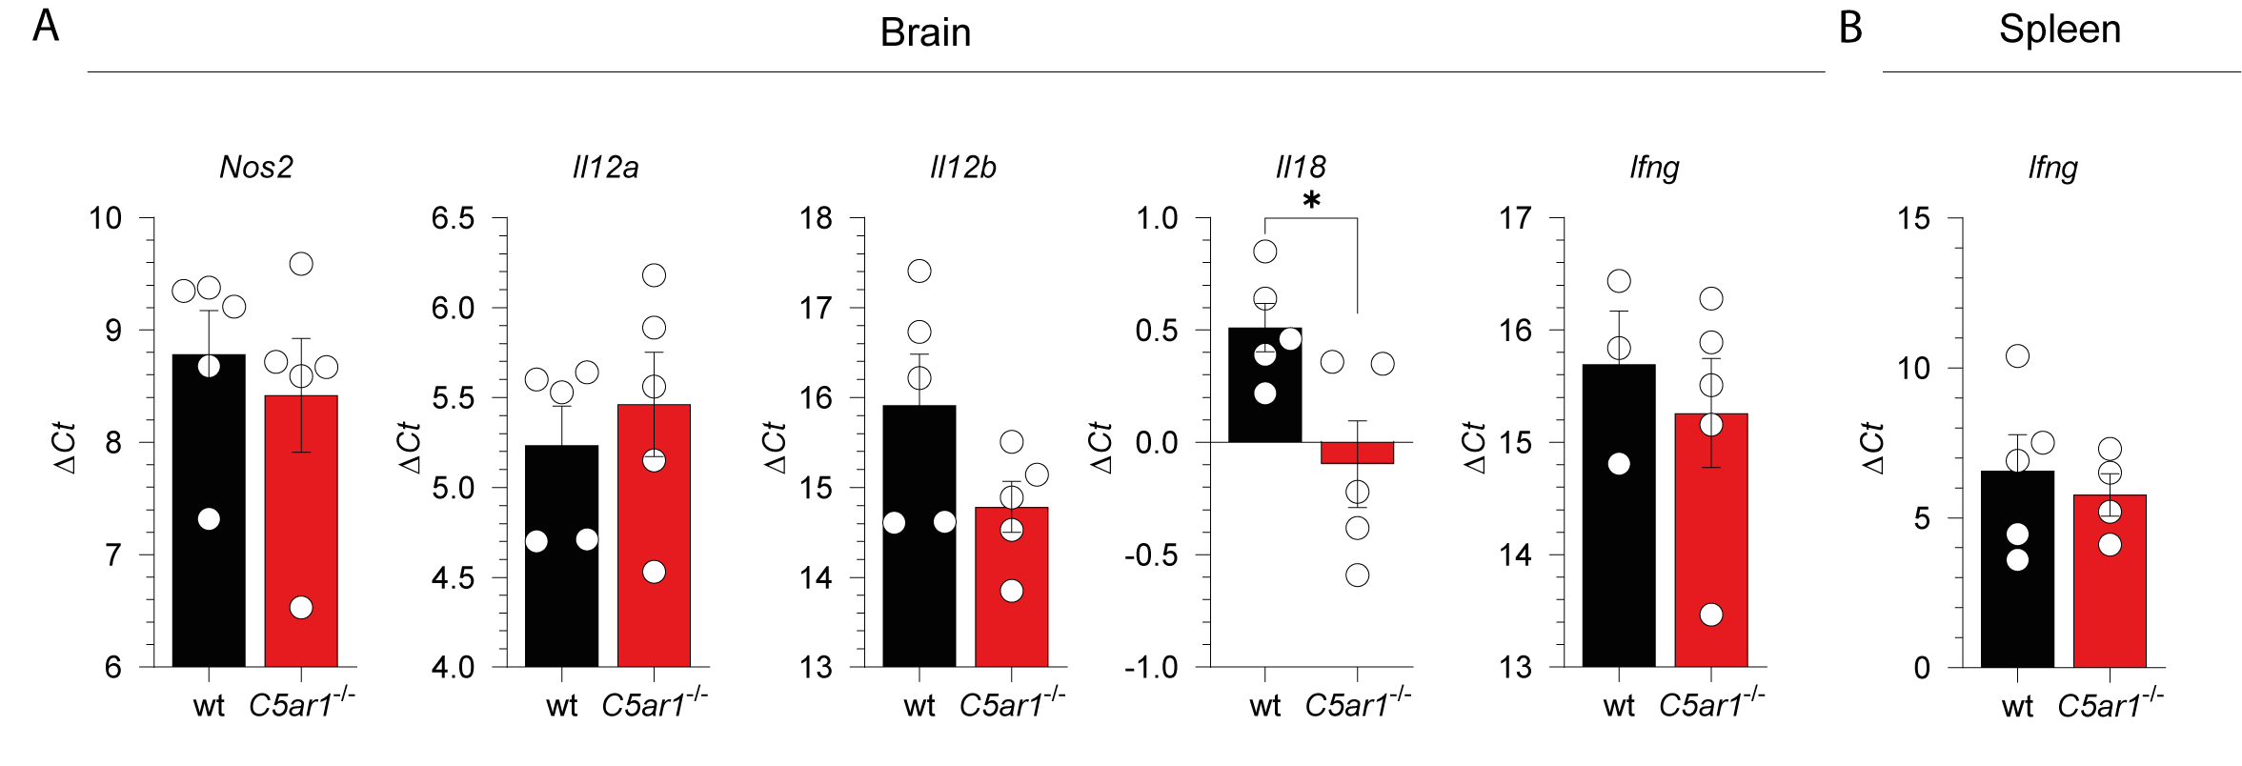Supplementary Figure 2. Baseline gene expression in the brain and spleen of naïve wt and C5ar1^{-/-} mice. (A) Nos2, Il12a, Il12b, Il18, and Ifng and Il18 mRNA transcription was determined in the brain and (B) Ifng mRNA transcription was determined in the spleen of wt and C5ar1^{-/-} mice by RT-qPCR. The data show the relative mRNA transcripts in comparison to β-actin, n = 3-5/group. Values shown are the mean ± SEM, differences between groups were determined by unpaired t-test, *** p < 0.001.

Supplementary Figure 3. Gating strategy to identify IL-12p40 production in CD8⁺ and CD11b⁺ DCs in the spleen of wt and C5ar1^{-/-} mice. (A) Representative dot plots depicting intracellular IL-12p40 staining in spleen cells from uninfected wt or C5ar1^{-/-} mice five days after T. gondii infection. CD11b DCs were identified as CD3⁻CD11c⁺CD11b⁺CD8⁻ (I) and CD8α⁺ DCs were identified as CD3⁻CD11c⁺CD11b⁻CD8a⁺ (II). Numbers represent frequencies of the parent gate. (B) Frequencies of CD8a⁺ (black) and CDD8a⁻ (red) cells within the population of CD11c⁺ DCs in the spleen of naïve wt and C5ar1^{-/-} mice.

Supplementary Figure 4. Gating strategy to identify IFN-γ-producing NK, NKT and T cells in the spleen of naïve wt and C5ar1^{-/-} mice. Representative dot plots depict intracellular IFN-γ production in (I) NK (CD3e⁻NK1.1⁺), (II) NKT (CD3e⁺NK1.1⁺) and (III) T cells (NK1.1⁻CD3e⁺CD8⁺ and NK1.1⁻CD3e⁺CD8⁻) in the spleen of uninfected wt or C5ar1^{-/-} mice and five days after T. gondii infection. Numbers represent frequencies of the parent gate.

