Supplementary Figures

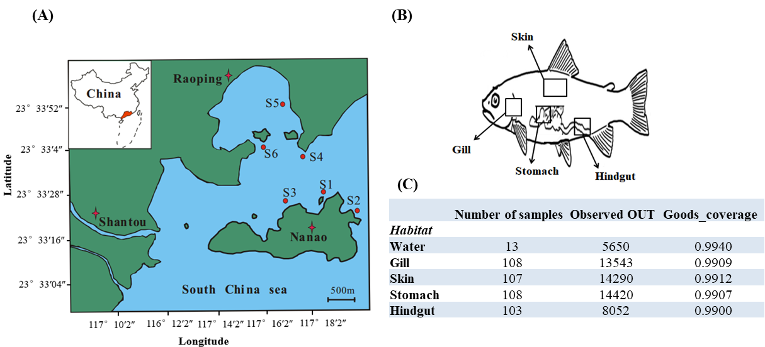
Supplementary Figure 1. The overview of S. fuscescens samples. (A) Sampling sites in Shantou Nanao Isand and Raoping. 108 wild S. fuscescens with different sizes (weight 8.9 ~307.4 g) were captured from six coastal sites in June, August and October 2017, respectively. The distance between any two of these sites is about 600-3,000 meters. (B) Diagram of the tissue sampling strategy for the present study. (C) Overview of S. fuscescens samples including groups, quality sequences and core OTU number (abundance > 1%). Operational taxonomic units (OTUs) are defined at 97% sequence similarity.

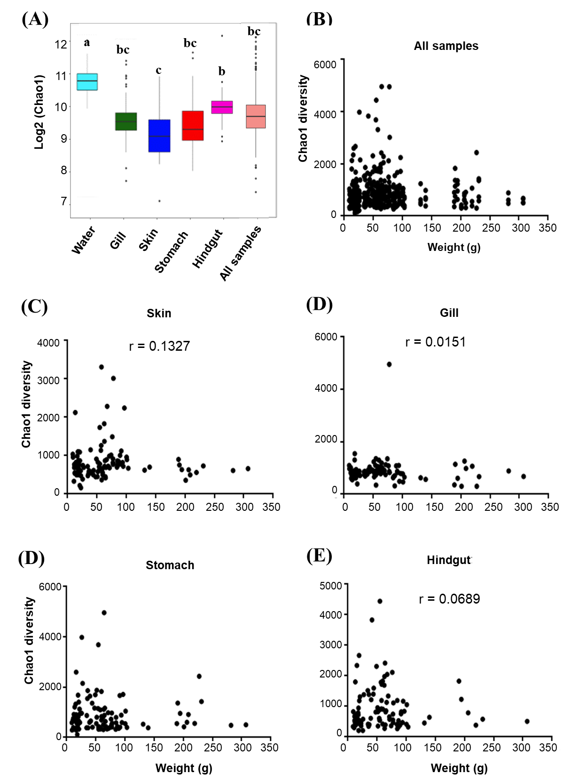
Supplementary Figure 2. Bacterial biodiversity of S. fuscescens at different body habitats and correlation with body weight. (A) The Chao1 diversity of microbial communities from different body habitats of S. fuscescens. ANOVA multiple comparisons were used to test the significance among body habitats. The relationship between body weight and Chao1 diversity in (B) all samples, (C) gill, (D) skin, (E) stomach and (F) hindgut.

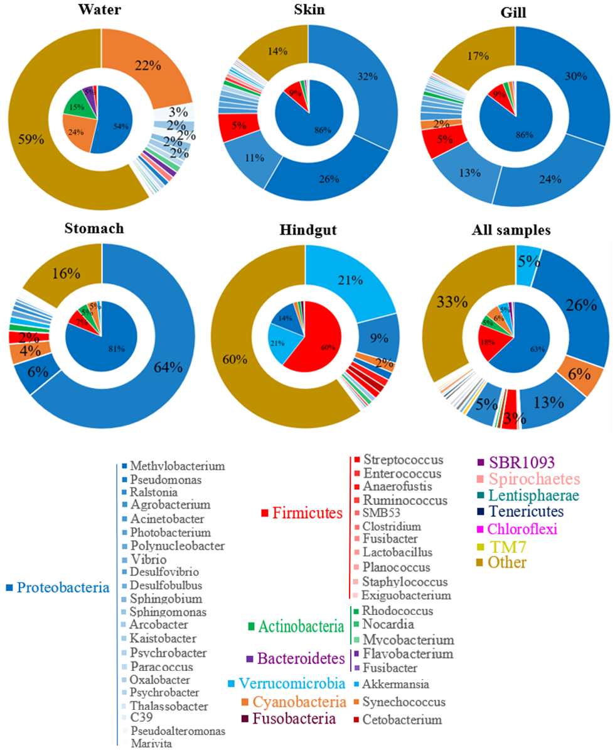
Supplementary Figure 3. The microbiome of various anatomical locations of the fish body. The relative abundance of most abundance phyla and genera in five habitats with the inner ring at the phylum level, the outer ring at the genus level, and the gradient of the same color belong to different genera within a phylum.

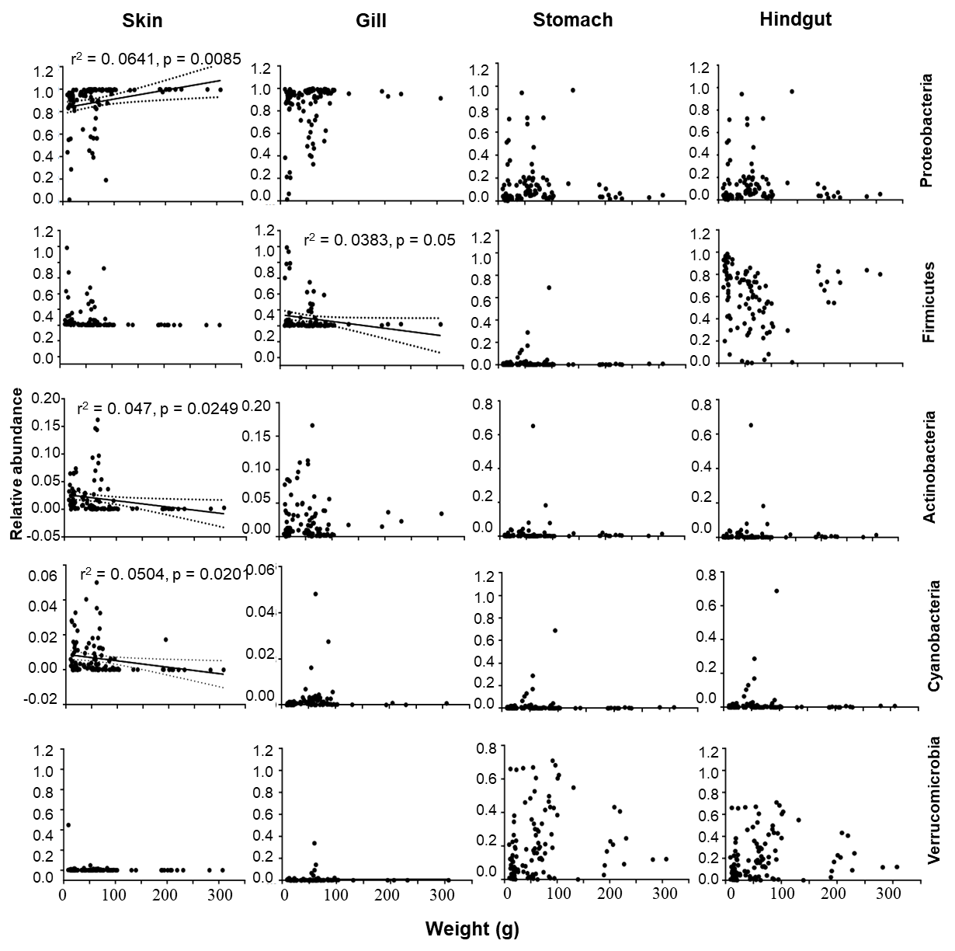
Supplementary Figure 4. The change of most abundance phyla: Firmicutes, Proteobacteria, Verrucomicrobia, Cyanobacteria and Actinobacteria in different body habitats as body weight increased at skin, gill, stomach and hindgut with 95% confidence interval (CI) of regression lines in different body habitats at genus level.
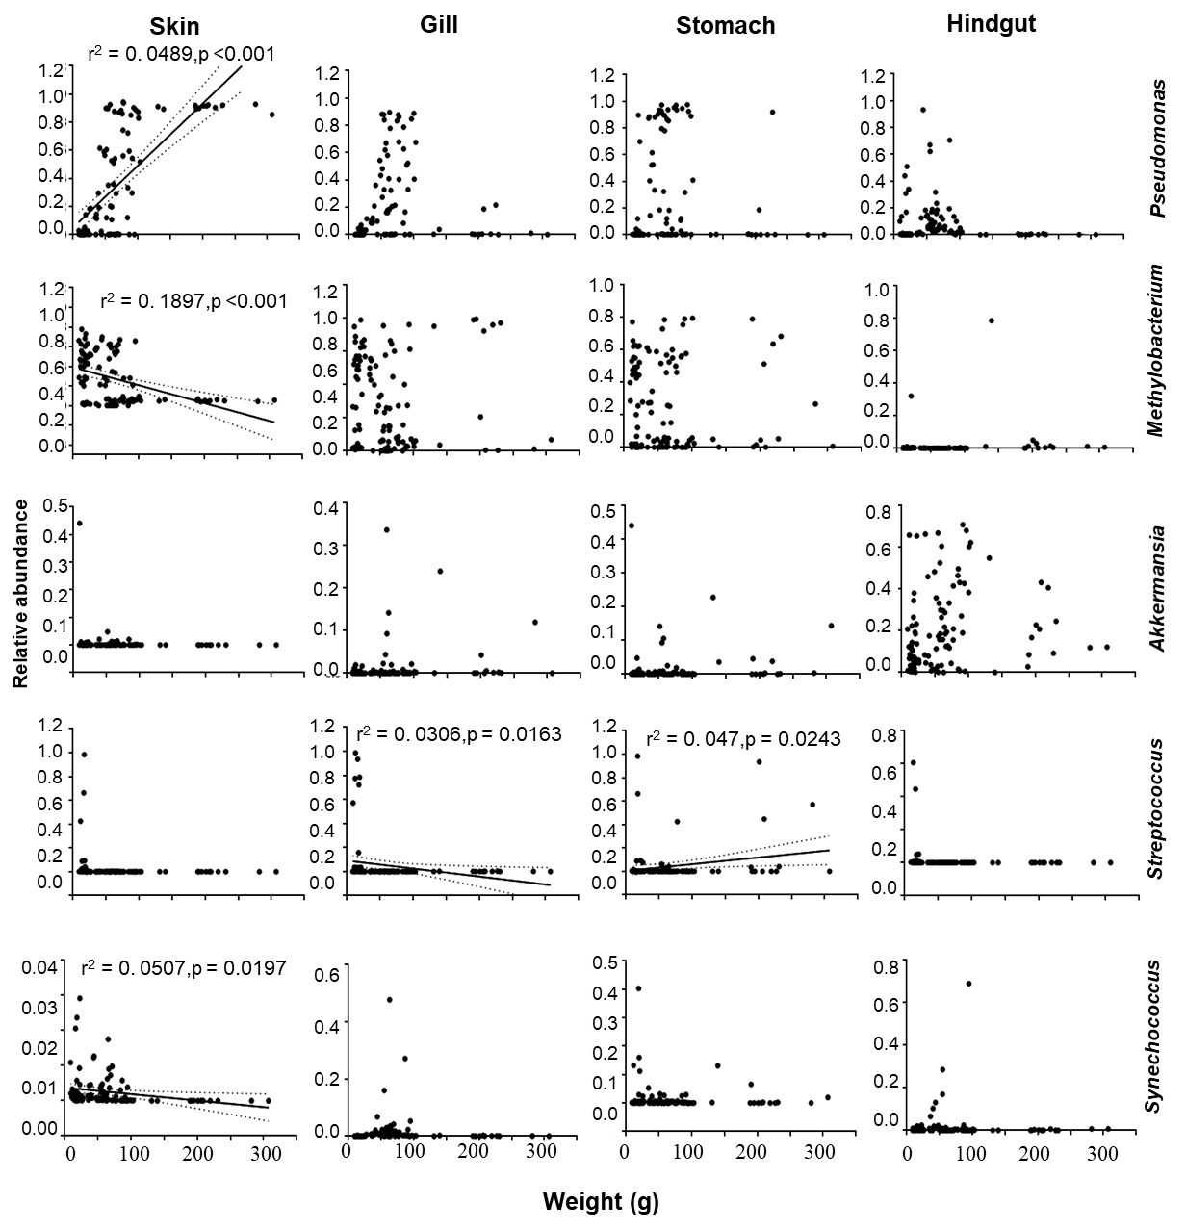
Supplementary Figure 5. The change of most abundance genus: Pesudomonas, Methylobacterium, Akkermansia, Streptococcus and Synechococcus in different body habitats as body weight increased at skin, gill, stomach and hindgut with 95% confidence interval (CI) of regression lines in different body habitats at genus level.

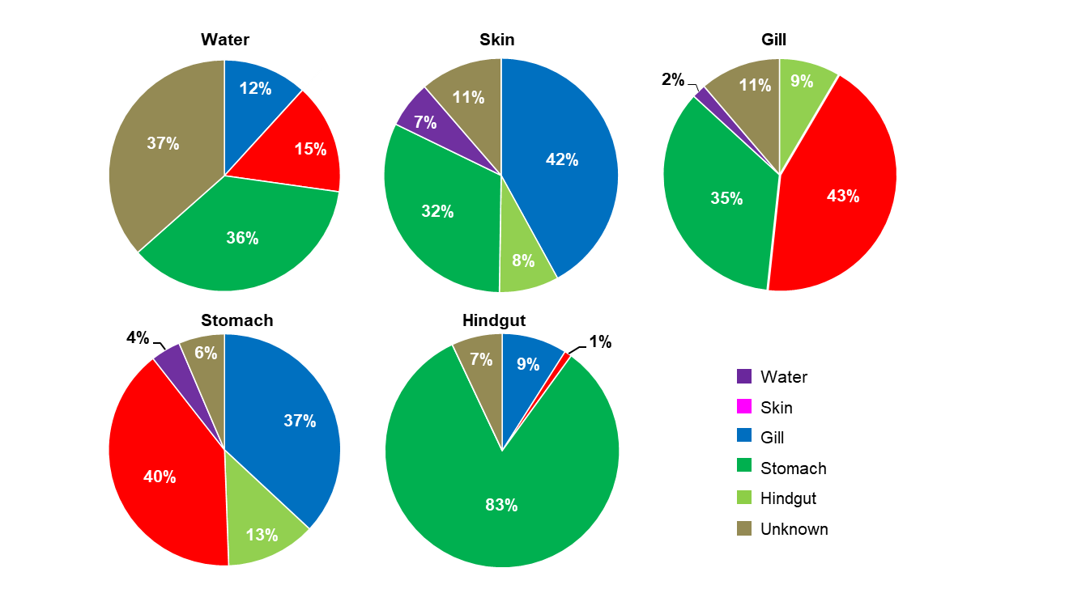
Supplementary Figure 6. Source-Tracker analysis of source contributions to the sink. The contribution of different source communities to each habitat, respectively.

Supplementary tables
Supplementary Table 1. Overview of S. fuscescens samples including groups, sampling time, sampling body habitat, body weight, Shannon diversity, Chao1 diversity, Observer_otu and Goods coverage, and see in the XLS file.

Supplementary Table 2. The most abundant bacterial groups at phyla level were detected in different habitats (gill, skin, stomach, hindgut and water). ANOVA multiple comparisons were used to test the significance among habitats.
 | Water (%) | Gill (%) | Skin（%） | Stomach (%) | Hindgut (%) | All samples (%)
Proteobacteria | 53.95^{c} | 81.82^{ab} | 88.28ª | 78.10^{b} | 13.71^{d} | 62.90^{c}
Firmicutes | 2.11^{b} | 11.13^{b} | 6.98^{b} | 10.17^{b} | 60.33ª | 18.07^{b}
Actinobacteria | 14.26ª | 2.51^{c} | 1.98^{c} | 5.00^{b} | 1.42c | 5.01^{b}
Cyanobacteria | 23.52ª | 1.90^{bc} | 0.66^{c} | 4.36^{b} | 1.89^{bc} | 6.44^{b}
Verrucomicrobia | 0.33^{b} | 1.23^{b} | 0.71^{b} | 1.62^{b} | 20.91ª | 4.94^{b}
Bacteroidetes | 5.72ª | 0.84^{b} | 1.03^{b} | 0.23^{c} | 0.08^{c} | 1.57^{b}
Fusobacteria | NA | 0.31 | 0.2 | 0.11 | 1.3 | 0.38
Spirochaetes | NA | 0.05 | NA | NA | NA | 0.01
Tenericutes | 0.02 | 0.05 | NA | 0.16 | 0.08 | 0.06
Chloroflexi | 0.02 | NA | 0.04 | 0.04 | 0.07 | 0.03
TM7 | NA | NA | 0.01 | NA | NA | 0.00
SBR1093 | NA | NA | NA | 0.08 | NA | 0.02
Lentisphaerae | NA | NA | NA | NA | 0.16 | 0.03
Others | 0.04 | 0.41 | 0.25 | 0.39 | 1.61 | 0.54

Supplementary Table 3. The most abundant bacterial groups at genera level were detected in different habitats (gill, skin, stomach, hindgut and water). ANOVA multiple comparisons were used to test the significance among habitats.
 | Water (%) |  | Gill (%) | Skin (%) | Stomach (%) | Hindgut (%) |  | All samples (%)
Akkermansia | NA |  | 0.33^{b} | 0.48^{b} | 1.26^{b} | 20.87ª | 4.59^{b}
Pseudomonas | 0.96e |  | 23.54^{c} | 32.12^{b} | 63.98ª | 8.80^{d} | 25.88^{b}
Synechococcus | 22.08ª |  | 1.66^{b} | 0.08^{c} | 3.67^{b} | 1.74^{b} | 5.85^{b}
Methylobacterium | NA |  | 30.42ª | 26.11ª | 5.98^{c} | 1.38^{c} | 12.78^{b}
Anaerofustis | NA |  | NA | NA | NA | 1.36 | 0.27
Cetobacterium | NA |  | 0.23^{b} | NA | 0.11^{b} | 1.30ª | 0.33^{b}
Streptococcus | NA |  | 5.5ª | 5.36ª | 2.29ª | 1.18ª | 2.87ª
Arcobacter | 2.14ª |  | 0.37ª | 0.36ª | NA | 0.84ª | 0.74ª
Nocardia | NA |  | NA | NA | 1.27 | 0.84 | 0.42
Ruminococcus | NA |  | NA | NA | NA | 0.4 | 0.08
Desulfovibrio | NA |  | NA | NA | NA | 0.36 | 0.07
SMB53 | NA |  | NA | NA | 0.12 | 0.23 | 0.07
Ralstonia | NA |  | 13.18ª | 11.26ª | 0.87^{c} | 0.21^{c} | 5.10^{b}
Desulfobulbus | NA |  | NA | NA | NA | 0.1 | 0.02
Clostridium | NA |  | NA | NA | NA | 0.09 | 0.02
Agrobacterium | NA |  | 1.48ª | 1.17ª | 0.44ª | 0.07ª | 0.63ª
Acinetobacter | NA |  | 1.15ª | 1.06ª | 0.80ª | 0.05ª | 0.61ª
Oxalobacter | NA |  | NA | NA | NA | 0.05 | 0.01
Fusibacter | NA |  | NA | NA | NA | 0.04 | 0.01
Mycobacterium | 0.41 |  | NA | NA | 0.13 | 0.04 | 0.12
Photobacterium | NA |  | 0.98ª | 1.06ª | 1.14ª | NA | 0.64
Roseibium | NA |  | NA | NA | 0.36 | NA | 0.07
Shewanella | NA |  | NA | NA | 0.27 | NA | 0.05
Paracoccus | NA |  | 0.18 | NA | 0.26 | NA | 0.09
Rhodococcus | NA |  | 0.79ª | 0.88ª | 0.24ª | NA | 0.38 ª
Sphingobium | NA |  | 0.53ª | 0.48a | 0.14a | NA | 0.23
Vibrio | 0.41 |  | 0.61^{b} | 1.05ª | 0.13^{c} | NA | 0.44
Marivita | 0.24 |  | NA | NA | 0.12 | NA | 0.07
Polynucleobacter | NA |  | 0.92 | NA | NA | NA | 0.18
Sphingomonas | NA |  | 0.42 | 0.34 | NA | NA | 0.15
Kaistobacter | NA |  | 0.37 | 0.48 | NA | NA | 0.17
Enterococcus | NA |  | 0.27 | 0.65 | NA | NA | 0.18
Psychrobacter | 0.81 |  | 0.26 | 1.02 | NA | NA | 0.42
Lactobacillus | NA |  | NA | 0.65 | NA | NA | 0.13
Pseudoalteromonas | 1.8 |  | NA | 0.4 | NA | NA | 0.44
Staphylococcus | NA |  | NA | 0.35 | NA | NA | 0.07
Exiguobacterium | 1.08 |  | NA | 0.31 | NA | NA | 0.28
ProteobacteriaCandidatus Portiera |  | 3.19 | NA | NA | NA | NA | 0.64
Loktanella | 1.7 |  | NA | NA | NA | NA | 0.34
Erythrobacter | 1.69 |  | NA | NA | NA | NA | 0.34
Anaerospora | 1.15 |  | NA | NA | NA | NA | 0.23
Candidatus Aquiluna | 1.15 |  | NA | NA | NA | NA | 0.23
Flavobacterium | 1.1 |  | NA | NA | NA | NA | 0.22
Thalassobacter | 0.43 |  | NA | NA | NA | NA | 0.09
Idiomarina | 0.27 |  | NA | NA | NA | NA | 0.05
Fluviicola | 0.27 |  | NA | NA | NA | NA | 0.05
C39 | 0.21 |  | NA | NA | NA | NA | 0.04
Planococcus | 0.21 |  | NA | NA | NA | NA | 0.04
Other | 58.72 |  | 16.81 | 14.39 | 16.43 | 60.03 | 33.27

Supplementary Table 4. The taxonomy of core OTU (the OTU shared by >80% samples and abundances>0.01) in five habitats (skin, gill, stomach, hindgut and water), and asterisks denote OTU that was significantly correlative with weight mass.
OUT ID | Phylum | Class |  |  |  |  |  | Order | Family |  |  |  | Genus
All samples
OTU_1 | Proteobacteria | Gammaproteobacteria |  | Pseudomonadales |  |  |  |  | Pseudomonadaceae |  |  |  | Pseudomonas
OTU_2 | Proteobacteria | Alphaproteobacteria |  | Rhizobiales |  |  |  |  | Methylobacteriaceae |  |  |  | Methylobacterium
OTU_4 | Firmicutes | Clostridia |  | Clostridiales |  |  |  |  | Clostridiales_Incertae Sedis XIII |  |  |  | Anaerovorax
OTU_6 | Proteobacteria | Deltaproteobacteria |  | Desulfovibrionales |  |  |  |  | Desulfovibrionaceae |  |  |  | -
OTU_788 | Proteobacteria | Deltaproteobacteria |  | Desulfovibrionales |  |  |  |  | Desulfovibrionaceae |  |  |  | -
OTU_33295 | Firmicutes | Erysipelotrichia |  | Erysipelotrichales |  |  |  |  | Erysipelotrichaceae |  |  |  | Holdemania
OTU_46724 | Firmicutes | Clostridia |  | Clostridiales |  |  |  |  | Clostridiales_Incertae Sedis XIII |  |  |  | Anaerovorax
Gill
OTU_1 | Proteobacteria | Gammaproteobacteria |  |  |  | Pseudomonadales |  |  |  | Pseudomonadaceae |  | Pseudomonas
OTU_2 | Proteobacteria | Alphaproteobacteria |  |  |  | Rhizobiales |  |  |  | Methylobacteriaceae |  | Methylobacterium
OTU_9 | Bacteroidetes | Sphingobacteriia |  |  |  | Sphingobacteriales |  |  |  | Chitinophagaceae |  | -
OTU_13 | Proteobacteria | Alphaproteobacteria |  |  |  | Rhizobiales |  |  |  | Rhizobiaceae |  | Rhizobium
OTU_23 | Chlamydiae | Chlamydiia |  |  |  | Chlamydiales |  |  |  | Parachlamydiaceae |  | Neochlamydia
OTU_33295 | Firmicutes | Erysipelotrichia |  |  |  | Erysipelotrichales |  |  |  | Erysipelotrichaceae |  | Holdemania
OTU_42368 | Proteobacteria | Betaproteobacteria |  |  |  | Burkholderiales |  |  |  | Burkholderiaceae |  | Ralstonia
Skin
OTU_1 | Proteobacteria | Gammaproteobacteria |  |  |  | Pseudomonadales |  |  |  | Pseudomonadaceae |  | Pseudomonas
OTU_2 | Proteobacteria | Alphaproteobacteria |  |  |  | Rhizobiales |  |  |  | Methylobacteriaceae |  | Methylobacterium
OTU_9 | Bacteroidetes | Sphingobacteriia |  |  |  | Sphingobacteriales |  |  |  | Chitinophagaceae |  | -
OTU_42368 | Proteobacteria | Betaproteobacteria |  |  |  | Burkholderiales |  |  |  | Burkholderiaceae |  | Ralstonia
Table S4 continued
Hindgut
OTU_1 | Proteobacteria |  | Gammaproteobacteria |  |  | Pseudomonadales |  |  |  | Pseudomonadaceae |  |  |  | Pseudomonas
OTU_4 | Firmicutes |  | Clostridia |  |  | Clostridiales |  |  |  | Clostridiales_Incertae Sedis XIII |  |  |  | Anaerovorax
OTU_6 | Proteobacteria |  | Deltaproteobacteria |  |  | Desulfovibrionales |  |  |  | Desulfovibrionaceae |  |  |  | -
OTU_10 | Verrucomicrobia |  | Verrucomicrobiae |  |  | Verrucomicrobiales |  |  |  | Verrucomicrobiaceae |  |  |  | Akkermansia
OTU_11 | Verrucomicrobia |  | Verrucomicrobiae |  |  | Verrucomicrobiales |  |  |  | Verrucomicrobiaceae |  |  |  | Akkermansia
OTU_12 | Firmicutes |  | Clostridia |  |  | Clostridiales |  |  |  | Lachnospiraceae |  |  |  | Hespellia
OTU_14 | Firmicutes |  | Clostridia |  |  | Clostridiales |  |  |  | Ruminococcaceae |  |  |  | -
OTU_15 | Proteobacteria |  | Deltaproteobacteria |  |  | Desulfovibrionales |  |  |  | Desulfovibrionaceae |  |  |  | -
OTU_18 | Firmicutes |  | Clostridia |  |  | Clostridiales |  |  |  | Ruminococcaceae |  |  |  | -
OTU_25 | Proteobacteria |  | Deltaproteobacteria |  |  | Desulfovibrionales |  |  |  | Desulfovibrionaceae |  |  |  | -
OTU_44 | Verrucomicrobia |  | Verrucomicrobiae |  |  | Verrucomicrobiales |  |  |  | Verrucomicrobiaceae |  |  |  | Akkermansia
OTU_74 | Proteobacteria |  | Deltaproteobacteria |  |  | Desulfovibrionales |  |  |  | Desulfovibrionaceae |  |  |  | Desulfovibrio
OTU_788 | Proteobacteria |  | Deltaproteobacteria |  |  | Desulfovibrionales |  |  |  | Desulfovibrionaceae |  |  |  | -
OTU_1966 | Verrucomicrobia |  | Verrucomicrobiae |  |  | Verrucomicrobiales |  |  |  | Verrucomicrobiaceae |  |  |  | Akkermansia
OTU_33295 | Firmicutes |  | Erysipelotrichia |  |  | Erysipelotrichales |  |  |  | Erysipelotrichaceae |  |  |  | Holdemania
OTU_37134 | Proteobacteria |  | Deltaproteobacteria |  |  | Desulfovibrionales |  |  |  | Desulfovibrionaceae |  |  |  | -
OTU_43331 | Firmicutes |  | Clostridia |  |  | Clostridiales |  |  |  | Ruminococcaceae |  |  |  | -
OTU_45495 | Proteobacteria |  | Deltaproteobacteria |  |  | Desulfobacterales |  |  |  | Desulfobacteraceae |  |  |  | -
OTU_45499 | Firmicutes |  | Clostridia |  |  | Clostridiales |  |  |  | Lachnospiraceae |  |  |  | Dorea
OTU_46724 | Firmicutes |  | Clostridia |  |  | Clostridiales |  |  |  | Clostridiales_Incertae Sedis XIII |  |  |  | Anaerovorax
Stomach
OTU_1 | Proteobacteria | Gammaproteobacteria |  |  |  |  | Pseudomonadales |  |  | Pseudomonadaceae |  |  |  | Pseudomonas
OTU_2 | Proteobacteria | Alphaproteobacteria |  |  |  |  | Rhizobiales |  |  | Methylobacteriaceae |  |  |  | Methylobacterium
OTU_4 | Firmicutes | Clostridia |  |  |  |  | Clostridiales |  |  | Clostridiales_Incertae Sedis XIII |  |  |  | Anaerovorax
Table S4 continued
OTU_6 | Proteobacteria | Deltaproteobacteria |  |  |  |  | Desulfovibrionales |  |  | Desulfovibrionaceae |  |  |  | Unclassified
OTU_8 | Cyanobacteria | Cyanobacteria |  |  |  |  | Unclassified |  |  | Family II |  |  |  | GpIIa
OTU_46724 | Firmicutes | Clostridia |  |  |  |  | Clostridiales |  |  | Clostridiales_Incertae Sedis XIII |  |  |  | Anaerovorax
Water
OTU_8 | Cyanobacteria | Cyanobacteria |  |  | - |  |  |  |  |  | Family II |  |  |  | GpIIa
OTU_28 | Actinobacteria | Actinobacteria |  |  | Actinomycetales |  |  |  |  |  | Acidothermaceae |  |  |  | Acidothermus
OTU_54 | Firmicutes | Bacilli |  |  | Bacillales |  |  |  |  |  | Bacillales_Incertae Sedis XII |  |  |  | Exiguobacterium
OTU_63 | Cyanobacteria | Cyanobacteria |  |  | - |  |  |  |  |  | Family II |  |  |  | GpIIa
OTU_68 | Proteobacteria | Alphaproteobacteria |  |  | Rhodobacterales |  |  |  |  |  | Rhodobacteraceae |  |  |  | -
OTU_72 | Actinobacteria | Actinobacteria |  |  | Acidimicrobiales |  |  |  |  |  | Acidimicrobiaceae |  |  |  | Ilumatobacter
OTU_78 | Bacteroidetes | Flavobacteriia |  |  | Flavobacteriales |  |  |  |  |  | Flavobacteriaceae |  |  |  | Tenacibaculum
OTU_92 | Proteobacteria | Gammaproteobacteria |  |  | Alteromonadales |  |  |  |  |  | Pseudoalteromonadaceae |  |  |  | Pseudoalteromonas
OTU_107 | Actinobacteria | Actinobacteria |  |  | Actinomycetales |  |  |  |  |  | Microbacteriaceae |  |  |  | Agrococcus
OTU_140 | Proteobacteria | Alphaproteobacteria |  |  | Sphingomonadales |  |  |  |  |  | Erythrobacteraceae |  |  |  | Erythrobacter
OTU_186 | Proteobacteria | Gammaproteobacteria |  |  | Gammaproteobacteria_incertae_sedis |  |  |  |  |  | - |  |  |  | Congregibacter
OTU_202 | Proteobacteria | Alphaproteobacteria |  |  | Kiloniellales |  |  |  |  |  | Kiloniellaceae |  |  |  | Kiloniella
OTU_7752 | Proteobacteria | Alphaproteobacteria |  |  | Rhodobacterales |  |  |  |  |  | Rhodobacteraceae |  |  |  | -
OTU_26261 | Cyanobacteria | Cyanobacteria |  |  | - |  |  |  |  |  | Family II |  |  |  | GpIIa
OTU_32877 | Cyanobacteria | Cyanobacteria |  |  | - |  |  |  |  |  | Family II |  |  |  | GpIIa
OTU_33198 | Proteobacteria | Alphaproteobacteria |  |  | Rhodobacterales |  |  |  |  |  | Rhodobacteraceae |  |  |  | -
OTU_39575 | Proteobacteria | Alphaproteobacteria |  |  | Rhodobacterales |  |  |  |  |  | Rhodobacteraceae |  |  |  | Youngimonas
OTU_41803 | Proteobacteria | Alphaproteobacteria |  |  | Rhodobacterales |  |  |  |  |  | Rhodobacteraceae |  |  |  | -
OTU_46944 | Cyanobacteria | Cyanobacteria |  |  | - |  |  |  |  |  | Family II |  |  |  | GpIIa
OTU_47076 | Proteobacteria | Alphaproteobacteria |  |  | Rhodobacterales |  |  |  |  |  | Rhodobacteraceae |  |  |  | Nautella

