New Plant Growth-Promoting, Chromium-Detoxifying Microbacterium Species Isolated From a Tannery Wastewater: Performance and Genomic Insights

Supplementary Figures :
Content
Figure S1. In vitro plant growth-promoting traits of the TL13 strain : (a) Atmospheric nitrogen fixation ; (b) Siderophore production ; (c) Phosphate solubilization ; (d) EPS production ; (e) Cellulase activity and (f) IAA production.
Figure S2. Antibiogram illustrated TL13 strain sensitivity against 13 antibiotics (from left to right) : Cefoxitin (FOX : 30µg) ; Pristinamycin (PTN : 15µg) ; Neomycin (NE : 30µg) ; Rifampicin (RD : 30µg) ; Norfloxacin (NOR : 5µg) ; Streptomycin (S : 10µg) ; Erythromycin (E : 15µg) ; Cefotaxime (CTX : 30µg) ; Tetracycline (TET : 30µg) ; Vancomycin (VAN : 30µg) ; Ceftazidime (CAZ : 30µg) ; Spiramycin (SP : 100µg) and Oxytetracyclin (OT : 30µg).
Figure S3. Graphical representation of a taxonomic tree made with strains from the DSMZ cultivable collection according to the Gold database. A: Overview. B: Zoom on the area framed in circle in image A. Each point represents a type of strain. In red are represented the strains for which a sequencing project is in progress, the others are represented in green. The empty points represent higher taxonomic levels. The length of the branches is not significant. Figure extracted from https://microbial-earth.namesforlife.com/.

Figure S1. In vitro plant growth-promoting traits of the TL13 strain : (a) Atmospheric nitrogen fixation ; (b) Siderophore production ; (c) Phosphate solubilization ; (d) EPS production ; (e) Cellulase activity and (f) IAA production.

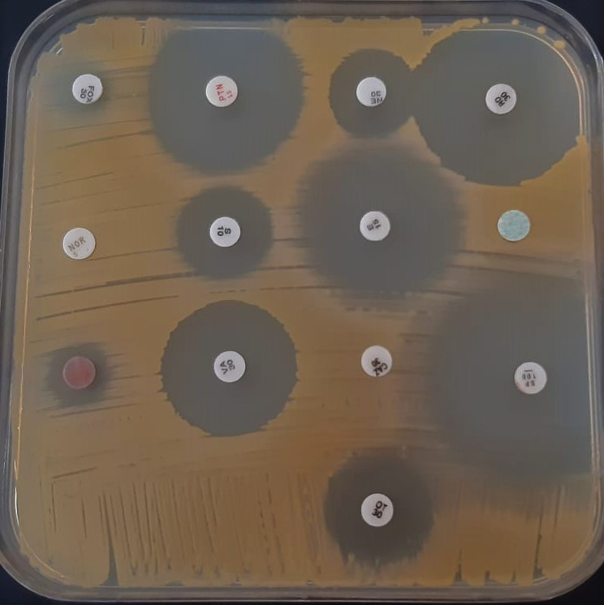
Figure S2. Antibiogram illustrated TL13 strain sensitivity against 13 antibiotics (from left to right) : Cefoxitin (FOX : 30µg) ; Pristinamycin (PTN : 15µg) ; Neomycin (NE : 30µg) ; Rifampicin (RD : 30µg) ; Norfloxacin (NOR : 5µg) ; Streptomycin (S : 10µg) ; Erythromycin (E : 15µg) ; Cefotaxime (CTX : 30µg) ; Tetracycline (TET : 30µg) ; Vancomycin (VAN : 30µg) ; Ceftazidime (CAZ : 30µg) ; Spiramycin (SP : 100µg) and Oxytetracyclin (OT : 30µg).

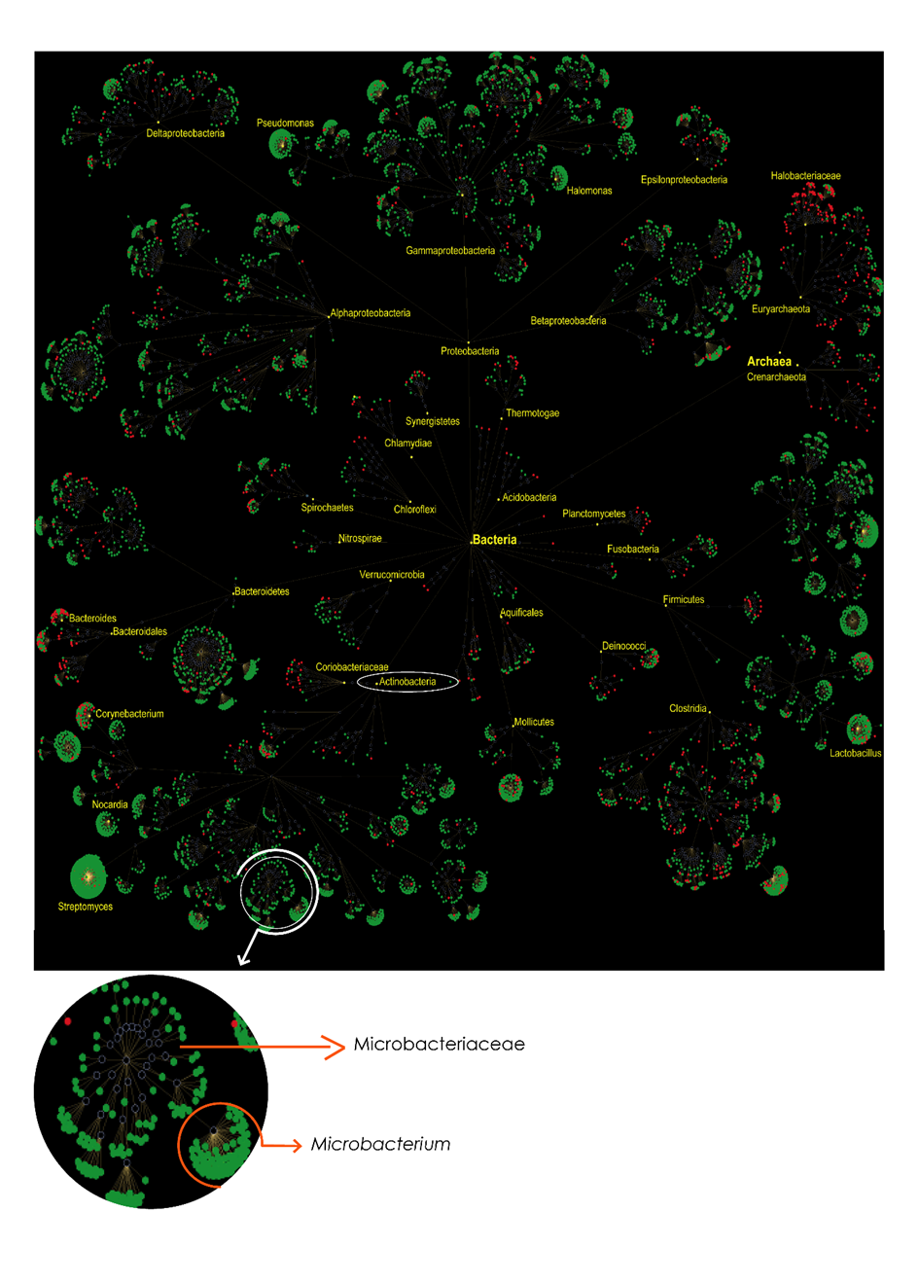Figure S3. Graphical representation of a taxonomic tree made with strains from the DSMZ cultivable collection according to the Gold database. A: Overview. B: Zoom on the area framed in circle in image A. Each point represents a type of strain. In red are represented the strains for which a sequencing project is in progress, the others are represented in green. The empty points represent higher taxonomic levels. The length of the branches is not significant. Figure extracted from https://microbial-earth.namesforlife.com/.
Supplementary Tables :
Content
Table S1. Result of antibiotic sensitivity test.
Table S2. The RAST Iron acquisition metabolic reconstruction of the submitted genome of Microbacterium metallidurans TL13 (A) compared to Cupriavidus metallidurans CH34 (B).
Table S3. KEGG map biosynthesis of siderophore group nonribosomal peptides for Microbacterium metallidurans TL13 and Cupriavidus metallidurans CH34

Table S1. Result of antibiotic sensitivity test.
Antibiotic | Code | Disk content (µg) | Antibiotic group | Resistance or Sensitivity | Inhibition zone (mm)
Cefoxitin | FOX | 30 | Cephamycin | Sensitive | 14
Pristinamycin | PTN | 15 | Streptogramin | Sensitive | 33
Neomycin | NE | 30 | Aminoglycoside | Sensitive | 20
Rifampicin | RD | 30 | Rifampicin | Sensitive | 37
Norfloxacin | NOR | 5 | Fluoroquinolone | Resistant | -
Streptomycin | S | 10 | Aminoglycoside | Sensitive | 21
Erythromycin | E | 15 | Macrolide | Sensitive | 35
Cefotaxime | CTX | 30 | β-lactam | Resistant | -
Tetracycline | TET | 30 | Tetracycline | Sensitive | 19
Vancomycin | VAN | 30 | Glycopeptide | Sensitive | 28
Ceftazidime | CAZ | 30 | β-lactam | Resistant | -
Spiramycin | SP | 100 | Macrolide | Sensitive | 42
Oxytetracyclin | OT | 30 | Oxytetracyclin | Sensitive | 22

Table S2. The RAST Iron acquisition metabolic reconstruction of the submitted genome of Microbacterium metallidurans TL13 (A) compared to Cupriavidus metallidurans CH34 (B).
Presence | Category | Subcategory | Subsystem | Role | Organism A | SS active A | SS active B
A | Iron acquisition and metabolism | no subcategory | Ferrous iron transporter EfeUOB, low-pH-induced | Ferrous iron transport periplasmic protein EfeO, contains peptidase-M75 domain and (frequently) cupredoxin-like domain | fig|69370.7.peg.2712 | yes | no
A | Iron acquisition and metabolism | no subcategory | Ferrous iron transporter EfeUOB, low-pH-induced | Ferrous iron transport permease EfeU | fig|69370.7.peg.2713 | yes | no
A | Iron acquisition and metabolism | no subcategory | Ferrous iron transporter EfeUOB, low-pH-induced | Ferrous iron transport peroxidase EfeB | fig|69370.7.peg.2711 | yes | no
A | Iron acquisition and metabolism | no subcategory | Heme, hemin uptake and utilization systems in GramPositives | Heme ABC transporter, ATPase component HmuV | fig|69370.7.peg.3272 | yes | no
A | Iron acquisition and metabolism | no subcategory | Heme, hemin uptake and utilization systems in GramPositives | Heme ABC transporter, cell surface heme and hemoprotein receptor HmuT | fig|69370.7.peg.3270 | yes | no
A | Iron acquisition and metabolism | no subcategory | Heme, hemin uptake and utilization systems in GramPositives | Heme ABC transporter, permease protein HmuU | fig|69370.7.peg.3271 | yes | no
A | Iron acquisition and metabolism | no subcategory | Heme, hemin uptake and utilization systems in GramPositives | Heme oxygenase (EC 1.14.99.3) | fig|69370.7.peg.1850, fig|69370.7.peg.3267 | yes | no
A | Iron acquisition and metabolism | no subcategory | Heme, hemin uptake and utilization systems in GramPositives | Hemoglobin, heme-dependent two component system sensory histidine kinase ChrS | fig|69370.7.peg.1952 | yes | no
A | Iron acquisition and metabolism | no subcategory | Heme, hemin uptake and utilization systems in GramPositives | Hemoglobin-dependent two component system response regulator HrrA | fig|69370.7.peg.1008 | yes | no
A | Iron acquisition and metabolism | no subcategory | Heme, hemin uptake and utilization systems in GramPositives | Hemoglobin-dependent two component system, sensory histidine kinase HrrS | fig|69370.7.peg.1009 | yes | no
A | Iron acquisition and metabolism | no subcategory | Heme, hemin uptake and utilization systems in GramPositives | Iron compound ABC uptake transporter substrate-binding protein PiaA | fig|69370.7.peg.2515 | yes | no
A | Iron acquisition and metabolism | no subcategory | Heme, hemin uptake and utilization systems in GramPositives | Iron-dependent repressor IdeR/DtxR | fig|69370.7.peg.755 | yes | no

Table S2. The RAST Iron acquisition metabolic reconstruction of the submitted genome of Microbacterium metallidurans TL13 (A) compared to Cupriavidus metallidurans CH34 (B) (continued).
Presence | Category | Subcategory | Subsystem | Role | Organism A | SS active B | SS active A
B | Iron acquisition and metabolism | Siderophores | Iron siderophore sensor & receptor system | FIG006045: Sigma factor, ECF subfamily | fig|266264.4.peg.1525, fig|266264.4.peg.4388 | yes | no
B | Iron acquisition and metabolism | Siderophores | Iron siderophore sensor & receptor system | Iron siderophore receptor protein | fig|266264.4.peg.4386 | yes | no
B | Iron acquisition and metabolism | Siderophores | Iron siderophore sensor & receptor system | Iron siderophore sensor protein | fig|266264.4.peg.1524, fig|266264.4.peg.4387 | yes | no
B | Iron acquisition and metabolism | Siderophores | Siderophore assembly kit | 2,3-dihydroxybenzoate-AMP ligase (EC 2.7.7.58) | fig|266264.4.peg.4166 | yes | no
B | Iron acquisition and metabolism | Siderophores | Siderophore assembly kit | TonB-dependent hemin receptor | fig|266264.4.peg.5751 | yes | no
B | Iron acquisition and metabolism | no subcategory | Encapsulating protein for DyP-type peroxidase and ferritin-like protein oligomers | [NiFe] hydrogenase nickel incorporation protein HypA | fig|266264.4.peg.1690, fig|266264.4.peg.1937 | yes | no
B | Iron acquisition and metabolism | no subcategory | Encapsulating protein for DyP-type peroxidase and ferritin-like protein oligomers | [NiFe] hydrogenase nickel incorporation-associated protein HypB | fig|266264.4.peg.1689, fig|266264.4.peg.1938 | yes | no
B | Iron acquisition and metabolism | no subcategory | Heme, hemin uptake and utilization systems in GramNegatives | ABC-type Fe3+-siderophore transport system permease component | fig|266264.4.peg.3180 | yes | no
B | Iron acquisition and metabolism | no subcategory | Heme, hemin uptake and utilization systems in GramNegatives | ABC-type hemin transport system, ATPase component | fig|266264.4.peg.5756 | yes | no
B | Iron acquisition and metabolism | no subcategory | Heme, hemin uptake and utilization systems in GramNegatives | Ferric siderophore transport system, biopolymer transport protein ExbB | fig|266264.4.peg.942 | yes | no
B | Iron acquisition and metabolism | no subcategory | Heme, hemin uptake and utilization systems in GramNegatives | Ferric siderophore transport system, periplasmic binding protein TonB | fig|266264.4.peg.2675 | yes | no
B | Iron acquisition and metabolism | no subcategory | Heme, hemin uptake and utilization systems in GramNegatives | Hemin ABC transporter, permease protein | fig|266264.4.peg.5755 | yes | no
B | Iron acquisition and metabolism | no subcategory | Heme, hemin uptake and utilization systems in GramNegatives | Hemin transport protein HmuS | fig|266264.4.peg.5753 | yes | no
B | Iron acquisition and metabolism | no subcategory | Heme, hemin uptake and utilization systems in GramNegatives | Hemin uptake protein | fig|266264.4.peg.2678 | yes | no
B | Iron acquisition and metabolism | no subcategory | Heme, hemin uptake and utilization systems in GramNegatives | Paraquat-inducible protein A | fig|266264.4.peg.4475, fig|26626 | yes | no

Table S3. KEGG map biosynthesis of siderophore group nonribosomal peptides for Microbacterium metallidurans TL13 and Cupriavidus metallidurans CH34.
KEGG map | Microbacterium trichothecenolyticum TL13 | Cupriavidus metallidurans CH34
Biosynthesis of siderophore group nonribosomal peptides | 3 (42.9 %) | 4 (57.1 %)
Phenylalanine, tyrosine and tryptophan biosynthesis | 18 (58.1 %) | 21 (67.7 %)

