Supplementary materials
M. Cristina Mangano^{1*}, Nova Mieszkowska^{2,3}, Brian Helmuth⁴, Tiago Domingos⁵, Tania Sousa⁵, Giuseppe Baiamonte⁶, Giuseppe Bazan⁷, Angela Cuttitta⁸, Fabio Fiorentino⁹, Antonio Giacoletti¹⁰, Magnus Johnson¹¹, Giuseppe D. Lucido¹⁰, Marco Marcelli^{12,13}, Riccardo Martellucci^{12,13}, Simone Mirto⁸, Bernardo Patti⁸, Fabio Pranovi¹⁴, Gray A. Williams¹⁵ and Gianluca Sarà¹⁰

MOVING TOWARDS A STRATEGY FOR ADDRESSING CLIMATE DISPLACEMENT OF MARINE RESOURCES: A PROOF-OF-CONCEPT
Running title: Climate-informed management at sea

Frontiers in Marine Science: Marine Fisheries, Aquaculture and Living Resources

Model description. In order to avoid further repetitions of the considerable amount of literature already published on this topic, this section comprises a short preface, as an excellent comprehensive descriptions of the Standard DEB model and its fundamentals is widely available (van der Meer 2006; Kooijman 2010; Sousa et al. 2010). Dynamic Energy Budget theory incorporates whole-organism bioenergetics, connecting individual behaviours to population growth and rely on the assumption that flows of energy and matter (and time) through habitats and organisms are subjected to conservation laws (Charnov and Krebs 1974) and, consequently, are traceable (and budgetable) processes. The mechanistic nature of the model made it an extremely powerful tool to link individual bioenergetics to environmental forcing variables (i.e. temperatures and food, Figures S2, S3), so that the functioning of each species and thereby the magnitude and variability of life-history traits (Loreau 2010, Kearney 2012, Pethybridge 2013) can be reliably predicted. This is only feasible if the organismal body temperature (BT) and food densities are available for the target species, here the European anchovy, and above all if the full set of DEB parameters has been previously estimated (Pethybridge 2013) (Table S2, Figure S1).

The reason behind the choice of this particular set of parameters instead of the more recent available online in the Add my pet collection (Pecquerie and Kooijman 2015) is that with the latest set of parameters, probably more specific to Northern European populations, our specimens did not grow and neither reproduce as with Pethybridge’s (2013) parameters, that are instead specific for the Mediterranean anchovy. As models capture life-history traits that are susceptible to evolution, at the same time their parameter values can presumably vary as a function of genetic (Valladares et al. 2014). The assumption of “stationarity” has recently been tested in Monaco et al. (2019) with parameters for native Mytilus galloprovincialis’ populations unable to perform well for non-native populations. The authors state models and parameters as a reflection of environmental and biological data used to train and validate them causing incorrect estimations in some cases.

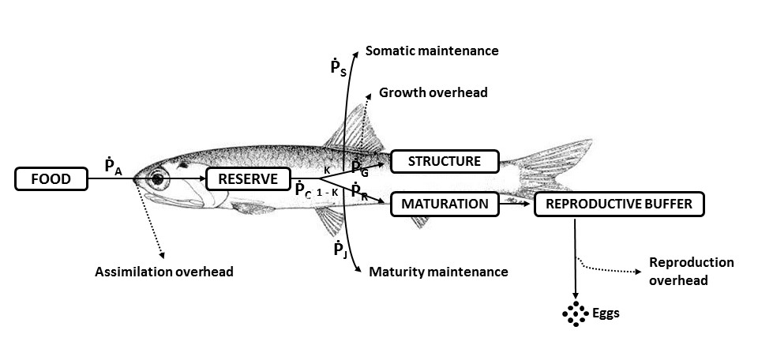
Figure S1. General structure of DEB model.

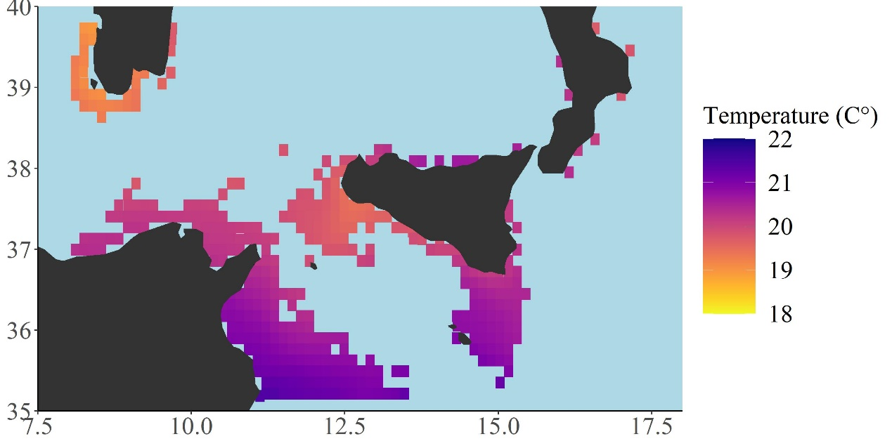Figure S2. Daily Sea Surface Temperatures (SST; 1 km resolution) from JPL MUR SST data (2010) (https://podaac.jpl.nasa.gov/Multi-scale_Ultra-high_Resolution_MUR-SST) over a time range of 4 years (2011-2014). Total number of cells = 346, cells resolution of 12.5 x 12.5 km². Maps were created using R software (ggplot2 package).

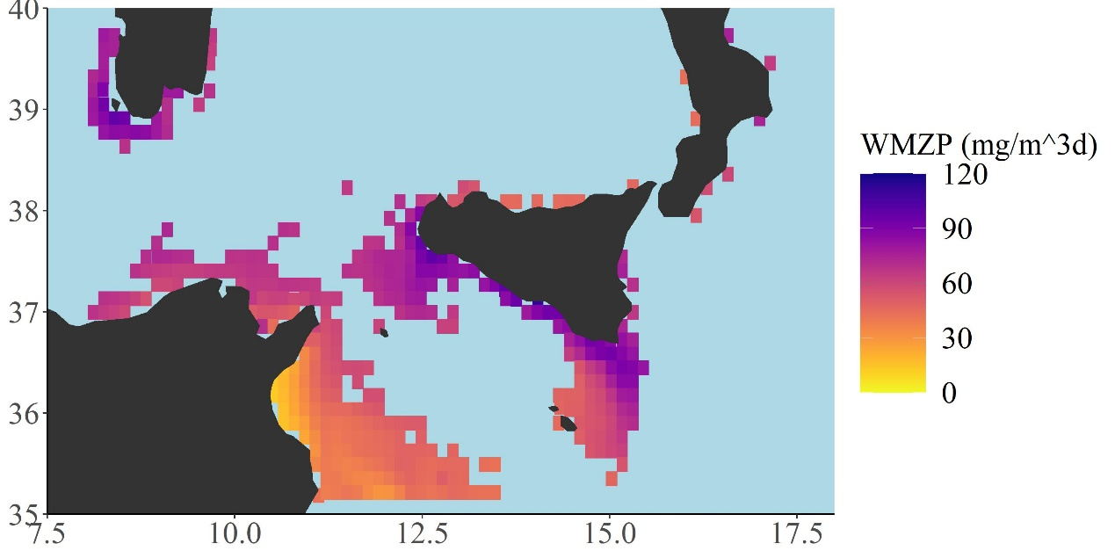
Figure S3. Daily Wet Mass of ZooPlankton (WMZP, mg m⁻³) obtained using the conversion coefficient provided by the ICES Committee on Terms and Equivalents (Cushing 1958) starting from NPP values of carbon per unit volume expressed as grams of carbon/meter³/day. The NPP dataset was obtained from Oregon State University (2017). Total number of cells = 346, cells resolution of 12.5 x 12.5 km². Maps were created using R software (ggplot2 package).

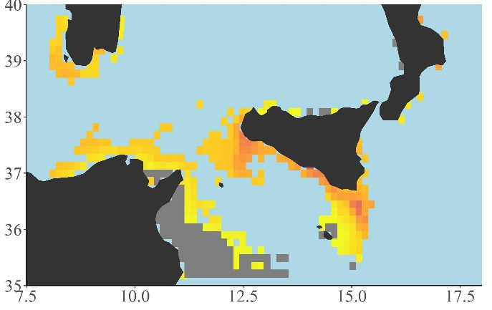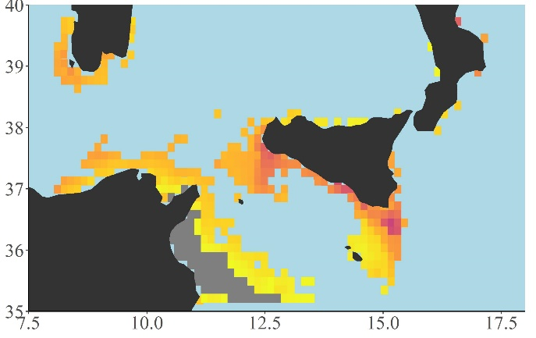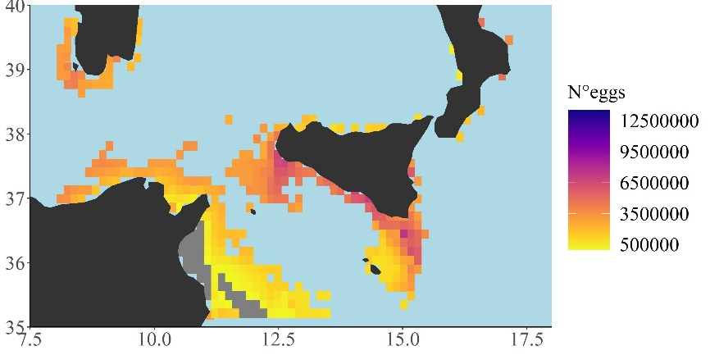
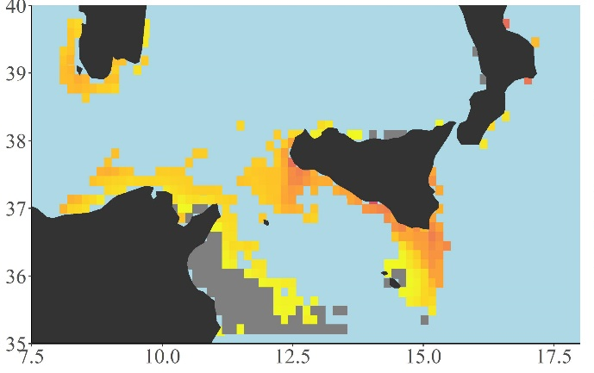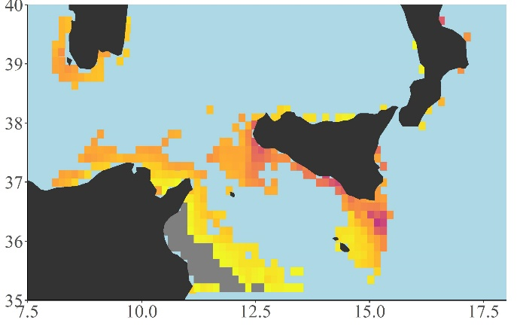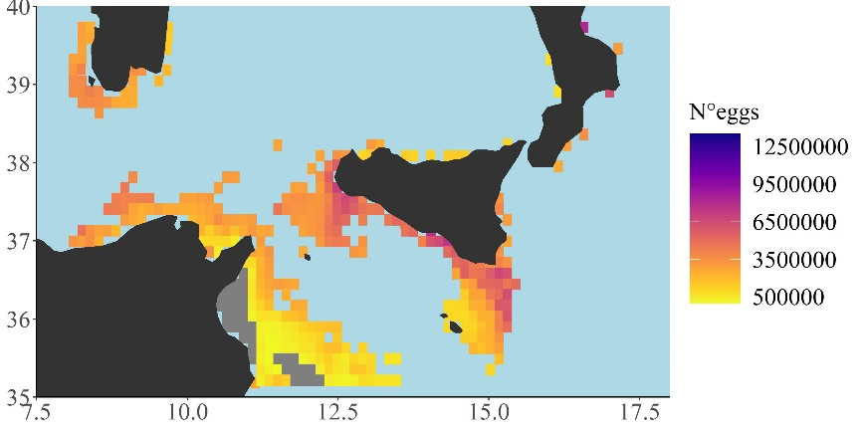
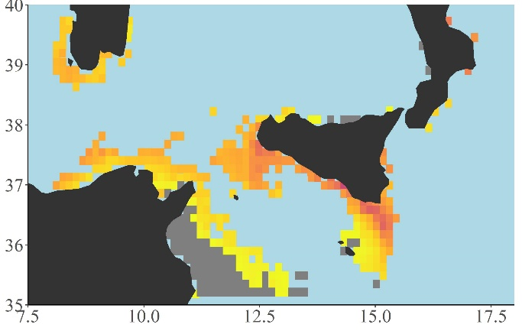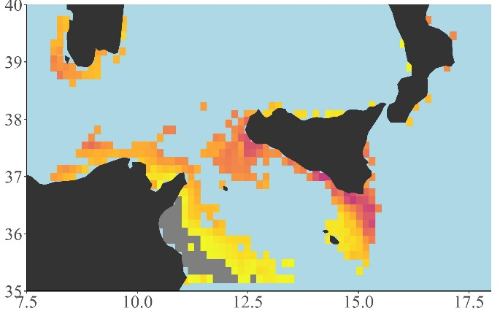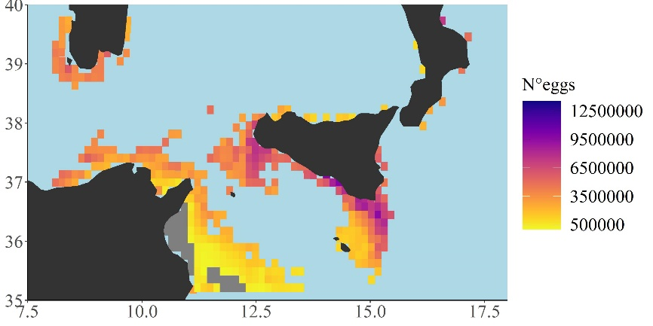

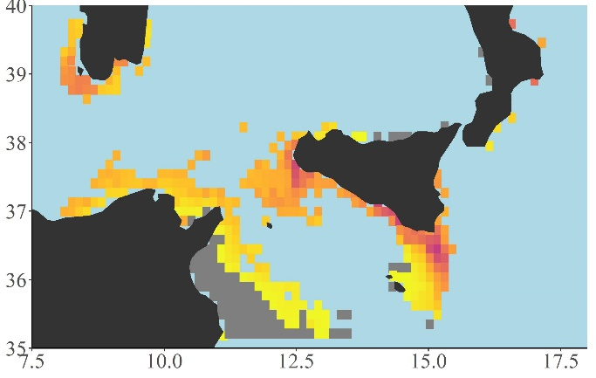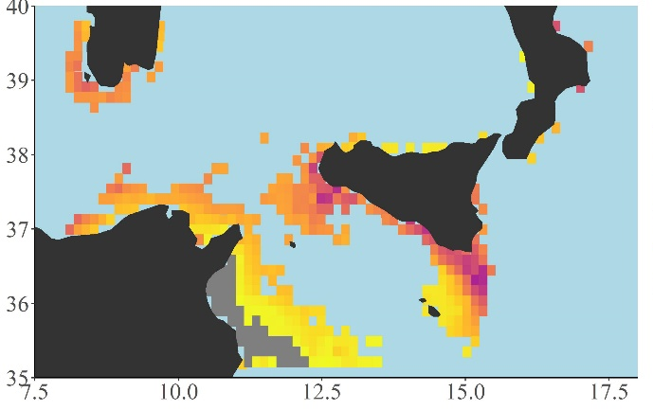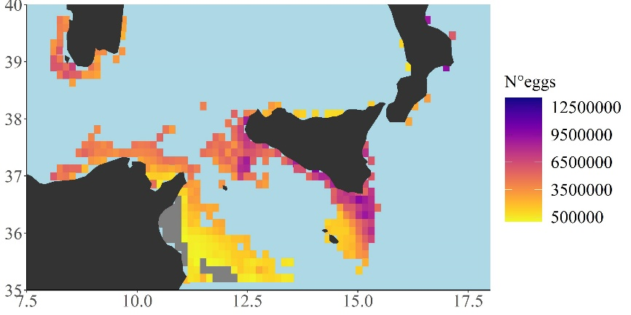
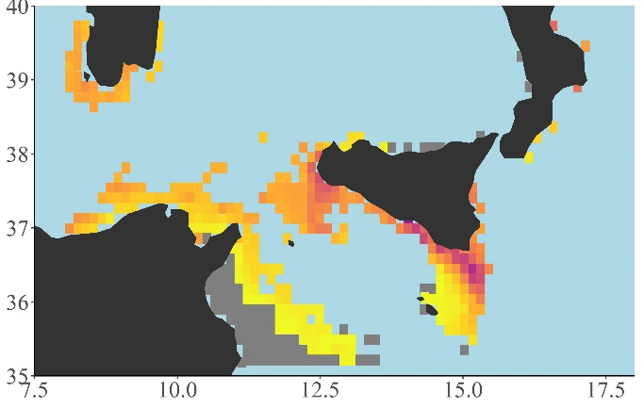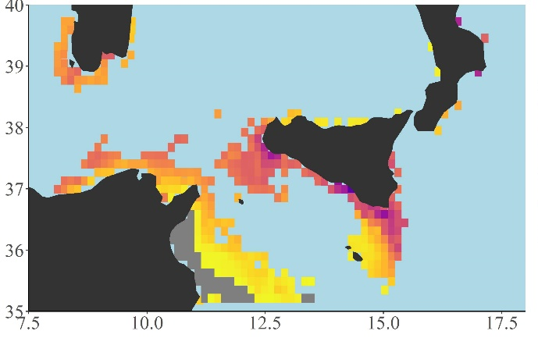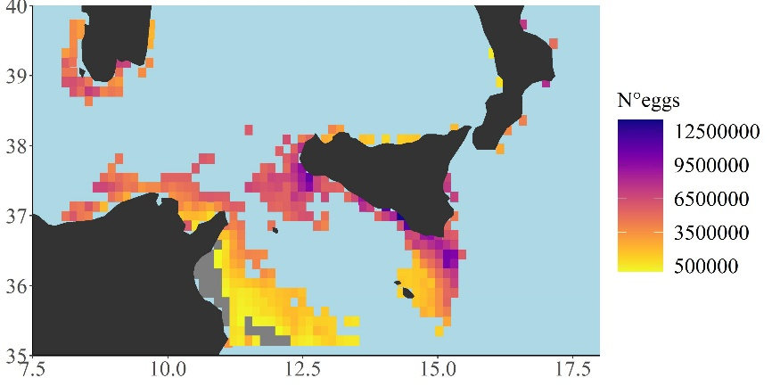
Figure S4. Scenarios-based quantitative maps showing differences between “Eggs” (n.) described by a continuous scale (from 0 to 13,500,000) respectively across the examined temperature scenarios (central panel, current temperature vs all the four temperature increasing scenarios of +0.5°C increase up to +2 °C). Differences between current primary production food condition and oligotrophic, - 10%, food condition per each temperature scenarios (+ 0.5; + 1.0; + 1.5; + 2.0 °C, left panel). Differences between current primary production food condition and eutrophic, +10%, food condition per each temperature scenarios (right panel). Minimum, maximum, mean and median values for each scenario have been also reported inside each map as well as the global G statistic values. Total number of cells = 346, cells resolution of 12.5 x 12.5 km². Maps were created using R software (ggplot2 package).

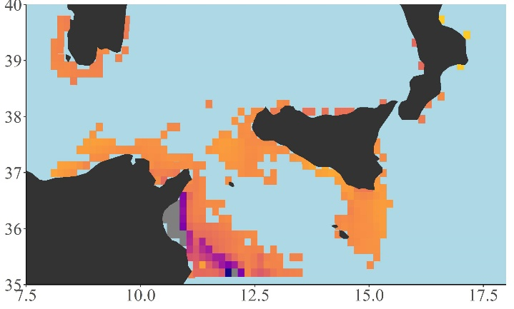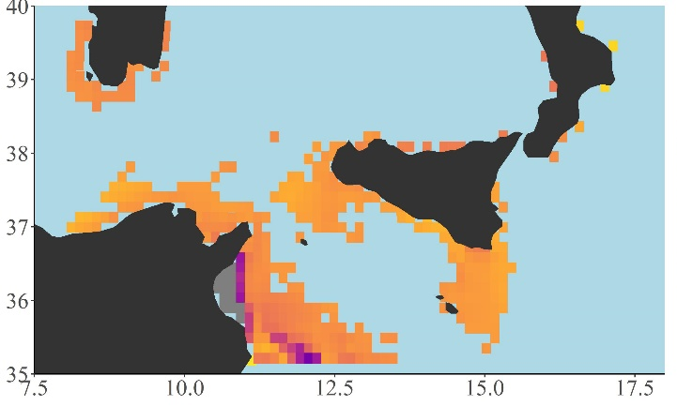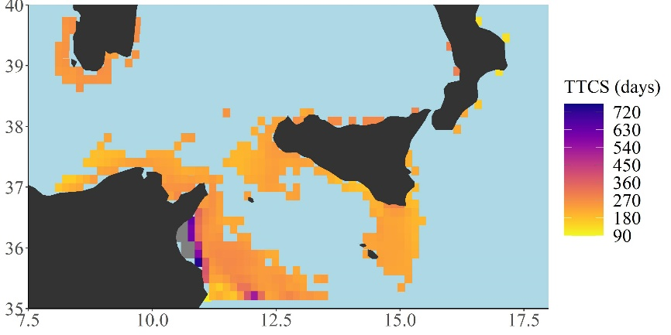
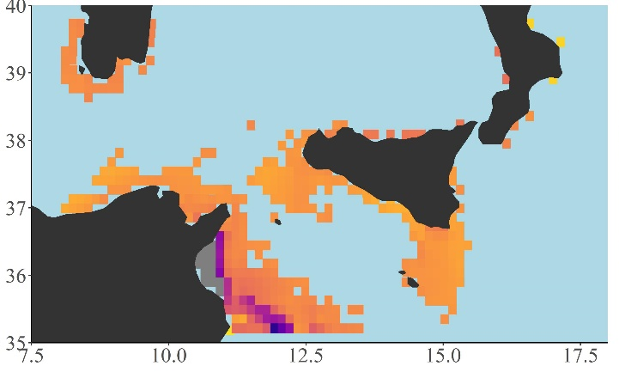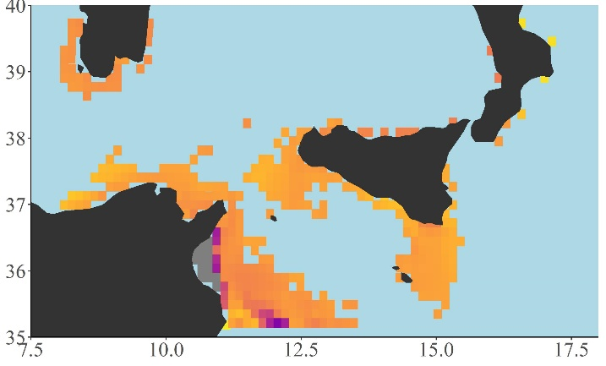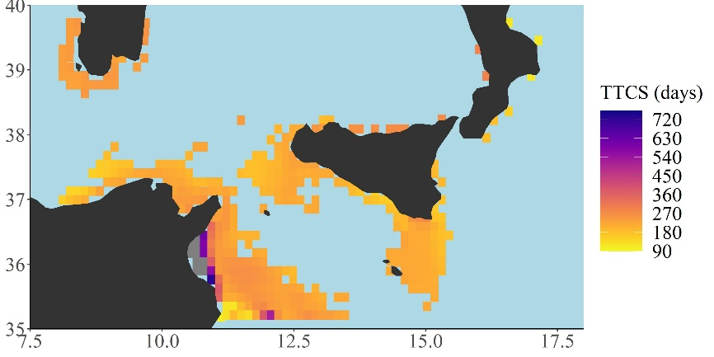
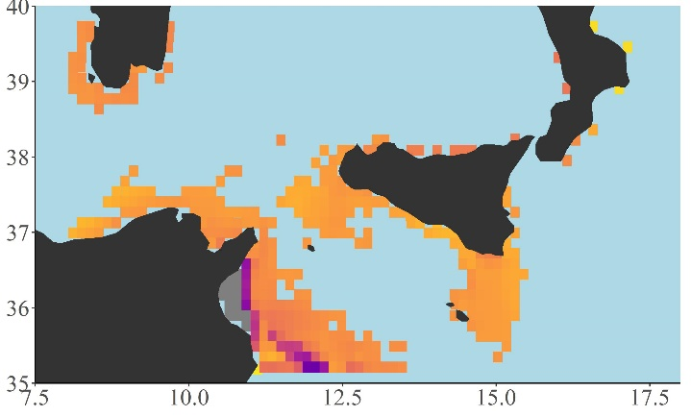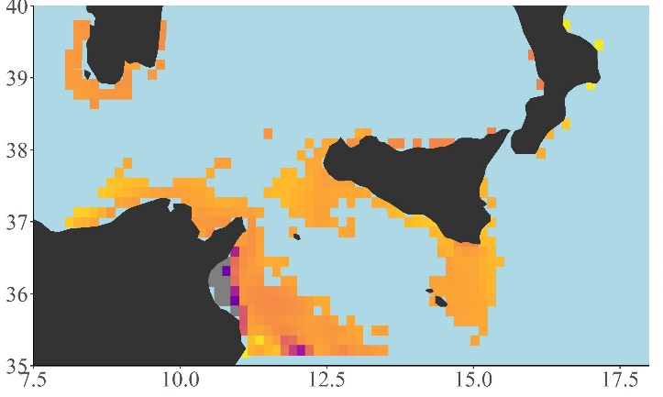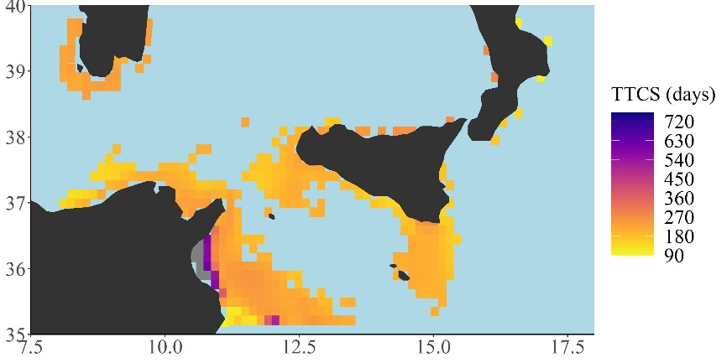

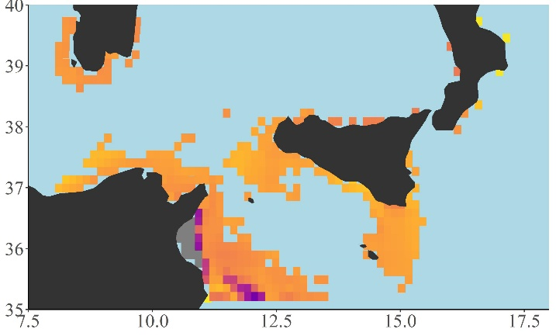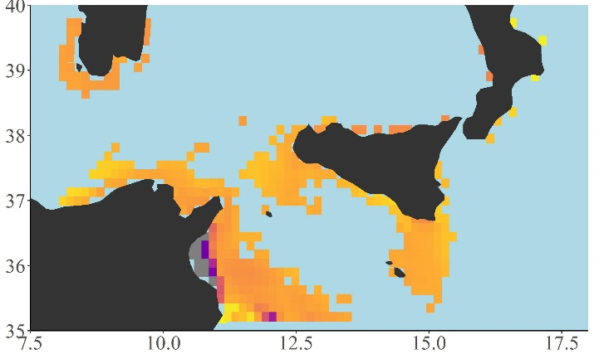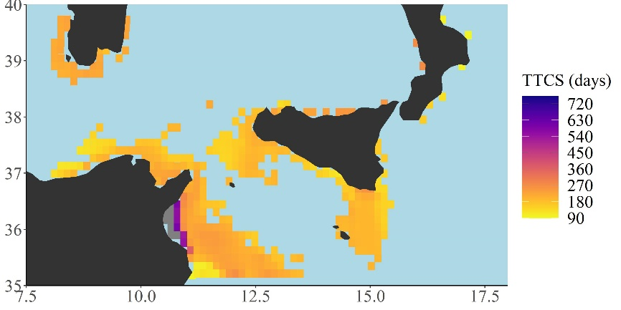
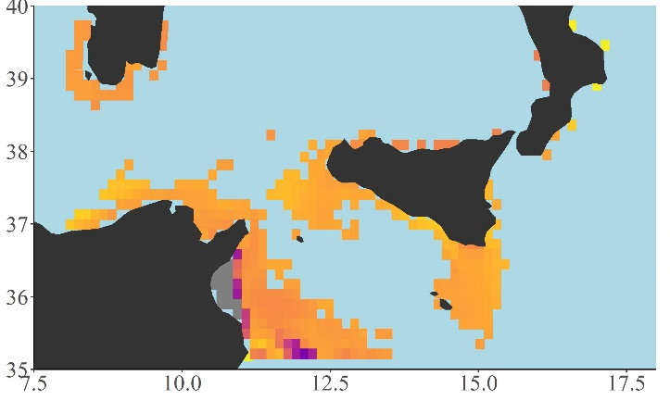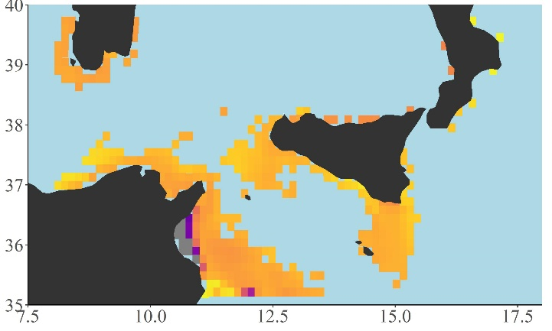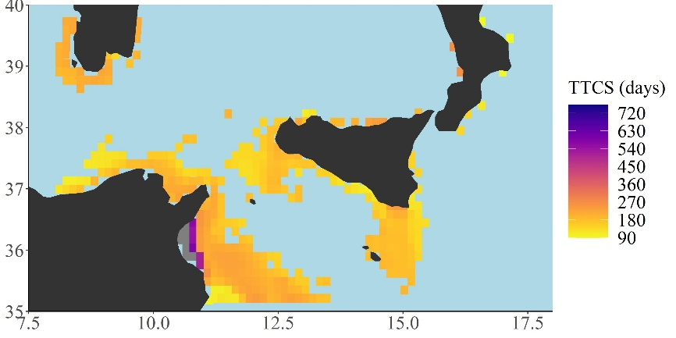
Figure S5. Scenarios-based quantitative maps showing differences between “Time to Cath” (TTC, days) described by a continuous scale (from 90 to 1320 days) respectively across the examined temperature scenarios (central panel, current temperature vs all the four temperature increasing scenarios of +0.5°C increase up to +2 °C). Differences between current primary production food condition and oligotrophic, - 10%, food condition per each temperature scenarios (+ 0.5; + 1.0; + 1.5; + 2.0 °C, left panel). Differences between current primary production food condition and eutrophic, +10%, food condition per each temperature scenarios (right panel). Minimum, maximum, mean and median values for each scenario have been also reported inside each map as well as the global G statistic values. Total number of cells = 346, cells resolution of 12.5 x 12.5 km². Maps were created using R software (ggplot2 package).

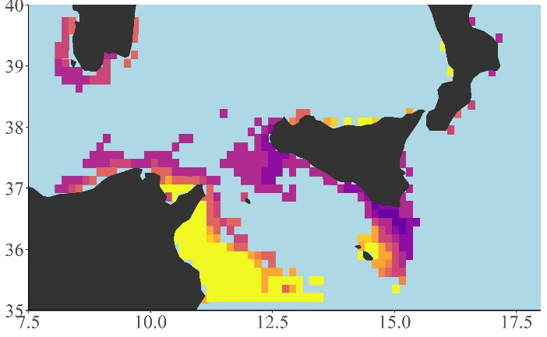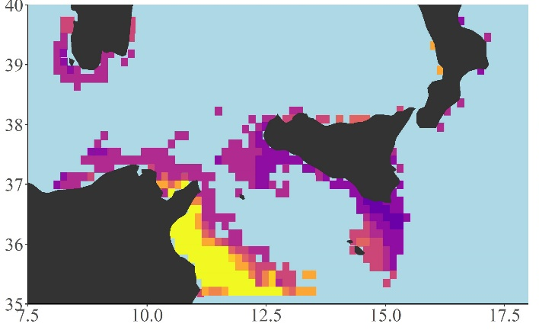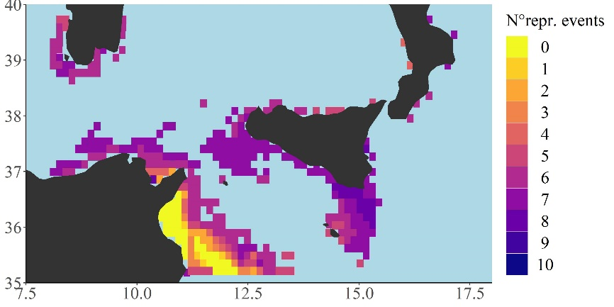
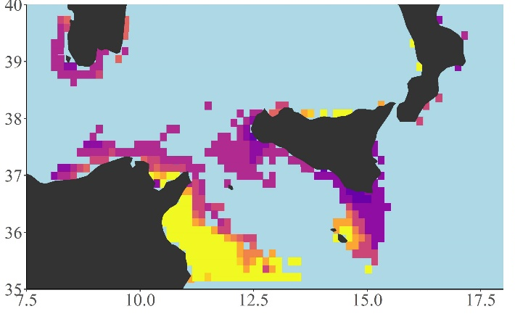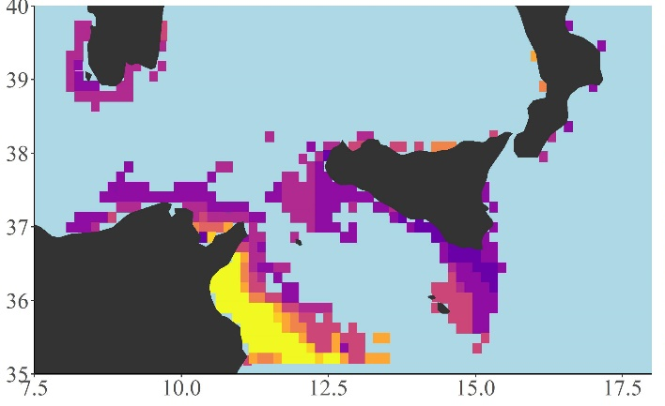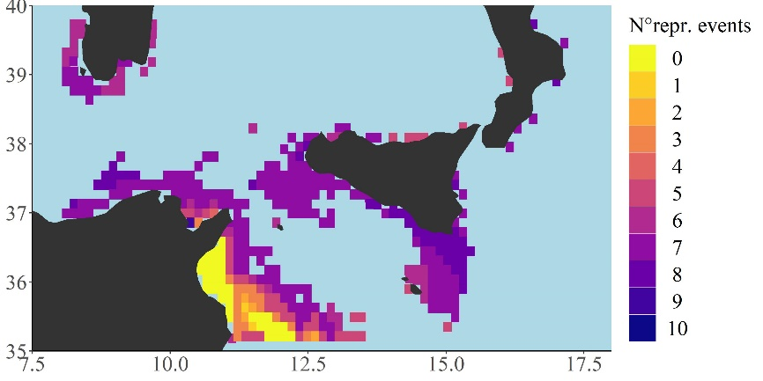
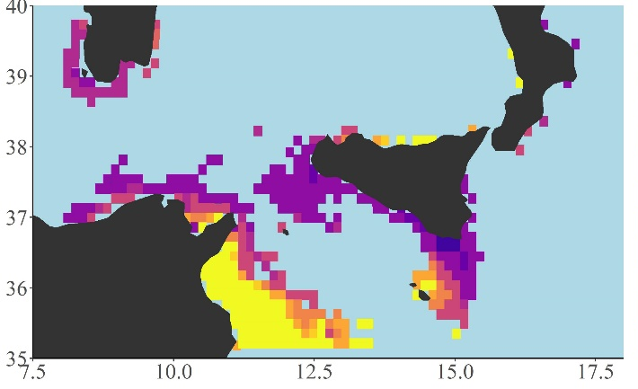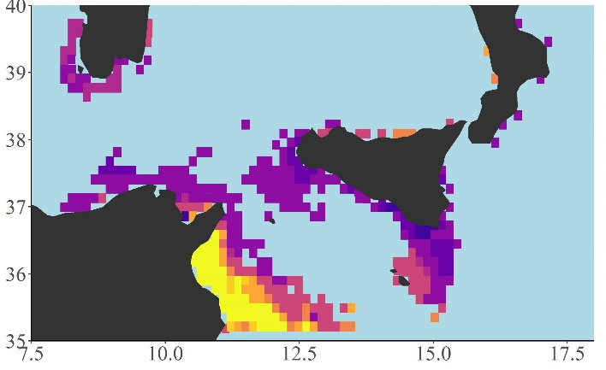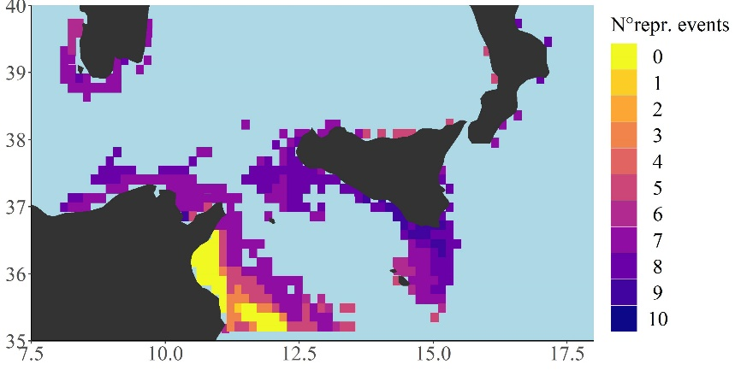

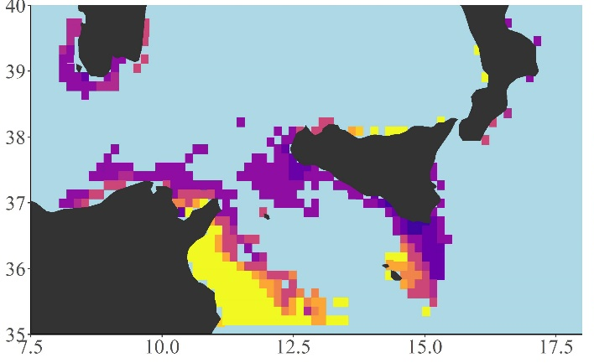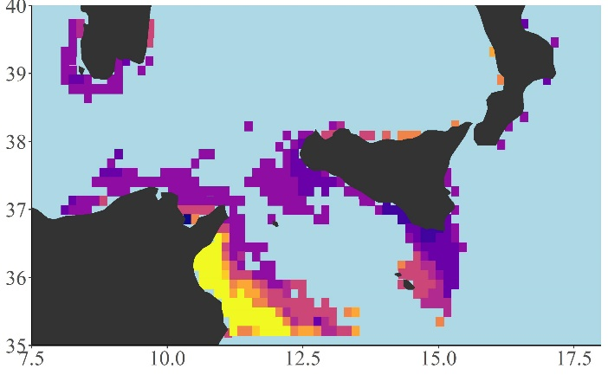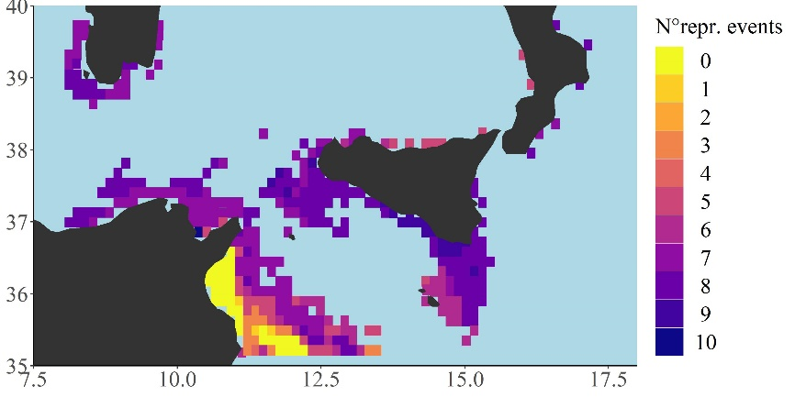
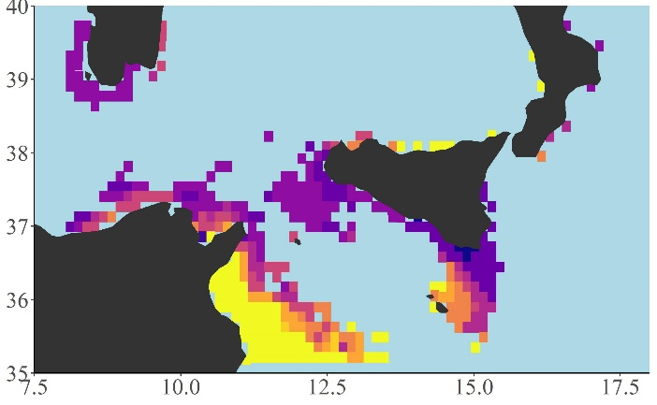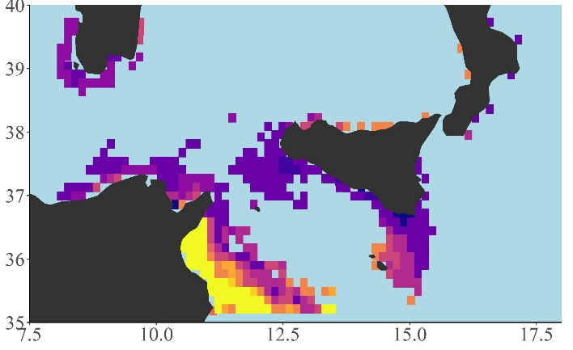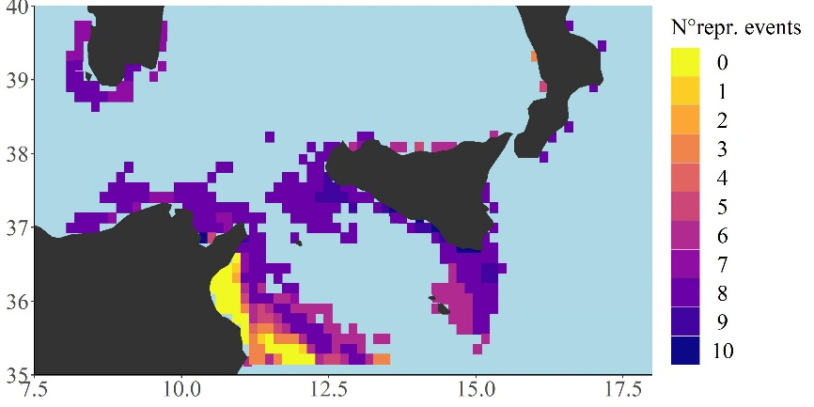
Figure S6. Scenarios-based quantitative maps showing differences between “Reproductive Events” (n.) described by a continuous scale (from 0 to 10) respectively across the examined temperature scenarios (central panel, current temperature vs all the four temperature increasing scenarios of +0.5°C increase up to +2 °C). Differences between current primary production food condition and oligotrophic, - 10%, food condition per each temperature scenarios (+ 0.5; + 1.0; + 1.5; + 2.0 °C, left panel). Differences between current primary production food condition and eutrophic, +10%, food condition per each temperature scenarios (right panel). Minimum, maximum, mean and median values for each scenario have been also reported inside each map as well as the global G statistic values. Total number of cells = 346, cells resolution of 12.5 x 12.5 km². Maps were created using R software (ggplot2 package).

Table S1. List of DEB state variables, fluxes and formulas
State variables | Units | Formula
Reserve energy | J | $$\frac{dE}{dt}= \dot{p_{A}}- \dot{p_{C}}$$
Structural volume | cm³ | $$\frac{dV}{dt}= \dot{\frac{p_{G}}{\left[E_{G}\right]}}$$
Maturity energy | J | $$\frac{dE_{H}}{dt}= \dot{p_{R}}(E_{H}<E_{H}^{p})$$
Fluxes: | Units | Formula
Assimilation | J d⁻¹ | $${\dot{p}}_{A}= f(X)\left\{\dot{p_{Am}}\right\} V^{2/3}$$
Mobilization | J d⁻¹ | $$\dot{p_{C} }=E \left(\frac{\left[E_{G}\right]\dot{v} V^{2/3}+ \dot{p_{S}}}{kE+ \left[E_{G}\right] V}\right)$$
Somatic maintenance | J d⁻¹ | $${\dot{p}}_{S}=\left[\dot{p_{M}}\right]V+\left\{\dot{p_{T}}\right\}V^{2/3}$$
Maturity maintenance | J d⁻¹ | $${\dot{p}}_{G}= k{\dot{p}}_{C}- {\dot{p}}_{S}$$
Growth | J d⁻¹ | $${\dot{p}}_{J}=\dot{k_{J}}E_{H}$$
Maturation/reproduction | J d⁻¹ | $${\dot{p}}_{R}=\left(1-k\right){\dot{p}}_{C}-{\dot{p}}_{J}$$

Table S2. List of DEB parameters used in this study for European anchovy model, central Mediterranean Sea.
 |  |  | Engraulis encrasicolus
Primary DEB parameters | Symbol | Units | Value | Reference
Structural volume at birth | $$V_{b}$$ | cm³ | 0.0002 | Pethybridge et al. 2013
Structural volume at puberty | $$V_{p}$$ | cm³ | 1.73 | Pethybridge et al. 2013
Shape coefficient larva | $$δ_{larva}$$ | - | 0.154 | Pethybridge et al. 2013
Shape coefficient adult | $$δ_{adult}$$ | - | 0.169 | Pethybridge et al. 2013
Max. surface area-specific ingestion rate | $$\left\{{\dot{p}}_{Xm}\right\}$$ | J cm⁻² h⁻¹ | 13.50 | Pethybridge et al. 2013
Assimilation rate | $$ae$$ | - | 0.71 | Pethybridge et al. 2013
Saturation coefficient | $$X_{k}$$ | mg m⁻³ | 33 | Pethybridge et al. 2013
Volume-specific cost of growth | $$\left[E_{G}\right]$$ | J cm³ | 4,000 | Pethybridge et al. 2013
Energy content of an egg | E_{egg} | Jegg⁻¹ | 0.15 | Pethybridge et al. 2013
Energy maturity at birth | E_{Hb} | J | 0.0001 | Pethybridge et al. 2013
Energy maturity at metamorphosis | E_{Hj} | J | 0.6741 | Pethybridge et al. 2013
Maximum storage density | $$\left[E_{m}\right]$$ | J cm³ | 2,700 | Pethybridge et al. 2013
Volume-specific maintenance cost | $$\left[{\dot{p}}_{M}\right]$$ | J cm⁻³ h⁻¹ | 2.00 | Pethybridge et al. 2013
Fraction of utilized energy spent on maintenance plus growth | $$κ$$ | - | 0.7 | Pethybridge et al. 2013
Fraction reproductive energy fixed | $$κ_{r}$$ | - | 0.95 | Pethybridge et al. 2013
Arrhenius temperature | $$T_{A}$$ | K | 9,800 | Pethybridge et al. 2013
Lower boundary of tolerance range | $$T_{L}$$ | K | 278 | Teal et al. 2012
Upper boundary of tolerance range | $$T_{H}$$ | K | 305 | Teal et al. 2012
Rate of decrease at lower boundary | $$T_{AL}$$ | K | 50,000 | Teal et al. 2012
Rate of decrease at upper boundary | $$T_{AH}$$ | K | 100,000 | Teal et al. 2012

Table S3. Maximum length (Lmax) and Total reproductive Output (TRO) values of Minimum (Min.), first quartile (Q1), Median, Mean, third quartile (Q3), Maximum (Max.), global G statistic (G) and p-value, values reported respectively across the examined temperature scenarios (from current temperature up to +2 °C, increasing scenarios of +0.5°C increase) and food scenario, current food and oligotrophic, - 10% food, and eutrophic, +10%, food.
 | Temperature Current, -10% Food |  | Temperature Current, Food Current |  | Temperature Current, Food +10%
 | Lmax | TRO | Lmax | TRO | Lmax | TRO
Min. | 6,76 | 0,00 | 7,14 | 0,00 | 7,48 | 0,00
Q1 | 11,74 | 0,00 | 12,19 | 75992,50 | 12,60 | 153803,00
Median | 12,72 | 167269,00 | 13,13 | 240986,00 | 13,49 | 345783,00
Mean | 12,40 | 170487,01 | 12,81 | 258127,14 | 13,17 | 343480,50
Q3 | 13,18 | 267028,00 | 13,57 | 395115,00 | 13,91 | 496165,50
Max. | 14,50 | 697245,00 | 14,85 | 925462,00 | 15,14 | 1021668,00
G | 14,29 | 14,29 | 12,15 | 12,15 | 9,92 | 9,92
p-value | 0,00 | 0,00 | 0,00 | 0,00 | 0,00 | 0,00
 | Temperature +0.5 °C, Food -10% |  | Temperature +0.5 °C, Food Current |  | Temperature +0.5 °C, Food +10%
 | Lmax | TRO | Lmax | TRO | Lmax | TRO
Min. | 6,86 | 0,00 | 7,23 | 0,00 | 7,57 | 0,00
Q1 | 11,79 | 0,00 | 12,25 | 99095,00 | 12,66 | 164910,00
Median | 12,85 | 177305,00 | 13,24 | 251721,00 | 13,59 | 376319,00
Mean | 12,50 | 182142,99 | 12,91 | 273135,76 | 13,27 | 356733,34
Q3 | 13,30 | 284559,00 | 13,68 | 415981,50 | 14,02 | 500376,00
Max. | 14,60 | 786135,00 | 14,94 | 931606,00 | 15,24 | 1016557,00
G | 14,20 | 14,20 | 11,42 | 11,42 | 9,51 | 9,51
p-value | 0,00 | 0,00 | 0,00 | 0,00 | 0,00 | 0,00
 | Temperature +1 °C, Food -10% |  | Temperature +1 °C, Food Current |  | Temperature +1 °C, Food +10%
 | Lmax | TRO | Lmax | TRO | Lmax | TRO
Min. | 6,95 | 0,00 | 7,32 | 0,00 | 7,66 | 0,00
Q1 | 11,87 | 3505,50 | 12,31 | 106484,50 | 12,71 | 178464,00
Median | 12,94 | 188162,00 | 13,35 | 295673,00 | 13,71 | 401627,00
Mean | 12,60 | 208767,20 | 13,00 | 308050,23 | 13,36 | 397008,78
Q3 | 13,42 | 342191,50 | 13,80 | 500657,00 | 14,14 | 586103,00
Max. | 14,73 | 829670,00 | 15,04 | 894013,00 | 15,33 | 1099616,00
G | 13,87 | 13,87 | 12,03 | 12,03 | 10,16 | 10,16
p-value | 0,00 | 0,00 | 0,00 | 0,00 | 0,00 | 0,00
 | Temperature +1.5 °C, Food -10% |  | Temperature +1.5 °C, Food Current |  | Temperature +1.5 °C, Food +10%
 | Lmax | TRO | Lmax | TRO | Lmax | TRO
Min. | 7,04 | 0,00 | 7,41 | 0,00 | 7,75 | 0,00
Q1 | 11,94 | 18048,50 | 12,39 | 111693,50 | 12,78 | 193010,00
Median | 13,03 | 206027,00 | 13,45 | 317858,00 | 13,81 | 442487,00
Mean | 12,70 | 227428,40 | 13,10 | 324788,00 | 13,46 | 432044,93
Q3 | 13,53 | 348223,00 | 13,91 | 503020,00 | 14,25 | 628281,00
Max. | 14,86 | 898101,00 | 15,17 | 1050302,00 | 15,44 | 1200157,00
G | 14,08 | 14,08 | 12,01 | 12,01 | 10,14 | 10,14
p-value | 0,00 | 0,00 | 0,00 | 0,00 | 0,00 | 0,00
 | Temperature +2 °C, Food -10% |  | Temperature +2 °C, Food Current |  | Temperature +2 °C, Food +10%
 | Lmax | TRO | Lmax | TRO | Lmax | TRO
Min. | 7,12 | 0,00 | 7,50 | 0,00 | 7,84 | 0,00
Q1 | 12,02 | 24391,50 | 12,46 | 115168,50 | 12,85 | 214032,50
Median | 13,14 | 217412,00 | 13,53 | 348905,00 | 13,88 | 495475,00
Mean | 12,80 | 244603,03 | 13,19 | 363121,53 | 13,55 | 472557,96
Q3 | 13,64 | 386391,00 | 14,02 | 590337,00 | 14,35 | 704749,50
Max. | 14,99 | 987239,00 | 15,30 | 1236163,00 | 15,56 | 1342325,00
G | 14,38 | 14,38 | 11,75 | 11,75 | 9,43 | 9,43
p-value | 0,00 | 0,00 | 0,00 | 0,00 | 0,00 | 0,00

Table S4. Number of eggs (N. eggs), Time To Commercial Size (TTCS) and Number of reproductive events (N. rep. events) values of Minimum (Min.), first quartile (Q1), Median, Mean, third quartile (Q3), Maximum (Max.), global G statistic (G) and p-value, values reported respectively across the examined temperature scenarios (from current temperature up to +2 °C, increasing scenarios of +0.5°C increase) and food scenario, current food and oligotrophic, - 10% food, and eutrophic, +10%, food.
 | Temperature Current, -10% Food |  |  | Temperature Current, Food Current |  |  | Temperature Current, Food +10%
 | N. eggs | TTCS | N. repr. events | N. eggs | TTCS | N. repr. events | N. eggs | TTCS | N. repr. events
Min. | 0,00 | 163,00 | 0,00 | 0,00 | 115,00 | 0,00 | 0,00 | 105,00 | 0,00
Q1 | 0,00 | 265,00 | 0,00 | 295079,00 | 244,00 | 4,00 | 795511,00 | 221,00 | 5,00
Median | 786887,00 | 279,00 | 5,00 | 1403366,00 | 257,00 | 6,00 | 2113359,00 | 236,00 | 6,00
Mean | 1014327,41 | 341,01 | 3,70 | 1633741,68 | 306,47 | 4,74 | 2282203,99 | 273,24 | 5,51
Q3 | 1593558,00 | 305,00 | 6,00 | 2464636,50 | 279,00 | 6,00 | 3314614,00 | 258,00 | 7,00
Max. | 5024252,00 | 1644,00 | 8,00 | 6853506,00 | 1644,00 | 8,00 | 7589807,00 | 1644,00 | 8,00
G | 14,29 | 14,29 | 14,29 | 12,15 | 12,15 | 12,15 | 9,92 | 9,92 | 9,92
p-value | 0,00 | 0,00 | 0,00 | 0,00 | 0,00 | 0,00 | 0,00 | 0,00 | 0,00
 | Temperature +0.5 °C, Food -10% |  |  | Temperature +0.5 °C, Food Current |  |  | Temperature +0.5 °C, Food +10%
 | N. eggs | TTCS | N. repr. events | N. eggs | TTCS | N. repr. events | N. eggs | TTCS | N. repr. events
Min. | 0,00 | 122,00 | 0,00 | 0,00 | 107,00 | 0,00 | 0,00 | 100,00 | 0,00
Q1 | 0,00 | 253,00 | 0,00 | 428365,50 | 230,50 | 5,00 | 986988,50 | 204,00 | 5,00
Median | 950785,00 | 267,00 | 5,00 | 1508798,00 | 244,00 | 6,00 | 2547094,00 | 222,00 | 7,00
Mean | 1137405,47 | 324,95 | 4,03 | 1807150,78 | 290,12 | 5,10 | 2495247,84 | 258,09 | 5,93
Q3 | 1712397,50 | 289,00 | 6,00 | 2780352,50 | 266,00 | 7,00 | 3510407,00 | 246,00 | 7,00
Max. | 6289082,00 | 1644,00 | 8,00 | 7452847,00 | 1644,00 | 8,00 | 8132456,00 | 1644,00 | 9,00
G | 14,20 | 14,20 | 14,20 | 11,42 | 11,42 | 11,42 | 9,51 | 9,51 | 9,51
p-value | 0,00 | 0,00 | 0,00 | 0,00 | 0,00 | 0,00 | 0,00 | 0,00 | 0,00
 | Temperature +1 °C, Food -10% |  |  | Temperature +1 °C, Food Current |  |  | Temperature +1 °C, Food +10%
 | N. eggs | TTCS | N. repr. events | N. eggs | TTCS | N. repr. events | N. eggs | TTCS | N. repr. events
Min. | 0,00 | 113,00 | 0,00 | 0,00 | 103,00 | 0,00 | 0,00 | 95,00 | 0,00
Q1 | 7011,50 | 241,00 | 2,00 | 519524,00 | 216,50 | 5,00 | 1096983,00 | 189,00 | 6,00
Median | 1084181,00 | 256,00 | 5,00 | 1989588,00 | 232,00 | 7,00 | 2811389,00 | 210,00 | 7,00
Mean | 1394066,20 | 309,60 | 4,42 | 2142480,92 | 273,29 | 5,43 | 2956065,81 | 242,67 | 6,30
Q3 | 2344556,00 | 276,00 | 7,00 | 3503484,00 | 253,00 | 7,00 | 4403306,00 | 234,00 | 8,00
Max. | 6637363,00 | 1644,00 | 9,00 | 7218662,00 | 1644,00 | 9,00 | 9896542,00 | 1644,00 | 9,00
G | 13,87 | 13,87 | 13,87 | 12,03 | 12,03 | 12,03 | 10,16 | 10,16 | 10,16
p-value | 0,00 | 0,00 | 0,00 | 0,00 | 0,00 | 0,00 | 0,00 | 0,00 | 0,00
 | Temperature +1.5 °C, Food -10% |  |  | Temperature +1.5 °C, Food Current |  |  | Temperature +1.5 °C, Food +10%
 | N. eggs | TTCS | N. repr. events | N. eggs | TTCS | N. repr. events | N. eggs | TTCS | N. repr. events
Min. | 0,00 | 108,00 | 0,00 | 0,00 | 99,00 | 0,00 | 0,00 | 92,00 | 0,00
Q1 | 36097,50 | 231,00 | 2,00 | 513129,00 | 202,00 | 5,00 | 1150336,50 | 171,00 | 6,00
Median | 1266594,00 | 245,00 | 6,00 | 2104363,00 | 221,00 | 7,00 | 3174906,00 | 196,00 | 7,00
Mean | 1567292,18 | 295,42 | 4,60 | 2321007,82 | 258,73 | 5,63 | 3278536,59 | 227,60 | 6,45
Q3 | 2437562,50 | 265,00 | 7,00 | 3552219,00 | 242,00 | 7,00 | 4932418,50 | 223,50 | 8,00
Max. | 7184806,00 | 1644,00 | 9,00 | 8402418,00 | 1644,00 | 10,00 | 9790719,00 | 1644,00 | 10,00
G | 14,08 | 14,08 | 14,08 | 12,01 | 12,01 | 12,01 | 10,14 | 10,14 | 10,14
p-value | 0,00 | 0,00 | 0,00 | 0,00 | 0,00 | 0,00 | 0,00 | 0,00 | 0,00
 | Temperature +2 °C, Food -10% |  |  | Temperature +2 °C, Food Current |  |  | Temperature +2 °C, Food +10%
 | N. eggs | TTCS | N. repr. events | N. eggs | TTCS | N. repr. events | N. eggs | TTCS | N. repr. events
Min. | 0,00 | 106,00 | 0,00 | 0,00 | 98,00 | 0,00 | 0,00 | 91,00 | 0,00
Q1 | 59274,00 | 220,00 | 2,00 | 527803,00 | 189,00 | 5,00 | 1391583,00 | 154,00 | 6,00
Median | 1305131,00 | 235,00 | 6,00 | 2309169,00 | 212,00 | 7,00 | 3827167,00 | 183,00 | 8,00
Mean | 1714535,11 | 281,87 | 4,71 | 2746537,39 | 244,55 | 5,93 | 3702804,17 | 213,25 | 6,73
Q3 | 2755338,50 | 254,00 | 7,00 | 4722695,00 | 232,00 | 8,00 | 5649960,00 | 211,50 | 8,00
Max. | 9035068,00 | 1644,00 | 10,00 | 11125464,00 | 1644,00 | 10,00 | 13423249,00 | 1644,00 | 10,00
G | 14,38 | 14,38 | 14,38 | 11,75 | 11,75 | 11,75 | 9,43 | 9,43 | 9,43
p-value | 0,00 | 0,00 | 0,00 | 0,00 | 0,00 | 0,00 | 0,00 | 0,00 | 0,00

Table S5. Maximum length (Lmax) and Total reproductive Output (TRO) values of differences among scenarios; Minimum (Min.), first quartile (Q1), Median, Mean, third quartile (Q3), Maximum (Max.), global G statistic (G) and p-value, values reported respectively across the examined temperature scenarios (from current temperature up to +2 °C, increasing scenarios of +0.5°C increase) and food scenario, current food and oligotrophic, - 10% food, and eutrophic, +10%, food.
 | Temperature + 0.5°, Food Current vs Food -10% |  | Temperature Current vs Temperature + 0.5° |  | Temperature + 0.5°, Food Current vs Food +10%
 | Lmax | TRO | Lmax | TRO | Lmax | TRO
Min. | -0,47 | -448701,00 | 0,03 | -189150,00 | 0,27 | -294433,00
Q1 | -0,43 | -152616,50 | 0,08 | -10152,00 | 0,34 | 47697,75
Median | -0,40 | -111731,00 | 0,10 | 17059,00 | 0,36 | 91960,00
Mean | -0,40 | -112552,53 | 0,10 | 17641,55 | 0,36 | 92988,18
Q3 | -0,38 | -74493,50 | 0,11 | 42270,00 | 0,39 | 136628,50
Max. | -0,31 | 159760,00 | 0,16 | 309425,00 | 0,43 | 307810,00
 | Temperature + 1°, Food Current vs Food -10% |  | Temperature Current vs Temperature + 1° |  | Temperature + 1°, Food Current vs Food +10%
 | Lmax | TRO | Lmax | TRO | Lmax | TRO
Min. | -0,47 | -304659,00 | 0,05 | -233956,00 | 0,27 | -183236,00
Q1 | -0,43 | -171583,50 | 0,17 | 10222,50 | 0,33 | 40695,00
Median | -0,40 | -103021,00 | 0,20 | 38096,00 | 0,35 | 92841,00
Mean | -0,40 | -119136,63 | 0,19 | 58029,88 | 0,36 | 98031,01
Q3 | -0,38 | -63644,50 | 0,22 | 92027,50 | 0,39 | 161857,25
Max. | -0,31 | 79721,00 | 0,31 | 356729,00 | 0,43 | 377440,00
 | Temperature + 1.5°, Food Current vs Food -10% |  | Temperature Current vs Temperature + 1.5° |  | Temperature + 1.5°, Food Current vs Food +10%
 | Lmax | TRO | Lmax | TRO | Lmax | TRO
Min. | -0,47 | -379331,00 | 0,06 | -162096,00 | 0,27 | -251375,00
Q1 | -0,43 | -174687,25 | 0,25 | 23784,25 | 0,33 | 51819,50
Median | -0,40 | -103036,00 | 0,29 | 56330,00 | 0,35 | 110736,50
Mean | -0,40 | -115547,96 | 0,29 | 77062,39 | 0,35 | 117633,52
Q3 | -0,38 | -63320,50 | 0,33 | 119225,00 | 0,38 | 178046,00
Max. | -0,31 | 172425,00 | 0,46 | 442259,00 | 0,43 | 461686,00
 | Temperature + 2°, Food Current vs Food -10% |  | Temperature Current vs Temperature + 2° |  | Temperature + 2°, Food Current vs Food +10%
 | Lmax | TRO | Lmax | TRO | Lmax | TRO
Min. | -0,47 | -562550,00 | 0,06 | -129695,00 | 0,26 | -195101,00
Q1 | -0,43 | -202055,50 | 0,33 | 50039,00 | 0,33 | 54746,75
Median | -0,40 | -117638,00 | 0,39 | 105172,00 | 0,35 | 104518,50
Mean | -0,40 | -139717,87 | 0,38 | 123990,51 | 0,35 | 118602,45
Q3 | -0,38 | -67521,00 | 0,44 | 187567,00 | 0,38 | 174693,25
Max. | -0,30 | 81535,00 | 0,60 | 621405,00 | 0,43 | 577740,00

References
Charnov, E. L. & Krebs, J. R. (1974). On clutch size and fitness. Ibis 116, 217-219.
Loreau, M. From Populations to Ecosystems: Theoretical Foundations for a New Ecological Synthesis (2010). Princeton University Press, Princeton: 328 pp.
Kearney, M. Metabolic theory, life history and the distribution of a terrestrial ectotherm (2012). Functional Ecology 26 (1), 167-179.
Kooijman, S. A. L. M. (2010). Dynamic Energy Budget Theory for Metabolic Organisation, 3rd ed. Cambridge University Press, Cambridge.

Monaco, C. J., Porporato, E. M., Lathlean, J. A., Tagliarolo, M., Sarà, G., & McQuaid, C. D. (2019). Predicting the performance of cosmopolitan species: dynamic energy budget model skill drops across large spatial scales. Marine biology 166 (2), 14.

Pecquerie, L., Kooijman, Bas, (2015). AmP Engraulis encrasicolus, version 2015/09/21 https://www.bio.vu.nl/thb/deb/deblab/add_my_pet/entries_web/Engraulis_encrasicolus/Engraulis_encrasicolus_res.html

Pethybridge, H., Roos, D., Loizeau, V., Pecquerie, L. & Bacher, C., (2013). Responses of European anchovy vital rates and population growth to environmental fluctuations: An individual-based modelling approach. Ecological Modeling 250, 370-383.
Sousa, T., Domingos, T., Poggiale, J.C., Kooijman, S.A.L.M., (2010). Dynamic energy budget theory restores coherence in biology. Philosophical Transactions of the Royal Society B: Biological Sciences 365, 3413-3428.
Teal, L.R., Hal, R., Kooten, T., Ruardij, P., Rijnsdorp, A.D., (2012). Bio-energetics underpins the spatial response of North Sea plaice (Pleuronectes platessa L.) and sole (Solea solea L.) to climate change. Global Change Biology 18 (11), 3291 - 3305
Valladares, F., Matesanz, S., Guilhaumon, F., Araújo, M.B., Balaguer, L., Benito-Garzón, M., Cornwell, W., Gianoli, E., Kleunen, M., Naya, D.E. (2014). The effects of phenotypic plasticity and local adaptation on forecasts of species range shifts under climate change. Ecology Letters 17, 1351–1364.
van der Meer, J., (2006). An introduction to Dynamic Energy Budget (DEB) models with special emphasis on parameter estimation. Journal of Sea Research 56, 85-102.

