Supplementary Material

Supplementary Figures and Tables

Supplementary Figures
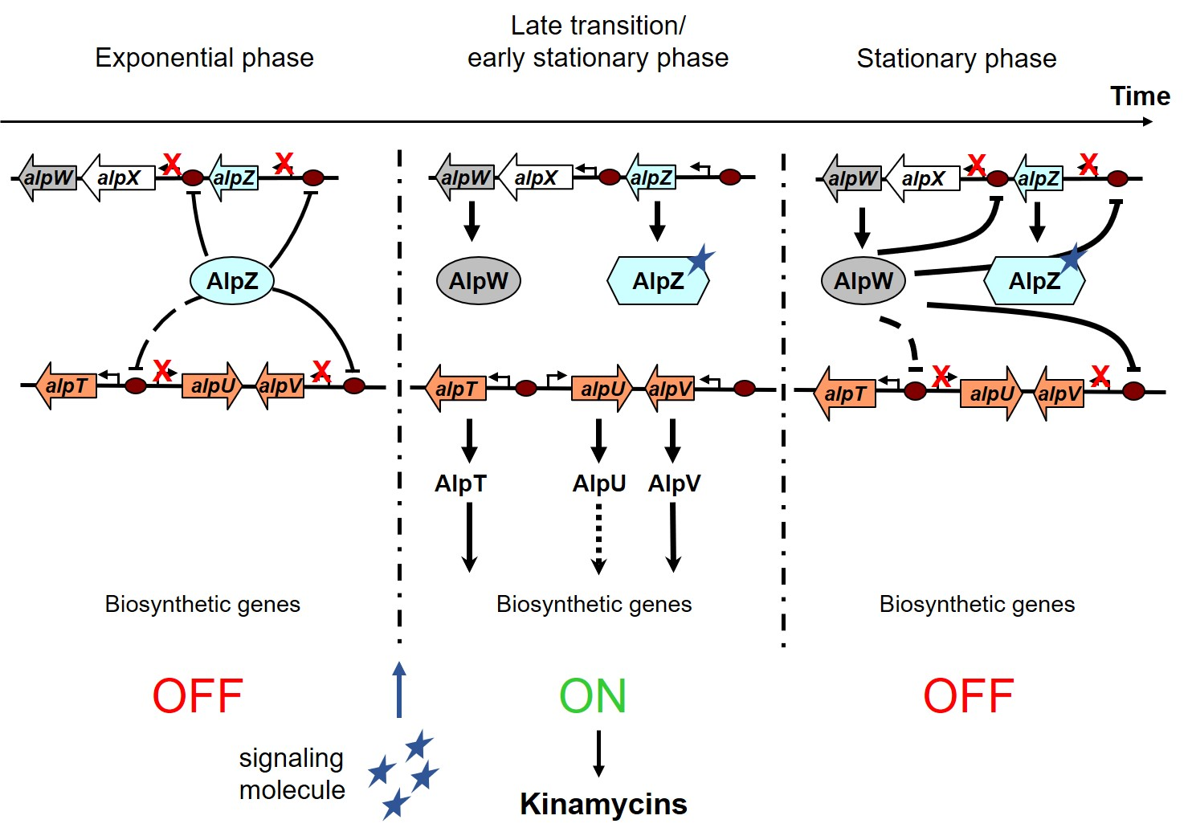

Figure S1. Model of the regulation of kinamycin biosynthesis in S. ambofaciens. In the initial growth phase, AlpZ represses the expression of the operon alpXW, the positive regulator encoding gene alpV and its own encoding gene by specifically binding the AREV sequences located in the promoter region (brown circles), preventing the expression of the biosynthetic genes and therefore leading to no kinamycin production. Then, the unknown signaling molecule accumulates and interacts during the transition phase with AlpZ releasing it from its binding sites, allowing gene expression and consequent kinamycin biosynthesis in the late transition to early stationary phase. In the later growth stages, the negative regulator AlpW represses expression of its targets alpZ, alpXW and alpV, effectively switching off kinamcyin biosynthesis. Note that the ARE motif located in the intergenic alpT-alpU region is not a target of AlpZ or AlpW, although deletion of either alpZ or alpW genes affects the expression of these SARP encoding genes.

Supplementary Tables

Table S1. Primers used in this work
Primer description and name | Sequence (5’-3’)
Mutant strain verification
CK1 | TGGTGGGCGGGAAGATGC
CK2 | CGAAGGGCGTGCGGCTCC
EMSA probe
AREV-1 | GCCGTATCCGCCGCATCT
AREV-2 | CCTGACGCGGTTTGGGAG
dsoverhangs
nanoAREV1 | CTCACATTGACAAACCGACTGTGCTGTTTTTTTATCAGGGATCAGCGTTCGATGCTTCCGACTAATCAGCCATATCAGCTTACGACTA
nanoAREV2 | CCCTGATAAAAAAACAGCACAGTCGGTTTGTCAATGTGAG
nanoControl1 | GGGGGGTGTGAGAACGGGGTGTTCTGGTGTTTGCGCCGGAATCAGCGTTCGATGCTTCCGACTAATCAGCCATATCAGCTTACGACTA
nanoControl2 | TCCGGCGCAAACACCAGAACACCCCGTTCTCACACCCCCC

