Supporting Information
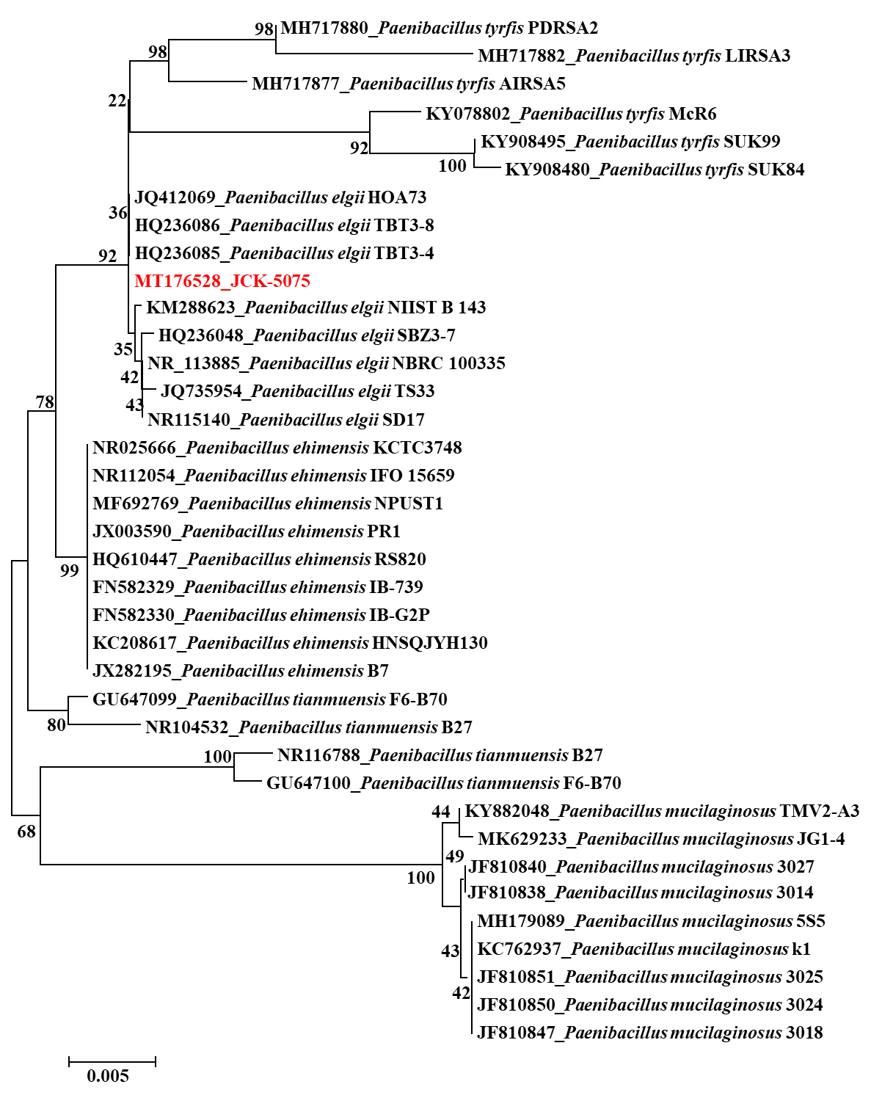
FIGURE S1 | Neighbor-joining phylogenetic tree of JCK-5075 based on 16S rRNA sequences analysis. The number at nodes indicates the level of bootstrap support (%) based on 1000 replicates dataset. The scale bar at the bottom indicates genetic distance unit.

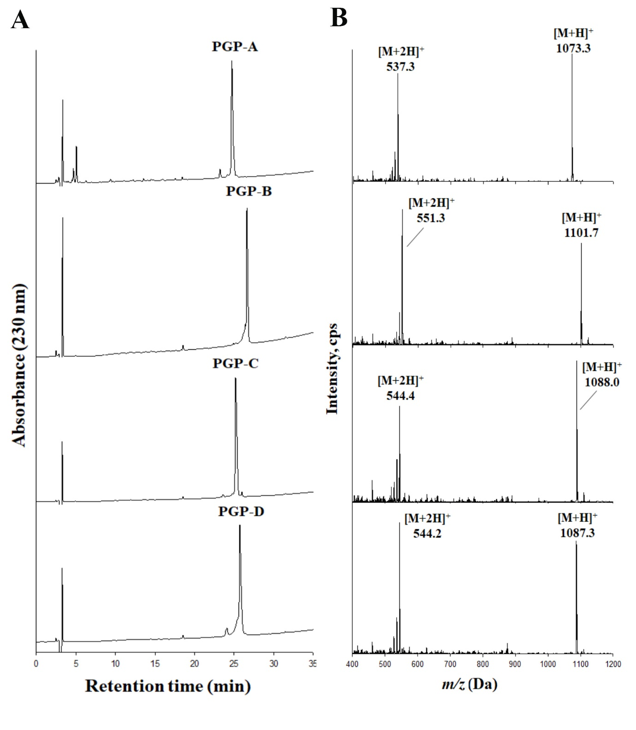
FIGURE S2 | Liquid chromatography electrospray ionization mass spectrometry (LC-ESI-MS) analysis of the purified pelgipeptins (PGPs). Reverse-phase high performance liquid chromatography (RP-HPLC) chromatogram (A), ESI-MS spectrum in positive mode (B).

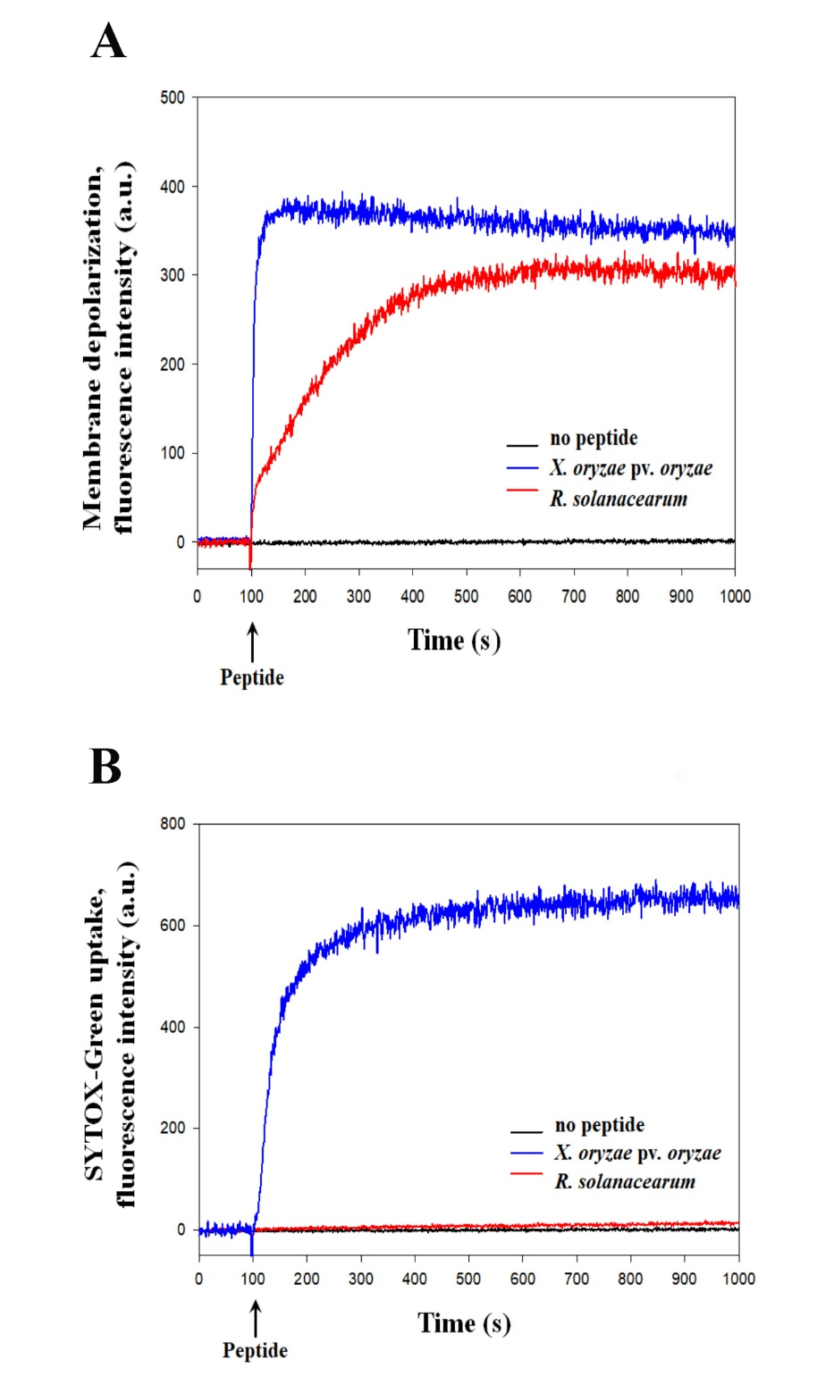

FIGURE S3 | The comparison of the cell membrane depolarizations. The depolarization of the cytoplasmic membrane was induced by pepgipeptin-C (PGP-C) peptide at 8 µg/ml, that was determined using the membrane potential-sensitive fluorescent dye DiSC3-(5) (A). The comparison of cell membrane permeabilization caused by PGP-C peptide at 8 µg/ml (B).

