Supplementary Material

Submerged carbonate banks aggregate pelagic megafauna in offshore tropical Australia

Phil J Bouchet, Tom B Letessier, M Julian Caley, Scott L Nichol, Jan M Hemmi, & Jessica J Meeuwig

E-mail: pjbouchet@gmail.com

Table S1. Summary of opportunistic cetacean sightings in the Oceanic Shoals Australian Marine Park (AMP). Total group size is indicated for (adults/calves). Behaviours include Bow-riding (BOR), Diving (DI), Milling (swimming in erratic directions, M), Resting (RES), Spy-hopping (SH), Splashing (SPL), Socialising (SO), and Travelling (directional movement, TR).

Date | Time (UTC) | Area | Species | Group size | Longitude | Latitude | Behaviour | Notes
2012-09-19 | 01:01 | 1 | Tursiops truncatus | 10 (8/2) | 127.388 | -12.195 | TR, DI, M | Mixed aggregation with P. crassidens. Circling an injured sailfish.
2012-09-19 | 01:01 | 1 | Pseudorca crassidens | 15 (14/1) | 127.388 | -12.195 | TR, DI, M | -
2012-09-19 | 01:58 | 1 | Tursiops truncatus | 6 (6/?) | 127.394 | -12.175 | TR | -
2012-09-19 | 02:28 | 1 | Tursiops truncatus | 15 (15/?) | 127.453 | -12.202 | RES, SO, DI, M | Tight social cohesion, slow surface movements and shallow dives - likely resting. Possible presence of calves.
2012-09-19 | 02:46 | 1 | Tursiops truncatus | 25 (23/2) | 127.452 | -12.203 | SO, DI, SPL, M | Tail-up dives, short jumps and surface displays - possibly feeding.
2012-09-22 | 02:45 | 2 | Orcinus orca | 3 (2/1) | 126.996 | -11.798 | TR, DI SH, BOR | Bull, cow and calf interacting with vessel.
2012-09-27 | 23:18 | 3 | Tursiops truncatus | 3 (3/0) | 126.973 | -11.446 | BOR, TR, SO | 3 adults bow riding - one confirmed male and possibly two females. Rolling behaviour, exposing underside and genitals. Repeated tactile interactions between individuals.
2012-09-27 | 09:01 | 3 | Tursiops truncatus | 3 (3/0) | 126.957 | -11.405 | TR | -
2012-09-29 | 23:00 | 3 | Tursiops truncatus | 5 (5/0) | 127.024 | -11.416 | BOR, TR, DI | Bow riding.

Table S2. Summary of species detected on midwater stereo-BRUVs within the Oceanic Shoals Australian Marine Park (AMP), including some of their vulnerability attributes. IUCN: IUCN status (CR = Critically endangered, DD = Data deficient, LC = Least concern, NE = Not evaluated, NT = Near threatened, VU = Vulnerable); TL: Trophic level; VUL: Vulnerability to fishing pressure [from 0 = low to 100 = very high]; Exp: Exploitation status (C = Commercial, HC = Highly commercial, G = Gamefish, MC = Minor commercial, ONI = Of no interest). Superscript letters indicate species grouped into complexes due to uncertainties regarding identification (A: Scomberomorus complex; B: Carcharhinus complex).

Family | Species | Common name | IUCN |  | TL | Guild |  | V VUL |  | Exp
Carangidae | Alectis ciliaris | African pompano | LC |  | 3.46 | Herbivore |  | 69 |  | MC, G
 | Atule mate | Yellowtail scad | NE |  | 3.27 | Herbivore |  | 19 |  | MC, G
 | Carangoides armatus | Longfin trevally | NE |  | 4.20 | Predator |  | 34 |  | C, G
 | Caranx ignobilis | Giant trevally | NE |  | 4.48 | Predator |  | 82 |  | C, G
 | Decapterus macarellus | Mackerel scad | NE |  | 3.24 | Plankton eater |  | 23 |  | C, G
 | Elagatis bipinnulata | Rainbow runner | NE |  | 3.59 | Predator |  | 51 |  | HC, G
 | Psenes sp. | Drift fish | - |  | 3.65 | Predator |  | - |  | -
 | Seriolina nigrofasciata | Blackbanded trevally | NE |  | 4.17 | Predator |  | 37 |  | MC, G
Carcharhinidae | Carcharhinus amblyrhynchoides | Graceful shark ^{A} | NT |  | 4.22 | Predator |  | 63 |  | MC
 | Carcharhinus amblyrhynchos | Grey reef shark | NT |  | 4.50 | Predator |  | 55 |  | MC, G
 | Carcharhinus amboinensis | Pigeye shark | DD |  | 4.29 | Predator |  | 74 |  | MC, G
 | Carcharhinus brevipinna | Spinner shark | NT |  | 4.50 | Predator |  | 59 |  | C, G
 | Carcharhinus falciformis | Silky shark | NT |  | 4.40 | Predator |  | 78 |  | HC
 | Carcharhinus leucas | Bull shark | NT |  | 4.34 | Predator |  | 88 |  | C, G
 | Carcharhinus tilstoni | Australian blacktip shark ^{A} | LC |  | 4.50 | Predator |  | 70 |  | MC
 | Carcharhinus limbatus | Australian blacktip shark ^{A} |  | NT | 4.46 | Predator | 55 |  | C, G
 | Carcharhinus sorrah | Spottail shark ^{A} |  | NT | 4.31 | Predator | 51 |  | MC
 | Galeocerdo cuvier | Tiger shark |  | NT | 4.42 | Predator | 62 |  | C, G
Cheloniidae | Lepidochelys olivacea | Olive ridley turtle |  | VU | 3.10 | Herbivore | 14 |  | C
Delphinidae | Orcinus orca | Killer whale |  | DD | 4.50 | Predator | 66 |  | C
Echeneidae | Echeneis naucrates | Shark sucker |  | NE | 3.40 | Cleaner | 54 |  | MC, G
Hydrophiidae | Hydrophiidae sp. | Sea snakes |  | - | 4.00 | Predator | - |  | -
Istiophoridae | Istiompax indica | Black marlin |  | NE | 4.47 | Predator | 44 |  | C, G
Mobulidae | Manta birostris | Manta ray |  | VU | 3.46 | Filter-feeder | 78 |  | MC
Monacanthidae | Aluterus monoceros | Unicorn leatherjacket |  | NE | 3.49 | Plankton eater | 63 |  | C
 | Paramonacanthus filicauda | Threadfin leatherjacket |  | NE | 2.78 | Herbivore | 31 |  | –
 | Pseudomonacanthus peroni | Pot-bellied leatherjacket |  | NE | 3.00 | Herbivore | 49 |  | –
Rachycentridae | Rachycentron canadum | Cobia |  | NE | 4.26 | Predator | 44 |  | MC, G
Scombridae | Acanthocybium solandri | Wahoo |  | LC | 4.42 | Predator | 46 |  | C, G
 | Scomberomorus commerson | Narrow-barred Spanish mackerel ^{B} |  | NT | 4.38 | Predator | 41 |  | HC, G
 | Scomberomorus semifasciatus | Broad-barred Spanish mackerel ^{B} |  | LC | 4.50 | Predator | 39 |  | C, G
Sphyraenidae | Sphyraena barracuda | Great barracuda |  | NE | 4.50 | Predator | 79 |  | MC, G
Sphyrnidae | Sphyrna lewini | Scalloped hammerhead |  | EN | 4.21 | Predator | 83 |  | C, G
 | Sphyrna mokarran | Great hammerhead |  | EN | 4.43 | Predator | 86 |  | C

Table S3. Geomorphometrics considered in predictive models of pelagic species richness and abundance within the Oceanic Shoals Australian Marine Park (AMP). Large-scale: 1,000 m neighbourhood; small-scale: 100 m neighbourhood. Units are as follows: deg = degrees, d.u. = dimensionless unit, m = metres, rad = radians, dB = decibels. Formulae, definitions, and key references are described in Bouchet et al. (2015), Lecours et al. (2017), and Nichol et al. (2013). TPI: Topographic position index. Slope was computed in degrees, and aspect in radians using package raster in R (Hijmans, 2019), following Horn’s method (Horn, 1981). Easting and northing were taken as the sine and cosine of aspect values, respectively. TPI and rugosity were calculated using the focal function in package raster. Curvature was derived as total curvature in package spatialEco (Evans, 2018), ﻿via a quadratic equation fit to a 3 x 3 focal window as per Zevenbergen and Thorne (1987).

Geomorphometric | Code | Unit | Ecological rationale / interpretation
Acoustic backscatter | bk | dB | Benthic biomass, prey availability
Aspect easting | east | rad | Exposure to currents, oxygenation, nutrient input
Aspect northing | north | rad | Exposure to currents, oxygenation, nutrient input
Curvature | curv | rad.m⁻¹ | Vertical mixing, eddy formation, prey entrapment
Depth | depth | m | Light availability, primary productivity
Seabed slope | slope | deg | Vertical mixing, upwelling, eddy formation
TPI (large-scale) | tpi1000 | d.u. | Habitat complexity, prey refugia, benthic biomass
TPI (small-scale) | tpi100 | d.u. | Habitat complexity, prey refugia, benthic biomass
Rugosity (local standard  deviation of depth) | stde | d.u. | Habitat complexity, prey refugia, benthic biomass

Table S4. Selection frequencies for generalised additive mixed model (GAMM) formulations used to predict species richness (S) and abundance (N) within each sampling area. Values are calculated as the number of times each candidate model minimised the AICc over n=100 bootstrap replicates of the original data. Also included were a random effect term for the sampling area, and an offset term for deployment duration.
Response variable | te(depth, bk) | s(curv) | s(east) | s(north) | s(slope) | s(stde) | s(tpi100) | s(tpi1000) | Freq
Species richness (S) | • |  |  |  |  |  |  |  | 0.204
 |  |  |  |  |  |  |  | • | 0.184
 | • |  | • |  |  |  |  |  | 0.153
 |  |  | • |  |  |  |  | • | 0.102
 | • |  |  |  |  |  |  | • | 0.051
 | • |  |  |  | • |  |  |  | 0.041
 | • |  |  | • |  |  |  |  | 0.031
 |  |  | • | • |  |  |  | • | 0.031
 |  |  |  |  |  |  | • | • | 0.031
 | • | • |  |  |  |  |  |  | 0.020
 |  | • | • |  |  |  |  | • | 0.020
 | • |  |  | • |  |  |  | • | 0.020
 |  |  | • |  |  |  |  |  | 0.020
 |  | • | • | • |  | • |  |  | 0.010
 | • |  | • |  |  |  |  | • | 0.010
 | • |  |  |  |  |  | • | • | 0.010
 |  |  | • |  | • |  |  |  | 0.010
 |  |  | • |  |  |  | • | • | 0.010
 |  |  |  | • |  |  |  | • | 0.010
 |  |  |  |  | • |  |  |  | 0.010
 |  |  |  |  |  | • |  | • | 0.010
 |  |  |  |  |  | • |  | • | 0.010
Abundance (N) | • |  |  |  | • |  | • |  | 0.080
 | • | • |  |  |  |  |  | • | 0.070
 |  | • | • |  | • |  |  | • | 0.070
 | • | • |  |  |  |  | • |  | 0.050
 | • |  | • | • |  |  |  |  | 0.050
 | • |  |  | • |  |  |  | • | 0.050
 | • | • |  |  |  |  |  |  | 0.040
 | • | • |  |  |  | • |  |  | 0.040
 | • |  | • |  |  | • |  |  | 0.040
 | • |  |  |  |  | • | • |  | 0.040
 | • |  |  |  |  |  | • | • | 0.040
 |  | • | • |  |  | • |  | • | 0.030
 | • |  | • |  |  |  |  | • | 0.030
 | • |  |  | • |  |  |  |  | 0.030
 | • | • | • |  |  |  |  |  | 0.020
 |  | • | • | • |  |  |  | • | 0.020
 |  | • | • |  |  |  |  | • | 0.020
 |  | • | • |  |  |  | • | • | 0.020
 |  | • |  | • |  |  |  | • | 0.020
 |  | • |  |  |  |  | • | • | 0.020
 | • |  | • |  |  |  | • |  | 0.020
 | • |  |  |  | • |  |  |  | 0.020
 |  | • | • | • |  | • |  |  | 0.010
 |  | • |  | • |  | • | • |  | 0.010
 |  | • |  | • |  |  | • | • | 0.010
 |  | • |  |  | • |  |  | • | 0.010
 |  | • |  |  | • |  | • | • | 0.010
 |  | • |  |  |  |  |  | • | 0.010
 | • |  |  |  |  |  |  |  | 0.010
 | • |  | • |  |  |  |  |  | 0.010
 | • |  | • |  | • |  |  |  | 0.010
 | • |  |  |  | • |  |  | • | 0.010
 | • |  |  |  |  | • |  |  | 0.010
 | • |  |  |  |  | • |  | • | 0.010
 | • |  |  |  |  |  | • |  | 0.010
 |  |  | • | • | • |  |  | • | 0.010
 |  |  | • | • | • |  | • |  | 0.010
 |  |  | • | • |  | • | • |  | 0.010
 |  |  | • | • |  |  | • | • | 0.010
 |  |  | • |  |  |  | • |  | 0.010

Table S5. SIMPER analysis showing which taxa were primarily responsible for the zero-adjusted Bray-Curtis dissimilarity between assemblages found on carbonate banks and those away from them. Diss: ﻿Species contribution to average between-group dissimilarity. SD: ﻿Standard deviation of contribution. r: Ratio of dissimilarity and standard deviation Diss/SD. Av. Ab = Average abundance (on fourth root-transformed data). cum: ﻿Ordered cumulative contribution. p: ﻿Permutation p-value, that is probability of getting a larger or equal average contribution in a random permutation of the geom factor.
Species name | Diss | SD | r | Av. Ab (bank) | Av. Ab (non-bank) | cum | p
Decapterus macarellus | 0.15 | 0.14 | 1.04 | 1.20 | 1.48 | 0.24 | 0.047
Aluterus monoceros | 0.10 | 0.10 | 1.01 | 0.56 | 0.65 | 0.40 | 0.189
Carcharhinus [complex] | 0.08 | 0.09 | 0.94 | 0.60 | 0.38 | 0.54 | 0.028
Seriolina nigrofasciata | 0.06 | 0.08 | 0.68 | 0.20 | 0.30 | 0.63 | 0.780
Scomberomorus [complex] | 0.04 | 0.07 | 0.53 | 0.31 | 0.03 | 0.69 | 0.002
Echeneis naucrates | 0.04 | 0.06 | 0.57 | 0.21 | 0.13 | 0.75 | 0.160
Paramonacanthus filicauda | 0.04 | 0.07 | 0.49 | 0.08 | 0.20 | 0.81 | 0.846
Sphyrna lewini | 0.02 | 0.06 | 0.38 | 0.06 | 0.11 | 0.84 | 0.769
Atule mate | 0.02 | 0.05 | 0.33 | 0.07 | 0.06 | 0.87 | 0.488
Carangoides armatus | 0.01 | 0.04 | 0.30 | 0.07 | 0.03 | 0.89 | 0.232
Alectis ciliaris | 0.01 | 0.03 | 0.22 | 0.02 | 0.03 | 0.90 | 0.471
Lepidochelys olivacea | 0.01 | 0.03 | 0.21 | 0.00 | 0.05 | 0.91 | 0.890
Carcharhinus falciformis | 0.01 | 0.02 | 0.24 | 0.05 | 0.02 | 0.92 | 0.145
Pseudomonacanthus peroni | 0.01 | 0.04 | 0.14 | 0.02 | 0.00 | 0.93 | 0.275
Acanthocybium solandri | 0.00 | 0.02 | 0.19 | 0.02 | 0.02 | 0.93 | 0.478
Sphyraena barracuda | 0.00 | 0.02 | 0.21 | 0.04 | 0.00 | 0.94 | 0.120
Istiompax indica | 0.00 | 0.03 | 0.16 | 0.00 | 0.03 | 0.95 | 0.785
Caranx ignobilis | 0.00 | 0.02 | 0.21 | 0.04 | 0.00 | 0.95 | 0.126
Galeocerdo cuvier | 0.00 | 0.02 | 0.17 | 0.00 | 0.03 | 0.96 | 0.799
Elagatis bipinnulata | 0.00 | 0.02 | 0.15 | 0.04 | 0.00 | 0.97 | 0.271
Rachycentron canadum | 0.00 | 0.03 | 0.12 | 0.00 | 0.02 | 0.97 | 0.592
Psenes sp. | 0.00 | 0.02 | 0.14 | 0.02 | 0.00 | 0.98 | 0.270
Sphyrna mokarran | 0.00 | 0.02 | 0.15 | 0.02 | 0.00 | 0.98 | 0.266
Carcharhinus amboinensis | 0.00 | 0.02 | 0.12 | 0.00 | 0.02 | 0.98 | 0.640
Hydrophiidae sp. | 0.00 | 0.02 | 0.12 | 0.00 | 0.02 | 0.99 | 0.638
Carcharhinus brevipinna | 0.00 | 0.01 | 0.15 | 0.02 | 0.00 | 0.99 | 0.270
Carcharhinus leucas | 0.00 | 0.02 | 0.12 | 0.00 | 0.02 | 0.99 | 0.656
Carcharhinus amblyrhynchos | 0.00 | 0.01 | 0.15 | 0.02 | 0.00 | 1.00 | 0.270
Manta birostris | 0.00 | 0.01 | 0.15 | 0.02 | 0.00 | 1.00 | 0.270
Orcinus orca | 0.00 | 0.01 | 0.12 | 0.00 | 0.02 | 1.00 | 0.720

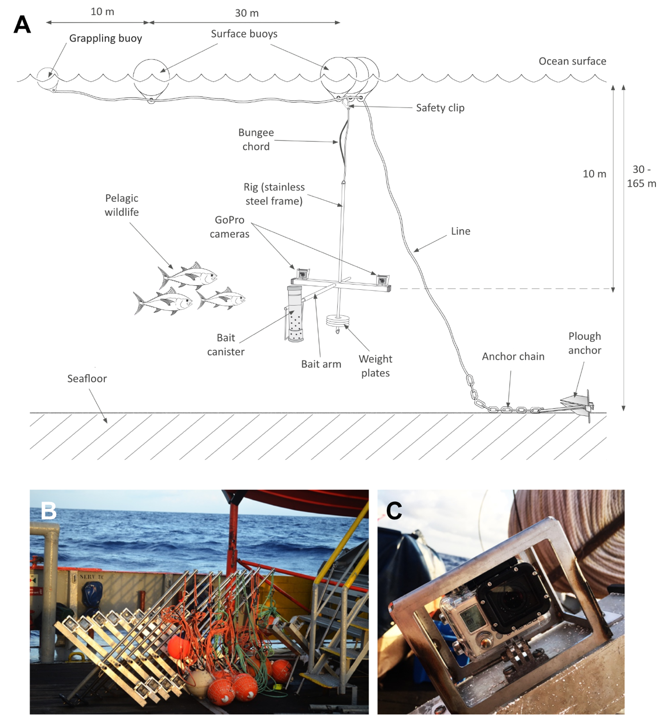

Figure S1. (A) Schematic diagram of a midwater BRUV. Camera units are moored to the seafloor and suspended at a depth of 10 m below the ocean surface. (B) Equipment stacked on deck before deployment. (C) Close up view of a GoPro camera in its housing. Photo credits: Phil J. Bouchet and Tom B. Letessier.

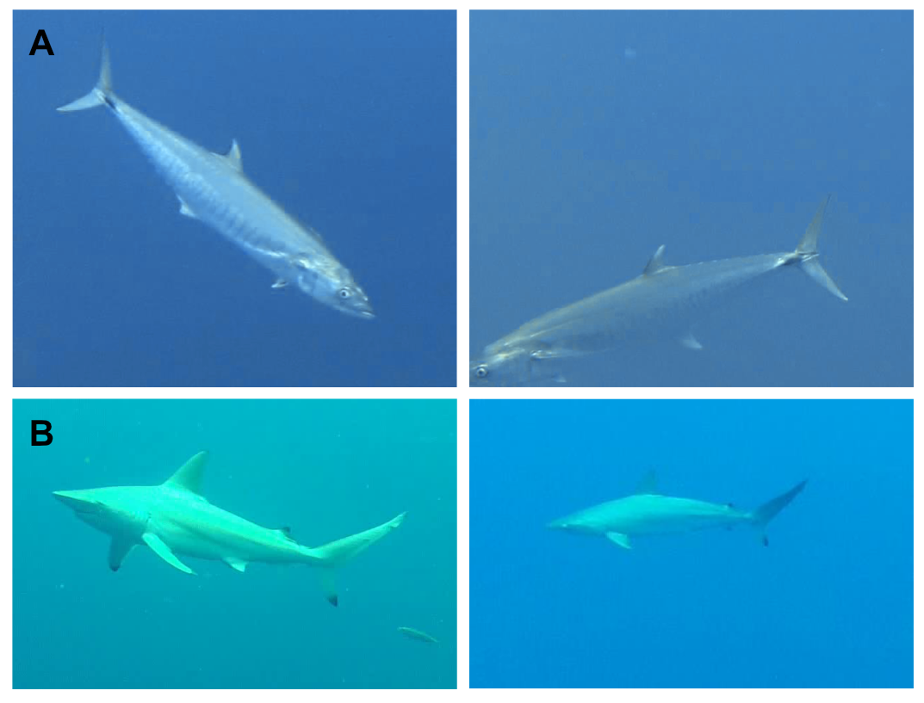

Figure S2. Example species which could not be reliably identified on video. Animals in the top row (A) were assigned to the Scomberomorus spp. complex (comprising both S. commerson and S. semifasciatus), whereas animals in the bottom row (B) were grouped into the Carcharhinus spp. complex (comprising C. tilstoni, C. sorrah, and C. amblyrhynchoides).

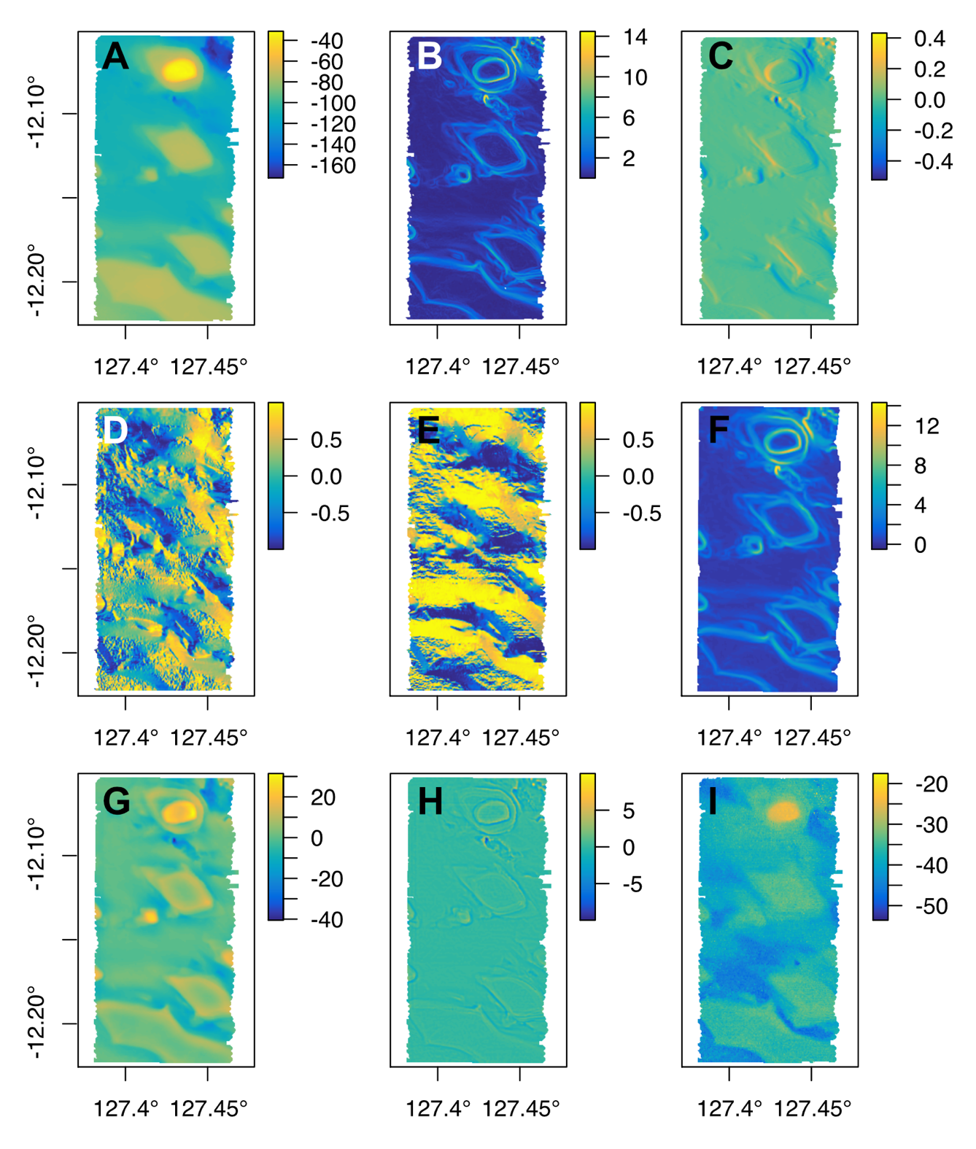

Figure S3. Example maps of seabed (A) depth, (B) slope, (C) total curvature, (D) aspect easting, (E) aspect northing, (F) rugosity, (G) TPI (large-scale), (H) TPI (small-scale), and (I) acoustic backscatter for sampling area 1. Descriptions of each geomorphometric can be found in Table S3.

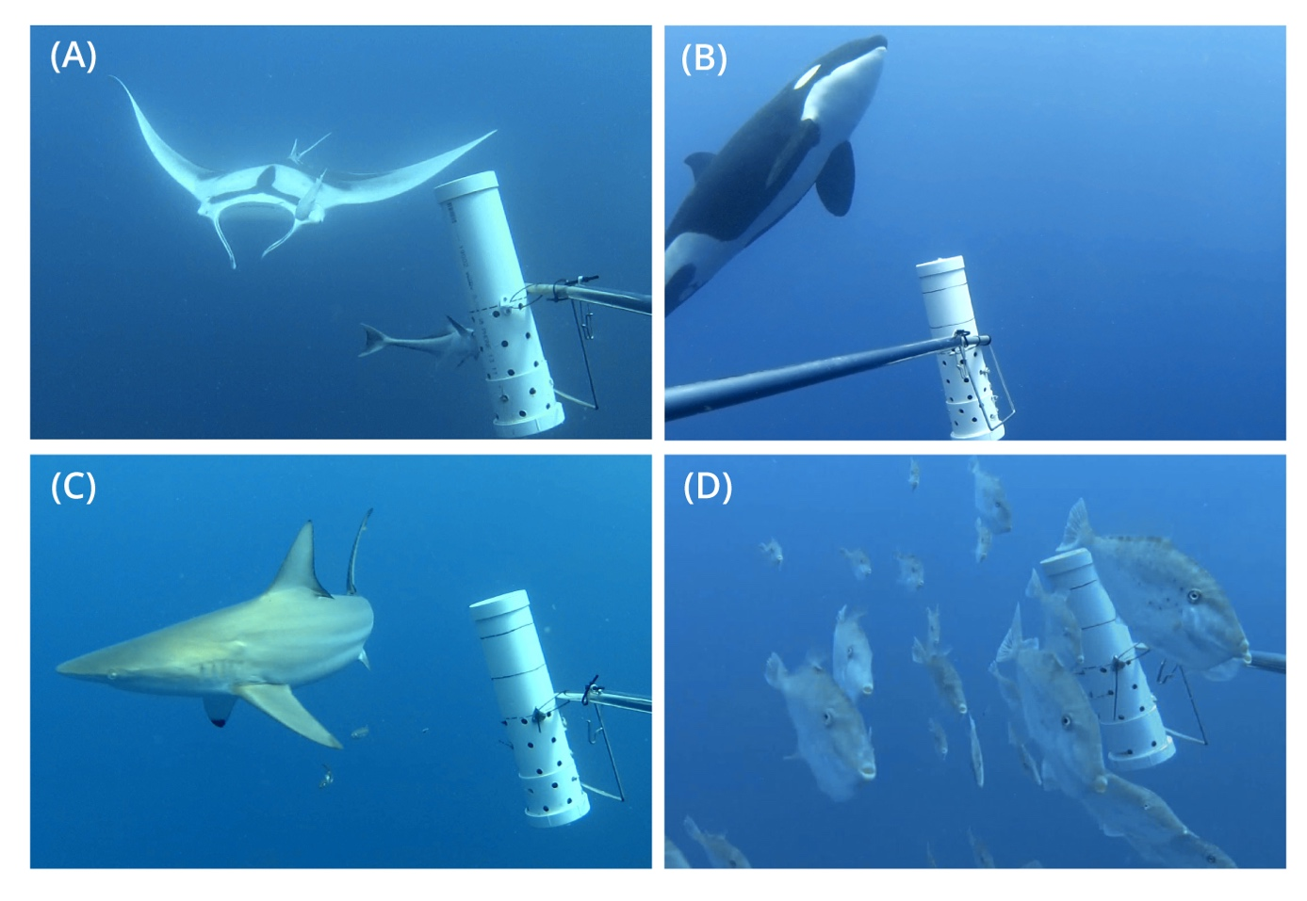
Figure S4. Example pelagic species observed on midwater BRUVs in the Oceanic Shoals Australian Marine Park (AMP). (A) Manta ray, Manta birostris; (B) Killer whale, Orcinus orca; (C) Australian blacktip shark, Carcharhinus tilstoni; (D) Unicorn leatherjackets, Aluterus monoceros. Photo credits: Centre for Marine Futures, University of Western Australia.

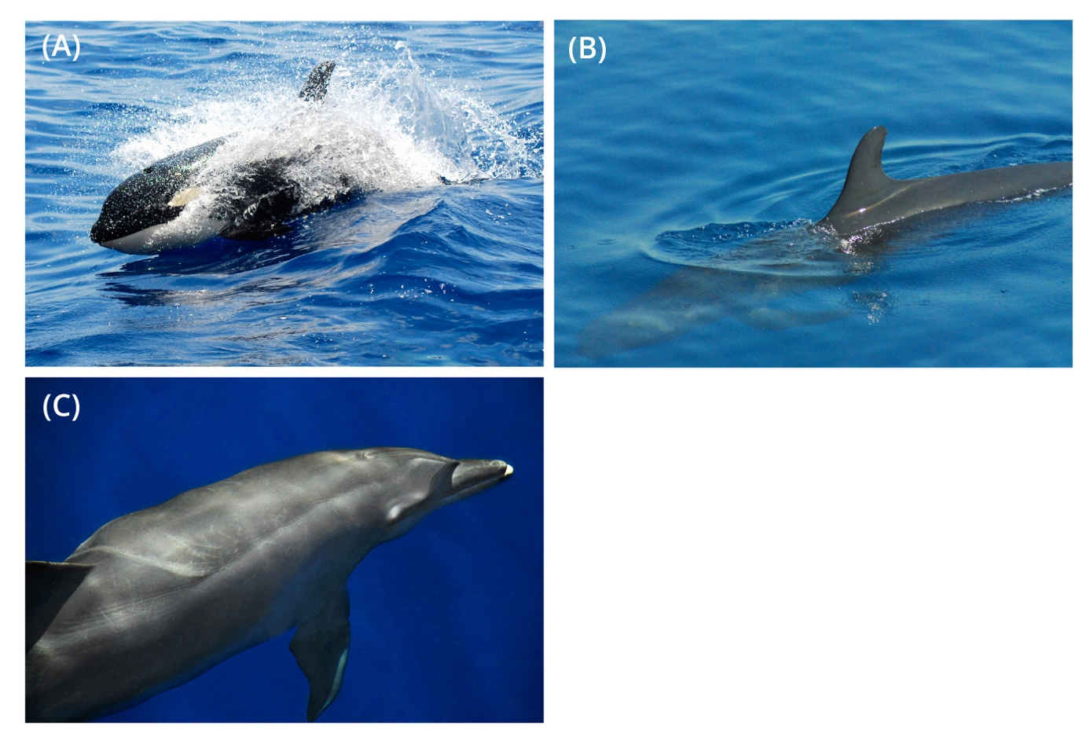
Figure S5. Cetacean species observed in the Oceanic Shoals Australian Marine Park (AMP). (A) Killer whale, Orcinus orca; (B) False killer whale, Pseudorca crassidens; (C) Bottlenose dolphin, Tursiops truncatus. Photo credits: Phil J. Bouchet and Tom B. Letessier.

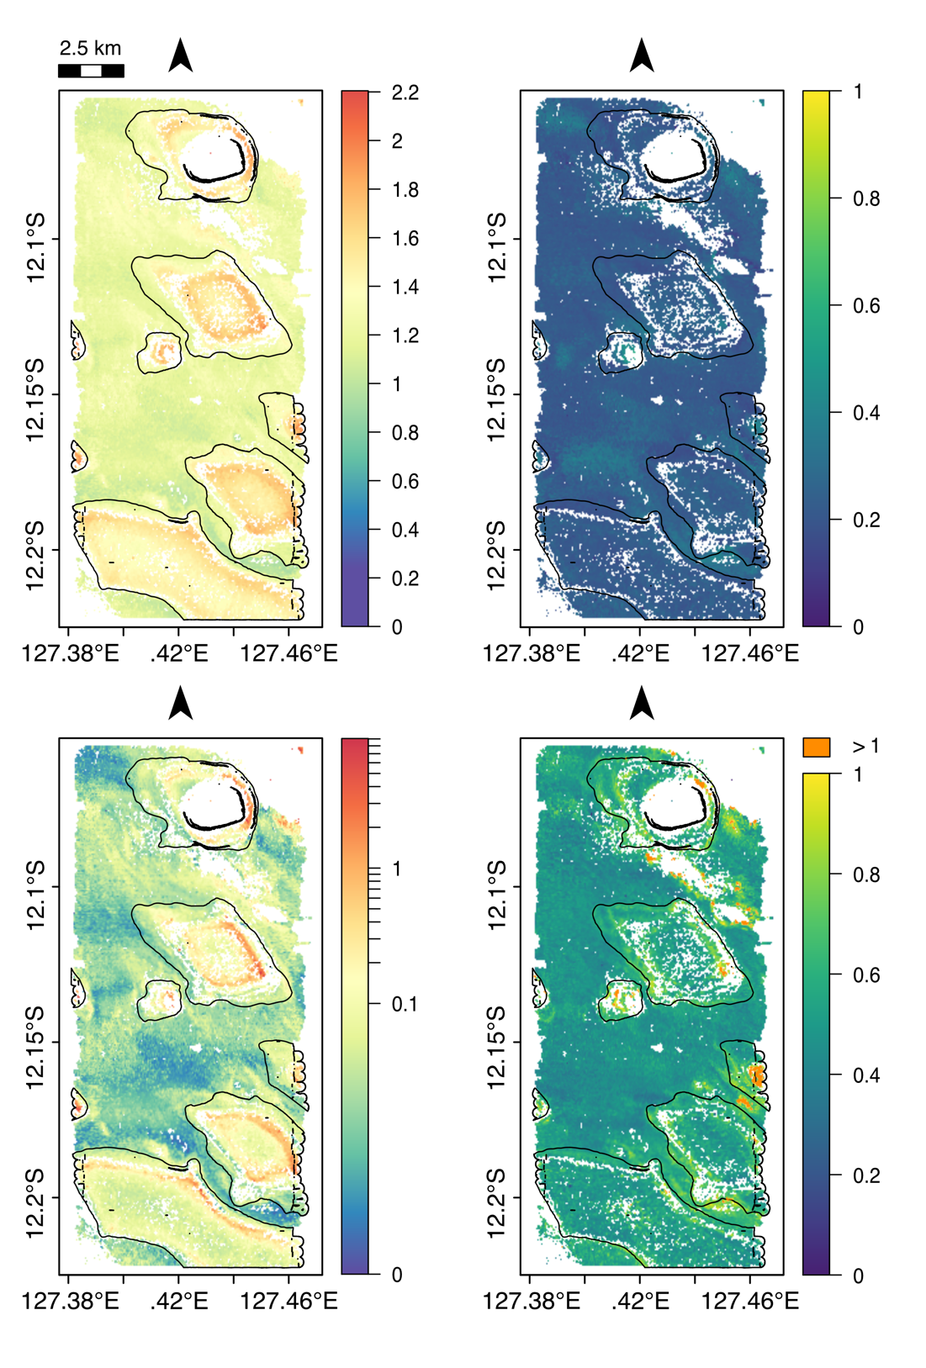
Figure S6. Median predictions of pelagic species richness (S, top left) and abundance (N, bottom left) in sampling area 1. Uncertainty (top and bottom right) was assessed as the robust coefficient of variation (rCV, %) of bootstrapped predictions within individual grid cell. The outlines of each bank are superimposed in black.
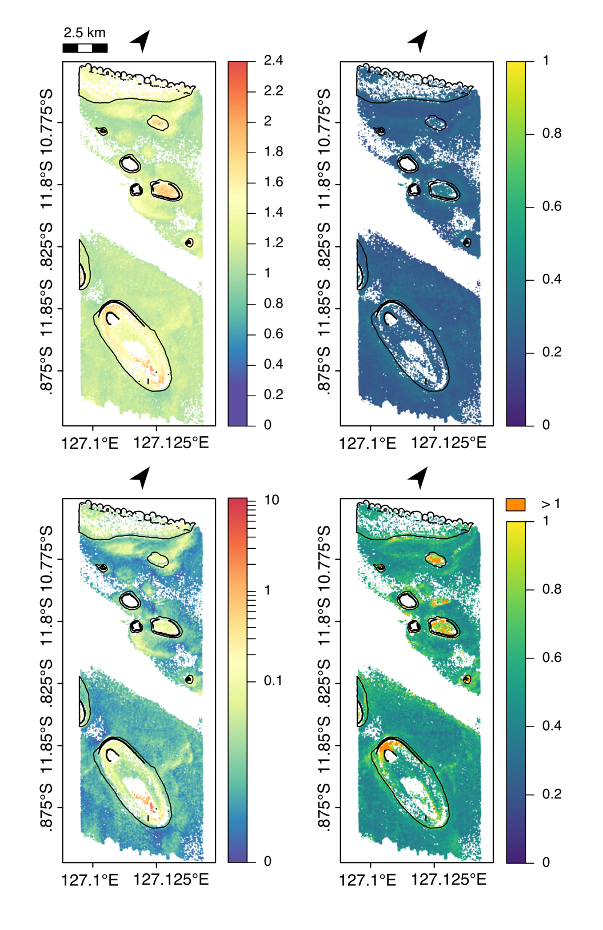
Figure S7. Median predictions of pelagic species richness (S, top left) and abundance (N, bottom left) in sampling area 2. Uncertainty (top and bottom right) was assessed as the robust coefficient of variation (rCV, %) of bootstrapped predictions within individual grid cell. The outlines of each bank are superimposed in black.
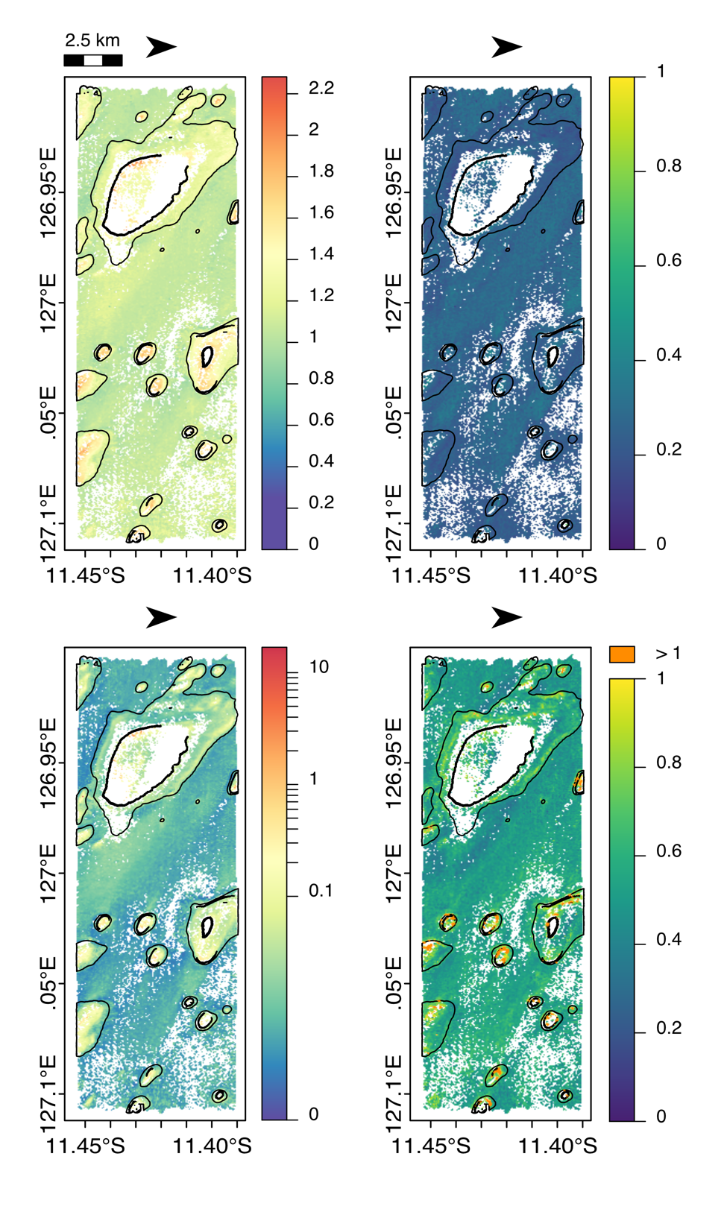
Figure S8. Median predictions of pelagic species richness (S, top left) and abundance (N, bottom left) in sampling area 3. Uncertainty (top and bottom right) was assessed as the robust coefficient of variation (rCV, %) of bootstrapped predictions within individual grid cell. The outlines of each bank are superimposed in black.
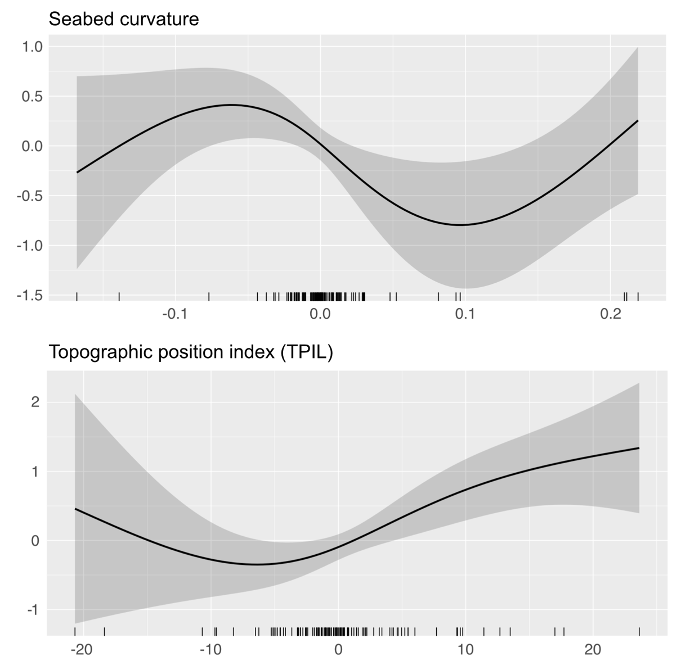

Figure S9. Partial plots of pelagic species abundance (N) as a function of seabed total curvature (top) and large-scale topographic position index (bottom) in the Oceanic Shoals Australian Marine Park, based on the best GAMM fitted to midwater BRUV data. Both the fitted smooth functions (solid line) and the associated 95% confidence interval (shaded areas) are shown. Data points are represented as rug plots on the horizontal axes.

References
Bouchet, P. J., Meeuwig, J. J., Salgado Kent, C. P., Letessier, T. B., and Jenner, C. K. (2015). Topographic determinants of mobile vertebrate predator hotspots: Current knowledge and future directions. Biol. Rev. 90, 699–728. doi:10.1111/brv.12130.
Evans, J. S. (2018). spatialEco. R package version 0.1.1-1. Available at: https://cran.r-project.org/package=spatialEco.
Hijmans, R. J. (2019). raster: Geographic Data Analysis and Modeling. R package version 3.0-2. Available at: https://cran.r-project.org/package=raster.
Horn, B. K. P. (1981). Hill shading and the reflectance map. Proc. IEEE 69, 14–47. doi:10.1109/PROC.1981.11918.
Lecours, V., Devillers, R., Simms, A. E., Lucieer, V. L., and Brown, C. J. (2017). Towards a framework for terrain attribute selection in environmental studies. Environ. Model. Softw. 89, 19–30. doi:http://dx.doi.org/10.1016/j.envsoft.2016.11.027.
Nichol, S. L., Howard, F. J. F., Kool, J., Stowar, M., Bouchet, P. J., Radke, L., et al. (2013). Oceanic Shoals Commonwealth Marine Reserve (Timor Sea) Biodiversity Survey. Available at: https://goo.gl/FbT45v.
Zevenbergen, L. W., and Thorne, C. R. (1987). Quantitative analysis of land surface topography. Earth Surf. Process. Landforms 12, 47–56. doi:10.1002/esp.3290120107.

